|  |
| --- |
| The Sulawesi island earthquake 2021, Indonesia |

**Where is Sulawesi island?**

Indonesia is an archipelago of 17,000 islands between the Pacific and Indian Oceans. The islands have all been created, over time, from the convergent plate boundary as the Australian plate moves over the Sunda Block (a minor tectonic plate). The reason for this is that the Australian tectonic plate is thicker and more buoyant than the oceanic Sunda Block. (This movement unusually reverses near Lombok with the Australian plate sliding underneath its counterpart). This is a part of the ‘Pacific Ring of Fire’ marking a very tectonically active area.

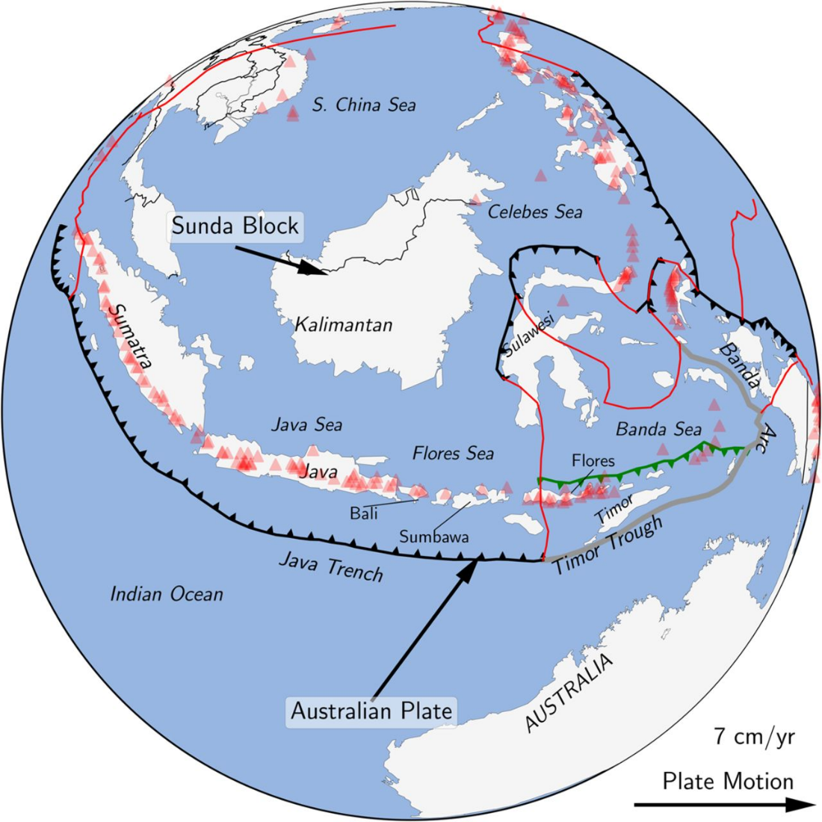

Indonesia © Geological Society Publications <https://sp.lyellcollection.org/content/441/1/1>

Sulawesi is the fourth largest island in Indonesia (by size, km²). The latest official estimate is that there are roughly 19,573,800 people living on the island, which accounts for 7.2% of the country’s population. The interior of the island is rugged and mountainous with the majority of the population stretching out on the island’s four peninsulas. The three bays are called Tomini, Tolo and Boni.

**What happened last week?**

Last week an earthquake struck the Indonesian island of Sulawesi. It measured 6.2 on the Richter Scale, was recorded at a shallow depth with an epicentre 6km northeast of Majene city, in west Sulawesi. The hardest hit city was Mamuju, with over half of the buildings either collapsed or badly damaged. The earthquake struck just after 1am in the early hours of Friday morning, 15 January 2021.

**What were the impacts?**

84 people were killed in the earthquake and this figure is expected to rise as electricity remains cut off, hampering rescue efforts and communications. There have been over 39 aftershocks which have continued to wreak havoc and cause further loss of life. Some important buildings such as the office of the governor of west Sulawesi have been badly damaged, the five-storey Mitra Manakarra hospital in Mamuju also partially collapsed, killing 8 people.

Excavators, cranes, rescue teams and rescue dogs have all been deployed.

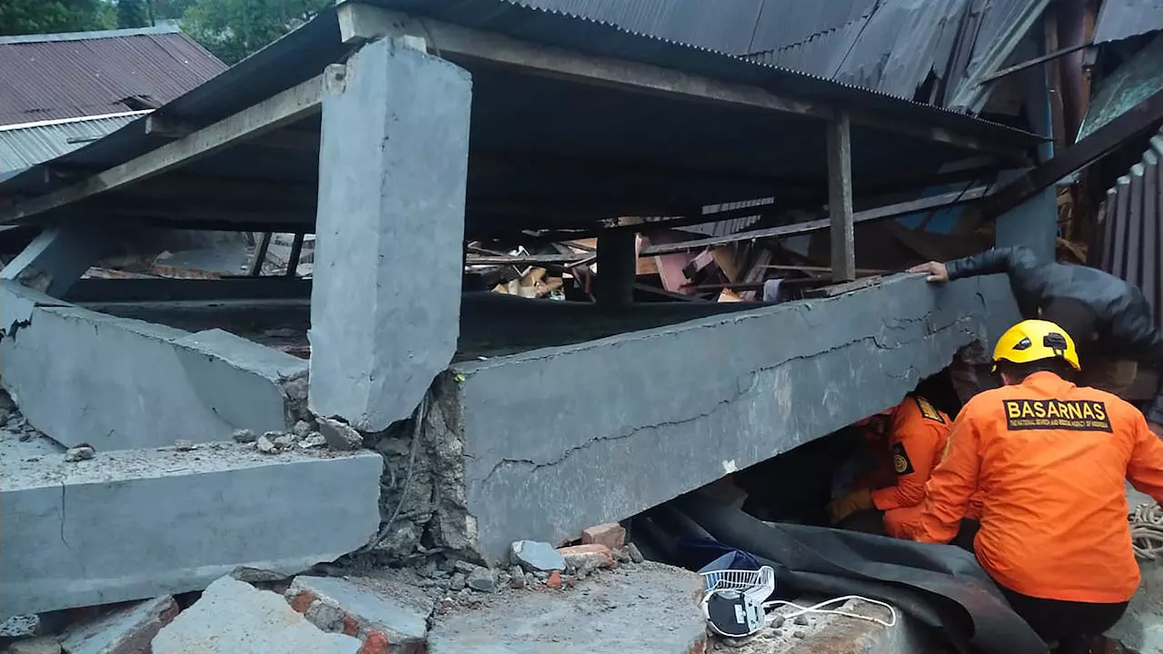

A handout photo released by BASARNAS of the Sulawesi earthquake © BASARNAS AFP

**The situation**

There are widespread concerns that aftershocks remain a severe danger to life as strong repeated shocks could lead to further building collapse and could even trigger a tsunami. People on the island of Sulawesi are being urged to stay away from damaged buildings and should move to safe ground, away from low-lying coastal areas. They are not being encouraged into the interior of the island as there are also fears of landslides on unstable, high ground.

The Indonesian President Joko Widodo flew into South Kalimantan, on Borneo island, to view flood damage on Monday 18 January 2021. At least 15 people have died here from weeks of torrential rain.

Heavy rain continues to be forecast for the island of Sulawesi which makes this a multi-hazardous environment. The Indonesian army corps of engineers have cleared the roads between Mamuju and Majene. The National Disaster Mitigation Agency has moved 27,850 survivors to shelter, although ‘only a few were lucky to be protected by tarpaulin-covered tents’.

Authorities now fear an outbreak of and spread of coronavirus in the cramped overcrowded shelters which are lacking medical infrastructure. Medical workers have already begun separating high and low risk people who are suffering from displacement.

**Further reading**

* Deadly earthquake <https://www.youtube.com/watch?v=iCDK9JkhI00>
* Monsoon rains slow search <https://www.theguardian.com/world/2021/jan/18/indonesia-earthquake-monsoon-rains-slow-search-for-survivors-as-death-toll-passes-80>
* Indonesia earthquake: rescue workers search rubble with dozens reported dead <https://www.youtube.com/watch?v=qipfv7b5EOY>
* Dozens dead as search for survivors continues <https://www.bbc.co.uk/news/world-asia-55672126>
* Sulawesi earthquake toll at 84 as Indonesia battles series of disasters <https://www.reuters.com/article/us-indonesia-quake/sulawesi-quake-death-toll-at-84-as-indonesia-battles-series-of-disasters-idUSKBN29N087?il=0>
* Tsunami potential <https://www.france24.com/en/asia-pacific/20210115-deadly-earthquake-hits-indonesia-s-sulawesi-island>