|  |
| --- |
| Tuvalu |

**Location Basic facts**

|  |  |
| --- | --- |
| Population per km2 | 373 (2022) |
| GDP/GNI per person | $7,160 (2022) |
| Climate | Tropical with a wet and dry season |
| HDI (closest to 1 = most developed) | 0.641 (2021) |

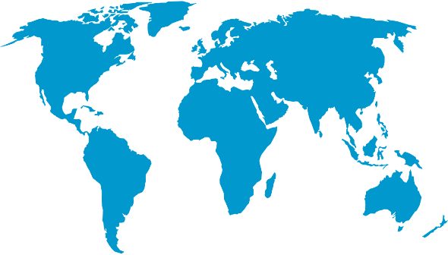

*World Map © Clker-Free-Vector-Images, Pixabay*

**Environmental facts**

|  |  |
| --- | --- |
| 1. | Tuvalu faces various natural hazards, including tropical cyclones with strong winds and storm surges, droughts, flooding, and the challenges of climate change such as rising sea levels. During the wet season, the average rainfall can reach around 3,000 mm per year. The people of Tuvalu could be one of the first environmental refugees due to the increase threat of climate change on their islands. |
| 2. | Tuvalu’s land is very low lying; the coastline is 24 kilometres long. Some parts are barely 3 metres above sea level, in fact, the highest is 4.6 metres above sea level. The sea has risen so much here that the land is often flooded in storms and groundwater supplies have been contaminated by saltwater meaning that the population are reliant on rainfall for fresh water. |
| 3. | 100% of the marine ecosystem in Tuvalu is warm water corals. These trap sediment to help island building and are home to approximately 350 species of fish. The reefs once had more life but due to bleaching and rising sea temperatures, the coral is dying leaving. |

**Protecting the oceans**

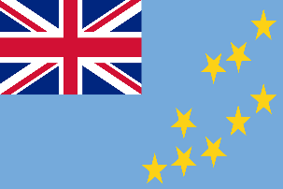Tuvalu is a nation that has already experienced the impacts of climate change. It is relativly poor in comparison to other countries. It is having to resort to adapting to the issue rather than solving it. Therefore, the people there intend to create 7.3 hectares of new land designed to remain well above sea levels in 2100, for settlement without the threat of coastal flooding.

*Flag of Tuvalu © OpenClipart-Vectors, Pixabay*