|  |
| --- |
| Kamchatka earthquake |

# Location and background

On Wednesday 30th July 2025, at 11:25am local time, a powerful earthquake hit the Kamchatka Peninsula in Eastern Russia. The epicentre was located 119km southeast of the city of Petropavlovsk-Kamchatsky. With a magnitude of 8.8, it ranks as the joint sixth strongest earthquake ever recorded[1]. The quake was so powerful that it triggered tsunami warnings across the Pacific Ocean.

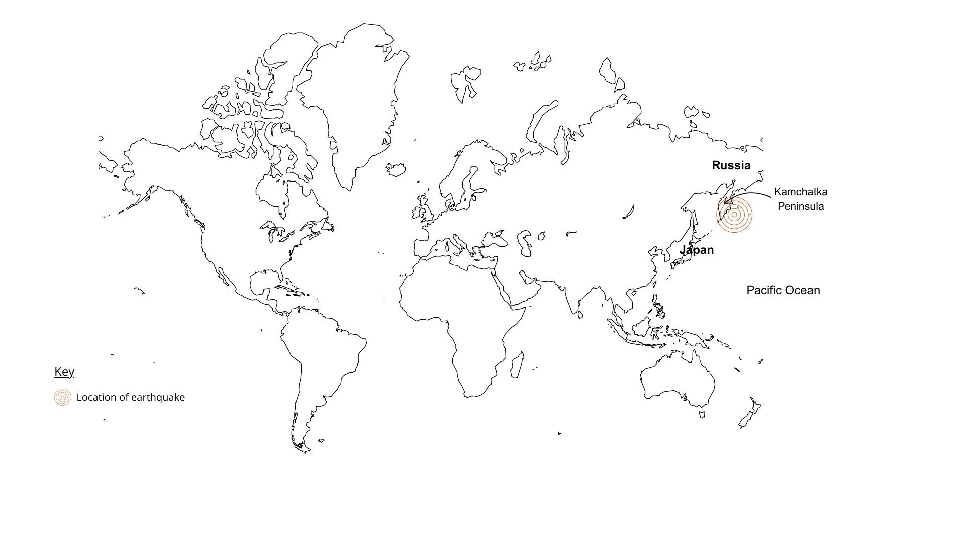

Figure 1: An illustrative location of the Kamchatka earthquake © RGS. Please note: The circles illustrate the location of the earthquake – they are not to scale or representative of its extent or magnitude.

Click [here](https://earthquake.usgs.gov/earthquakes/eventpage/pt25210002/map) for an interactive map from the USGS showing the magnitude of the earthquake as well as patterns of previous quakes in the region.

# Causes

This earthquake was caused by the subduction of the Pacific Plate beneath the North American Plate. As they slowly move - at around 88mm per year - the plates get stuck due to friction. Over time, pressure builds up until it is suddenly released, causing a powerful earthquake. This type of earthquake is known as a megathrust earthquake. When it happens under the ocean, it can displace a large amount of water and trigger a tsunami.

This earthquake was shallow, occurring at a depth of just 20.7km, and caused around 30 metres of displacement along a 200km stretch of the plate boundary.

To find out more about how megathrust earthquakes can generate tsunamis, click on this [link](https://www.youtube.com/watch?v=WuTbDnd_8nA) from the Alaska Earthquake Center.

# Effects

The earthquake caused minimal damage with no reported loss of life and limited injuries or damage to property. However, bigger concerns centred around the potentially deadly tsunami the displacement could generate. 4-meter waves were reported in the town of Severo-Kurilsk in Russia – one of the closest settlements to the epicentre, causing flooding and damage to infrastructure and 1.09-meter waves reached Crescent City in California.

The displacement of water radiated out from the epicentre of the earthquake, but it was thought the strongest waves would travel in a southeast direction.

Tsunamis are not just one wave but several successive ones, the first of which is not always the strongest. When they are out in the deep ocean, they are a few meters high. However, as they reach shallower water, they slow but grow in height, drawing in water from the shore creating a sudden reduction of water near the shore and a stronger, more devastating wave along the coast.

Multiple waves crashing on the shore


Figure 2: Tsunamis are usually a series of successive waves. Image credit: Magda Ehler, Pexels

Tsunamis travel at approximately 800 km/h – around the speed of a passenger jet plane. After the devastating tsunami in the Indian Ocean on Boxing Day, 2004, there have been vast improvements in early warning systems in places more prone to these hazards. In this instance, tsunami warnings were broadcasted over most of the Pacific including nearby Japan where 1.9 million people were ordered to evacuate and find higher land.

The early tsunami warnings meant that most people had enough time to get to safety. However, even at this speed, the waves can take hours to arrive and therefore there were mixed responses to the threat of the wave. The time it took for the waves to travel across the Pacific dissipated their strength and therefore most of the tsunami warnings were downgraded.

# Prediction Vs reality

Tsunami warning systems across the Pacific worked well, giving people enough time to evacuate if a tsunami had occurred. In the end, though, the wave energy had weakened before it posed any serious threat to coastal communities meaning that most warnings were downgraded.

This is very different from the Boxing Day (2004) and the Tohoku (2011) tsunamis, both of which were caused by similar earthquakes and yet caused widespread destruction and significant loss of life.

This highlights how difficult it can be to predict these events accurately and respond in the right way. To protect lives, authorities are choosing to be cautious - issuing early warnings and then reducing the threat level as more reliable data becomes available. Over time, as more events are recorded and analysed, tsunami models are likely to improve, helping to make future predictions more accurate.

# Further reading

[Expert reaction to earthquake off Russia and tsunami warnings across the Pacific](https://www.sciencemediacentre.org/expert-reaction-to-earthquake-off-russia-and-tsunami-warnings-across-the-pacific/#:~:text=%E2%80%9CThis%20earthquake%20occurred%20where%20the,'Great%20Tohuku%20Earthquake').). Science Media Centre, July 30, 2025

[Russia earthquake: Magnitude 8.8 megaquake hits Kamchatka, generating tsunamis across the Pacific.](https://www.livescience.com/planet-earth/earthquakes/russia-earthquake-magnitude-8-8-megaquake-hits-kamchatka-generating-tsunamis-across-the-pacific) Live Science July 30, 2025

[Why did Russian mega earthquake not cause more tsunami damage](https://www.bbc.co.uk/news/articles/c0l6pj7kjg7o)? BBC, July 30, 2025

[Why the Pacific tsunami was smaller than expected – a geologist explains.](https://theconversation.com/why-the-pacific-tsunami-was-smaller-than-expected-a-geologist-explains-262273#:~:text=The%20earthquake%20near%20the%20east,the%20largest%20quakes%20ever%20recorded.) The Conversation, July 30, 2025

[Why some underwater earthquakes cause tsunamis – and others, just little ripples.](https://theconversation.com/why-some-underwater-earthquakes-cause-tsunamis-and-others-just-little-ripples-262352?utm_medium=email&utm_campaign=Latest%20from%20The%20Conversation%20for%20July%2031%202025%20-%203471835353&utm_content=Latest%20from%20The%20Conversation%20for%20July%2031%202025%20-%203471835353+CID_9b6c9892a643ca79dc3116fb6048524a&utm_source=campaign_monitor_uk&utm_term=Why%20some%20underwater%20earthquakes%20cause%20tsunamis%20%20and%20others%20just%20little%20ripples) The Conversation, July 31, 2025

1. [Russia’s far east rocked by 8.8 mega-quake: Where it ranks in history.](https://www.independent.co.uk/news/science/earthquake-russia-8-8-magnitude-tsunami-warnings-b2798541.html) The Independent July 30, 2025.