Typhoon Ragasa

Introduction
Super Typhoon Ragasa (also known as Nando) formed on September 18, 2025, in the Western Pacific Ocean. It is the most intense tropical storm so far in the 2025 Pacific typhoon season which is usually most active between May and November, though it can span the entire year. This season has so far been particularly quiet with The National Aeronautics and Space Administration (NASA) Earth Observatory reporting that this region is only half as active as usual for this time of year.

Super typhoons are the equivalent to a Category 4 or 5 hurricane and have sustained windspeeds of between 185 and 240 km per hour.

They are areas of low pressure and high winds which bring rain and are generated by warm water over oceans.

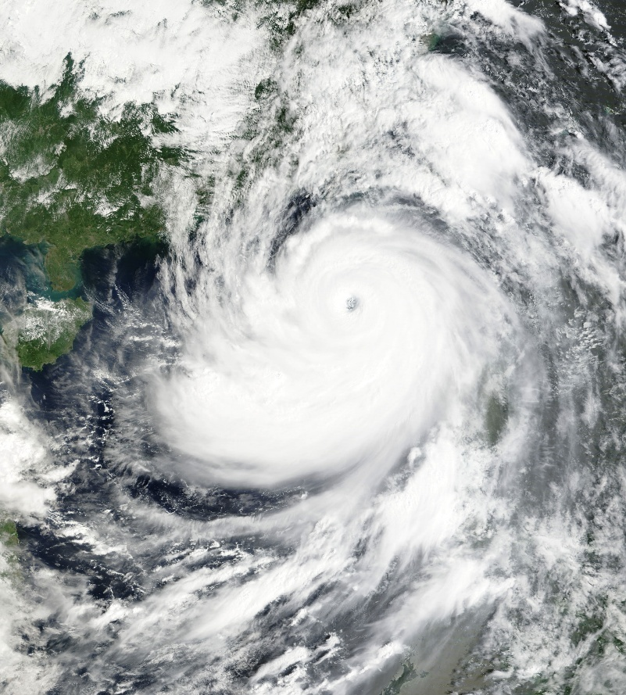
Figure 1: Satellite image of Typhoon Ragasa on September 23, 2025. Image credit: NASA Earth Observatory

Location
The super typhoon started in the Western Pacific Ocean a few hundred kilometres east of the Philippines where it rapidly gained strength. It first made landfall in northern Luzon (Philippines) then over the Luzon Strait towards Hualien County (Taiwan), finally moving westwards towards China and making landfall in the Guandong province on September 24. At its height, the mean average windspeed reached 266 kph with some areas experiencing up to 269 kph.

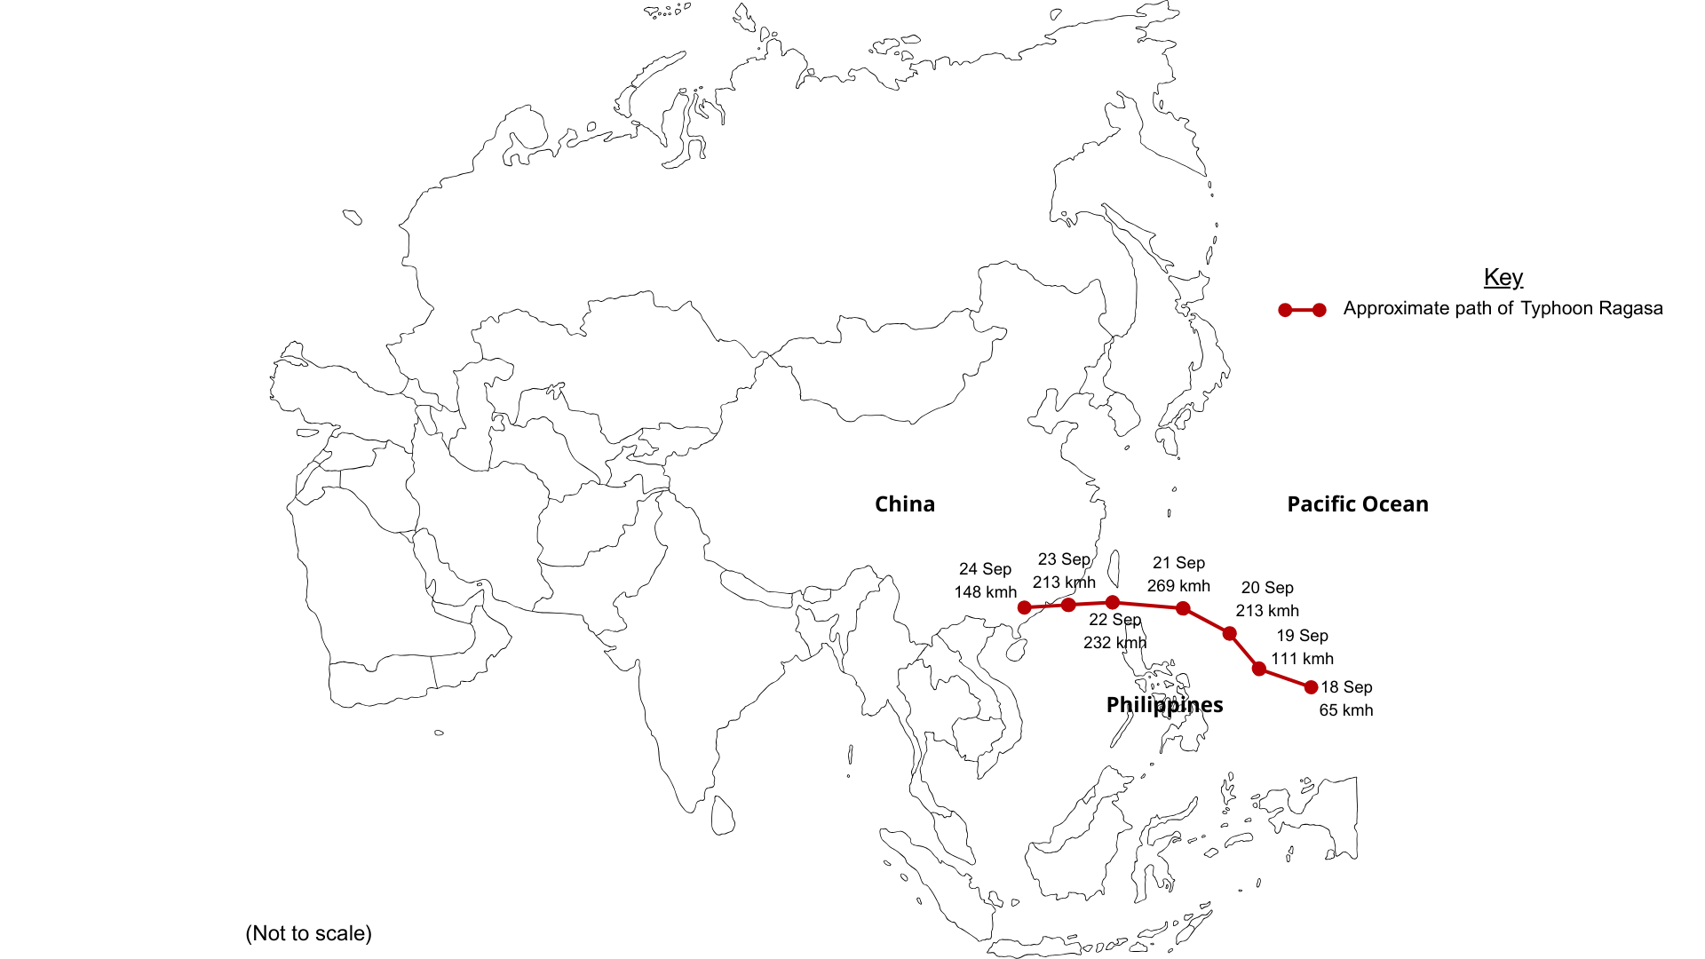

Figure 2: Path of Typhoon Ragasa © RGS

Impacts
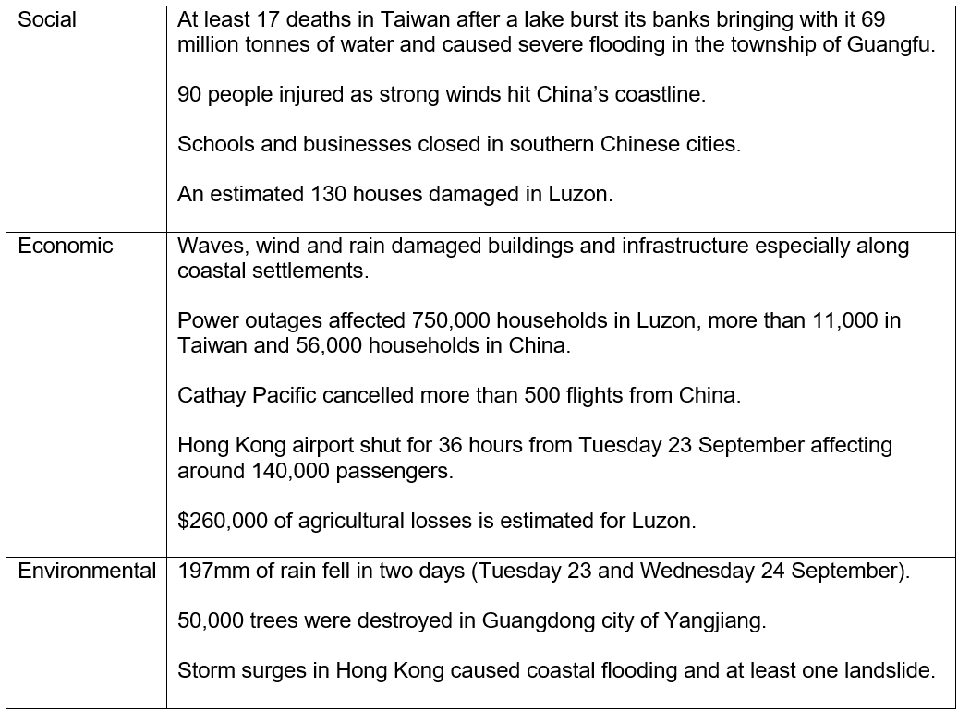

Figure 3: Summary of the impacts of Typhoon Ragasa ©RGS

Responses
Throughout history, cities in southern China have experienced frequent storm events and, as a result, have ensured that they mitigate against as many impacts as they can. For example, spending $3.8 billion on improving drainage networks in Hong Kong, creating areas within the city to protect sea faring vessels such as the Causeway Bay Typhoon Shelter and having clear evacuation plans - nearly 2 million people were evacuated in the Guangdong province of China before Ragasa hit.

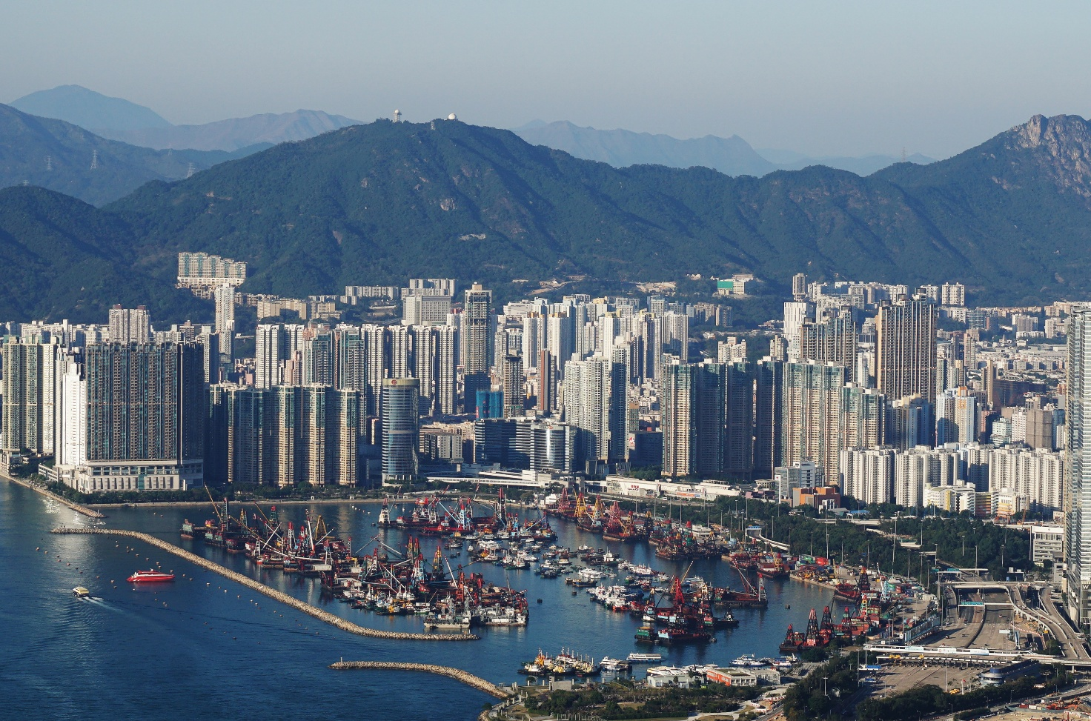

Figure 4: Causeway Bay Typhoon Shelter, Hong Kong. Image credit: Exploring life, CC BY-SA 4.0

During the typhoon, police patrolled the streets urging people to stay indoors. 760 people sought refuge at the 50 temporary shelters in Hong Kong.

After the typhoon had passed, volunteers and military troops went door to door along China’s southern coast to assist those who need it. According to state media, China’s central government put aside $49 million to help with relief efforts.

Further reading
World view of Typhoon Ragasa, NASA Earth Observatory
Typhoon Ragasa, live update, BBC September 24, 2025
Nearly 2 million evacuated as Ragasa slams into southern China, after killing at least 14 in Taiwan, CNN September 25, 2025
Super Typhoon Ragasa rampages through Taiwan, Hong Kong and southern China, The Guardian, September 26, 2025
What is a super typhoon? South China Morning Post

What Is the Difference Between a Typhoon and a Super Typhoon? Britannica.com

