|  |
| --- |
| United States of America |

**Location Basic facts**

|  |  |
| --- | --- |
| Population per km2 | 37 (2023) |
| GDP/GNI per person | $76,770 (2022) |
| Climate | the USA has a diverse climate ranging from tropical and desert to arctic and alpine. |
| HDI (closest to 1 = most developed) | 0.927 (2022) |

*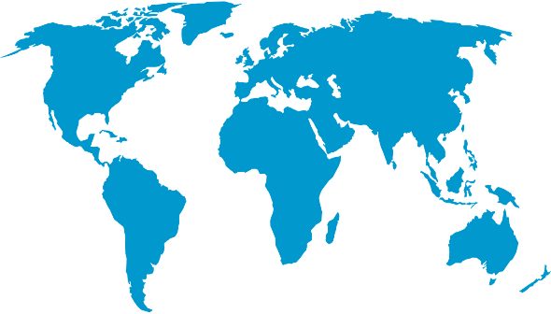World Map © Clker-Free-Vector-Images, Pixabay*

**Environmental facts**

|  |  |
| --- | --- |
| 1. | Due to its diverse climate and landscape, the USA experiences many different natural hazards including wildfires, earthquakes, tornadoes, hurricanes, winter storms, landslides, volcanoes, heatwaves and tsunamis. |
| 2. | The USA has just over 1.3 million kilometres of coastline. The landscape is varied with sandy beaches, rocky cliffs, marshes and mudflats. With the Atlantic to the east and Pacific to the west both sides of the country can experience large, destructive waves. |
| 3. | The USA has a vast range of marine life that visits its coastline including 6 different species of whale, dolphins, sharks, seas, sea lions, rays, thousands of different fish species including sea bass (which humans can eat). |

**Protecting the oceans**

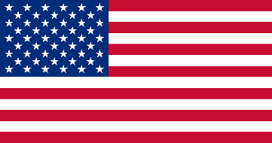On 17th April 2024, the US announced at the Our Ocean Conference that they will dedicate $508 million in the protection of the ocean. This money is shared between many different projects including sustainable blue economies, combating the effects of climate change. Advancing marine protected areas, achieving sustainable fisheries, achieving maritime security and combatting marine pollution. In addition, they have passed many acts to protect and conserve marine species within their own coastal regions. The US have never, however, ratified any UN Law of the Sea themselves.

*US Flag © Clker-Free-Vector-Image, Pixabay*