|  |
| --- |
|  |

This teacher support pack supplements the Royal Geographical Society’s ‘Geographers and the Thames Estuary 2100 Plan’ resource.   
  
This teacher support park contains the following:   
  
1. Aim of student resource

2. Links to GCSE and A Level specification

3. Answers to the activities in the student resource

4. Links to further support

1. **Aim of student resource**

The aim of the ‘Geographers and the Thames Estuary 2100 Plan’ resource is to show students the role that geographers play in contributing to the development of flood risk strategy in response to climate change. More specifically, the resource focuses on the development of the TE2100 Plan in response to heightened tidal flood risk along the Thames Estuary. The resource showcases the numerous organisations that have contributed to the development of the Thames Estuary 2100 Plan, therefore exposing students to employers who hire geographers. It also introduces students to the types of real jobs available to geographers who work in these organisations, and the role that each of these jobs plays in contributing to flood risk strategy.

Teachers may wish to spend time reading through page 1 and 2 of the resource with students, pausing at points to allow for questioning and/or group discussion.

The activity has a decision making, fieldwork focus; requiring students to place themselves in the position of geographical professionals involved in flood risk strategy. Activity 1a and 1b requires students to reflect on the aims of the TE2100 Plan, and decide which geographer is best place to advise on each aim. Activity 2 is a fieldwork-based exercise that asks students to plan their own fieldwork investigation to measure the success of the TE2100 Plan. Activity 2 is well-suited to GCSE and A Level students, helping prepare them for conducting their own geographical investigations, boosting their overall understanding of the fieldwork investigation process.

More information about the TE2100 Plan, and partner organisations involved can be found here: [Thames Estuary 2100 (TE2100) - GOV.UK](https://www.gov.uk/government/collections/thames-estuary-2100-te2100#datasets,-monitoring-reviews-and-previous-plan) and [Thames Estuary 2100 Plan | JBA Consulting](https://www.jbaconsulting.com/projects/thames-estuary-2100-plan/).   
  
Please note that, as referenced, the employment data on page 2 has been put together using data published on LinkedIn, therefore may not reflect actual employment statistics.   
   
The resource supports teachers in providing careers provision under *Gatsby Benchmark 4: Linking curriculum learning to careers*. For more information on the Gatsby Benchmarks, visit: [Gatsby benchmarks of good career guidance](https://www.rgs.org/schools/careers-and-progression/gatsby-benchmarks-of-good-career-guidance)

1. **Links to specification**

**GCSE links:**   
  
Edexcel A: 1B River landscapes and processes, 1.9: ‘Human activities can lead to changes in river landscapes which affect people and the environment’, 1.9a and 1.9b

Edexcel B: Topic 4 sub topic: river processes and pressure; enquiry question, ‘What are the challenges for river landscapes, people and property and how can they be managed?’, Key Idea 4.8 (b)

AQA: Living with the physical environment, Section C: Physical landscapes in the UK, 3.1.3.3 River landscapes in the UK ‘Different management strategies can be used to protect river landscapes from the effects of flooding.’

OCR A: Living in the UK today, 1.3 UK Environmental challenges 1.3.2 ‘the management of a flood event at a variety of scales’

OCR B: Our Natural World, 3.2b ‘What are the characteristics of your chosen landscapes?’, more specifically ‘how human activity, including management, works in combination with geomorphic processes to impact the landscape’   
  
WJEC: Key idea 3.2 Vulnerability and hazard reduction, specifically 3.2.2 ‘How might the risks associated with tectonic hazards be reduced?’

**A Level links:**   
  
AQA: 3.1.1 Water and carbon cycles, specifically 3.1.1.6 Case studies, ‘Case study of a river catchment at a local scale’, 3.1.5.5 Storm hazards,’ risk management designed to reduce the impacts of the hazard through preparedness, mitigation, prevention and adaptation’, 3.3 Geographical fieldwork investigation

Edexcel: Area 3, Topic 5 ‘The water cycle and water insecurity’, Enquiry question 2, 5.5a ‘Human actions that can exacerbate flood risk (changing land use within the river catchment, mismanagement of rivers using hard engineering systems’   
Topic 6 ‘The carbon cycle and energy security’, Enquiry question 3, 6.9b ‘Adaptation strategies for a changed climate (water conservation and management, resilient agricultural systems, land-use planning, flood-risk management) have different costs and risks.’ Fieldwork

OCR: Topic 3 Climate change, 4 ‘In what ways can humans respond to climate change?’,4.c ‘Mitigation and adaptation are complementary strategies for reducing and managing the risks of climate change.’ 2e Geographical fieldwork and skills

WJEC: Unit 3 Global Systems, Water and carbon cycles ‘field survey to investigation .. areas of flood risk/vulnerability’ , Unit 4, Section B 4.5 Weather and climate, 4.5.7 People, climate and the future Strategies to mitigate and adapt to climate change at a variety of scales’, Unit 5 Independent investigation

1. **Answers**

**Activity 1a:**

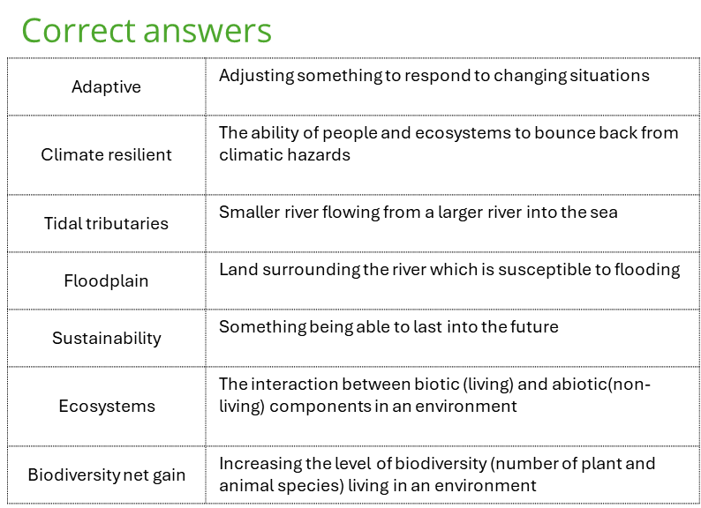

**Activity 1b:**

Whilst there is no one correct answer as students have autonomy over which geographical professional they assign to each role, an example response may look like this:

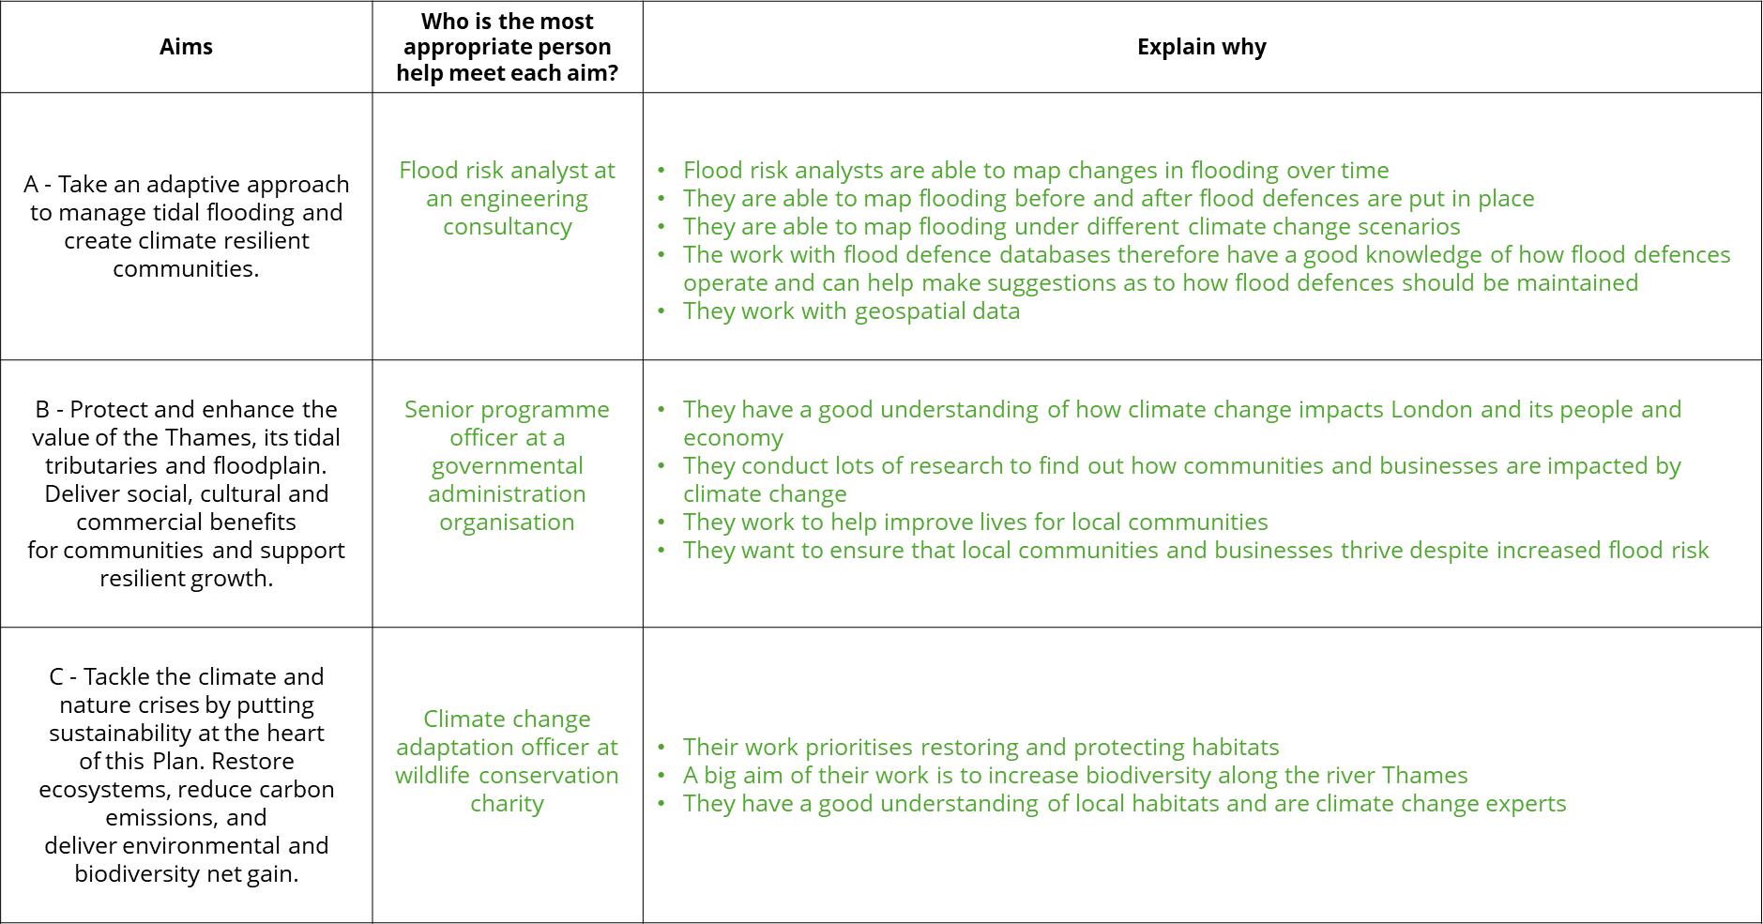

**Activity 2 – Example response:**

This example explores local economic changes over the last decade as a result of the implementation of the Thames Estuary 2100 Plan in 2012.

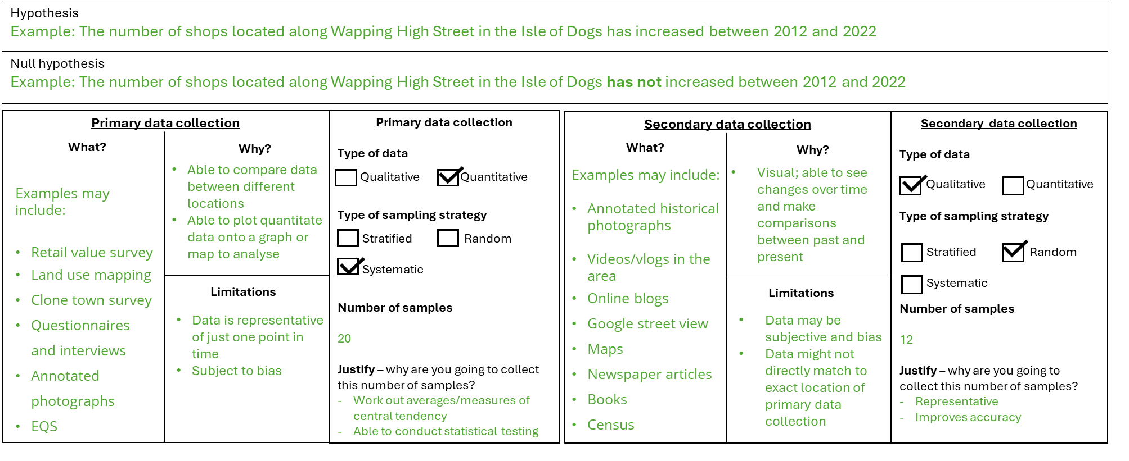

You may wish to adapt how this resource is used. For example, by providing students with the completed template and asking them to critique the hypothesis and/or fieldwork methods. Critiques may include:

* Is measuring change over a 10 year period too long/unrealistic?
* Is Wapping High Street an appropriately sized area to carry out research? Is this area too large, too small or is it appropriate?
* What other locations could data be collected from?
* What are the ethical considerations of carrying out fieldwork like this?

Students may also wish to structure their investigation around the following themes:

* Changes in biodiversity over time
* Changes in land use over time
* Opinions of local community groups/ place perception
* Changes in flood risk over time
* Changes in retail value over time
* Population trends over time

**Links to further support**

* Royal Geographical Society’s career pages: [Choose a career with geography - RGS](https://www.rgs.org/choose-geography/choose-a-career-with-geography)
* Teacher CPD: [Teacher events - RGS](https://www.rgs.org/schools/teacher-events)
* I am a geographer: [I am a geographer - RGS](https://www.rgs.org/choose-geography/i-am-a-geographer)
* Statutory careers guidance for schools: [Careers guidance and access for education and training providers - GOV.UK](https://www.gov.uk/government/publications/careers-guidance-provision-for-young-people-in-schools)