|  |
| --- |
| Working in energy law – student activity |

**Section A – Research Activity**

The energy sector has lots of job opportunities for geographers, based all around the UK. These range from working on energy policy for the national government, to working on the development of renewable energy.

**Task** – Research the following companies and sort them into the categories below

Department for Energy Security and Net Zero, Climate Change Committee

Green Alliance

The Carbon Trust

Octopus Energy

SEE Renewables

National Grid

Centre for Sustainable Energy

Ørsted

EDF Energy

Sellafield

Ofgem

Jacobs

Renewables First

EDF Renewables

E.ON UK

British Gas

National Grid

AECOM

Shell

PwC

BP

**Government Body**

A part of the government that makes rules, keeps order, or provides services for people, like building roads or protecting the environment.

**Charity**

A group that helps people, animals, or the planet, using money from donations instead of selling things for profit.

**Oil and gas firm**

A business that finds, drills, and sells oil or natural gas for fuel and products.

**Nuclear energy firm**A company that uses nuclear reactions to make electricity.

**Energy provider**   
A company that brings power (like electricity or gas) to homes and businesses, also called an energy supplier.

**Utility infrastructure company**   
A business (sometimes owned by the government) that provides the infrastructure for everyday essentials like water, gas, or electricity.

**Engineering and construction firm**

A company that designs and builds big projects like bridges, skyscrapers, power plants, or roads.

**Consulting and research firm** A business that gives expert advice or does research to help other companies or organisations solve problems.

**Renewable energy firm**

A company produces power from natural sources that will not run out e.g. solar and wind.

**Section B -** **Energy Law & Geography**

**Energy law** involves regulating the extraction and distribution of different types of energy, and ensuring that energy companies are operating within the law1. **Energy lawyers** help ensure that energy companies are following rules and regulations. For example, if an energy company wants to build a new solar farm in the countryside, energy lawyers help ensure that the company is operating within the law, and has the correct permissions to build the new solar farm.



**Marianne** is an example of a geographer working in energy law. Although she studied law at university, her work requires her to apply lots of geographical knowledge to ensure she’s supporting her clients well – she has to think like a geographer *and* a lawyer.

Specifically, Marianne is a **Partner** for a law firm based in London. She works in the power and renewable sector of the law firm. Her work involves drawing on lots of geographical knowledge to help renewable energy companies secure permission to build new renewable infrastructure, such as building an offshore wind farm or solar power farm.

She has good knowledge of rules and licenses that companies have to follow if they want to invest in renewable energy, as well as the laws around setting up energy projects more generally. When companies want to connect to the power grid, or work in countries where the rules aren’t clear yet, she helps them figure out the right questions to ask so they don’t run into problems later. Marianne also negotiates deals called **power purchase agreements (PPAs)**. These are contracts that decide how renewable energy is sold to businesses.

Geography is key to Marianne’s work. Understanding **borders**, **natural environments** and **governance** is super important. For example, having an understanding of a country’s territorial seabed, and legal rights to explore and utilise natural resources all rely on having a good understanding of the physical and political geography of different places. Understanding the impacts of **climate change** is also essential to Marianne’s work. For example, understanding the impacts of climate change and extreme weather events is really important when considering where to build new infrastructure. Again, understanding **tectonic plate boundaries**, particularly the boundaries between the oceanic plate and continental shelf, is important when looking at building new offshore wind farms.

Territorial seabed refers to the bottom of the seabed that belongs to a country, typically 12 nautical miles (or 22km) from the country’s coast.

1All about law (2025) *Energy Law*. Available at <https://www.allaboutlaw.co.uk/stage/areas-of-law/energy-law> (Accessed 26 August 2025)

**Activity**

Offshore wind will play a big part in helping the UK achieve **net zero** by 2050. It is Marianne’s job to provide legal expertise for a renewable energy company who are looking to build an offshore wind farm in the UK. Marianne will need to help the energy company secure a licence for building the offshore wind farm.

**Complete the following activities based on Marianne’s job.**

**1a.** Circle the correct definition of offshore wind …

1. *Offshore wind refers to the generation of electricity using wind turbines located in bodies of water, usually in the ocean*
2. *Offshore wind is a type of tidal energy that uses the movement of ocean waves to spin underwater turbines and produce electricity.*
3. *Offshore wind describes strong winds that blow from the land out toward the sea*

**1b**. What geographical knowledge will Marianne need to help advise the energy company on where is best to build an offshore wind farm? Tick all that apply

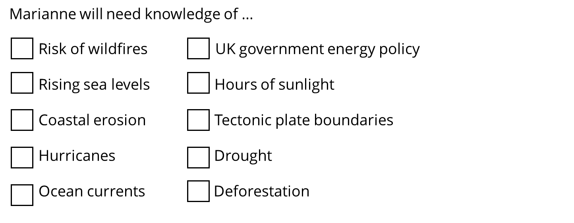

**1c(i).** Using the information on page 3, fill in the table to show what geographical knowledge versus what legal expertise Marianne will need.

|  |  |
| --- | --- |
| **Geographical knowledge** | **Legal Expertise** |
| * Understanding boundaries of UK’s territorial seabed | * How energy is connected to the power grid |

**1c(ii).** Complete the sentence

Geography and energy law are interconnected because …

………………………………………………………………………………………………………………………………………………………………………………………………………………………………………………………………………………………………………………………………………………………………………………………………………………………………………………………

…………………………………………………………………………………………………………………………………………………

…………………………………………………………………………………………………………………………………………………

**Extension**

To help Marianne provide expertise, it’s important to know the reasons in favour of offshore wind, and the challenges associated with it.   
  
**1c.** Sort the statements below into reasons for and reasons against offshore wind in the UK

1. UK is an island which has up to 12 miles of territorial water
2. Wind is unpredictable
3. Creates jobs
4. UK government is aiming for net zero power system by 2030
5. Wind is an abundant and free resource
6. Lots of other countries are building offshore wind farms which means lots of competition for supplies
7. UK lacks current infrastructure to support high level of offshore wind farm
8. Will lead to more investment in the infrastructure of ports

|  |  |
| --- | --- |
| Reasons for | Reasons against |
|  |  |

**1d.** Using the answers to activity 1c and your own geographical knowledge, complete the following sentences

The UK is a good location to build an offshore wind farm because …

………………………………………………………………………………………………………………………………………………………………………………………………………………………………………………………………………………………………………………………………………………………………………………………………………………………………………………………

However, one challenge with building an offshore wind farm in the UK is …

………………………………………………………………………………………………………………………………………………………………………………………………………………………………………………………………………………………………………………………………………………………………………………………………………………………………………………………