|  |
| --- |
| Madagascar |

**Location Basic facts**

|  |  |
| --- | --- |
| Population per km2 | 49 (2021) |
| GDP/GNI per person | $530 (2023) |
| Climate | sub-equatorial: hot, rainy season and cooler, dry season |
| HDI (closest to 1 = most developed) | 0.487 (2022) |

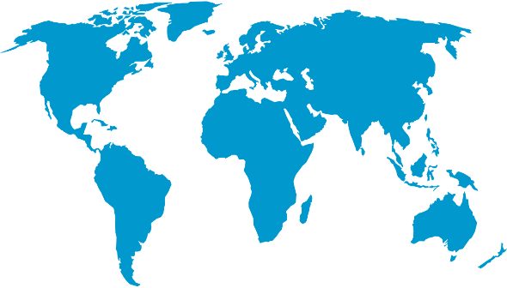

*World Map © Clker-Free-Vector-Images, Pixabay*

**Environmental facts**

|  |  |
| --- | --- |
| 1. | Madagascar is exposed to many natural hazards such as flooding, droughts and, as it is the first major landmass before the African continent, is usually the first to be hit by cyclones bringing with them strong winds, storm surges and heavy rainfall. Madagascar has got a low GDP per capita and struggles to manage the effects of climate change such as droughts and extreme heat. |
|  |  |
| 2. | The coastline of Madagascar is 6,000 kilometres long. There are coastal forests as well as beaches. There are some hard rock formations which have withstood the effects of erosion over time. In addition, there are coral reefs in the northeast and northwest coasts. |
| 3. | 55% multiple habitats, 14% warm water corals, 1% seagrasses. The northern tip of Madagascar is rich in marine diversity, second only to that of the Coral Triangle in Indonesia. It is home to two species of turtle, eight species of shark, the last populations of Dugong (sea cow) in the region, dolphins and many crustations. |

**Protecting the oceans**

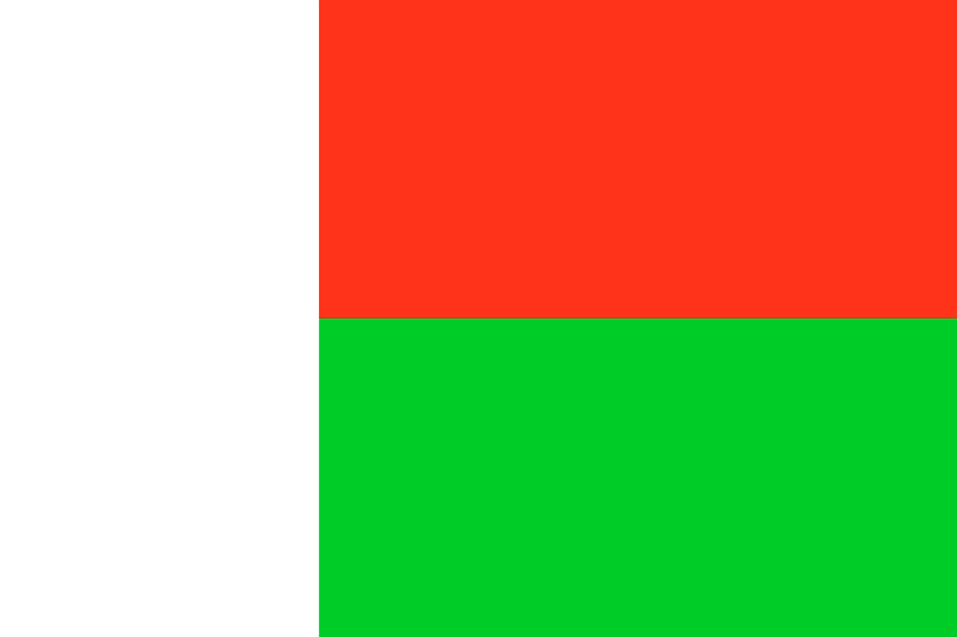Madagascar needs to strike a balance between economic development and management of their fragile coastal ecosystems. In 2022 they signed a charter to collectively fight against unregulated fishing. There has been an increase in community-led conservation activities along the coast spearheaded by the country’s Vezo fishers who are ensuring that small scale fishing communities are at the heart of conservation efforts.

*Madagascan flag © Clker-Free-Vector-ImagesPixabay*