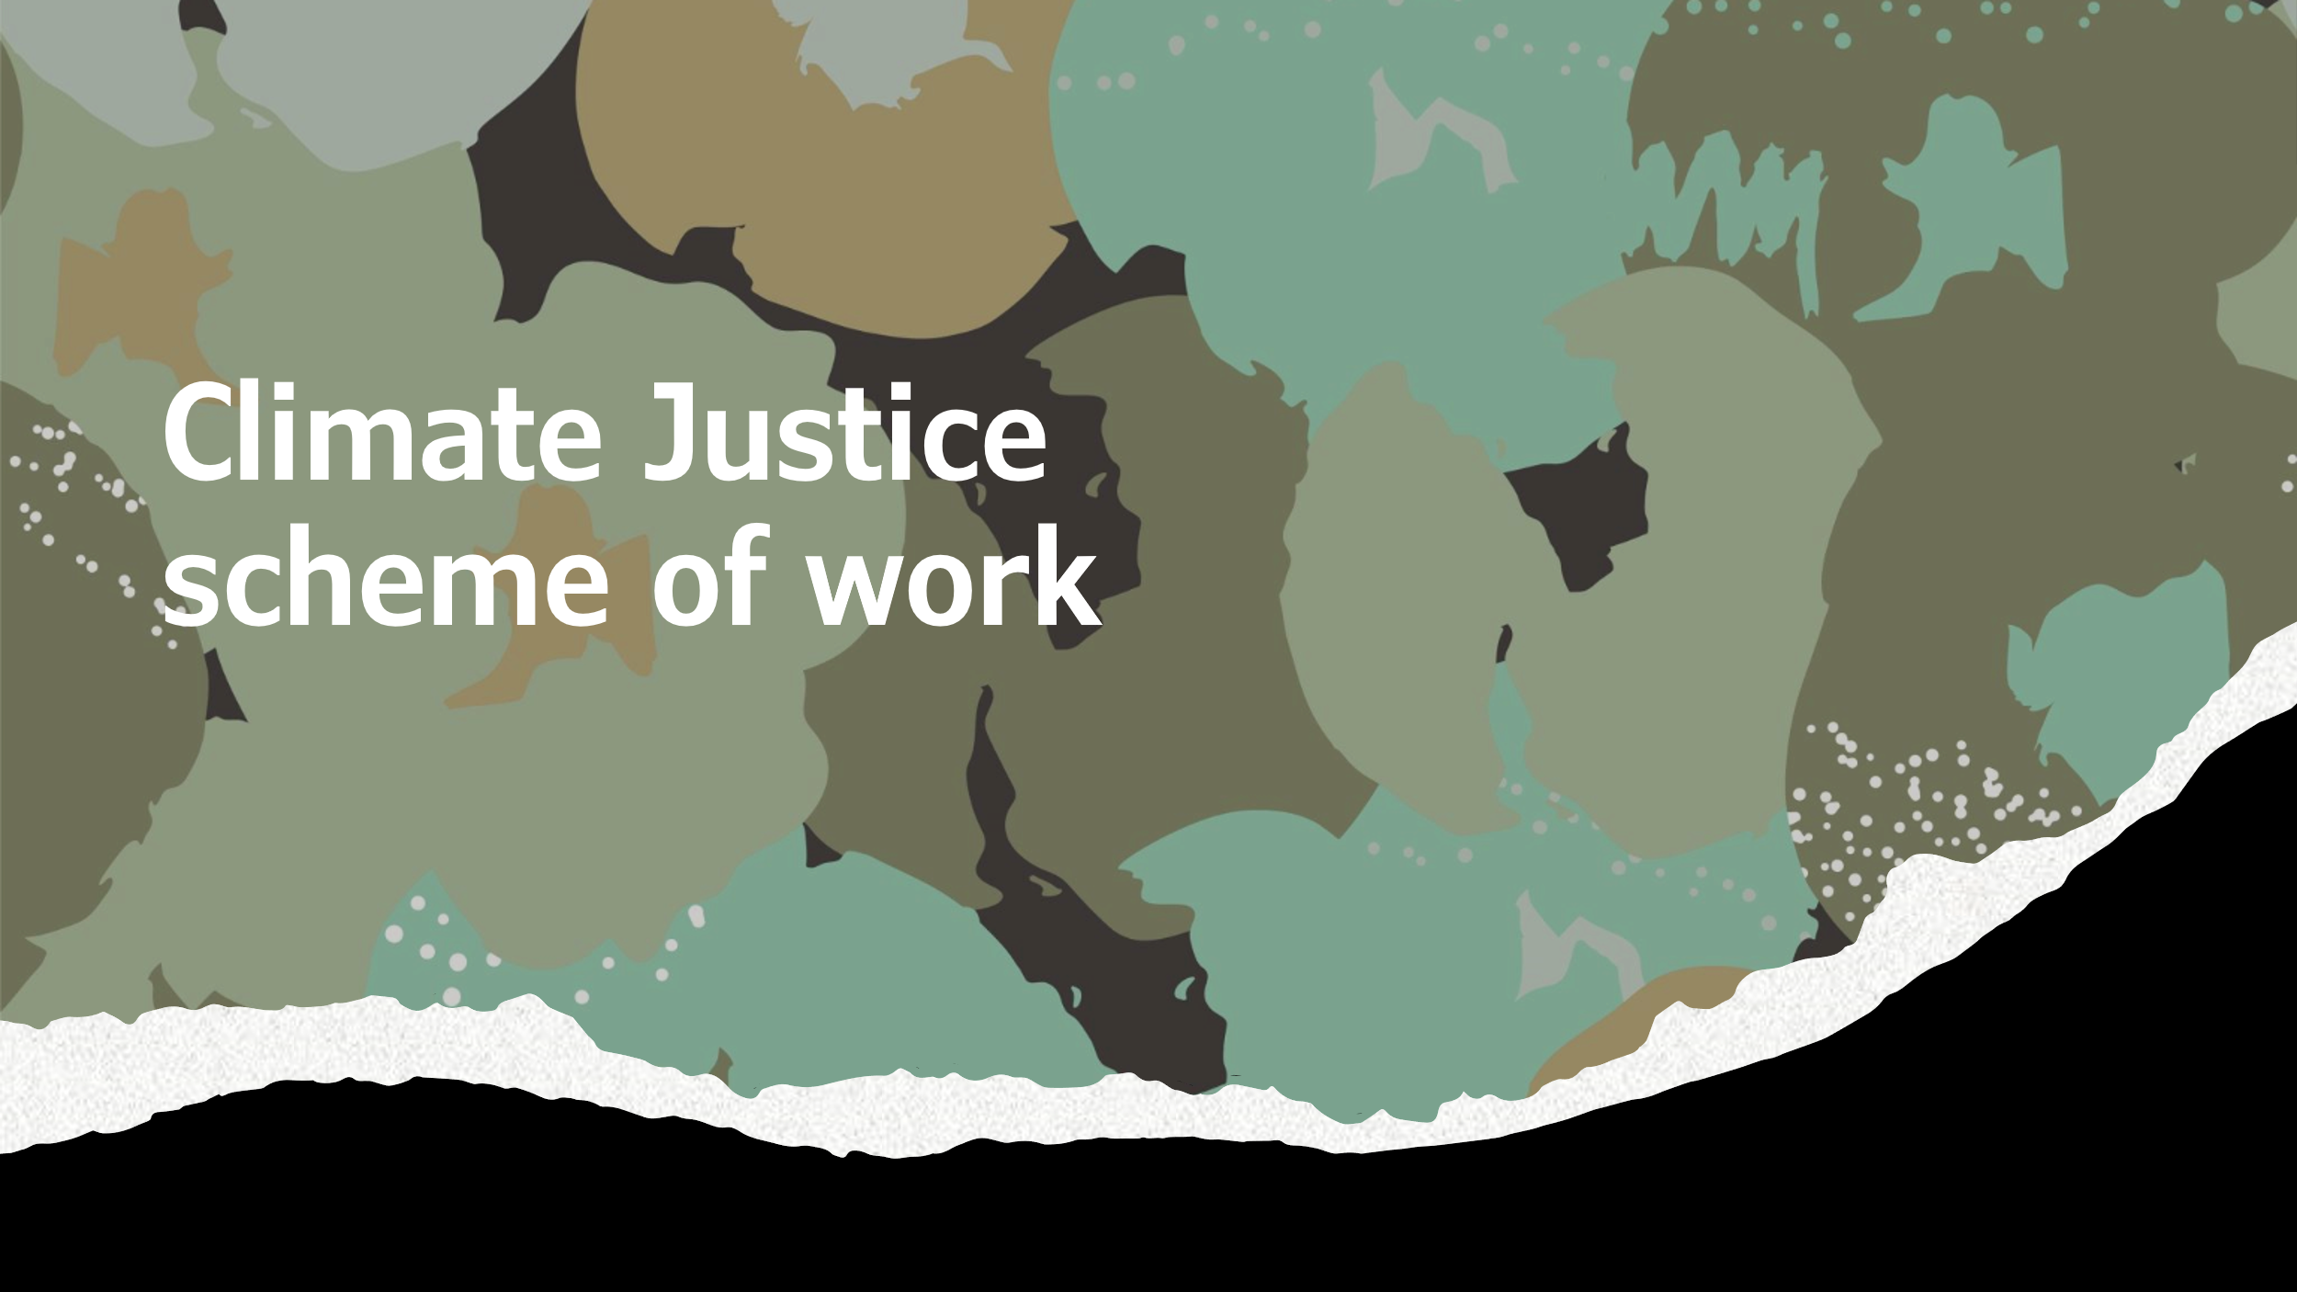

|  |  |  |  |  |
| --- | --- | --- | --- | --- |
| Slide | Content | Suggested Activity  Lesson 1- What is climate change? | Instructions | Writing frames |
| 1 | What is climate change | Per school policy |  |  |
| 2 | Assess prior knowledge | Do now - Students write down: 1) What the image shows, 2) How it connects to prior knowledge, and 3) What they want to learn about it. | Present the image. Ask students to respond to the three questions in their books or posits. Clarify any confusion after they write. | "This image shows... It connects to what I know because... I want to learn..." |
| 3/4 | Define climate change | Note Taking - Students copy the IPCC definition of climate change and highlight key terms. | Display the definition and explain each part briefly. Student think per share definitions. Have students write it in their books and underline key phrases. | "Climate change refers to... Key terms include..." |
| 5 | Myth busting climate change | True or False Activity - Students decide if statements are true or false and correct false statements in their books. | Read each statement aloud. Students write "True" or "False" for each. Discuss answers briefly, then ask students to rewrite false statements correctly. | "The statement, '...' is false because..." |
| 6 | Review myths about climate change | Reflection on myths - Students reflect on which myth surprised them the most and explain why. | Ask students to choose a myth from the slide and write 2-3 sentences about why they found it surprising or impactful. | "The myth that surprised me the most was... because..." |
| 7 | Describe trends in temperature data | Temporal Graph Analysis - Students describe trends, patterns, and significant changes in a graph of mean daily temperature. | Provide a printed copy of the graph. Ask students to identify the general trend, any patterns, and periods of significant change. | "The general trend in the graph shows... A pattern I noticed is... A significant change occurred when..." |
| 8 | Explore uneven temperature changes across the globe | Spatial Map Activity - Students analyse a map showing temperature changes and answer specific questions about the data. | Hand out the map and a set of guiding questions (e.g., "Which regions show the greatest increase?"). Students answer in their books. Compared to previous slide, discuss temporal vs spatial | "The regions with the greatest temperature increase are... because..." |
| 9 | Summarise spatial vs temporal | Plenary Reflection | Students summarise the role of heat-trapping gases in a short paragraph. | "While the temporal graph shows changes in climate over time, highlighting trends such as [example], the spatial graph focuses on differences across regions, showing how [example]. This comparison reveals that..." |
| 10 | Summarise impacts and contributions to climate change | Comprehension Paragraph - | Guide students through the reading and support with completing answers. | "Global average temperatures have increased by…” |

Lesson 2 The Enhanced Greenhouse Effect

|  |  |  |  |  |
| --- | --- | --- | --- | --- |
| Slide | Content | Suggested Activity | Instructions | Writing Frames |
| 1 2 | Key terms | Key Term Match-Up - Students match the key terms. | Provide cards or a worksheet with key words descriptions. Ask students to draw lines connecting terms to their effects. | "Carbon dioxide contributes to climate change by..." |
| 3 | Climate change and extreme weather | Article Comprehension Task - Students read an adapted article and answer questions about extreme weather events. | Distribute the article and a question sheet. Guide students to answer using the provided key terms. | "One extreme weather event is... Climate change increases this risk because..." |
| 4 | Personal response to climate change imagery | Emotional Reflection - Students write 2-3 sentences on how images of climate change make them feel. | Display the images and ask students to reflect in their books. Provide hints: "Do the images make you feel worried, hopeful, or inspired?" | "The image of the polar bear makes me feel... because..." |
| 5 6 | Eco-anxiety and climate action | Reflection and Hope - Students write a list of actions from the slide that give them hope for addressing climate change. | Present examples of climate action wins. Ask students to list two actions they find most inspiring and explain why. | "One action that gives me hope is... because..." |
| 7 | Summary and plenary | Takeaway - Students summarise what they learned about the greenhouse effect and climate change impacts in 3 sentences. | Ask students to write a summary of the lesson's key points in their books. Offer sentence starters for support. | "The greenhouse effect is important because... Climate change impacts include... We can act by..." |

|  |  |  |  |  |
| --- | --- | --- | --- | --- |
| Slide | Content  Lesson 3- Why should human geographers think about climate change? | Suggested Activity | Instructions | Writing Frames |
| 2/3 | Recap on key climate concepts | Question Response Task - Students write answers to recap questions on key terms and impacts of climate change. | Display the questions from the slide. Ask students to write their answers in their books. Review key points briefly. | "The main greenhouse gas is... Climate change is defined as..." |
| 4 | Understand local and global impacts of climate change | Categorisation Task - Students classify images or examples as either local or global impacts. Students write down key terms | Provide printed or displayed images/examples. Ask students to categorise them and write a justification for their choices. | "This is a local impact because... A global impact is..." |
| 5 | Definition of social-mobility, race and income | Key terms - Students copy down key words into their books | Ask students to provide examples of each key term. | "One of the social impacts of climate is mobility, for instance..." |
| 6 | Definition of political, economic, environmental | Key terms - Students copy down key words into their books | Ask students to provide examples of each key term. | "One of the political impacts of climate change is..." |
| 7 | Examples – reflecting on Indigenous peoples | How Indigenous people might be affected by climate change | Ask students how these communities might be affected by climate change. | "One way is...” |
| 8/9 | Local/global, social/economic/environmental/political factors | Concept shading - Students choose one factor (mobility, race, or income) and shade the work sheet | Provide handout of sheet for students to shade.  Go through answers with students.  Extension task- students to write short response on who they think is most affected. | "One factor that increases vulnerability is... This is because..." |
| 10 | Mobility, race and income | Think, pair share task | Students discuss issues related to the statements | “Richer people tend be less impacted because...” |
| 11 | Read article – climate and race | Discuss with class | Students summarise 3 main points | “One reason to suggest why climate change is racist …” |
| 12 | Read adapted article | Emotional Reflection - Students choose a factor from the slide and write about why they feel it in relation to climate change. | Ask students to write 3-4 sentences on their chosen emotion and connect it to the challenges of climate change. | "I feel [emotion] about climate change because..." |
| 13 | Journal response | Writing Task - Climate change affects people differently? | Ask students to follow success criteria and writing prompts | "One way climate change affects people differently is story that inspires me is... because..." |

Lesson 4- What is climate justice?

|  |  |  |  |  |
| --- | --- | --- | --- | --- |
| Slide | Content | Suggested Activity | Instructions | Writing Frames |
| 1/2 | Recap on Climate previous learning. | Answer recap questions. | Display the questions from the slide. Ask students to write their answers in their books. Review key points briefly. | The main greenhouse gas is... Climate mobility refers to... |
| 3/4 | Greta Thunberg’s Speech Evaluate "Who is responsible" for climate justice. | Read and discuss Greta Thunberg’s speech. | 1. Read the speech excerpt. 2. Highlight key points Greta makes about responsibility for climate justice. 3. Discuss your initial thoughts in pairs or as a class. | Greta argues that...  She supports this by saying... I agree/disagree because... |
| 5/6 | What is climate justice | Students discuss their meanings of justice.  Students get down definition of climate justice | Gather feedback from students  Break down definition of climate justice |  |
| 7 | Responsibility Debate | Students discuss who they think is responsible for climate change | Provide rules and discussion points. | I think the main responsibility for climate change lies with… |
| 8 | Explore how different actors impact climate change. | Group discussion: Analyse individual contributions to climate change. | Provide examples, e.g., Chelsea Football Club | Individuals contribute by...  This is significant because |
| 9 | Evaluate the impact of corporate actions on climate change. | Case Study Review: Analyse data on top corporate emitters. | 1.Present data showing that 100 companies produce 70% of global emissions. 2. Ask students to consider how companies can mitigate their environmental impact. | Companies are responsible because... An example is… |
| 10/11 | Analyse the role of nations in addressing climate change. | Map Activity: Identify countries with the highest per capita emissions. | 1. Use a world map or graph to compare emissions by continent or country. 2. Discuss why some countries emit more and others are more vulnerable to climate impacts. |  |
| 12 | Reflect on how consumer behaviour affects climate change. | Debate: Should consumers be held accountable for their purchasing habits? | 1. Present examples of consumer goods with significant carbon footprints. | The consumers' role is… |
| 13 | Shading Visualise responsibility for climate change among individuals, companies, countries, and consumers. | Shading Activity: Colour-code responsibility levels for each stakeholder group. | 1. Provide a blank table or diagram with categories for Individuals, Companies, Countries, and Consumers. 2. Instruct students to shade areas based on the level of responsibility they believe each group holds, using darker shading for higher responsibility and lighter shading for less responsibility. 3. Use the discussions from slides 8–13 to guide their decisions. |  |
| 14 | Consolidation | Write a journal article following the prompts |  |  |
| 15 | Article Chris Waugh -plenary | Read to class | Students listen to summary of lesson |  |

Lesson 5 Adaption

|  |  |  |  |  |
| --- | --- | --- | --- | --- |
| Lesson | Objective | Activities | Instructions | Writing Frames |
| 1/2 | Recap on Climate previous learning. | Answer recap questions. | Display the questions from the slide. Ask students to write their answers in their books. Review key points briefly. |  |
| 3/4 | Understand the concept of adaptation in the context flooding | Discussion activities | Display images of various floods and adaption methods | Adaptation is the process of... It involves adjusting to... |
| 5 | Definition | Define adaptation using key terms: adaptation, changing, climate, and risk. | 1. Ask students to define "adaptation" using the four key terms. 2. Provide a sentence starter to help them frame their definitions. 3. Discuss the key points as a class. | The goal of adaptation is... |
| 6/7/9/10 | Describe different adaptation strategies. | Elicit discussion from images. | Have students summarise the image in their own words | Adaptation in climate change refers to... It helps to reduce the risks of... The goal is to... |
| 11/12 | Understand different methods of adaptation by matching definitions to methods. | Matching activity: Match the correct adaptation definition to the method. | 1. Provide a list of adaptation methods and their definitions. 2. Ask students to match the definition with the correct adaptation method. 3. Discuss the answers as a group. | The adaptation method that fits this definition is... This method helps with... |
| 13 | Consolidation | Students complete extended writing on chosen adaptation method | Students use writing frame provided | See slide |
| 14 | Plenary | From memory students chose 3 adaptions | Provide sheet or slides for students write from | One method for adapting to climate change is… |

|  |  |  |  |  |
| --- | --- | --- | --- | --- |
| Lesson | Objective | Activities | Instructions | Writing Frames |
| 1 | Define mitigation | What do you already know about this topic? | Elicit what students know about this topic | The mitigation method that fits this definition is...  This method helps with... |
| 2/3 | Understand different methods of mitigation by matching definitions to methods. | Matching activity: Match the correct mitigation definition to the method. | 1. Provide a list of adaptation methods and their definitions. 2. Ask students to match the definition with the correct adaptation method. 3. Discuss the answers as a group. | The adaptation method that fits this definition is... This method helps with... |
| 4 | Extended writing task | What is more affective- students complete essay on information provided | Use writing frame provided | See slide |
| 5 | Just transition | Students define just transition | Use of image to compare and contrast the impacts of mitigation | In London, it is clear the policy is successful/unsuccessful |
| 6 | Example of just transition | Article Comprehension Task - Students read an adapted article | Distribute the article. Guide students to answer using the provided key terms. | One extreme weather event is... Climate change increases this risk because... |
| 7 | Scenario stimulation | Students image they are a policy maker and need to use the information learned from the lesson | Read through success criteria | One way to support workers who is lose their jobs is by… |

Lesson 6 Mitigation

|  |  |  |  |  |
| --- | --- | --- | --- | --- |
| Slide | Content | Activities  Lesson 7 Climate justice case studies | Instructions | Writing Frames |
| 1/2 | Identify countries most vulnerable to climate change and the hazards they face. Locating Case Study Areas Describe adaptation strategies to cope with climate change impacts. | Analyse two maps provided. Map and describe case study locations (Tuvalu, Fairbourne, and U.S. communities). | 1. List countries most at risk from climate change. 2. Identify commonalities between these countries (e.g., geography, economic status). 3. Compare these risks to the UK.  4. Locate and describe Tuvalu, Fairbourne, and selected U.S. communities. 5 Use maps and geographical resources to understand their vulnerabilities. | Countries most at risk include...  Commonalities are...  Compared to the UK, these countries...  Tuvalu is located...  Fairbourne is vulnerable because...  U.S. communities impacted include... |
| 3/4/5 | Sea Level Rise in Case Studies | Analyse the provided images and data. | 1. Compare images and data provided for Tuvalu and Fairbourne. | In Tuvalu, sea level rise has caused... Fairbourne faces unique challenges, such as... |
| 6 | Economic, social and environmental | Concept shading | Provide handout of sheet for students to shaded.  Go through answers with students. | One factor that increases vulnerability is... This is because... |
| 7/8 | Sea Level Rise in Case Studies comprehension | Analyse case studies (Tuvalu, Fairbourne, and U.S. communities) to compare sea level rise impacts and responses. | 1. Answer guided questions about sea level rise impacts and government strategies in each location. 2. Discuss as a group. |  |
| 9 | Comparing Vulnerabilities | Based on your readings today how the impacts of sea level rise in Tuvalu differ from those in Fairbourne and US communities? | 1.Develop criteria for measuring vulnerability (e.g., population exposure, resources, adaptation capacity). 2. Write an essay on sea level rise based on the writing criteria | One impact of sea level rise is  To compare vulnerabilities, we will measure... |

|  |  |  |  |  |
| --- | --- | --- | --- | --- |
| Slide | Objective | Activities  Lessons 8 and 9 - Fieldwork | Instructions | Writing Frames |
| 1 | Understand the purpose and methods of geographical fieldwork. | Brainstorm fieldwork methods geographers use to gather data. | 1. Ask students: "What is fieldwork?" 2. Discuss the definition provided in the slide. 3. Brainstorm methods geographers might use (e.g., surveys, interviews). | Fieldwork is... Some methods used in fieldwork include... |
| 2/3 | Identify the relationship between fieldwork methods and geographical topics. | Match fieldwork methods to suitable geographical topics. | 1. Provide a list of methods and ask students to pair them with topics (e.g., erosion, urban studies). 2. Discuss why specific methods suit certain topics. | (Method) is best for (topic) because... |
| 4 | Develop effective geographical research questions. | Create three research questions about a topic of interest. | 1. Provide examples of good and poor research questions. 2. In pairs, ask students to create three research questions on topics like climate change or urban growth. | A good research question is... It is effective because... |
| 5 | Understand how to create testable hypotheses for fieldwork. | Create three hypotheses for a geographical topic. | 1. Provide examples of good and poor hypotheses. 2. In pairs, ask students to write three hypotheses related to a chosen topic. | A hypothesis for this topic is... This can be tested by... |
| 6/7 | Identify research areas related to climate change and climate justice. | Brainstorm research topics based on previous lessons. Develop a fieldwork enquiry question and justify the location's suitability. | Reflect on prior knowledge of climate justice.  Brainstorm three research areas or questions related to climate change or climate justice.  Create an enquiry question, e.g., "What does climate justice look like in our community?"  Discuss why the chosen location is suitable for this question. | One area I’d like to research is... This is important because... |
| 8/9/10 | Select suitable methods for gathering data in a local area. | Propose data collection methods (e.g., interviews, surveys, photo collection). | 1. Discuss the suitability of methods for different types of research. 2. Create a list of data collection methods to use for local fieldwork. | For our research, we will use [method] because... This will help us gather data on... |
| 12/13/14 | Data collection sheet – please note flexibility is encourage- students can complete in class, at lunch or in their local area. |  |  |  |