West African empires

The purpose
This resource is an example of decolonising the curriculum with a specific focus on West Africa. This means that both the resource writer and you, the reader, are questioning whose viewpoint the information is coming from. This teacher resource seeks to challenge the conventional wisdom that significant social and economic development only began in West Africa with the advent of European Empire colonialism in the nineteenth century.

This is not true — West Africa has seen several prominent, indigenous empires which have had regional significance and global trade, largely from controlling trans-Saharan trade routes or the mining of gold.

In 1870 as little as 10% of the African continent was under direct European control but by 1914 approximately 90% had been colonised largely by Britain, Belgium, France, Germany, Italy, Portugal and Spain.

Decolonising a topic, such as West African empires, means identifying that we are learning a story. This is a resource on the powerful indigenous empires of West Africa between 750AD to 1902AD, pre-European colonialism, for both geography and history teaching. Listen to what SOAS senior lecturer Dr. Meera Sabaratnam says about decolonising the curriculum.

Ali Al’amin Mazrui is a Kenyan-born professor and political writer on African and Islamic studies.
Watch this explanation from 17:50 to 18:50, explaining how misguided academic understanding of Africa has been in the past.

GCSE specification links
AQA
3.1.2.3. Hot desert ecosystems have a range of ecosystems How plants and animals adapt to physical conditions.

The development of hot deserts environments creates opportunities and challenges A case study of a hot desert to illustrate development opportunities in hot desert environments: mineral extraction, energy, farming, tourism.

Edexcel
3.1 Large-scale ecosystem are found in different parts of the world and are important Distribution and characteristics of the world’s large-scale ecosystems (tropical, temperate, and boreal forests, tropical and temperate grasslands, deserts, and tundra.

OCR
2.1.2 Ecosystems have distinct distributions and characters. Overview of the global distribution of polar regions, coral reeds, grasslands, temperate forests, tropical rainforests, and hot deserts.

Overview of the climate, plants, and animals within these ecosystems.

Eduqas
Appendix C. Africa may be broadly divided by the Sahara Desert into two: North Africa and sub-Saharan Africa. WJEC suggests that learners use one or more of the following countries from sub-Saharan Africa when following this specification: Botswana, Burkina Faso, Cameroon, Cote d'Ivoire, Ethiopia, Gambia, Kenya, Lesotho, Malawi, Mali, Mozambique, Namibia, Niger, Nigeria, Rwanda, Somalia, South Africa, Tanzania, Uganda, Zimbabwe.

African boundaries and ArcGIS
The continent of Africa has experienced centuries of political boundary changes. Ethnic boundaries have given way to African empires which were redrawn and replaced by European colonial boundaries - which largely remain to the present day. Today a political boundary map is used to delineate the 54-countries in Africa.

Open this ESRI ArcGIS map showing African political boundaries, created in 2018, and explore the content. Answer the following questions:

- Once the map is open, untick the option ‘African Countries’ in the banner to the left of the screen. This will remove the data layer. Zoom into West Africa.

- Imagine you are travelling from the old capital in the Mali Empire, Niani, to the new capital of the Ashanti Kingdom, Kumasi. Search for ‘Niani, Mali’. Select the Measure tool and click on Niani, now use your Control button (ctrl) and the minus button (-) to zoom out. Double click on Kumasi. What is the distance between the two capital cities?

- For this exercise you now need to sign into ESRI ArcGIS to use the Add function to the banner. If you are not a registered user, this is a simple process and is free for schools. You can read more about access for schools on the ArcGIS Online for Schools homepage.

  - Click the Add button, and search for ‘World Terrestrial Ecosystems’ under the drop option ‘Browse Living Atlas Layers’. Click the ⊕ symbol and upload the ecosystem data to your African Countries ArcGIS map. If you can’t find the data you can view it as a separate map.
  - Using this new dataset, describe how the landscape changes as you move south eastwards from Niani to Kumasi.

- Continue by also accessing Explore the Ecological Tapestry of the World dataset.

The Sahara and the Sahel
The Sahara is a hot desert in North Africa. It is the largest hot desert in the world at 8,600,000 square kilometres. It stretches from the Red Sea in the east across the continent to the Atlantic Ocean. To the north are the Atlas Mountains and to the south is the Sahel. Deserts are dry areas which receive less than 250mm of rainfall each year.

The Sahel, on the other hand, is a semi-arid region that forms a transitional zone south of the Sahara. It is zone which separates the North African desert biome from the West African savannahs (and the equatorial rainforests further south). The Sahel is characterized by some natural pasture, low-growing grass, thorny shrubs and baobab and acacia trees.

The Sahara is often presented as an ‘empty space’, relatively devoid of people as a result of its desert environment and unconnected with the wider world. However, the presence of West African Empires over millennia is had

- Go to Appendix A. Can you identify which image is the Sahara and which one is the Sahel? Identify the clues in each picture by annotating around the images.

- It is important to understand the distinction between the Sahara and the Sahel. Using this Live Science resource on the Sahara, the Guardian Sahel region webpage, and the BBC case study sheet The impact of drought in a developing country: the Sahel write a definition for the two landscapes. Include comment on where they are found.

- Go to Appendix B. Click on the link under Image 3. Explain why the Sahel is described as the ‘canary in the coalmine’.

West African empires
Three empires have had a considerable and lasting effect on West Africa, namely: the ancient Empire of Ghana (largely modern-day Mauritania and western Mali), the Empire of Mali and the Ashanti Kingdom (modern-day Ghana). Confusingly the Empire of Ghana did not include the current country of Ghana. As so little is known about the Nok people, who were smelters of iron and agriculturalists, the Empire of Ghana is of particular interest as it is recognised as the first empire (c.1000BC to c.300AD) in West Africa.

Their timelines are drawn below in Figure 2.

Nok culture c.1000BC — c.300AD

Empire of Ghana c.700 — c.1240AD

Mali Empire c.1235 — c.1670AD

Ashanti Kingdom 1670 —1902AD

1000 0 100 200 300 400 500 600 700 800 900 1000 1100 1200 1300 1400 1500 1600 1700 1800 1900 2000

Figure 2

- What do you notice about the sequence and order of these influential empires in West Africa?

- Go to Appendix C. As well as these 4 West African civilisations the Songhai Empire and Ife Kingdom were also influential in the region. Can you identify where these African empires were located? Be careful, historic names did not necessarily evolve into similar-sounding empires. Add the African empire names from table 1 onto Figure 3 in Appendix C.

- Using your GIS on current African boundaries (or a paper atlas), answer the following:

  - What modern-day countries cover the ancient Empire of Ghana?

  - What modern-day countries cover the Mali Empire?

  - Which modern-day country covers the Ashanti Kingdom?

Access the BBC webpage Benin and other West African kingdoms to find the correct answer to where these 6 empires were located.

- There are multiple ethnic groups in these areas which blur national boundaries either from kinship or by migrate. Research the name of 3 important ethnic groups found in:

  - Mauritania. Which Sub-Saharan Mauritanians are found in the upper Senegal river?
  - Mali. What is the dominate ethnic group?

  - Ghana. What is the main ethnic subgroup which, in Twi, translates as ‘warlike’?

The Empire of Ghana and the desert ships
The rulers of the ancient Empire of Ghana (c.700 to c.1240AD) occupied a strategic position, halfway between the hot desert of north Africa and the gold fields of West Africa. A thread of staging posts were set up for camel caravans to move through the Sahara in north Mauritania. This trans-Saharan trade generally consisted of salt and gold with the Empire of Ghana also exporting iron and copper.

The Soninke people were founders of the Empire of Ghana, a commerce-based and largely peaceful kingdom. As an ethnic group, the Soninke were mostly clustered in the upper Senegal river valley stretching along the current Mali-Senegal-Mauritania border. Because of this unique position on the boundary of the Sahel Arab traders would arrive from the Middle East to meet gold traders from West Africa. The trans-Saharan trade routes were only made possible by the introduction of a very hardy animal, the camel.

- Go to Appendix D. Using this map, The Principal Trans-Saharan Caravan Routes from Princeton University can you create your own flow diagram for the routes of trade of gold, slaves, and salt? Finish Figure 4 by drawing a flow diagram to show the movement of Middle East traders and West African traders across the continent.

- What do you notice about the caravan routes from the Middle East through the Sahara to West Africa? It may help to look at Figure 5 in Appendix D, a colour topography map of North Africa.

Places like Wadan and Chinguetti in Mauritania became important staging posts for the Saharan caravans moving across the desert to West Africa. In fact, all conveys passing through the Sahara Desert had to go through Chinguetti — a Berber medieval trading centre mixing ideas, languages, and goods. It grew into a place of economic exchange and became an important religious ksar, as Islam spread across the Maghreb.
In order to facilitate trans-Saharan, travel the two-humped Central Asian camel, called the Bactrian camel, was crossbred with the one-hump Middle Eastern camel, called the Dromedary camel, to produce a different, slow-moving, heavy load-carrying species. Over time they have become known as ‘ships of the desert’ due to their ability to traverse long distances in the arid conditions. This infographic is a great visualisation of the crossbreeding and different breeds of camels.

- Go to Appendix E. Using Figure 6 and Internet Geography, annotate why the camel was so instrumental in allowing Middle Eastern traders to reach West Africa.

Contrary to popular belief there is a remarkable abundance of vegetation in hot deserts. There is a wide diversity of plants in the Sahara Desert which are either short trees or ground-hugging plants. From the Empire of Ghana to the current-day, desert Bedouin (nomadic Arab travellers in North Africa) have moved across the Sahara Desert navigating via vegetation, oases, and water.

- The African Peyote is a resilient native plant in the Sahara Desert. Using Figure 7 in Appendix E, add the labels and definitions for:

  - xerophytes (pronounced zero-fight)

  - phreatophytes (pronounced free-at-o-fights)

  - halophytes (pronounced hal-o-fight)
…are plants which have cells where they can store water
Xerophytes
Halophytes
Phreatophytes
…are desert plants with a shallow but extensive root system
…are tolerant to high levels of salinity (salt) from high evaporation
Once finished why not search for an image of the African Peyote to add colour and a root system?

The movement of Berber nomads, Arab merchants, trans-Saharan caravans, and Bedouin tribes created a very early example of a globalised trade network in North Africa. During the time of the Empire of Ghana the value of copper was high in this network, 1 gram of copper was worth 3 grams of gold, making it a fiercely sought-after mineral. Indeed, copper leaf was traded as a form of currency it was so valuable. Another mineral that was often sought after was salt, which was so valuable it was almost traded on a weight-for-weight basis throughout West and North Africa. Eventually the Empire of Ghana collapsed due to a loss of trade routes control, growing desertification and from the rise of a nearby power, the Mali Empire.

The Mali Empire and the legend of Mansa Musa
An ethnic group from Mali called the Mandé launched a devasting attack on the Empire of Ghana in 1235, under the leadership of Sundiata Keita. This marked the handover of power to a new regime with its capital in Niani.

What followed was the Mandé Charter of 1236, upholding the liberty, dignity, and equality of all citizens of Mali. It is an important social and cultural foundation which counters the colonisers’ notion that West Africa was a lawless, faithless region. Taxes on trans-Saharan goods strengthen the empire and Timbuktu became the new centre of commerce in West Africa. Wealth grew for the town and madrasas schools and universities were opened.

The Mansa Musa reign from 1307 to 1337 is a significant period in West African geography and history. He is the most well-renowned ruler of the Mali Empire with some reports estimating his personal wealth at $400 billion, making him the richest individual in history. In 1324, after undertaking the Hajj (an Islamic pilgrimage to Mecca), Mansa Musa’s legend grew as he travelled across the Sahara via Cairo with a reported 60,000 porters, 500 servants and as much as 150 kilograms of gold. Upon his return Mansa Musa learnt Arabic and set up the mosques of Timbuktu.

Figure 8 in Appendix F is a map taken from the archives of the RGS-IBG. It is a medieval manuscript which depicts the trade routes and wealth of Mansa Musa. It is called The Catalan Atlas, circa 1375. The unique original is held in the Bibliotheque National in Paris.

- In the map Mansa Musa is the figure at the bottom of the page, seated with a crown, orb and sceptre. Can you:

  - identify any geographic physical features?

  - explain what the black lines represent?

  - identify where these lines go, and why?

This map debunks some of stereotypes mistakenly associated with West Africa. Mansa Musa is thought to be the richest man to have ever walked the Earth with unimaginable wealth far outweighing European treasuries. It highlights the historic act of exchange and interaction across the Sahara and in West Africa in place before western intervention. This is supported by recent archaeological finds of elephant ivory from the Savannah and rare Chinese porcelain from this time.

The town of Djenné is another example of how misunderstood the development of West Africa has been. Djenné is one of the earliest settlements in Africa, being occupied from around 300BCE. Just like the historic settlements in the Empire of Ghana it became rich and well-known from cross-continental trade and grew in reputation as a trading post and a centre of Islamic scholarship.

- Play the first 30 seconds of this clip from the BBC programme Scared Wonders https://www.bbc.co.uk/programmes/p07kl857 — what is going on?

Image 4 in Appendix G is an image of the Great Mosque of Djenné, sometimes referred to as ‘the city of mud’ due to the structure of the mosque. It is a vast timber frame building with mud walls almost 1 metre thick and is the largest mud building on Earth. Every year, when the rains come, the 20,000 inhabitants of Djenné battle against the intensity of the Sahel sun (which bakes and cracks the mud walls) by repairing and replastering the mosque with mud. Riverbed mud is mixed with rice husks which is then used by local masons to recover the magnificent building.

Djenné has now been designated a UNESCO world heritage site as it is ‘one of the oldest towns in sub-Saharan Africa’ with ‘remarkable use of earth specifically in architecture’. You can read more about the unique universal value of Djenné on the UNESCO Old Towns of Djenné webpage.

Again, like the trading posts in the Empire of Ghana, the growth of Djenné is due to strategic position on the floodplain of the Bani and Niger rivers. This geographic position was a midway point between Sudanese traders to the east, the tropical rainforests of Guinea to the west and the gold mines of modern-day Côte d’Ivoire to the south. The Niger river is of particular importance as it connected Djenné to Timbuktu.

The Niger River Basin in the Sahel
Figure 9 in Appendix H shows the long-held significance of the Niger Delta for Mali. The river Niger connects 10 African countries and is nicknamed ‘the boomerang river’ due to its arching shape. It is very large measuring over 4,100 kilometres and has been a crucial economic thoroughfare from the days of the Mali Empire to present day. It has long been used for fishing, transportation, sand extraction and trade.

- Why are the two Mali settlements on the Niger River Basin map of modern-day significance?
  - The old capital of the Mali Empire, Niani, lies on the Sankarani River, how does this link to the previous answer?

  - What does that tell you about the overall importance of the Niger River?

Desertification is a growing problem in the Sahel region of West Africa. It was a mitigating factor in the downfall of both the Empire of Ghana and the Mali Empire and is currently increasing at an unprecedented rate due to 5 factors.

- Read this BBC Bitesize page and fill in Figure 10 in Appendix I.

Desertification is the advancement of deserts typically from drought, deforestation or (as the National Geographic explains) from ‘…human-caused land degradation in areas with low or variable rainfall, known as drylands’. Drylands now account for 40% of the Earth’s land area, which ¼ of the world’s population live on. The UN estimates that around 1 billion people, in some 100 countries, are at risk of desertification.

As a semi-arid zone with low rainfall, gusts of wind and a sunny, hot climate the Sahel is a fragile ecological area. It is under threat from desertification. It is specifically suffering from population pressure, over-cultivation, overgrazing and deforestation of limited vegetation. There is now global concern that land degradation in the area will be irreversible.

The River Niger brings much-needed water into the Sahel region of Mali, with seasonal flooding and the associated increase in soil fertility in the river basin. Image 5 in Appendix J from the MODIS imaging sensor aboard the NASA satellites Terra and Aqua, shows the importance of the River Niger by highlighting the green arc it creates as the river bends across the brown of the Sahel and the Savannah. The vegetated green concentration to the left is the Inner Niger Delta whilst on the far left are the tributaries of the Senegal River.

- Use this World Atlas map to replicate the topography and physical features of Mali onto Figure 11 in Appendix J.

The LANDSAT collaboration between NASA and the USGS (which began in 1972) has managed to document some remarkable and devasting changes to the Sahel region. For example, images 6 and 7 in Appendix K show the increasing aridity of Lake Faguibine in Mali. Over 28 years there has been a drop in precipitation and consequently the lake has steadily dried up over time. The lake is now almost completely dry.

- The Earth Observation webpage has some excellent freely available GIS data with over 11,400 images to click and read about. Zoom in and click on the data for Mali. Can you find these locations using a paper atlas?

The Ashanti Kingdom
The Ashanti Kingdom is the most recent pre-European empire of West Africa. It was comprised of a large ethnic community, the Akan meta-ethnicity, which broke apart into different Akan states along the Gulf of Guinea.

The Ashanti subgroup particularly favoured hilltop sites for their settlements and established the heart of their civilisation, Kumasi, on the edge of the rainforest allowing access to the forest and the Savannah. From this geographic position, mineral wealth, and a growing warrior mentality the empire grew outwards. In fact, ‘Ashanti’ means because of war. Over time, new access to European trade developed at the coast with the trade of gold, kola nuts and the fruit palm tree strengthening the empire. This part of West Africa had such an abundance of gold it soon came to be known as ‘the Gold Coast’. By the 1600s the Ashanti Kings became the most dominant of the Akan with a powerful mix of warriors and wealth.

Under the leadership of Asantehene (King of Ashanti) Osei Tutu (circa 1680 to 717) the fragmented Akan states were unified, and the Ashanti Kingdom was born. The Akan make up 45% of the modern-day Ghana population and 33% of Cote d'Ivoire.

A century of war then ensued during the 1800s between the British and Ashanti over the monopolisation of coastal trade along the Gold Coast, ultimately leading to the decline of the Ashanti Kingdom. Five wars were fought called the Anglo-Ashanti wars, between 1823 and 1900. You can read about the Anglo-Ashanti wars on Black Past, a web based reference centre linked to the University of Washington.

- Watch The Golden Stool episode from 6.22 to 7:00 on the palm fruit tree which was widely farmed with its produce traded regionally.

- In Appendix L Figure12 is a rarely seen 1873 map of the Ashanti Kingdom, taken from the RGS-IBG archives. What do you notice about the red colouring along the Gold Coast in this map?

- By the 1870s you can see the British controlled the Gold Coast. What effect would this have had on the Ashanti Kingdom?

In 1854 a German missionary called Sigismund Wilhelm Koelle publish a ground-breaking linguistics study in West Africa, called Polyglotta Africana. The Royal Geographical Society (with IBG) has an online collection called The Hidden Histories of Exploration which features his Polyglotta Africana map of over 100 African dialects, including Twi — the dialect of the Akan language spoken in central and southern Ghana. You can learn more about The Hidden Histories of Exploration by visiting https://www.rgs.org/about/our-collections/online-exhibitions/hidden-histories-of-exploration/.

This collection from the Royal Geographical Society (with IBG) focuses on the less visible aspects of exploration history, including explorers' dependence on local support and on intermediaries such as interpreters and guides, which are often overlooked. The aim of the Collection is to offer a new perspective on exploration, which has always fundamentally been a collective and shared experience.

Further learning
- Watch this montage of documentary videos called African Empires from 0:00 to 19:00 on Mali https://www.youtube.com/watch?v=pmWqa8yEtP8

- BBC Desert Empires — the history of Africa with Zeinab Badawi, gives an excellent overview https://www.youtube.com/watch?v=shEU4PQUxxA

- BBC The Golden Stool — the history of Africa with Zeinab Badawi (Ashanti Kingdom) https://www.youtube.com/watch?v=_KKnpSnXRxo

- If you are interested in black heritage and family genealogy take a look at the work Patrick Vernon has done with the RGS-IBG on African Diasporas https://www.rgs.org/CMSPages/GetFile.aspx?nodeguid=39ecf5de-61c7-40d9-82e7-53de54e78d0f&lang=en-GB

- View the Society’s Award-Winning teaching resources that look in depth at the ‘Migrants on the Margins’ Field Research Project, watch this School Member Lecture with Professor Michael Collyer and Professor Laura Hammond titled ‘Migrants on the Margins’ and learn about the three-year project on migrant vulnerability and opportunities in our Field research programme.

- The masons of the Great Mosque of Djenné, Mali, Series 1 episode 2 BBC Sacred Wonders https://www.bbc.co.uk/programmes/p07kl857

- The Royal Geographical Society (with IBG) The Hidden Histories of Exploration Collection https://www.rgs.org/about/our-collections/online-exhibitions/hidden-histories-of-exploration/

- Geography Directions (the Society’s blog linked to scholarly journals) The Mali Conundrum https://blog.geographydirections.com/2013/01/20/the-mali-conundrum/

- Urbanisation and migration ‘The sand diggers of Mali: the impacts of a rapidly growing city’ https://www.rgs.org/schools/teaching-resources/the-sand-diggers-of-mali-the-impacts-of-a-rapidly/
- Thinking geographically lecture by Professor Tariq Jazeel and Professor Anson Mackay, UCL https://vimeo.com/461317942/7adb3e9d52

- Introduction to the RGS-IBG for undergraduate geography students. A playlist of virtual student visit videos https://www.youtube.com/watch?v=MCw5KUgBhOE&list=PLizNzrM10r9GSxJwSqDaVKKDvi9_fXw_9

- Are you interested in black geography? Access our free series from the RGS-IBG Higher Education team titled ‘Black Geographies in the Society’s Journals’ for 26 open-access academic papers https://rgs-ibg.onlinelibrary.wiley.com/doi/toc/10.1111/(ISSN)1475-4959.black-geographies

- Equally if you want further reading in the drive for ‘Decolonising Geographical Knowledge’ access these 5 papers from the RGS-IBG 2017 conference https://rgs-ibg.onlinelibrary.wiley.com/doi/toc/10.1111/(ISSN)1475-5661.themed-interventions

- The Area journal series ‘Decolonising Geographical Knowledge in a Colonised and Re-colonising Postcolonial World’ has 5 full-access academic papers https://rgs-ibg.onlinelibrary.wiley.com/doi/toc/10.1111/(ISSN)1475-4762.decolonising-geographical-knowledge

The recommended papers above are collection which will disappear behind a paywall again shortly, however, from January 2021, all fellows will get digital access to the journals as part of their membership.

Consider
Do people in the West Africa only understand development as occurring in the last 200 years of colonialism?

Do the people of the Middle East call their region of the world the ‘Middle East’?

Do the nomadic Berbers of the Sahara view the desert as barren?

Appendix A

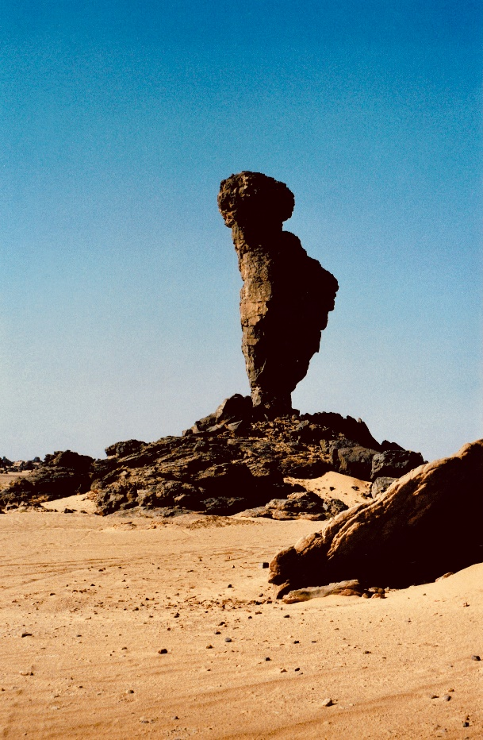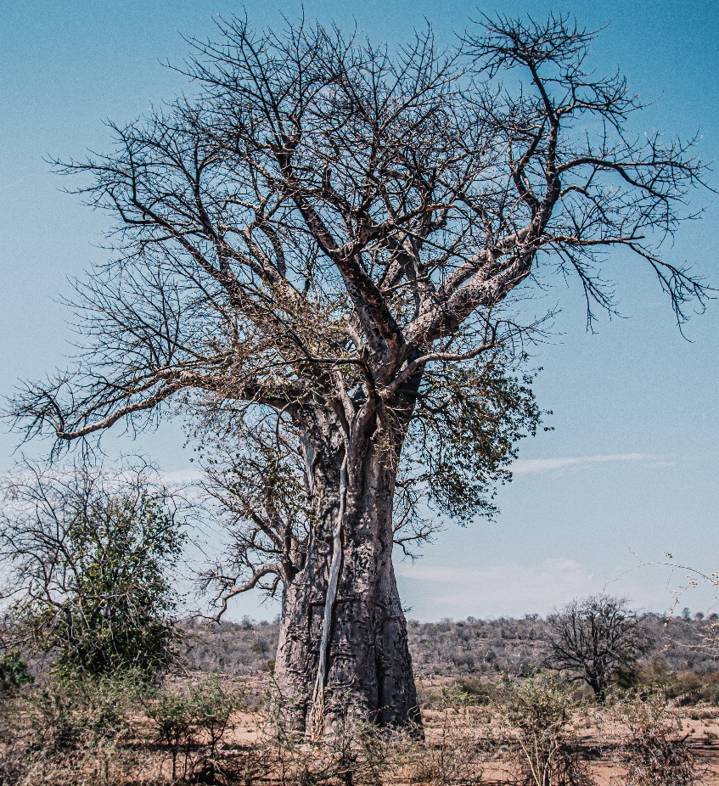
Image 1 © Azzedine Rouichi and Image 2 Nqobile Vundla www.unsplash.com

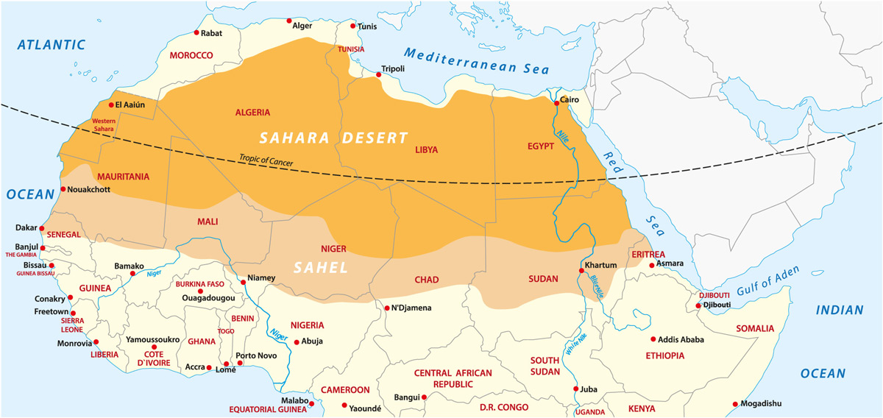
Figure 1 © Sahara http://geographical.co.uk/places/deserts/item/2739-just-desert-why-the-sahara-is-growing

Appendix B

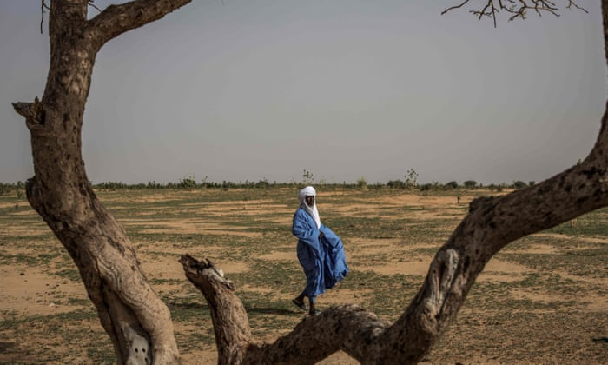
Image 3 © Marco Longari AFP via Getty Images. Sahel communities are much less resilient to climate change www.theguardian.com/world/2020/oct/19/sahel-region-is-canary-in-the-coalmine-on-climate-says-un-official

Appendix C

The Empire of Ghana | Nok culture | Asante
Mali Empire | Songhai | Ife
Table 1

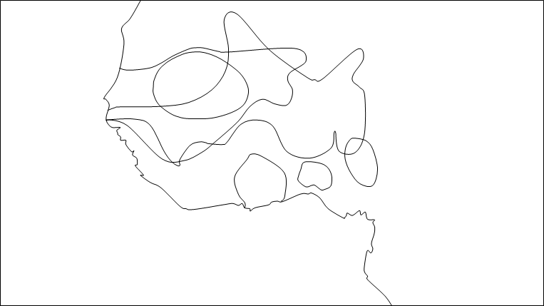
Figure 3 © BBC Bitesize Benin and other West African kingdoms

Appendix D

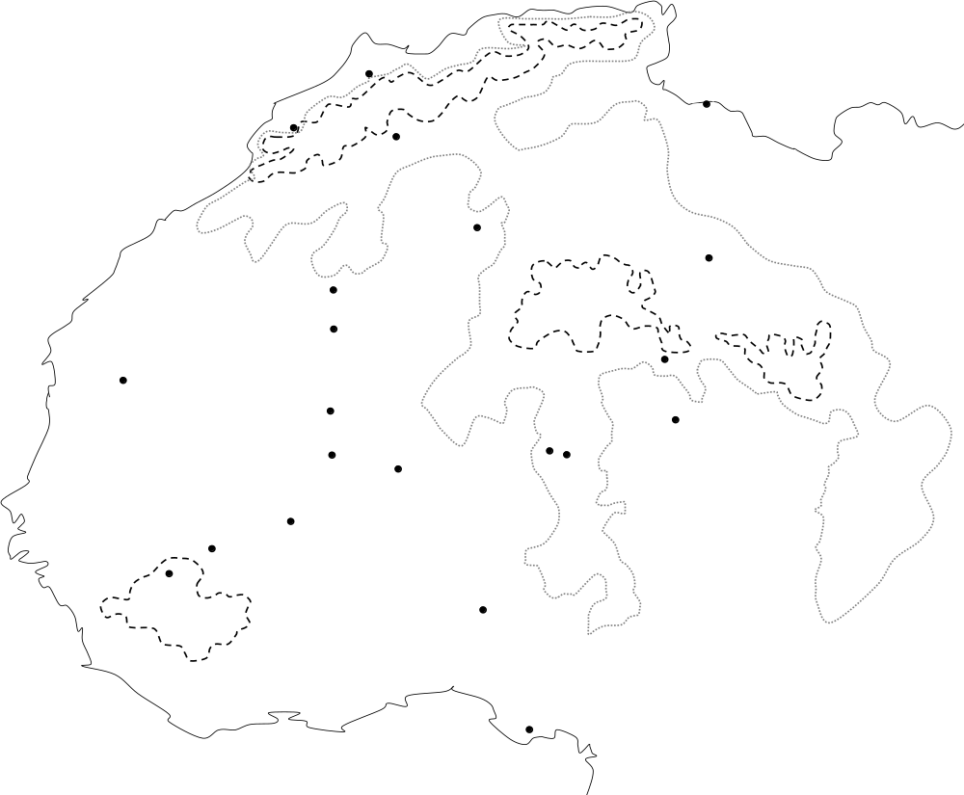
Figure 4 © RGS-IBG

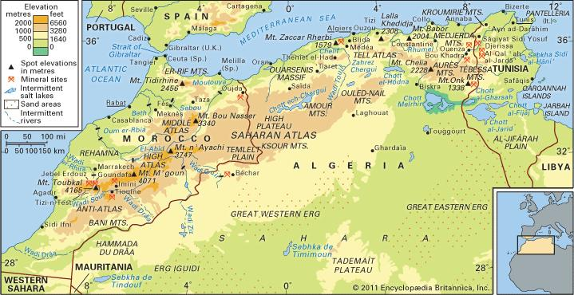
Figure 5 © Topography of North Africa https://www.britannica.com/place/Atlas-Mountains
Appendix E

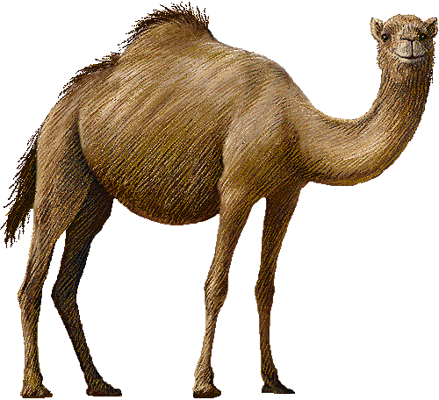
Figure 6 © The Free Clip Art Store

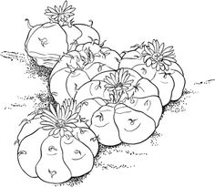

Figure 7 © am rastas on arts

Appendix F

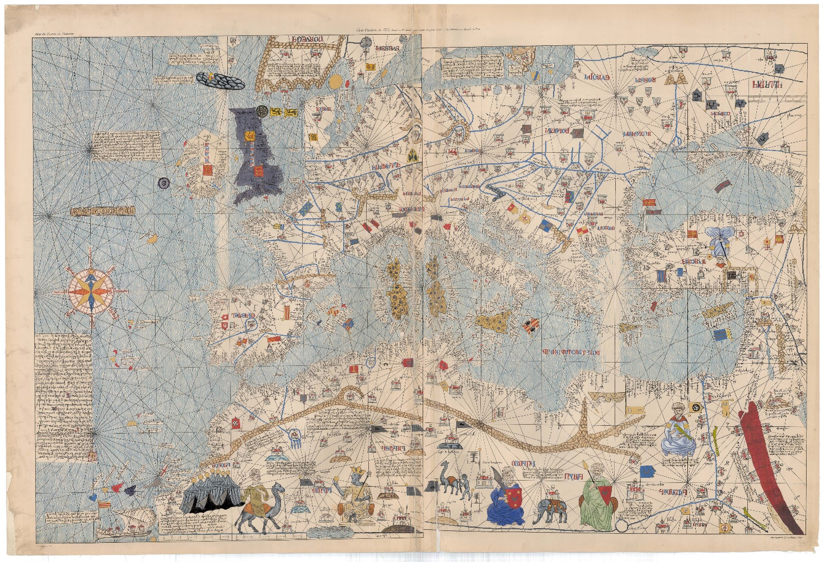
Figure 8 © RGS-IBG

Appendix G

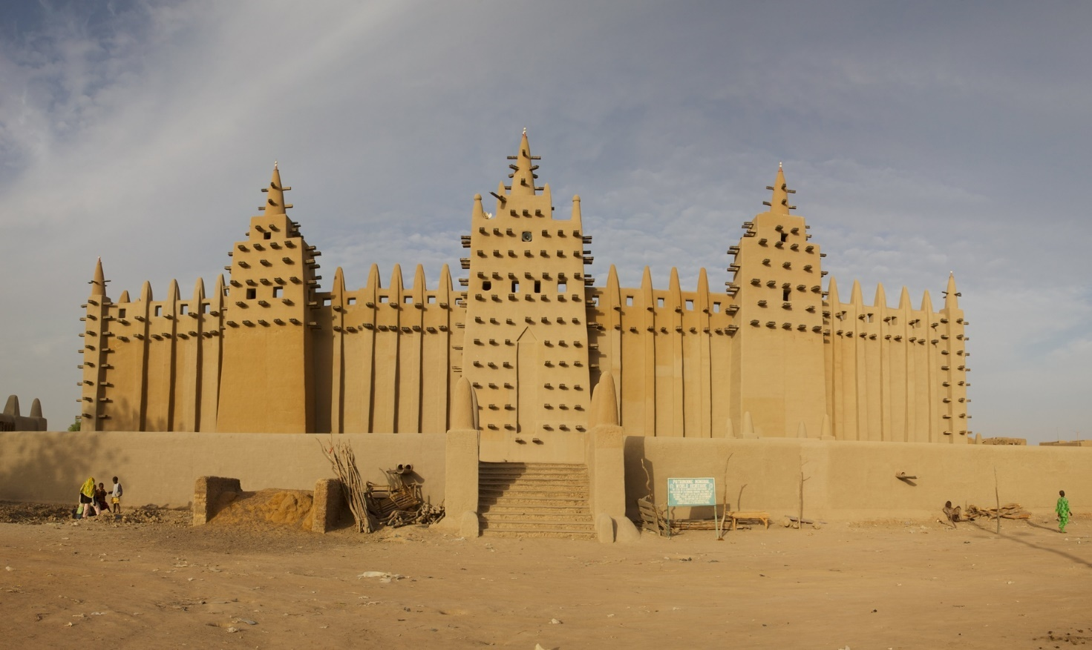
Image 4 © TravelStock Djenné, African City Of Mud

Appendix H

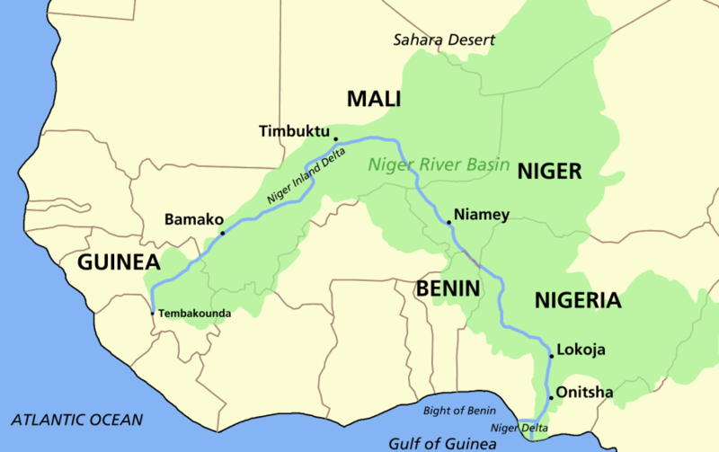 Figure 9 © Astrokey44 Wikimedia Commons

Appendix I

Figure 10

Appendix J

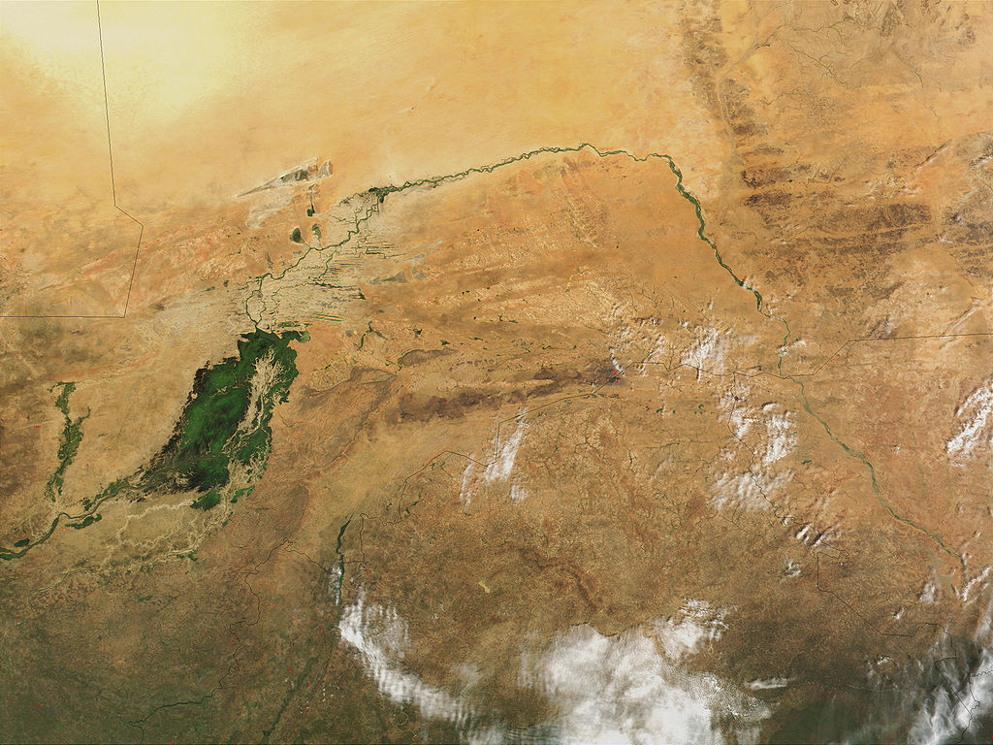
Image 5 © Jacques Descloitres, MODIS Land Rapid Response https://modis-land.gsfc.nasa.gov/index.html

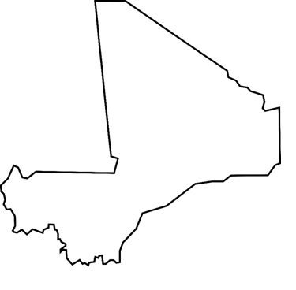
Figure 11 © WorldAtlas.com
Appendix K

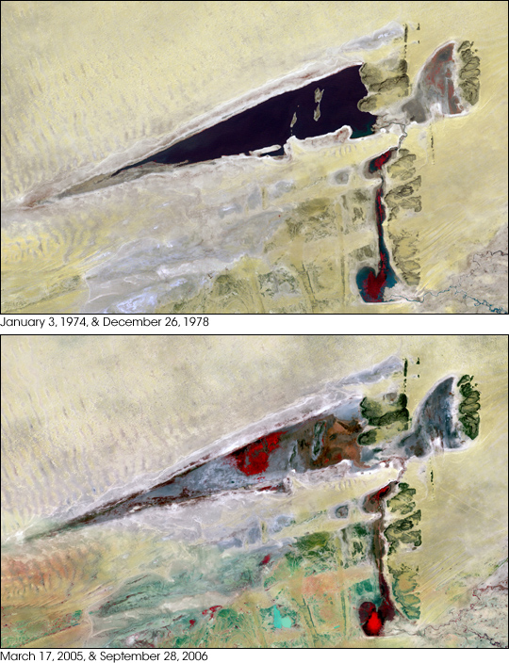
Images 6 and 7 © NASA LANDSAT

Appendix L

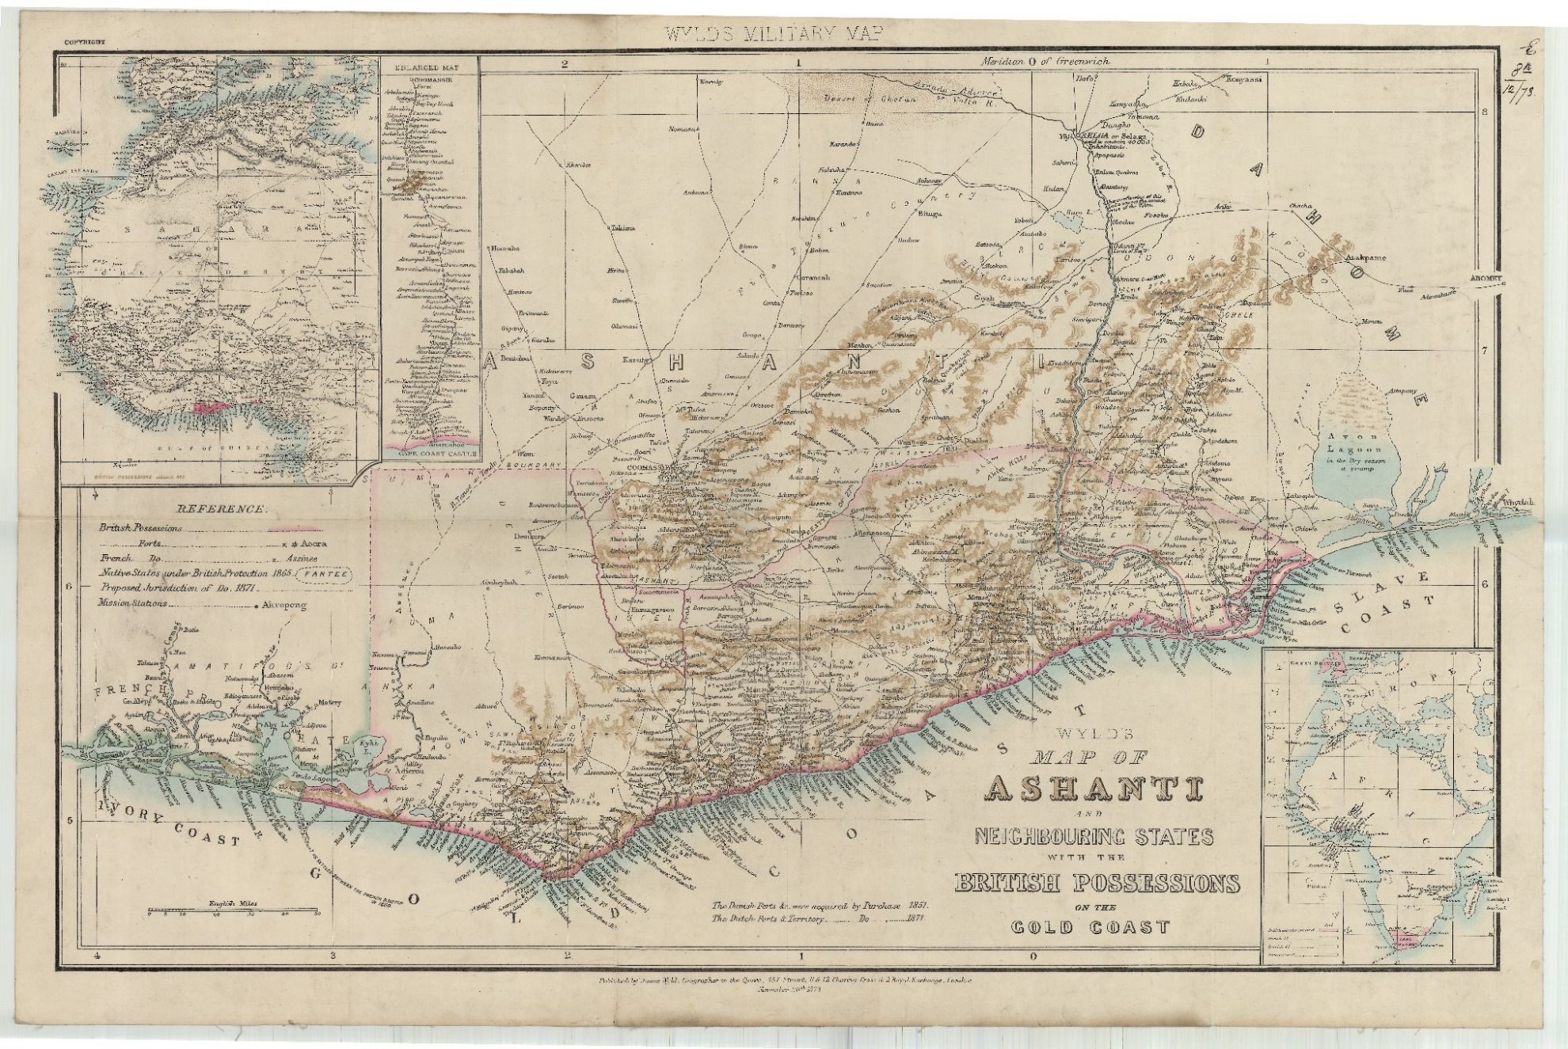
Figure 12 © RGS-IBG Wyld's map of Ashanti and neighbouring states with the British Possessions, 1873

