Using historical OS maps to identify at risk Public Rights of Way (PRoW)

Author: Dr Joe Thorogood, Geography, Coventry University
A public right of way (PRoW) is a footpath, bridleway, restricted byway or Byway Open to All Traffic (BOAT) that anybody can travel on, even if it crosses public lands. The names of the routes hint at their history. A bridleway refers to a route travelled by horses, as the bridle is the name of the straps that a horse wears on its head. Byways traditionally refer to minor roads that were not used by early cars.

In 2026, any PRoW that is not registered on a local authority’s Definitive Map and Statement will be removed threatening around 10,000km of PRoW. To protect these routes, we must find and register them with the respective local authority. This involves proving that a route does have the legal status of a ‘right of way’.

This tutorial will teach you how to identify an at-risk PRoW on historical maps. Historical maps are useful pieces of evidence when it comes to proving the existence of a PRoW. They show a route has been around for a long time and was recognised as a PRoW in the past. Since the legal principle ‘once a highway, always a highway’ ensure a route will exist in perpetuity (forever) then finding a route on historical maps provides even stronger evidence of a route’s existence. We will consider one important type of historical map: Ordnance Survey Maps. We can use clues in the landscape to identify areas where at risk rights of way will be.

This project uses What3Words (W3W) locations to help you precisely locate the features we are discussing. If you are not familiar with W3W, you can learn more here.

Investigating historical Ordnance Survey maps
The earliest maps produced by the Ordnance Survey, the UK’s mapping agency, date back to the 17th century. The oldest maps that have survived are housed in museums and collections. It’s hard to get hold of physical copies of maps dating back in time. Fortunately, The National Library of Scotland has a large collection of historical OS maps that it has digitised. This means we can view them, free of charge, online.

- Navigate to https://maps.nls.uk/os/

- This takes us to the National Library of Scotland’s online mapping repository for Ordnance Survey maps. There are many options to choose from. they are mainly organised by their different scales. Which should you go for?

- It’s important to remember that maps have different scales. A scale is a ratio of how much a specific measurement on the map refers to in the world. A scale of 1:1 would show 1 metre on the map for every 1 metre in the real world.
- We can’t obviously make maps this large. In the past, we needed maps that fit in pockets (as the Victorians couldn’t zoom in and out to different scales on smartphones). The OS used scales that showed different amounts of information, depending on your journey or activity.
- Today, the OS produces maps in two main scales that refer to the name of their maps: Landranger and Explorer. OS Explorer maps are 1:25,000 and OS Landranger Maps are 1:50,000.

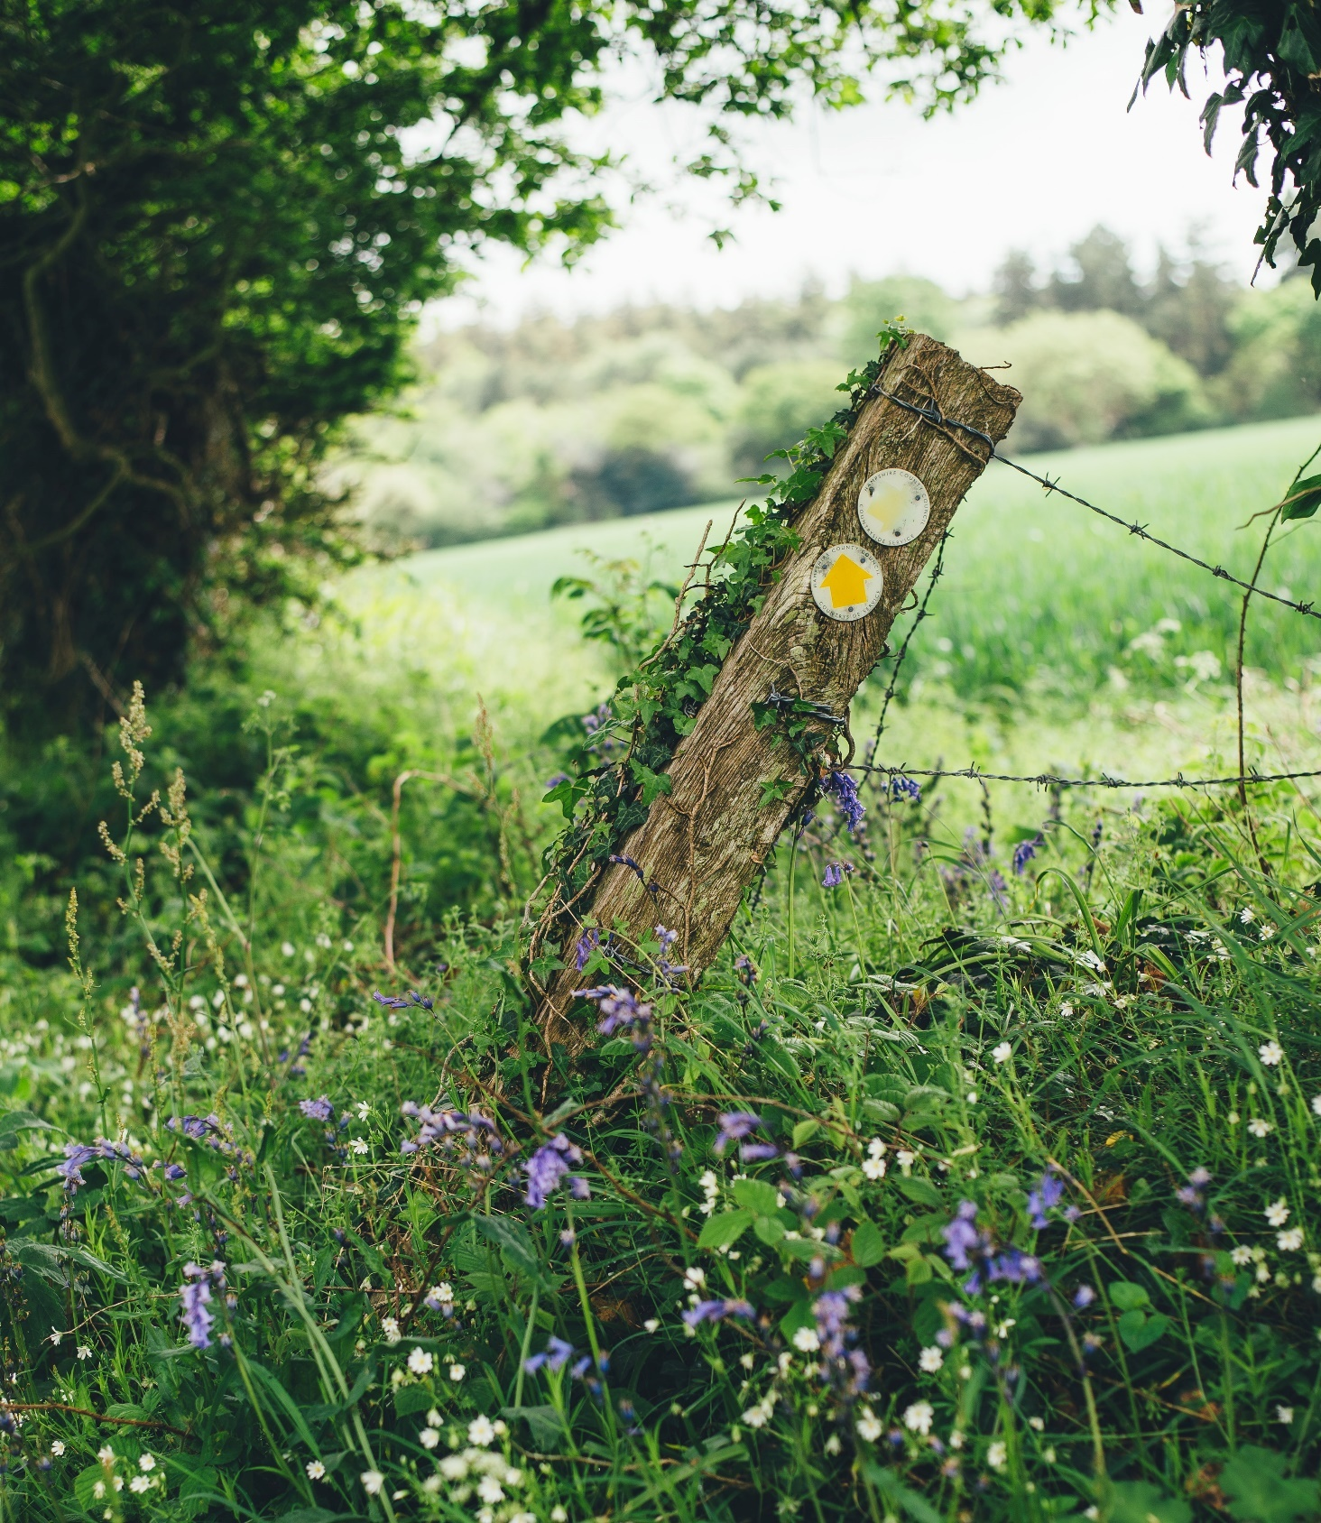
Purple petaled flower photo © Annie Spratt Unsplash

Quick question: which OS map is bigger? The Landranger or Explorer Map?

- This is a trick question that depends on how you define ‘bigger’. If ‘bigger’ means covering a larger area, then the Landranger maps are bigger. 1 cm on their map represents, 50,000 cm on the map. So 2cm on a Landranger map covers a kilometre of land in the real world. But if you defined ‘bigger’ as ‘bigger features on the map’ then the Explorer map would be what you were after. On these maps, 1cm is equal to 25,000cm in the real world, so 4cm on the map is equal to 1 kilometre. This means that if you compared a Landranger and an Explorer map side by side, the Explorer map will show a smaller area than the Landranger map but there will be more detail in that area.
- The question as to which map is most useful is entirely dependent on what you’re trying to do. If you’re planning to drive a long distance, you’d want the Landranger maps. These will show you less detail but cover more ground. If we wanted to go walking, we’re going to want to get more detail of the local area’s features, footpaths, buildings and services so we’d opt for the Explorer maps.
- The Ordnance Survey has been producing maps for 100s of years. They vary by scale, location and date of publication. Here’s a complete list of the maps published for the public by the OS:
Name | Scale | Publication Start Date | Duration (years)
Old Series | 1:63,360 (one inch to the mile) | 1805 | 69
Country Series | 1:2,500 | 1841 | 111
New Series | 1:63,360 (one inch to the mile) | 1847 | 51
Revised New Series | 1:63,360 (one inch to the mile) | 1897 | 17
Third Edition | 1:63,360 (one inch to the mile) | 1913 | 30
Fifth Edition | 1:63,360 (one inch to the mile) | 1934 | 5
Popular Series | 1:63,360 (one inch to the mile) | 1919 | 7
Sixth (or New Popular Series) | 1:63,360 (one inch to the mile) | 1946 | 16
Seventh Series | 1:63,360 (one inch to the mile) | 1952 | 27
Landranger Series | 1:50,000 (cm) | 1979 | 33
First Series | 1:25,000 (cm) | 1968 | 11
Pathfinder Series | 1:25,000 (cm) | 1979 | 20
Explorer Series | 1:25,000 (cm) | 1999 | 13

Reproduced and edited with permission of Bucks and Wadey (2017)

- Please note that the OS changed to a metric system in in 1974. The maps in grey are measured in inches (one inch to the mile) whereas the later maps are measured in centimetres. The County Series (in darker grey) did not cover the entirety of the UK.
- Generally, we’re interested in detail, so we want maps with a lower scale. The most detailed scale is by far the 1:2,500 maps. 25 inches on the map shows 1 mile in the real world, giving incredible detail.

Advanced information: The second edition of the County Series Maps are also useful for two more reasons. First, when created, OS surveyors also created Object Name Books that recorded the names of the features on each map. Second, they were used as base maps for the 1910 Finance Act’s Land Valuation Maps. Both are useful pieces of evidence for proving the existence of a PRoW for more information, see (Bucks and Wadey, 2017)

- Location is easy: we want the area that we’re interested. We’re going to focus on Worcestershire, so we want maps for England.
- Time is more difficult; The OS has produced maps since the mid-18th Century. How far back in time do we wish to go?
- There is one key date that can help our research, which is the year 1949. This is the year The National Parks and Access to the Countryside Act was passed. It required each County Council to survey their lands and provide a Definitive Map and Statement of the Rights of Way in their area. Since we know that at-risk routes are routes which are not included in Definitive Maps and Statements, any route which is included on a DMS will have been done so after 1949 and will not be at-risk. The We’re only interested in OS maps before 1949.

Advanced Information: We also know that the OS started mass producing maps for the public around 1805. According to Bucks and Wadey (2017) the oldest maps in the first edition do not mention Bridleways. While they are still useful, they can complicate a claim for a Bridleway. The County Series Maps do not make this error.

- Using this information, we’re looking for maps with plenty of detail that were published before 1949 of Worcestershire. The County Series Maps have the most detail as their scale is 1:2,500. They span from 1841, well before our cut-off date of 1949.

- Navigate to Map Series - England, Wales and Great Britain. Click on Ordnance Survey, 25 inch, England and Wales - 1841-1952

- The next page gives you three options for viewing the data:
- As individual sheets using a zoomable map of England and Wales.

- As a seamless zoomable overlay layer (1890s-1920s) on modern satellite images and OS maps.

- As a seamless zoomable layer (1890s-1920s) side-by-side with modern satellite images and OS maps.

- The most useful is option A. It allows you to navigate to the area in question quickly without having to load the data. As with the other exercise in this file, we’re going to navigate to Worcestershire, specifically an area called the Old Hills.

- Click option A. Type Old Hills into the ‘search gazetteer’ box (a gazetteer is an index of place names that accompanies a map). The first option should be for the ‘Old Hills’ followed by ‘Malvern’. Click this option. The map should zoom you to the area.

- You’ll notice a blue grid overlaying the map. This grid represents the ‘map sheets’ that were used to create the 25-inch (1:2,500) maps. In the early 1900s, you couldn’t just load up Google Maps, you had to buy individual sheets of the area you wanted! The maps are detailed, they only cover 1.5 miles west to east and 1 mile north to south. Each county would be comprised of 16 sub sheets (numbered 1-16) within a parent sheet (given a roman numeral). We’re interested in Worcestershire XL and subsheet 7 (Kempsey; Madresfield; Powick; Severn Stoke). If you’re struggling to find the numbers, follow this link

Worcestershire Parent Sheet (XL)
1 | 2 | 3 | 4
5 | 6 | 7 | 8
9 | 10 | 11 | 12
13 | 14 | 15 | 16
Figure 1: Sheets and Subsheets

- You can now view the map sheet and zoom into it. Scroll right to the bottom left hand corner of the map. You should see ‘Fakener’s Farm’. North of the farm is a dotted line marked ‘FP’ leading off to the southwest of the map.

Quick Question: What does BR Stand for?

- You might have deduced that FP stands for Footpath. We’re interested in other abbreviations as well, specifically BR. You’ll find the answer by looking at the map legend. You can find this by returning to the Ordnance Survey Map page and looking at Ordnance Survey Characteristics Sheet collection. From there, you’ll have to pick the correct legend for the map we’re examining. If you’re not sure, use this link.
- You can view an index of other Historic OS Symbols here.

- Compare this with a contemporary PRoW Data. If you have completed the previous GIS exercise in this folder, you can compare this map against the one you created using Worcestershire’s PRoW Data. Alternatively, you can view this data on the Worcestershire County Council Website. Follow this link to do this.
  - The link takes us to the online version of their ‘Definitive Map and Statement’. The official version is always a paper copy you have to visit in person but digital version are usually up to date. If you zoom in, you’ll see coloured lines with labels representing PRoW in Worcestershire. The colour line tells us what type of PRoW the route is and the label.

- Scroll to Fakener’s Farm, now called ‘Falconer’s Farm. You’ll notice the footpath is not located on the map.
  - W3W Location: https://w3w.co/unclaimed.conductor.slumped
  - This footpath is an example of an at-risk PRoW. There are clues as to why this PRoW is at risk.
    - There is a nearby PRoW that stops abruptly. It’s likely this route connected to our at-risk route. It’s very rare that a ProW is not connected to another ProW or road.
    - W3W Location: https://w3w.co/formless.obeyed.really
With this information, we can be reasonably sure we’re dealing with an at-risk PRoW. We may now wish to find more sources of evidence of the route on other OS maps at different scales. We can then also explore more complicated historical sources such as Tithe Maps, Enclosure Awards and Land Valuation Maps. Once we’ve collected all this information, we can apply to have the Definitive Map and Statement edited to register our at-risk routes.
For information on how to do this, please visit http://rowresearch.coventry.domains/

Optional instructions
You may wish to start examining the historical maps in your own area to identify at-risk routes; perhaps there are paths, roads and lanes in your area worth exploring. You can use this process to examine your local area.

References
Bucks, S. and Wadey, P. 2012. Rights of Way: Restoring the Record. Bucks and Wadey Publishing, Illminster

Securing Coventry’s Footpaths: Citizen Science, Cultural Collaboration and Public Engagement in Right of Way Preservation Project Website: http://rowresearch.coventry.domains/


