|  |
| --- |
| Geographical careers in real estate – teacher support pack |

This student activity is based on a careers session hosted by Knight Frank that took place in person at the Royal Geographical Society in June 2025. The images and maps in the student activity have been provided by Knight Frank.

The aim of the resource is to introduce students to the geographical career opportunities available in the real estate consultancy sector. The activity has a geospatial focus, introducing students to the relevance of GIS in this sector.

The activity is aimed at A Level geography students, to support them with interpreting, analysing and evaluating different types of data presentation. The questions aim to reflect the types of questions students are presented with in an exam, for example:

**AQA**   
  
Paper 1& 2, Question 2.2, such as:

‘Evaluate the usefulness of Figure X for …’

**OCR**

Paper 2, Question 2a(i) and 3a(i), such as:

‘Suggest two limitations of the data presentation technique for …’

OR   
  
‘Give one advantage and one disadvantage for this data presentation technique for …’

**Answers**

**Task 1a** - Using Map A, answer the following questions:

1. Describe the distribution of public parks and gardens that are 250+ hectares accessible in size.

* High concentration in West London; West of Dulwich & Victoria Park
* Largely situated with distance from the river
* Examples include Roehampton, Wimbledon Common, Mortlake (South West London)
* The only garden of this size located north of the river is Hampstead Heath
* Hampstead Heath is the largest garden of this size

1. Evaluate the effectiveness of Map A for showing the distribution of green space in London

* Visual making it easy to see spatial patterns
* Areas are labelled so comparisons between different places can be made
* Use of key means that it is easy to read
* Doesn’t include a date so unable to compare changes over time
* Interval data means that an exact value cannot be determined for each place
* Doesn’t specify between areas that are public parks and areas that are gardens
* Cannot see variations within the areas
* Only shows Zones 1-3 of London therefore isn’t representative of the whole of London

**Task 1b - Using Map B, answer the following questions:**

1. Describe the density of amenities within a 5, 10 and 15 minute walk of the RAY Farringdon.

* Within a 5 minute there are fewer amenities (less than 4)
* The density of amenities increases between a 5 minute and 15 minute walk, increasing from less than 4 to more than 8
* The highest density of amenities is within a 10 minute walk, where there are more than 8 amenities

1. Imagine you are part of Knight Frank’s Research Analytics Team. A property developer wants to build a block of flats that are less than a 15 minute walk away from the RAY Farringdon. Based on the density of amenities in the surrounding area, suggest a location for the block of flats:
2. Circle the location on the map

Example:

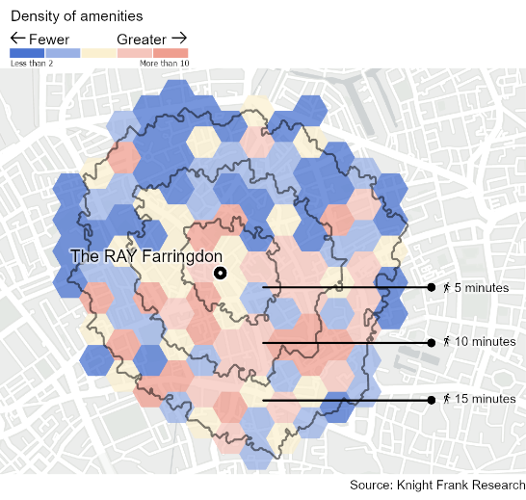

1. Justify your choice using evidence from the map

* South of the Ray Farringdon has the highest concentration of amenities, specifically the South East
* Area located 10 minutes South East has highest concentration of amenities (more than 10) and is a 10 minute walk away

1. Evaluate the effectiveness of Map B for showing density of amenities in London

* Visual making it easy to see spatial patterns
* Use of key means that it is easy to determine the number of amenities in an area
* Use of different shades of colour means its easy to compare areas of high density of amenities and areas where there is a low density of amenities
* Doesn’t specify what types of amenities are located in a certain area
* No scale so makes it difficult to measure walking distances that aren’t labelled on the map
* Only shows a small area of London

**Links to further careers support**

* Royal Geographical Society’s career pages: [Choose a career with geography - RGS](https://www.rgs.org/choose-geography/choose-a-career-with-geography)
* Teacher CPD: [Teacher events - RGS](https://www.rgs.org/schools/teacher-events)
* I am a geographer: [I am a geographer - RGS](https://www.rgs.org/choose-geography/i-am-a-geographer)
* Statutory careers guidance for schools: [Careers guidance and access for education and training providers - GOV.UK](https://www.gov.uk/government/publications/careers-guidance-provision-for-young-people-in-schools)