The CIS Tower, Manchester
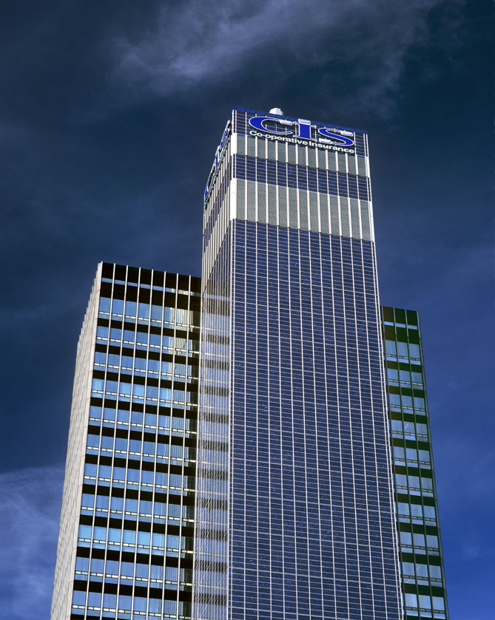
- Dominated the city's skyline for over 40 years
- Tallest office building outside London
- Built in 1962 to provide new premises for Co-operative Insurance Services
- Used millions of mosaic tiles to clad the windowless service tower – inspired by the steel buildings of the Chicago skyline.
- Tower was grade II listed in the mid-1990s.
- Pollution and repeated repairs meant that tower appeared more dull grey than shimmering silver.
- Further problems developed as mosaic tiles began to fall off, exposing structure to weather damage.
- 3 sides of the 25 storey service tower clad in ‘photo-voltaic’ panels
- 7,244 solar photovoltaic panels in total - convert daylight (not sunlight) into electricity
- Despite popular misgivings, will work regardless of the Manchester weather!
- Cost – £5.5million
- It will help combat climate change and generate180,000 units of electricity each year - enough energy to make 9,000,000 cups of tea!
- June 2006 – Work complete - all 7,000 photovoltaic panels are feeding electricity into the building.
- Solar panels now creating 181,000 units of renewable electricity each year - enough energy to power 55 homes for a year.

