Past and Present

The history of the land now known as Afghanistan is a long and complex one. It has been, and continues to be, the centre of political, social and economic struggles and is often called, char-su, the crossroads of Asia. The country lies on a crossroads between south, west and central Asia, and has been influenced from all these regions.

Boundaries have shifted over the years as many rulers have sought to control the land. Parts of Afghanistan were included in the Persian empire and the Greek empire.
Buddhist kings also ruled until the end of the tenth century, followed by Islam. In the eighteenth century, a group of Pashtun tribes under Durrani started their own empire, which also broke up.

This explains the many Buddhist sculptures and art dating from 3 BC. The harsh climate, natural disasters and war has meant many of these monuments have been destroyed.

Belooche’s in the Bolan Pass by J Atkinson, 1842

The nineteenth century

During the nineteenth century, the British tried to rule Afghanistan as they were afraid of Russia trying to take over. There were three Anglo-Afghan wars between the Afghans and the British. The ruler who was most responsible for turning Afghanistan into a nation was Abdul Rahman Khan (1881-1901)
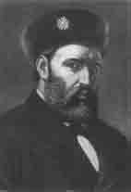
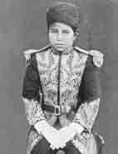

Amir Abdur Rahman Khan, Amir from Sirdar Mahomet Omar Jan 1880-1901 (first son of Abdur Rahman Khan)

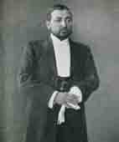
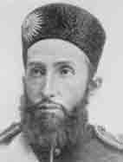

Sidar Nasarullah Khan Amir Habubullah Khan
(second son of Abdur Rahman Khan) (third son of Abdur Rahman Khan)

Modern Afghanistan

From the 1960s and 1970s, there was a form of democracy in Afghanistan. In 1973, the ex Prime Minster organised a coup against the government. There were groups competing for power and the Afghan army was losing control. In 1979, the Soviet Union sent in troops. There was resistance by groups who fought the Soviet forces. The US and other countries started to supply money and arms to the mujahadin. Fighting continued in Afghanistan forcing Afghan refugees to escape to neighbouring countries Pakistan and Iran. In 1991, the US and the Soviet Union agreed to end supplies of arms to both sides.

In 1996, the Taliban took control of Kabul, the capital city and introduced a hardline version of Islam, banning women from work, and introducing Islamic punishments. In 2001, the Taliban fell from power as other countries, including Britain and the US launched air strikes after the Taliban refused to hand over Osama bin Laden, held responsible for the September 11 attacks on America.

In December 2001, Hamid Karzai becomes leader of the power-sharing government and a new constitution was adopted in 2004.

