The Intergovernmental Panel on Climate Change IPCC scenarios

The IPCC bases its models and predictions on Representative Concentration Pathways (RCPs) of CO₂-equivalent (ppm). The 4 pathways represent a broad range of climatic outcomes for how the world will develop over the next 100 years.

RCPs were used in the IPCC Fifth Assessment Report. Read The anatomy of a climate scenario paragraph in 5 possible climate futures—from the optimistic to the strange, for reference to the most recent Sixth Assessment Report.

RCP 2.6

- Limit warming to 2°C (>67%)
- Low GHG emissions scenario

RCP 4.5

- Limit warming to 3°C (>50%)
- Intermediate GHG emissions scenario

RCP 6.0

- Limit warming to 4°C (>50%)
- High GHG emissions scenario

RCP 8.5

- Exceed warming of 4°C (>50%)
- Very high emissions scenario

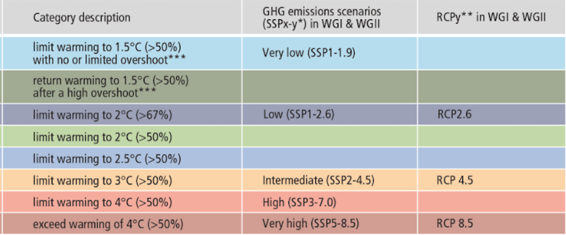
IPCC (2023) Box SPM.1, Table 1

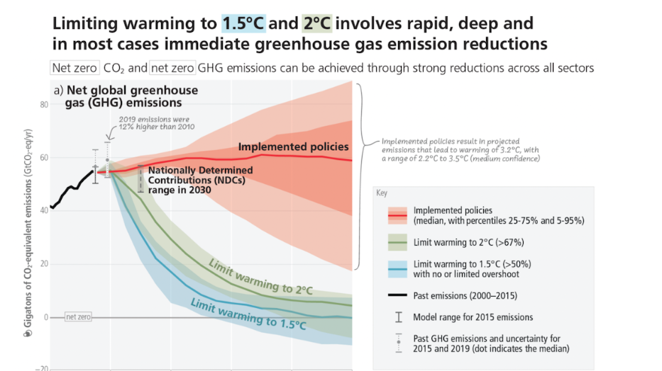
IPCC (2023) SPM.5

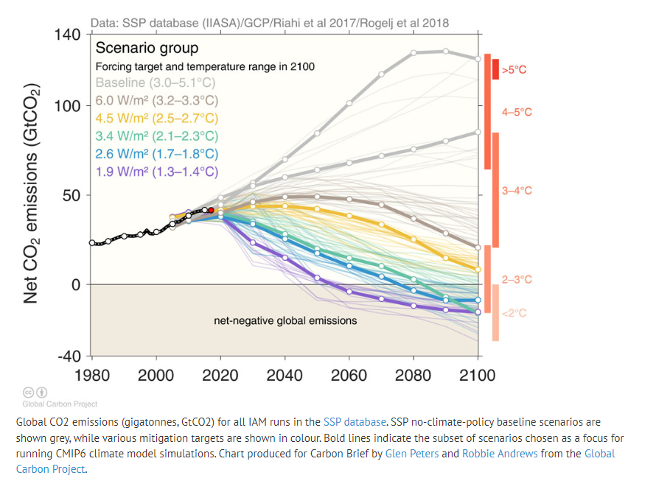

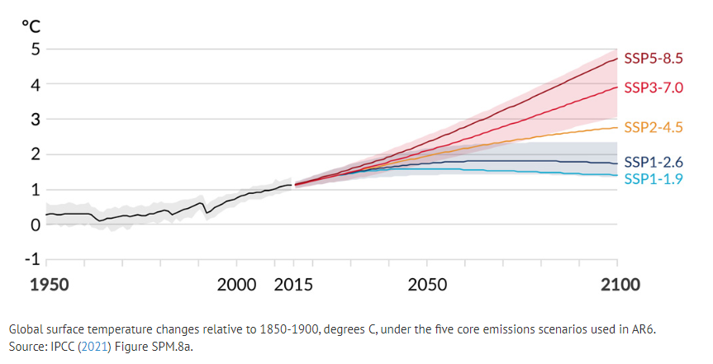
IPCC (2021) Figure SPM.8a

For more information and explanation, read Explainer: How ‘Shared Socioeconomic Pathways’ explore future climate change from Carbon Brief.

