|  |
| --- |
| Ecuador |

**Location Basic facts**

|  |  |
| --- | --- |
| Population per km2 | 70 (2022) |
| GDP/GNI per person | $6,300 (2022) |
| Climate | Temperate in the mountains, humid subtropical along the coast. |
| HDI (closest to 1 = most developed) | 0.740 (2021) |

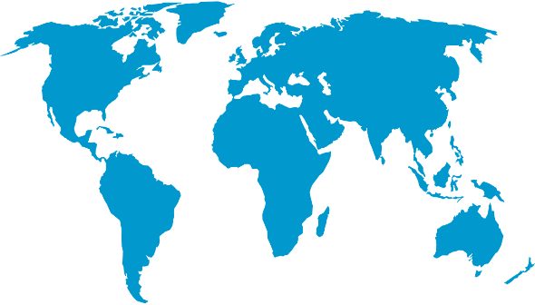

*World Map © Clker-Free-Vector-Images, Pixabay*

**Environmental facts**

|  |  |
| --- | --- |
| 1. | Ecuador faces a significant risk of flooding in both river and coastal areas. Additionally, the country is highly vulnerable to earthquakes, volcanoes, landslides, tsunamis, extreme heat, and wildfires. After flooding, landslides are the most frequent natural hazard in Ecuador. This is made worse by the fact that 96% of its population live in coastal and mountainous regions. |
| 2. | Ecuador’s coastline is 2,237 kilometres in length. It is very dramatic with high mountains over 300 metres high and low floodplains and estuaries. There are mainly igneous and metamorphic rocks, which do not easily erode. A lot of sediment is washed down the mountains into rivers and the sea generating a lot of silt, sand and mud. |
| 3. | 53% of Ecuador’s coastline is home to multiple habitats. 34% is mangrove forests and 2% saltmarshes. The Galapagos Islands off the coast of Ecuador offer some of the most unique flora and fauna in the world with more than 2,900 marine species being monitored. |

**Protecting the oceans**

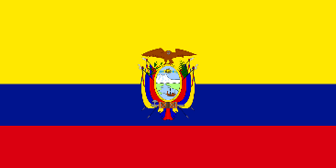Many of Ecuador’s marine vegetation can be found in protected areas, this includes all of their warm water corals, half of their mangrove forest and 44% of their saltmarshes. Since 1959, the government of Ecuador designated the Galapagos Islands (part of Ecuador) as a national park and then a marine protected area in 1998. This protected the Islands as well as 40 nautical miles from their coast. In 2022, this protection was extended adding over 37,000 km to this protected area.

*Ecuadorian flag © Clker-Free-Vector-Images, Pixabay*