5 Ways to learn the GAC

GCSE Specification Link
AQA
3.1.1.3a. Global atmospheric circulation helps to determine patterns of weather and climate.

Edexcel B
1.1a. The global atmospheric circulation and how circulation cells and ocean currents transfer and redistribute heat energy around the Earth.
1.1b. How global atmospheric circulation determines the location of arid (high pressure) and high rainfall (low pressure) areas.

Eduqas B
2.3.2. An overview of the global circulation of the atmosphere to include the operation of cells in the troposphere.
2.3.2 How does the global circulation of the atmosphere create distinctive climate zones?
3.4.1. What are the physical processes operating in hot semi-arid regions that make them vulnerable to desertification?

OCR B
1.1b. Outline of the global circulation system including the effects of high- and low-pressure belts in creating climatic zones. How the global circulation of the atmosphere causes extremes in weather conditions in different parts of the world.

WJEC/Eduqas A
5.2.1. An overview of global circulation of the atmosphere. How global circulation creates areas of low and high pressure. How these different pressure systems each lead to weather hazards.

Introduction
Learning about the Global Atmospheric Circulation Model (GAC) is one of the more challenging concepts at GCSE for pupils as it involves thinking in three dimensions, a knowledge of atmospheric pressure and the location of certain biomes to visualise the impacts circulation has on the planet’s weather systems.

If you have not covered biomes or air pressure yet, it might be worth using some of the following resources to help your class have a basic understanding. You can always return to them in a later lesson to go over them in more detail.

These lesson ideas have been designed to work with content on the GAC, some ideas of where to find it have been provided in this document but of course you can use any source which suits your class’s needs.

All of these lessons have been created to take approximately an hour of teaching time.

Suggested teaching materials
High and low pressure:

Met Office Learn – air pressure NOTE: this in context to general weather conditions rather than the GAC specifically.

RGS 60 second guides:

Cold Desert Biome
Temperate Deciduous Biome
Hot Desert Biome
Tropical Rainforest Biome

GAC:

Video from the Royal Meteorological Society
The Met Office – Global Circulation Patterns
BBC Bitesize - global atmospheric circulation
Seneca learn – global atmospheric circulation.

The contents table below has been added so that you can jump quickly to your preferred resource.

Contents

GCSE Specification Link 1
Introduction 1
Suggested teaching materials 2
Idea 1: Make it a model 3
Idea 2: Complete & retell it 5
Idea 2: GAC video summary 6
Idea 3: GAC Popup 7
Idea 3: Mix and match sheet (starter) 7
Idea 3: GAC pop up template 8
Idea 4: Sequencing 9
Idea 4: Statements (pupil copy) 9
Idea 4: Statements (answers) 10
Idea 5: Make an animation 11
GCSE style questions 12
Additional resources 12

Idea 1: Make it a model
This is a creative method to help your learners visualise the GAC in context to other factors such as solar radiation, the location of the equator etc. It will take a bit of setting up and an element of pre-learnt knowledge and understanding for pupils to work independently therefore, freeing you up to help support and challenge the class where needed.

Starter:

Use a quizzing site such as Quizlet, Seneca learn, Kahoot or create your own using your school’s quiz app (most likely MS or Google Forms) to test pupils current understanding of High and Low-pressure. You could develop this with including questions about biomes.
Main:

You will need the following items per group / pair for your class to use.

- Small box: shoe box size
- wooden / plastic doweling or a pencil
- self drying clay / play dough / plasticine: small hand full per group or pair (to make the Earth)
- x2 pipe cleaners: one to represent cold air, the other warm air
- scissors
- a torch (one on a phone can be used if school policy allows)
- a tool to draw on the earth. A sharp pencil will suffice.
- parcel labels cut to size depending on the size of the box
- an elastic band / hair band

1. Provide your class with information on how the GAC works. How you choose to deliver this will depend on your class. Please see ideas from the ‘suggested teaching materials’ above. For this activity, it might be worth giving it to them before the lesson i.e. previous lesson or homework.

2. Take or cut off the top of the shoe box or remove the side of a box so that the widest part is on view.

3. Turn the box on its side with the open part facing you.

4. Make a hole big enough to fit the pencil / dowel in the centre of the top of the box.

5. Make a similar sized hole on the right-hand side of the box – this will be where the light from the torch comes through.

6. Make a ball (roughly tennis ball size + a small additional piece) with the clay / play dough / plasticine to represent the Earth. You can also mark where the UK would be with a dot for reference (but not necessary).

7. Using the drawing tool, mark on the equator, and lines to represent 30º and 60º north and south of the Equator.

8. Draw arrows to represent the easterlies and westerlies.

9. Cut approximately 1.5 cm length of pipe cleaner in both colours.

10. Twist the last 0.5cm of the ends together then the same on the other side but leaving a short stump so that the cleaner will be able to be stuck into the clay. You should be left with a ‘p’ shape with an oval top and short length. A bit like the image below:

11. Repeat step 9, five more times.

12. On the left-hand side of the model, starting at the Equator line and moving in a straight-line north. Place the open end of the pipe cleaner into the clay. Then place the next ‘cell’ at the point of the 60º N line and turn it towards the first cell.

13. Place the final cell at the pole and turn it towards the last cell. If you were to look at it as a cross section, it will look a bit like this:

Equator
30º
60º

14. Repeat steps 12 and 13 but starting on the right-hand side of the model moving south from the Equator.

15. Using a separate parcel label for each, name the different cells and leave to one side.

16. On other parcel labels, write annotations to describe and explain the GAC. A challenge task could be to explain how the cells affect the weather and the role of the easterlies and westerlies.

17. Push the dowel / pencil through the hole at the top of the box.

18. Ensuring that the clay Earth is at a slight angle to represent the tilt of the real Earth (i.e. 23.5º) push the top of the Earth into the end of the pencil / doweling which is inside the box.

19. Position the earth so that the equator is in line with the hole on the side of the box. Your model Earth should be suspended roughly in the centre of the box and can spin (gently) in its space.

20. Once you have the right height, secure the dowel / pencil where it comes through the top of the box with the elastic band. This should stop it slipping but allow it to rotate.

21. Stick the labels and annotations to the back wall of the box so that they are visible and line up with what is happening in the model.

Plenary:

Pupils use their diagrams to tell their peers how the GAC works and / or complete an examination question on the GAC.

Idea 2: Complete & retell it
The age old ‘fill in the gaps’ exercise with a little extra. Ideal if you are short on time or if you wish to set this as a homework task.

Starter:

Put the class in pairs; one pupil represents High-pressure, the other Low-pressure. Set either a class agreed or pre-agreed criteria on what should be included on the board. Pupils then create a representation of High and / or Low-pressure. This can be in any format they wish as long as it covers the pre-agreed criteria. Pupils then present their creation to their partner which can then be peer assessed using the criteria.

Main:

1. Play the Meteorological Society video on the GAC. Pupils watch it once without filling in anything.

2. Once the video has finished, pupils can fill in any gaps they feel confident about on the sheet.

3. Play the video for the second time. This time, pupils can fill in the gaps they have missed.

4. Project the answers on the board to self-assess once finished.

5. Class discussion to support with any misconceptions plus challenge those who are confident.

6. Summarise the text in a series of annotated diagrams at the bottom of the page.

Idea 2: GAC video summary
Below is the summary of the video. Feel free to remove specific words for your class for their gap fill task.

As some parts of our planet is slanting towards and others away from the Sun, the Sun’s energy has different effects on the planet. In places that experience high Sun intensity, such as in the Tropics, the focus is strong and therefore hotter. Other parts which have lower sun intensity, the energy is spread out meaning there is more variation in the heat that area receives.

The Earth warms the air above it, causing it to rise. If the planet did not rotate, then there would just be one cell: hot air rising from the Tropics spreading north and south eventually cooling and sinking in the Polar regions then coming back towards the tropics in one complete convection cell.

However, as the planet rotates, it influences the movement of air. The Equator has the largest circumference (40,075 km). Around this part and into the tropics, the air moves quickly. However, as the Poles are effectively spinning on the spot, air barely moves.

The air from the Tropics to the Poles and from the Poles back to the Tropics is moving in a straight line but it is at a different speed in relation to the Earth, therefore, it appears to move east to west (easterlies) or west to east (westerlies). This is called the Coriolis Effect.

Because of the Coriolis Effect, the single cell is disrupted and therefore, the planet has three main cells: the Hadley, Ferrell, and Polar Cells. These are repeated on either side of the Equator in the Northern and Southern Hemispheres.

The Hadley Cell starts at the Tropics where heat from the Sun’s energy causes warm air to rise moving outwards towards the Polar regions. Warm air moves from the Tropics becoming more westerly as it gets deflected by the Coriolis Effect. So much so that eventually, the cell breaks down and air sinks at the sub-tropics (30º N or S of the Equator) and returns to the Tropics. This air moves more slowly over ground which, in relation to the air is moving faster making them look like they are moving from east to west (easterlies).

The same pattern happens in the Polar regions at the Polar Cell (60º N or S of the Equator). However, the differences are that this cell is driven by sinking cold air and generates slow moving polar air.

The Ferrel Cell behaves slightly differently to the Polar and Hadley Cells and is the net effect of all storms in the mid-latitudes with air sinking in sub-tropics and rising 50-70º N or S of the Equator. This air moves west to east (Westerlies). The air is pulled across the surface towards the Poles and picks up moisture along the way. When warmer, moisture ridden air meets colder air from the Polar regions, it rises, cools and condenses creating unsettled weather which is regularly experienced in the UK.

Plenary:

Pupils work in pairs to retell how the GAC works using their diagrams only.

Idea 3: GAC Popup
For this task, you would ideally need an A3 sized base paper. This could be a double page in an exercise book or an A3 sheet for a folder. A foundation of weather including High and Low-pressure would be an advantage.

Starter:
Mix and match on pre-learnt material including high and low pressure.

Main:

1. Hand each pupil a copy of the popup sheet (an example of this is on the next page).
2. Class discussion on what they can interpret from the image. Focus on what they can interpret from the arrows and what the colours represent. An opportunity to theorise the weather conditions and what is influencing these cells is relevant here for a challenge exercise.
3. Depending upon the ability of the class, provide them with a range of resources (including a teacher presentation if needed) on what the cells are called and how they work.
4. Pupils then use the text boxes on the left side of the image (inside the cells and opposite their names on the right-hand side) to explain what happens in each cell.
5. Complete the final two boxes to explain easterlies and westerlies.
6. Pupils construct the pop up ready to put in their books / folders by following the instructions on the sheet.

Plenary:

Picture reveal exercise to test understanding of the different cells.

Idea 3: Mix and match sheet (starter)
Key Term |  | Definition
High-pressure |  | Where warm, moist air rises, it cools. The moisture condenses and creates cloud usually with precipitation.
Low-pressure |  | The term used to describe water falling from clouds. Some examples are rain, hail, sleet, and snow.
Convection |  | Where air descends to the Earth’s surface creating dry, calm weather conditions with little to no cloud or precipitation.
Atmosphere |  | Angle of a planet’s rotation. For the Earth, this is currently 23.5º.
Axial tilt |  | The process of warmer, less dense air rising through the atmosphere and colder, denser air sinking to the Earth due to gravity.
Precipitation |  | The layer of gasses surrounding the Earth.

Idea 3: GAC pop up template
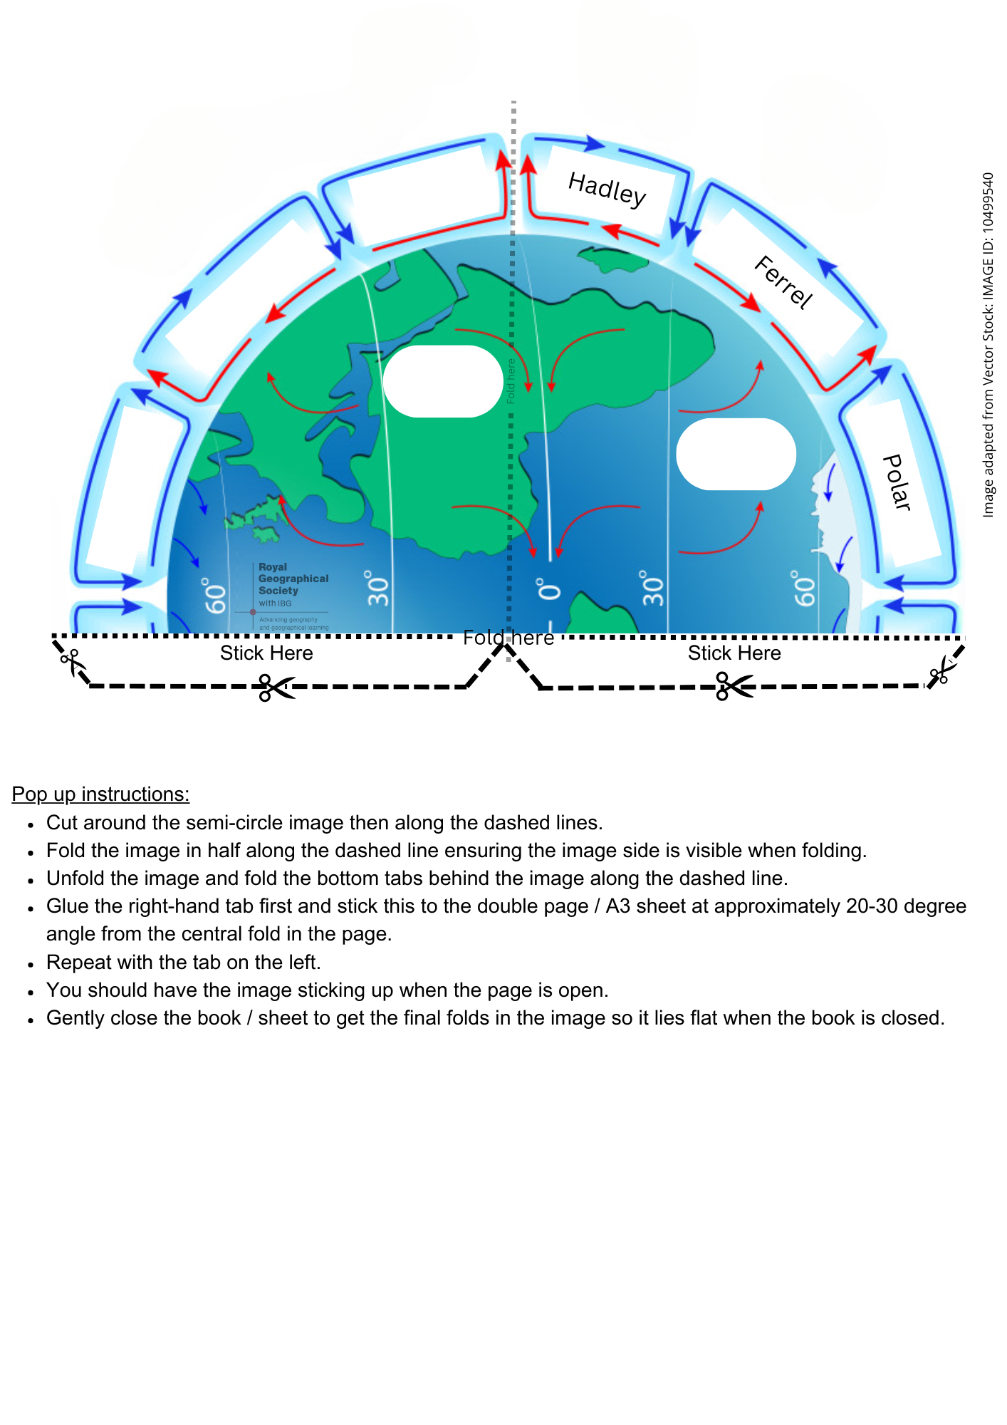

Idea 4: Sequencing
Sequencing is an effective practice to help pupils think through processes logically. This exercise is also supported with consolidating knowledge through application in a different method to help pupils visualise the GAC.

Starter:
Provide pupils with a biome map and give them time to think about why certain biomes are located where they are. Challenge them to think about how the weather affects these places and why.

Main:
1. Hand out the sheet with the statements about the GAC.
2. Play the Met Office Video on the GAC.
3. Pupils watch the video and then add numbers in the box next to each statement to put them in order.
4. Optional task: pupils can cut out the statements and put them in order in their notes if this is useful to them.
5. Peer mark sequence using answers on the board.

Idea 4: Statements (pupil copy)
Where air is rising, it generates more precipitation in these locations which is why Tropical rainforests are located where they area and the UK tends to be quite wet.
The cold, dense descending air in the Polar regions flow at low levels to about 60º – 70º north or south of the Equator.
However, because the planet rotates, we have three cells in both the northern and southern hemisphere.
They transfer heat from the Tropics to the Poles as well as being semi-permanent areas of High and Low-pressure.
The largest of the cells are the Hadley cells. These form at the Equator where the warmer, less dense air rises to a height of about 18km.
It then cools and sinks back to the Earth’s surface returning to the Equator.
The smallest of the cells are the Polar cells.
If the Earth didn’t rotate or have oceans, we would have a single cell in each hemisphere where heat from the Tropics would rise, move towards the Poles, cool, and return to the Equator.
They move in the same way at the Hadley cells but are driven by cold descending air.
The Ferrel cells are found between the Hadley and Polar cells. These are not driven by temperature but flow in the opposite direction to the other two cells like a cog.
As the air leaves the Polar regions, it starts to warm and rise, returning to the Poles at higher levels.
The Tropics receive more heat from the Sun than the poles.
Where air is descending, there are generally clear skies and little rainfall. This is often where our deserts are located.

Plenary:

Pupils create a sketched diagram of the GAC and use the numbers from the sequencing sheet to annotate the diagram.

Idea 4: Statements (answers)
1 | The Tropics receive more heat from the Sun than the poles.
2 | If the Earth didn’t rotate or have oceans, we would have a single cell in each hemisphere where heat from the Tropics would rise, move towards the Poles, cool, and return to the Equator.
3 | However, because the planet rotates, we have three cells in both the northern and southern hemisphere.
4 | The largest of the cells are the Hadley cells. These form at the Equator where the warmer, less dense air rises to a height of about 18km.
5 | It then cools and sinks back to the Earth’s surface returning to the Equator.
6 | The smallest of the cells are the Polar cells.
7 | They move in the same way at the Hadley cells but are driven by cold descending air.
8 | The cold, dense descending air in the Polar regions flow at low levels to about 60º – 70º north or south of the Equator.
9 | As the air leaves the polar regions, it starts to warm and rise, returning to the poles at higher levels.
10 | The Ferrel cells are found between the Hadley and Polar cells. These are not driven by temperature but flow in the opposite direction to the other two cells like a cog.
11 | They transfer heat from the Tropics to the Poles as well as being semi-permanent areas of High and Low-pressure.
12 | Where air is descending, there are generally clear skies and little rainfall. This is often where our deserts are located.
13 | Where air is descending, there is generally high pressure which provides calm, settled weather with clear skies and little rainfall often where our deserts are located.

Idea 5: Make an animation
This is a creative task which needs to have an element of collaboration across the class and within the groups. Prior learning of the GAC would be beneficial to reduce the time to gather information in class time.

Once the animations have been completed, they can be loaded onto the school’s learning platform to aid revision.

Starter:

Use a quizzing site such as Quizlet, Seneca learn, Kahoot or create your own using your school’s quiz app (most likely MS or Google Forms) to test pupils current understanding of High and Low-pressure. You could develop this with including questions about biomes.

Main:
You will need the following (per group)
- A recording device such as a school iPad or mobile phone (if school policy allows)
- Mini whiteboard
- drywipe pens of different colours i.e. black, blue, green and red.
- board rubber or paper towel

1. Split the class into groups or 3-4 of pairs depending on class size. You will need a group / pair for each part of the GAC (4 separate sections). You can repeat the groups if you have a large cohort i.e. 8 groups of 3 for a class of 24 pupils.
2. The groups will represent the following:
a. (most able) high and low pressure at the cells.
b. Hadley cell
c. Polar cell
d. Ferrell cell (middle ability)
3. Pupils use their notes from previous learning of the GAC to create a quick plan of how they want to present their animation. Teacher to double check content and make any adjustments (if necessary) before the group starts their animation.
4. Set guidance with the class in the form of a success criteria so that they all animations have a similar level of quality.
5. Using the mini whiteboards, board pens and board rubber, pupils create a stop animation on their section of the GAC.

Plenary:

Pupils peer mark and provide feedback based on the success criteria. They can then make any adjustments for homework before being uploaded onto the school’s learning platform).

GCSE style questions
1. Which of the following cells is located between the Equator and 30° latitude in the Global Atmospheric Circulation Model?
a) Ferrel Cell
b) Polar Cell
c) Hadley Cell
d) Coriolis Cell

2. What is the main reason for the formation of the Hadley Cell?
a) High pressure at the Poles
b) Rising warm air at the Tropics
c) Sinking cold air at 60° latitude
d) Earth's rotation

3. At what latitudes are the Earth's deserts typically found, according to the Global Atmospheric Circulation Model?
a) 0° (Equator)
b) 30° North and South
c) 60° North and South
d) 90° North and South (Poles)

4. Which atmospheric circulation cell is found between 30° and 60° latitude?
a) Hadley Cell
b) Polar Cell
c) Ferrel Cell
d) Jet Stream

5. With the use of a diagram, describe the main features of the Global Atmospheric Circulation Model.

6. Explain the process that leads to the formation of trade winds.

7. Explain the impact of trade winds on global weather systems.

8. Explain the role of the Ferrel Cell in transferring heat from the Tropics to the Poles.

9. Explain the relationship between the Global Atmospheric Circulation Model and the distribution of deserts and rainforests around the world.

Additional resources
MetLink - Royal Meteorological Society Teaching Resources
The Met Office Learn – Atmosphere

