Population change in Britain since the 19th Century

GCSE Specification links
AQA
3.1.2a. A growing percentage of the world’s population lives in urban areas.
3.1.2c. Urban change in cities in the UK leads to a variety of social, economic, and environmental opportunities and challenges.
3.4.1. Maps based on global and other scales…identify and describe significant features of the physical and human landscape on them, e.g. population distribution, population movements.
3.4.2. Interpret and extract information from different types of maps, graphs and charts, including population pyramids, choropleth maps, flow-line maps, dispersion graphs.

Edexcel A
4.2a. Distribution of urban population in the UK and the location of its major urban centres.
4.5a. Key population characteristics of the chosen UK city’s that is available from the Census and reasons for population growth or decline
Geographical skills: use online census sources to obtain population and local geo-demographic information.
Geographical skills: interpret population pyramids, choropleth maps and flow-line maps.

Edexcel B
3.3.a. How urban population numbers, distribution and spatial growth change over time (urbanisation, suburbanisation, deindustrialisation, counter-urbanisation and in some cases, regeneration).
Geographical skills: Use and interpretation of UK population pyramids from different time periods.

Eduqas A and WJEC
2.1.1. How are urban and rural areas of the UK linked?
2.3.2a. The reasons for a global city’s growth to include natural population change and migration.
4.3. Interpret population pyramids, choropleth maps and flow-line maps.

Eduqas B
1.1.2. What are the ways of life and current challenges created by urbanisation in two global cities?
4.3. Interpret population pyramids, choropleth maps and flow-line maps.

OCR A
1.2.4a. Changes in the UK’s population structure from 1900 to the present day, including its changing position on the Demographic Transition Model.
2.2.3. Many factors contribute to a country’s economic development.
Geographical skills (and OCR B): Interpret population pyramids, choropleth maps and flow-line maps.

Key terminology
Industrialisation: the period a country or region moves from agriculture to mechanisation typically manufacturing.
Deindustrialisation: the decline of the activity in a particular industry usually manufacturing and/or mining.
Brain drain: the reduction in young, educated workforce from an area.
Immigrants: people who have moved into an area.

Population changes in industrialised Britain
The industrial revolution in Britain is commonly agreed to have started in the 1700s. This era of increased mechanisation, innovation, and large scale manufacturing (industrialisation) led people away from rural areas to growing towns and cities such as Manchester, Sheffield, and Leeds. Consequently, urban centres experienced vast population growth between the 1800s and 1900s where, over this period, population in towns and cities increased from 30% to 50%.

This transformative phase not only influenced the distribution of population but also the nature of this growth. Certain urban areas grew around centres of power such as waterways to power mills or the availability of natural resources such as coal. For other places, the pull of opportunities in the service industry led to urban growth.

1. Explore the interactive population map from The University of Cambridge on the following website: populationspast.org

a. Select ‘population density’ then look at some of the major industrialised areas of the time such as Sheffield, Leeds, Manchester, and London (use the ‘side by side function for this).
b. Describe the population density of these areas and how these change over time (using the slider function at the top for this). You can also zoom in on smaller areas to identify a wider range of values to see changes on a more localised level.
c. Provide examples of push and pull factors for migration at this time in the table below.

Challenge: in your opinion, which do you feel is the most crucial factor and why?

 | Social | Economic
Push
Pull

2. Using the same map as above, select ‘type of place’. This is based on common occupations of people living in an area as well as population density.

a. Describe the distribution of different types of place across Britain. What patterns do you notice?
b. Now zoom into key industrial areas such as Manchester, London, Leeds, and Newcastle. Describe their dominant occupational groups.
c. Compare the dominant occupational groups of urban areas in the north and south of England.
d. Does this show a north south divide? Explain your opinion.

Social changes
Social changes in the 19th Century shaped population growth in ways which are still evident today. As industrial areas grew, they also became wealthier. The growing middle-class and increased accessibility to education meant that the social structure of the country changed.

In contrast to current industrialising countries, such as India and Nigeria, Britain and Northern Europe at this time did not follow the demographic pattern of early marriage and high birth rates. Instead, these regions adhered to the Western European Marriage Pattern. This pattern identified areas north of Mediterranean countries and east of St Petersburg in Russia (and excluding Ireland) where people married typically in their mid-twenties and had less children.

Rather than living in large multigenerational family dwellings, young married couples tended to live away from the main family, setting up their own homes on marriage.

With the rise of the middle-classes, there was an abundance of work for young people who earnt a living before settling down. However, when they did, social norms increasingly dictated that women did not return to work and those who could afford to often moved away from cramped urban areas to raise their family in the suburbs instead. A pattern that, in part, is similar to today’s society where urban areas such as London have a much larger proportion of young workers in comparison to other age ranges.

Specific areas in the UK, however, attracted predominantly male workers such as labourers and miners. The females who lived in these areas did not find as much work and tended to marry young, consequently having larger families bucking the national trend of falling birthrates. In modern society however, deindustrialisation of these areas has led to a decline in the young economic workforce commonly known as the ‘brain drain.’

3. Look at the interactive population pyramids from ONS. Select 2018, one area the UK and the other Sheffield.

a. Describe the population distribution in Camden, north London in 2018. Compare this with the UK national data.
b. How similar are modern demographics to that of the 19th century. Provide examples in your points. You could use the ‘PopulationsPast’ map from question 1 to help you.
c. Now search and area which has experienced deindustrialisation i.e. North Tyneside.
d. Compare the population pyramid for 22–40-year-olds with the national average.

London
London had the biggest pull for migrants both domestically and internationally. Despite its population being modest by today’s standards, it was home to 10% of England’s population in 1801 and 15.5% by 1900. The influx of economic migrants driven by the expanding influence of the British Empire cemented London’s status as a World City which is still evident today.

The demographic landscape of London revealed a distinct disparity depending upon the location. In the 19th century, affluent postcodes such as Mayfair in the west boasted an average of less than two children per household in 1851 and less than one child in 1901. In contrast, Wapping, a disadvantaged area in the east witnessed households with an average of four to six children. While overall birthrates were declining throughout the 19th century, this trend was not uniform in London.

The east of London has always been a traditional location for immigrants due to its affordability and therefore, conditions in this area were more cramped and less sanitary than the wealthier areas. With the continuous exposure of diseases from new arrivals and the living conditions it was no coincidence that mortality rates were also higher here.

4. Look the data on city classifications from Loughborough University.

a. Plot on the blank world map below the location of the Alfa++ and Alfa+ cities.
b. Describe and explain the distribution of World Cities.
c. Looking at the data from Loughborough, what cities could move from Alfa to Alfa+ cities in the future? Explain your answer.

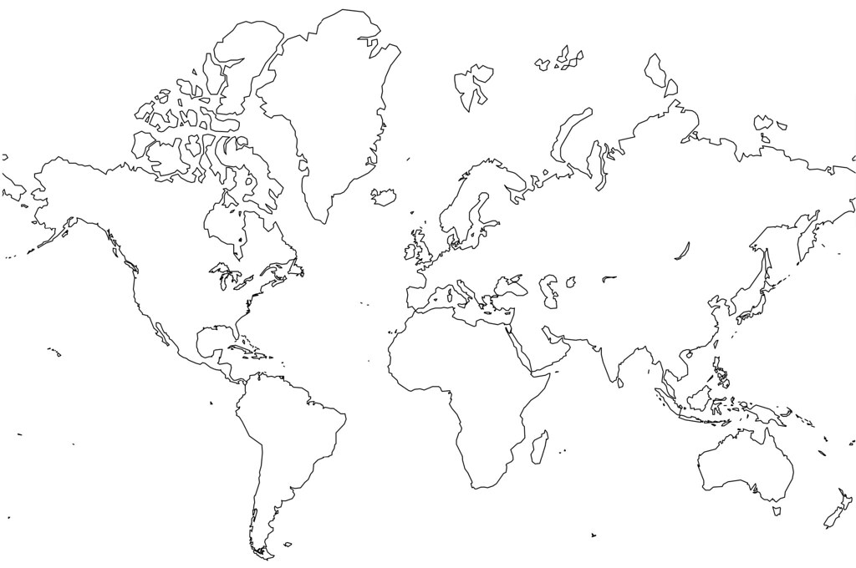
Figure 1: blank world map. Credit: Jason Rhode via Flickr

Bucking the trend – Baby Boomers
Fertility rates continued to decline through the late 1800s through to the 1930s when there were less than two children per women being born. Demographers predicted that this pattern would continue as development increased opportunities for different classes.

Therefore, the Baby Boomer generation, which started in the 1930s (not formally recognised until 1946) and continued into the mid-1960s, bucked the trend. A widely-held belief is that this post war era created a need for a sense of stability causing a peak in marriages and births. However, there was a second spike of birthrates in the 1950s. This has been linked to a sexual revolution which pre-dated the contraceptive revolution (i.e. the pill) and meant that unintended pregnancies provoked many earlier marriages. The baby boom abruptly stopped at the start of the 1970s due to the availability of contraceptives. With some variation, falling birthrates have been the trend since then.

5. You may know someone who was born between 1930 and 1960, speak to them. If not, read this short blog on reflections of a baby boomer by Julie Kent.
a. What are the common conceptions of Baby Boomers?
b. What was their life like growing up and how does it compare to yours?

Challenge: What are the opportunities and challenges of the Baby Boomer generation today?

Further reading
The Cambridge Group for the History of Population and Social Structure (Campop) https://www.campop.geog.cam.ac.uk/

