Glacier recession, the carbon cycle and microbial release

Throughout this resource the term ‘Alps’ will be used to describe the European mountain range, which covers a territory of approximately 190 700 km² and encompasses eight European countries: Austria, France, Germany, Italy, Liechtenstein, Monaco, Slovenia and Switzerland.

Thanks to Tris Irvine-Fynn (Aberystwyth University) for the constructive feedback that helped the development of this resource.

Specification
AQA 3.1.4.5 Human impacts on cold environments. Concept of environmental fragility.

3.1.1.1 Water and carbon cycles as natural systems. Inputs – outputs, energy, stores/components, flows/transfers, positive/negative feedback, and dynamic equilibrium.
Edexcel 2A.4 Mass balance is important in understanding glacial dynamics and glaciers as systems.

Area of study 3, Topic 6: The Carbon Cycle and Energy Security. 6.3 A balanced carbon cycle is important in sustaining other earth systems but is increasingly altered by human activities.

OCR 1.a. Glaciated landscapes can be viewed as systems.

WJEC A Level 1.2.1 The operation of a glacier as a system.

The situation
Recently, melting has been observed in glacier ice bodies from the Himalaya to the Andes, with the most visible apparent recession in Europe. Many of the continent’s glaciers are now in recession due to both a warm summer and a record warm winter in 2022.

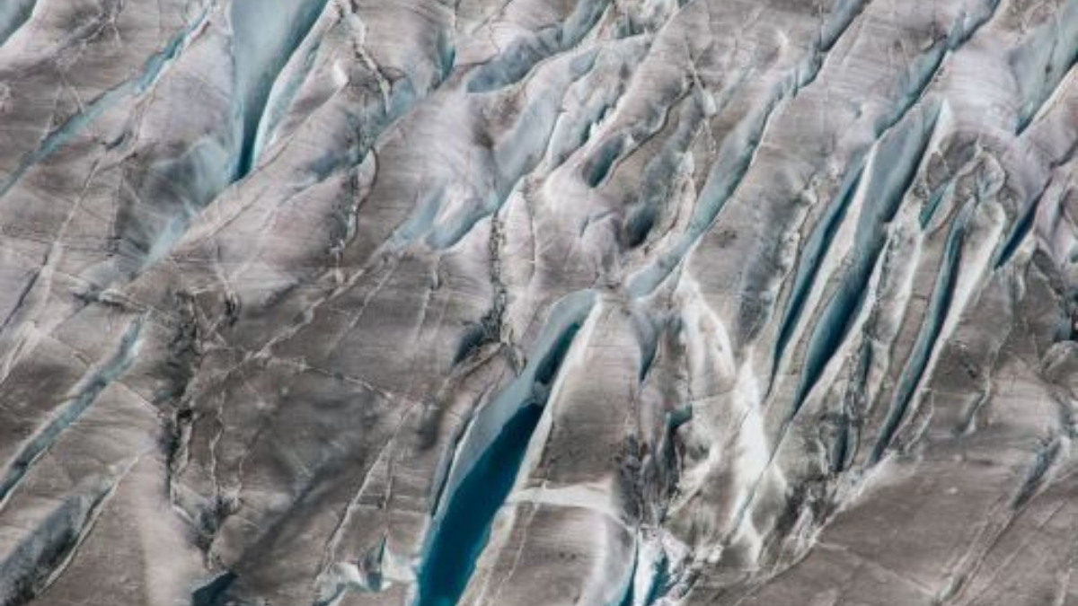
Figure 1 Glacial crevasses filled with meltwater in the lower regions of the Great Aletsch Glacier © FAU
Daniel Farinotti, a glaciologist at ETH, the research university of Zurich, explains ‘in many glaciers we now see features of what we call collapse – crevasses opening up and ice falling apart – and this is certainly not going to regrow next year’ as Alpine glaciers fall victim to Europe’s warming climate.

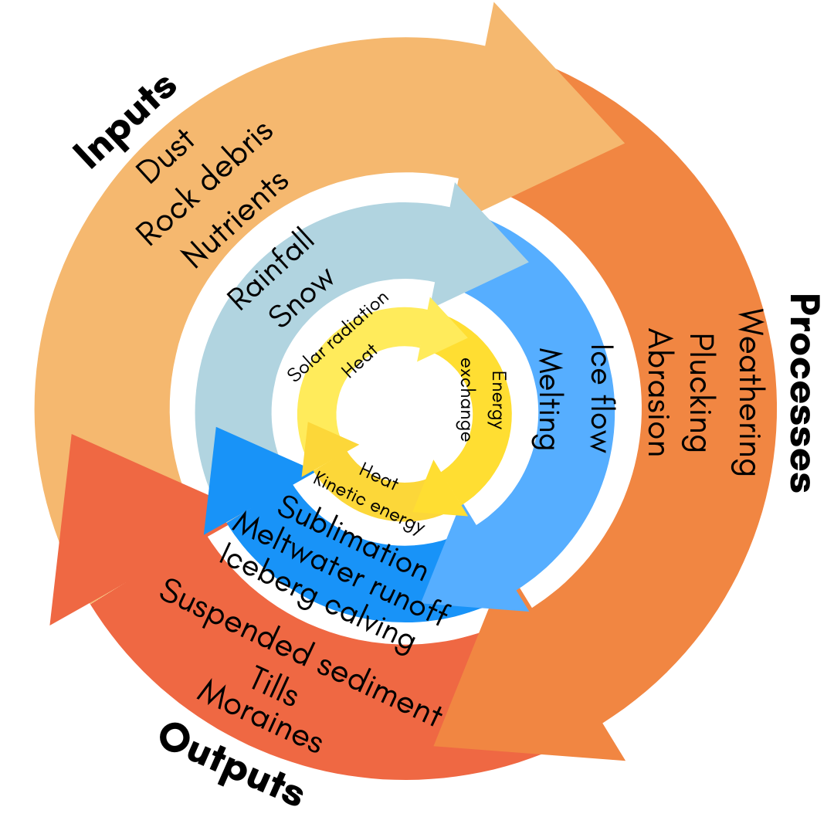
Figure 2 The glacier system Inputs, Processes, and Outputs are coloured into blue for water/ice, brown for sediments, and yellow for energy. Erosion, transportation and deposition would be along the blue/brown boundary (occurring to ice and sediment) © RGS-IBG

Introduction
Glaciers are natural systems because they are an assembly of interrelated parts that work together by way of driving processes. They have inputs and outputs of energy and material, and involve a flow of energy which goes beyond the boundary of the system out into the surrounding environment. This makes the glacier system an open system.

This resource will focus on how this glacial system is changing in the Alps, where glaciers are displaying negative mass balance, and what this means for cold environments. In particular, mountainous ones.

The term 'cold environments' covers four classifications: polar and alpine settings where glacial and/or periglacial conditions are dominant. Environmental descriptions are listed below.

Environments
Polar environments
Polar environments have extreme climates and are very cold. They include both the Arctic and Antarctic, which both contain the world’s coldest deserts, and are characterised by very low rates of snowfall. In past climates, around 115,000-25,000 years ago, when polar conditions extended to lower latitudes, ice sheets built up over North America (as the Laurentide Ice Sheet) and North Europe (over the UK, Norway and Sweden as FennoScandian Ice Sheet).

Alpine environments
Alpine environments are high elevation regions around the world. They are often cold, windy, and snowy, and are characterised by a very short frost-free period. They receive high seasonal snowfall with a cold winter and a warm summer season. Areas include the European Alps, the Andes, the Rocky Mountains, New Zealand's Southern Alps and the Himalaya. The Alpine biome usual lies between 3,000 meters and the place where the snow line of a mountain begins.

Conditions
Glacial conditions
Glacial conditions describe perennial accumulation of snow on land, which is compressed into ice, and then moved downslope under the influence of its own weight. As the glacier moves it erodes the landscape.

Periglacial conditions
Periglacial environments are usually areas with a cold climate, with permafrost in some form often being present. They typically occur near glacierised regions. Periglacial processes, such as weathering, mass movement, ground ice formation and erosion all contribute to the formation of periglacial landforms; blockfields, ice wedges, patterned ground, pingos, solifluction lobes, terracettes, and thermokarsts.

Types of glacier
There are many types of glacier, and the size or setting of a glacier often defines the type. These types include: ice sheets, ice caps, ice fields, ice streams, outlet glaciers, alpine glaciers, cirque glaciers, piedmont glaciers, rejuvenated glaciers, and tidewater glaciers.

In polar regions, there are Earth's two ice sheets (the Antarctic and Greenland Ice Sheets), which are large continuous volumes of glacier ice. Large portions of both ice sheets are cold ice, with ice temperatures well below freezing and the ice being frozen onto the bedrock. Accumulation rates are slow, there is little melting, and ice contained within the ice sheets can be very old (around 1 million years old). Elsewhere across the polar regions, there are many smaller valley glaciers, some of which also consist of cold ice so are slow moving.

A large proportion of Arctic valley glaciers are called polythermal glaciers. These glaciers represent an intermediate thermal state with both cold and warm (or temperate) ice. Temperate ice is ice very close to the melting point (approximately 0°C). The processes that lead to a polythermal glacier are complex but can involve warming of ice through frictional heat from glacier motion, or through latent heat release from melting and refreezing as snow is compressed into glacier ice. Polythermal glaciers are usually drained by supraglacial (above) or englacial (within) meltwater channels. As heat is absorbed by the ice (particularly in the summer months) latent heat is released internally, and meltwater is created.

In lower latitudes, valley glaciers in alpine settings are more typically warm-based or temperate, although some may be polythermal. These warm-based alpine valley glaciers are the active glacial systems, typically in places with warm summer temperatures contrasting heavy winter snowfall. The high winter snowfall with rapid summer melt rates associated with alpine glaciers leads to high rates of winter-time ice mass accumulation in winter and summer-time ice mass melting. Due to meltwater acting as a lubricant at the glacier bed these glaciers are more mobile than cold glaciers. On average, observed alpine glaciers in the Alps lost more than 24m in thickness between 1997 and 2017. In 2018, annual alpine glacier mass loss was amongst the top ten since the 1960s.

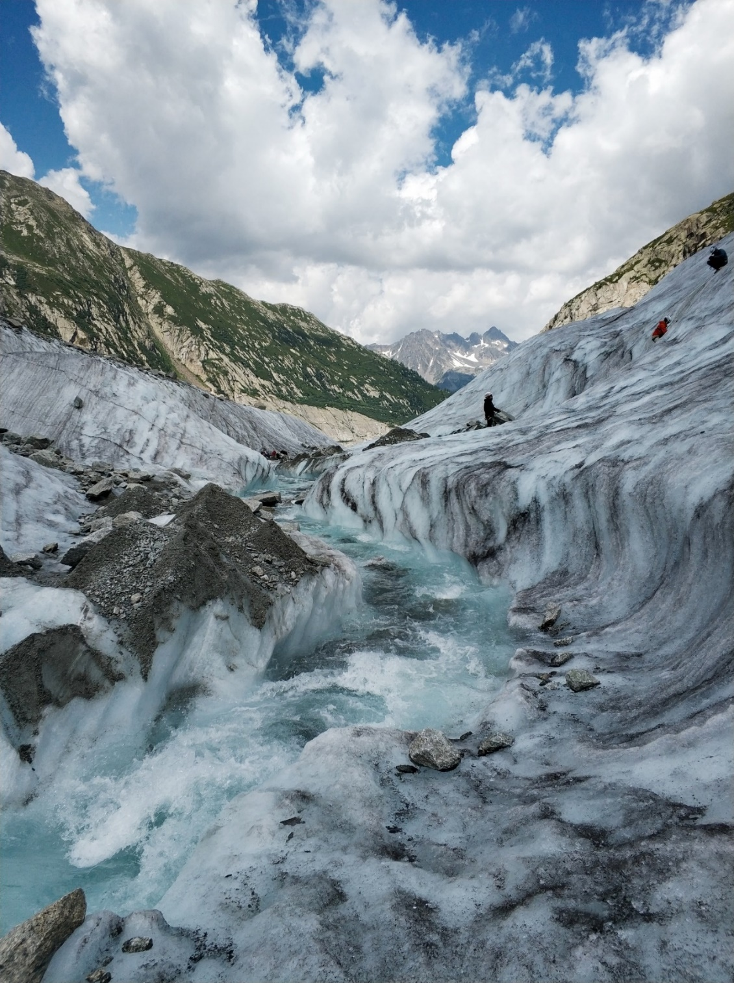
Figure 3 Meltwater stream on a glacier near Chamonix, France © Olha Fedchen

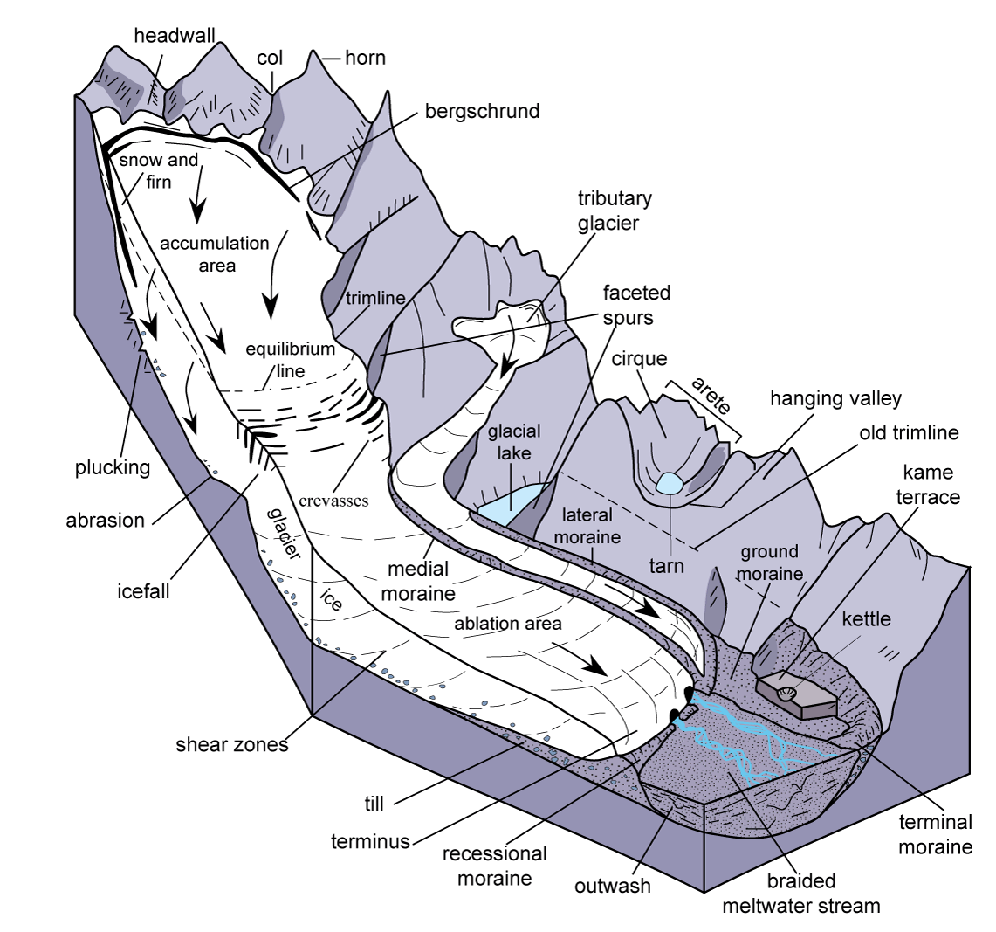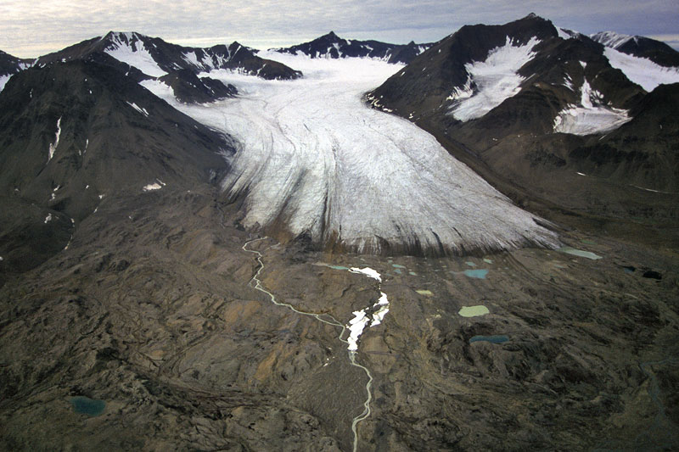

Figure 4 Showing features associated with alpine glaciers © Skinner and Porter (1992) and Figure 5 the Midtre Lovénbreen valley glacier © SwissEduc
Alpine glaciers are self-contained environments at high altitude, which have a declining level of inputs over the winter period. These glaciers move down through valleys they erode and shape mountains, lakes and valleys. In Britain much of the landscape in England, Scotland and Wales has been influenced by glaciers, as recently as 12000 years ago as shown in Figure 6. They are also evident in the Alps.

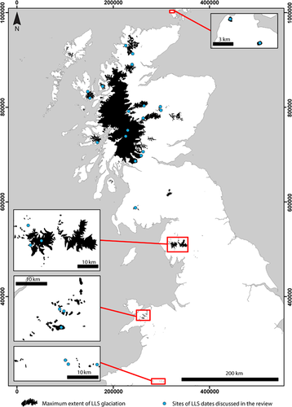

Figure 6 Regions in the UK where glaciers were active during the Loch Lomond Stadial (LLS) approximately 12,000 years ago. Ordnance Survey © Crown copyright and database 2015 extracted from The glacial geomorphology of the Loch Lomond (Younger Dryas) Stadial in Britain: a review

Mass balance and rising ELAs
A glacier’s ELA is an acronym which stands for the equilibrium-line altitude. The ELA – the point of elevation where the annual mass of accumulation (snow input) and ablation (ice melt output) are equal – marks where the climatic mass balance is zero. Calculating the location of this line allows scientists to monitor a glacier’s mass balance, shown in Figure 7. At the end of the summer season, above the ELA is the snow-covered accumulation area and below is the bare ice glacier surface.

The glacier mass balance dictates where the ELA lies. Figure 7 illustrates glacial mass balance. There are some places across a glacier that may have positive mass balance and other places with a negative one. Over the period of a year, we can add up all these places over a glacier to determine if there is an overall positive or negative net balance. The ELA for a low-slope glacier and a steep glacier is shown in Appendix D on page 15.

Across Earth's cold regions, with the exception of Antarctica, ELAs have been rising at up to 8m per year. The upward migration of this line is an effective signal of climate change.

In places like the Alps scientists study the movement of the ELA in ‘real time’ – it is an important indicator of climate change – offering undelayed and continuous data.

Cold environments in Europe are suffering from the effects of climate change because the glaciers are either warm-based or polythermal. These glaciers are particularly susceptible to melting as European summers become warmer, longer and drier. Throughout the twentieth century this has manifested in declining ice volumes across the mountain range, with a loss of 2 Gt of glacier ice per year since 1961.

Rising atmospheric temperatures are causing more and more glaciers to recede. Currently there are 4395 glaciers still present in the Alps with a total area of 1806km² of ice and snow. Between 1901 and 2000, the mean ELA rose by 114m mainly due to an increase of 0.8°C in summer temperature.

Over the next century, glacier ELAs are expected to continue to rise in altitude with a significant loss in volume of glacier ice. Appendix A shows the measurements for ELAs in Europe from 2012 to 2022. Across the European Alps many valley glaciers are expected to disappear completely by 2100, regardless of which emission scenario is used (Representative Concentration Pathways (RCP) 2.6, 4.5, 6.0 or 8.5).

The reason for the continued rise in glacial ELAs and the loss of ice is due to the continued atmospheric warming and the consequent down-wasting or thinning of glacier ice, and ultimately the disintegration or disappearance of the glacier. As a result, most alpine glaciers are now described as ‘in disequilibrium with current climate’.

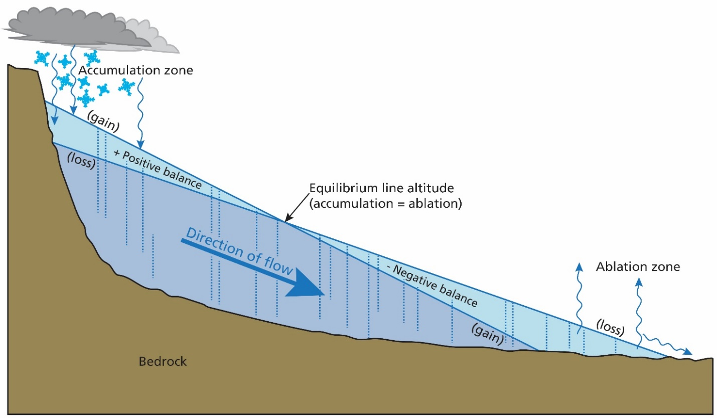

Figure 7 Diagram of a valley glacier system indicating accumulation, ablation and the equilibrium line © Trista Thornberry-Ehrlich (Colorado State University) National Park Service

Physical impacts
Glaciers all over the world are receding. The meltwater from this change will ultimately contribute to sea level rise. So glacial melt is a global issue. On the regional scale glaciers are very important due to their hydrological impact, specifically the increasing (or decreasing) volumes of runoff.

Glacial runoff is calculated as all the water that is released from the glacier system including snowmelt, rain on the glacier, and ice melt.

Over the next few decades, all climate model emissions scenarios predict longer and warmer summer melt seasons. These will continue to drive negative glacier mass balance, declining glacier volumes, and rising ELAs that will initially expand the bare ice glacier surface area a little.

Glacial recession will also decrease the local surface albedo as more solar energy is increasingly absorbed and will impact downstream ecosystems and the carbon and nutrient cycles.

As glaciers down-waste and recede, moraines are exposed at the ice margin, and the amount of mineral and organic dust on the surface can also increase. These changes lower the albedo, through exposing more rock and sediment or darkening the bare ice surface. This lowered albedo results in warmer air temperatures, and this then increases the melting of the glacier.

The increased melting results in higher runoff volumes, revealing the bare ice of glacier surfaces. It is a supraglacial ecosystem: containing mineral and organic dust, aerosols and microbes. The bare ice is in contact with the atmosphere and receives solar radiation. This habitat includes cryoconite (see Appendix B) and ice algae which will dramatically alter cold environments across Europe.

The micro-organisms are important for carbon cycling through photosynthesis and respiration but can also further the darkening of the bare ice surface and contribute to melting with more runoff in summer (melt season) months, an associated increase in the sediment delivered to glacier-fed rivers and an increase in the cold glacier-sourced water entering glacier-fed rivers, which can influence their biodiversity.

In the Alps, the current release rate is up to 100,000 tonnes of microbes will be released into the surrounding environment over the next 80 years.

Long-term impacts
Meltwater
Figure 8 illustrates the concept of 'peak water' which predicts as temperatures continue to rise, there will be a temporary increase in runoff from glaciers in the Alps, as ice is lost from the mountain environment. Figure 8b shows increasing air temperature (on the y-axis) over time (on the x-axis). Initially, as temperature rises over a few decades, the ELA also rises, and glacier melt increases, resulting in greater runoff volumes (see Figure 8a). The maximum runoff volume is called peak water. Subsequent to this peak water runoff volume, further warming sees glaciers recede further, and their reduced area and volume provides less runoff. Runoff then declines until the glacier completely disappears.

Stream quality and Biodiversity
Receding glaciers leave moraines and easily eroded sediments in their proglacial area. As runoff increases toward peak water, glacier meltwater can entrain the sediments and increase the suspended load in the rivers flowing downstream.

The volume of glacier meltwater entering streams and rivers impacts on water temperature. Following peak water, as the volumes of cold glacier meltwater decreases, streams will warm up and their biodiversity changes.
As the ELA rises for glaciers in the Alps, the release of nutrients and biological matter downstream will increase. The rate of release of microbes and nutrients, which may have been frozen for hundreds of years, is increasing.

Human impact
The melting of glaciers in the Alps could have a profound long-term impact downstream across the 8 countries encompassed by the mountain range (for the country list see page 1). Impacts such as average winter runoff are expected to continue to rise, whilst summer runoff rates subside.

In the future increasing runoff rates are likely to overwhelm water management systems downstream (channels, culverts, drains, sewars, weirs, reservoirs and pumping stations) in lower altitude towns and cities. Hydroelectric power generation may become unreliable or unviable. Irrigation needs may not be met for farmers downstream.

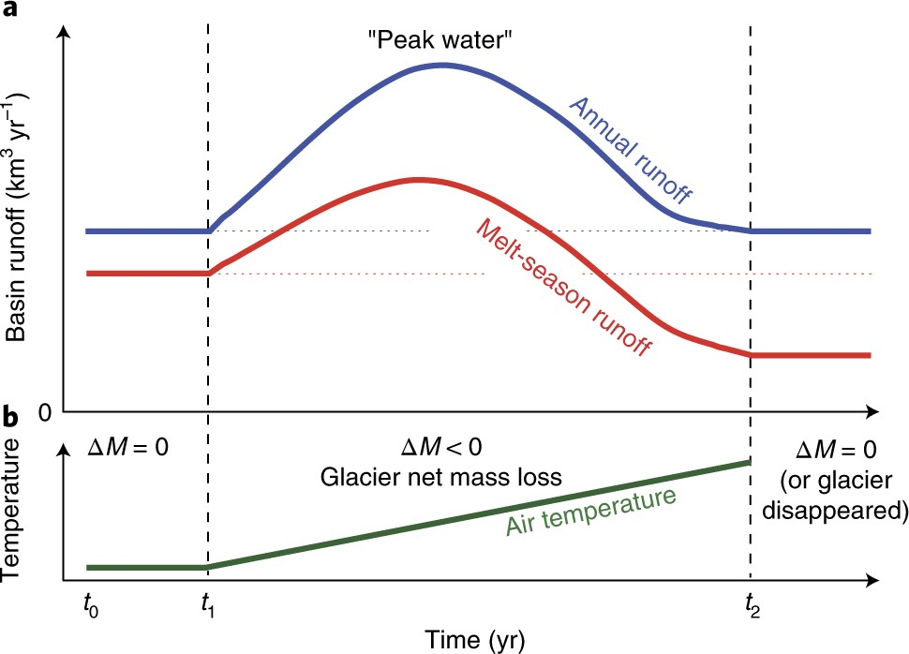
Figure 8 © Matthias Huss & Regine Hock 2018 extracted from Global-scale hydrological response to future glacier mass loss

Figure 8 is part illustration, part graphic. To the left total runoff is presented by daily time scale, yearly, and decadal. In the top section, the graph illustrates how rain will increase whilst Glacial meltwater will decline after peak water.

Snowmelt will also decrease but at a slower rate, continuing beyond the lifespan of the glacier.

On the yearly timescale rain meltwater will always be at its highest just after summer, particularly in the period of peak water.

Glaciers will still be present then but are expected to be severely depleted and in retreat. The components of runoff will therefore transition from a mixture of glacier, snow and rain to only originating from a small amount of snow at high altitude.
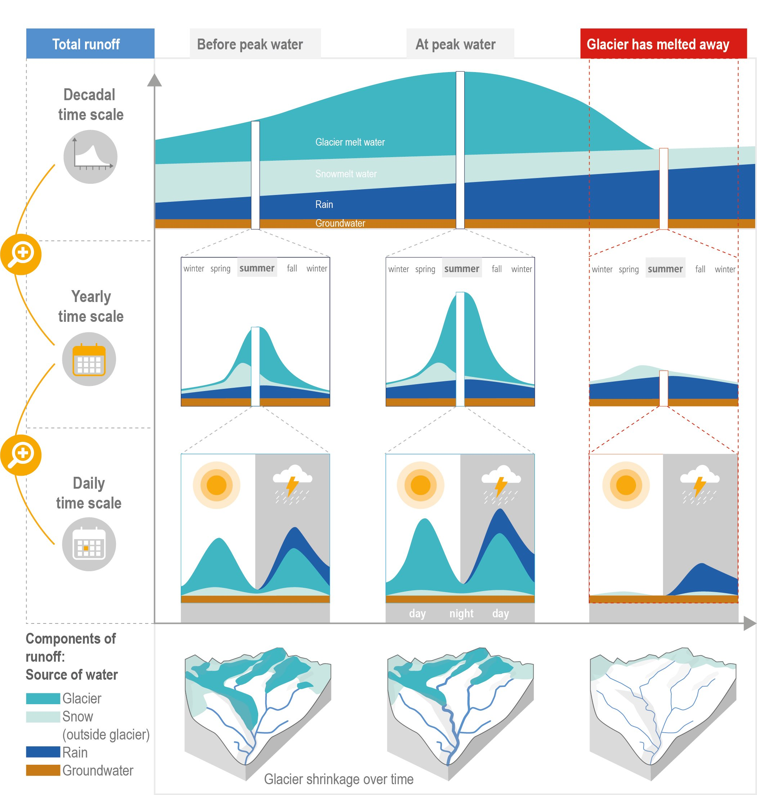
Figure 9 © IPCC SROCC-FAQ 2_1

Without a decisive response to climate change glacial melt will continue unabated in the Alps.

This will lead to a continued increase in ELA elevation, more bare ice, a further lowering of albedo, and an acceleration in the release of microbial life.

Scientists anticipate that sediment, microbes, organic matter, and nutrients in glacier runoff will impact on water quality and biodiversity for glacier fed rivers.

Activity
- Explain how glaciers can be thought of as natural systems.

- Using Figure 10 in Appendix C correctly add the following labels from Table 1.

Cirque basin | Accumulation zone | Terminal moraines | Kame
Equilibrium line | Medial moraine | Ablation zone | Crevasses
Snow | Firn | Glacial ice | Esker
Arête | Plucking | Abrasion | Ground moraine
Bedrock | Lateral moraine | Drumlins | Glacier
Table 1

- Study the diagrams in Appendix D. Figure 11 shows a low slope glacier and Figure 12 a steep slope – both ‘standard glaciers’ – with the same ELAs. With a 1°C increase in warming which glacier sees a higher rise in ELA?

- Using the highlighted cells in Table 2, create a column graph to chart the fluctuation of French glaciers between 2012 and 2022.

- Which glacier saw the highest level of ELA in this time period?

- What is peak water?

Further reading
- Copernicus climate change service Alpine glaciers in the European Alps

- The Guardian Record warm winter in parts of Europe forces closure of ski slopes

- FT Alpine glaciers fall victim to Europe’s warming climate

- Water, section 2.2. On the Shift of Glacier Equilibrium Line Altitude (ELA) under the Changing Climate

- The Conversation Glaciers in the Alps are melting faster than ever – and 2022 was their worst summer yet

- SpringerLink 200 years of equilibrium-line altitude variability across the European Alps

- France24 French Alps village says goodbye to ski lift of winters past

- National Geographic Climate 101: Glaciers | National Geographic

- The Conversation Skiing in the Alps faces a bleak future thanks to climate change

- The Guardian ‘Vast’ mass of microbes being released by melting glaciers

- BBC News Climate change: Melting glaciers could release tonnes of bacteria

- Antarctic Glaciers warm-based, cold-based and polythermal glacial processes

- Antarctic Glaciers An introduction to Glacier Mass Balance and ELAs

- The Guardian Two-thirds of glacier ice in the Alps 'will melt by 2100'

- Earth.com Melting glaciers release vast quantities of unknown microbes

Appendix A

Code | Glacier name | ELA_2012-11 | ELA_2022 | ± difference
FR | SAINT SORLIN | 3300 | 3300 | 0
FR | GEBROULAZ * | 3250 | 3250 | 0
FR | SAINT SORLIN | 3230 | 3230 | 0
FR | GEBROULAZ * | 3200 | 3200 | 0
FR | OSSOUE | 2867 | 3200 | -333
FR | OSSOUE | 2867 | 3200 | -333
FR | OSSOUE | 2867 | 3200 | -333
FR | OSSOUE | 2867 | 3200 | -333
FR | OSSOUE | 2867 | 3200 | -333
FR | OSSOUE | 2867 | 3200 | -333
FR | OSSOUE | 2867 | 3200 | -333
FR | OSSOUE | 2867 | 3200 | -333
FR | OSSOUE | 2867 | 3200 | -333
FR | OSSOUE | 2867 | 3200 | -333
FR | OSSOUE | 2867 | 3200 | -333
FR | OSSOUE | 2867 | 3200 | -333
FR | OSSOUE | 2867 | 3200 | -333
FR | OSSOUE | 2867 | 3200 | -333
FR | OSSOUE | 2867 | 3200 | -333
FR | SAINT SORLIN | 3200 | 3200 | 0
FR | OSSOUE | 2867 | 3150 | -283
FR | OSSOUE | 2867 | 3150 | -283
FR | SARENNES | 3150 | 3150 | 0
FR | SARENNES | 3150 | 3150 | 0
FR | SARENNES | 3150 | 3150 | 0
FR | SARENNES | 3150 | 3150 | 0
FR | GEBROULAZ * | 3100 | 3100 | 0
FR | OSSOUE | 2867 | 3100 | -233
FR | SAINT SORLIN | 3094 | 3094 | 0
FR | TRE LA TETE | na | 3050
FR | GEBROULAZ * | 3044 | 3044 | 0
FR | SAINT SORLIN | 3016 | 3016 | 0
FR | SAINT SORLIN | 3003 | 3003 | 0
FR | GEBROULAZ * | 2913 | 3000 | -87
FR | OSSOUE | 2867 | 3000 | -133
FR | SARENNES | 3150 | 2973 | 177
FR | SARENNES | 3150 | 2973 | 177
FR | SARENNES | 3150 | 2970 | 180
FR | SAINT SORLIN | 2969 | 2969 | 0
FR | SAINT SORLIN | 2950 | 2950 | 0
FR | SAINT SORLIN | 2946 | 2946 | 0
FR | GEBROULAZ * | 2913 | 2913 | 0
FR | SAINT SORLIN | 2906 | 2906 | 0
FR | ARGENTIERE | 2888 | 2900 | -12
FR | MER DE GLACE | na | 2900
FR | ARGENTIERE | 2850 | 2850 | 0
FR | SAINT SORLIN | 2837 | 2837 | 0
FR | SAINT SORLIN | 2788 | 2788 | 0
Table 2 ELA data for alpine glaciers in France only. Source: EEA and wgms FoG database * 2008
Appendix B

Terminology | Definition
Cold glaciers | Glaciers with low temperatures
Polythermal glaciers | Glaciers with high winter snowfall, rapid summer melt rates Ice is at the pressure melting point
Ablation | All processes that remove mass from a glacier system
Accumulation | All processes that add snow and ice to the glacier system
The Pleistocene | The last geological epoch, characterised by repeated glaciations, that ended 12,000 years ago after the Last Glacial Maximum (20,000 years ago) and was followed by the Holocene epoch
ELA | Equilibrium-line altitude
Disintegration | The final phase in a progressive retreat of a glacier as it collapses
Down-wasting | The thinning of a glacier due to the melting of ice
Cryoconite | A dark-coloured granular sediment on glacier surfaces made up of windblown rock dust, microbes and soot.
Algae | A photosynthetic micro-organism which causes the ice to absorb more solar energy and melt faster
Albedo | The amount of solar energy reflected by a surface. Dark-coloured surfaces (low albedo) reflect less sunlight than light-coloured surfaces (low albedo). Lower albedo surfaces can influence air temperature.
Microbes | Micro-organisms that are organisms that are too small to be seen without using a microscope. The most common types are bacteria, viruses and fungi.
Table 3 key terms

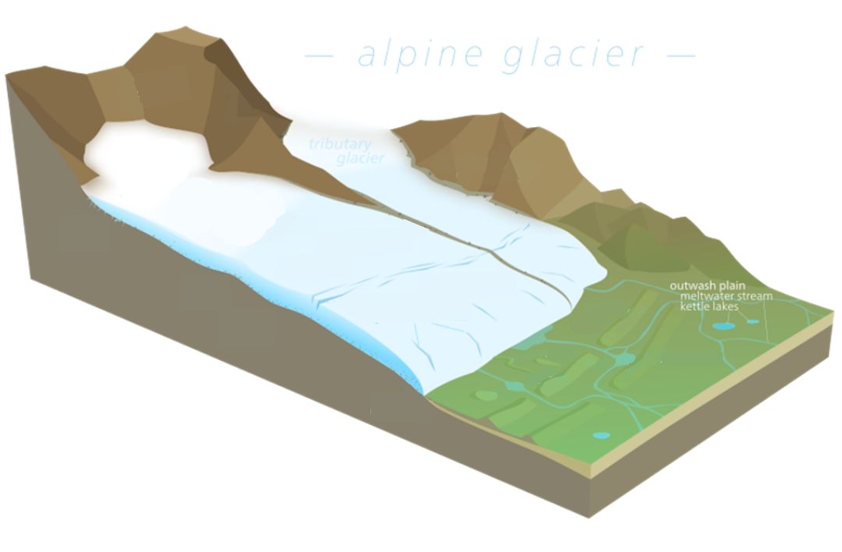
Appendix C

Figure 10

Appendix D

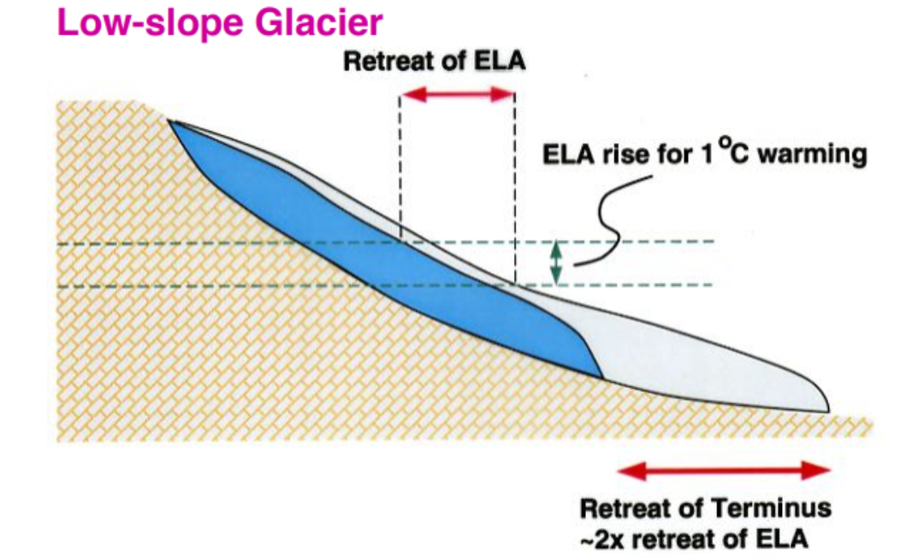
Figure 11

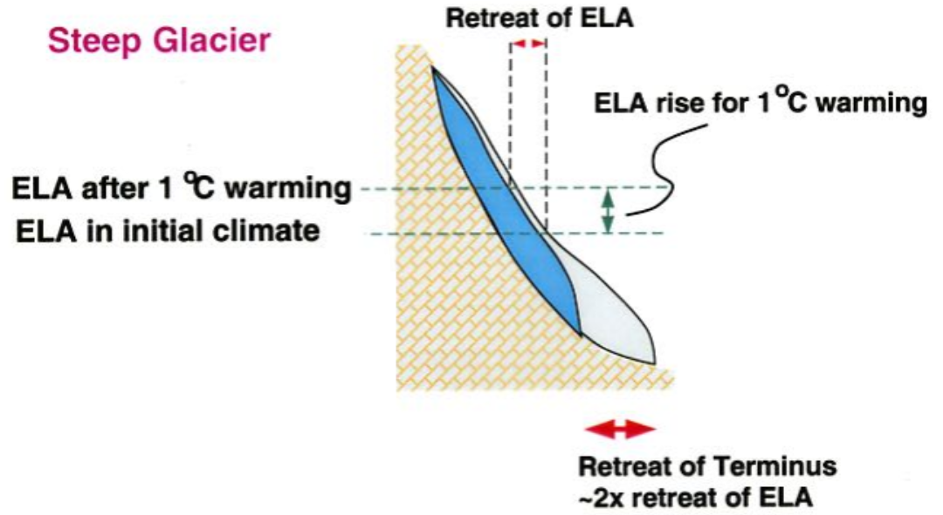
Figure 12

Answers
- Glaciers are natural systems because they operate with inputs, processes, and outputs. They are open systems because energy and material go beyond the boundary of the system into the surrounding environment. Glacial processes, like all physical environments, create a range of constantly changing erosional and depositional landforms. In terms of inputs and outputs, these systems ultimately reach a balance which is called a ‘state of dynamic equilibrium’. If this balance is altered, the equilibrium is upset, and feedback occurs which may be either positive or negative.

- The answers are annotated below on Figure 13.

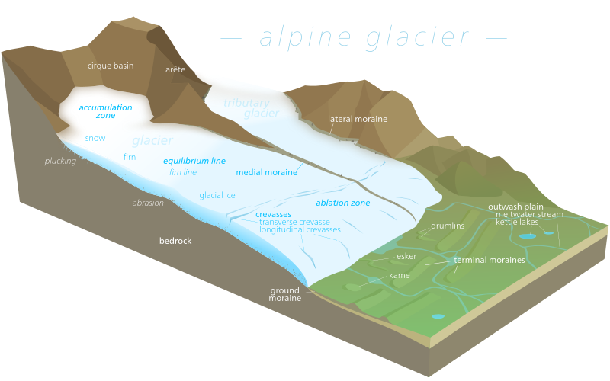
Figure 13

- The green dotted lines are identical, the ELA has risen by the same amount for both glaciers.

- Graph below.
Figure 14

- The Ossoue glacier ELA rose the most during this time period, retreating 333m.

- Peak water describes the runoff from glaciers as mass balance changes over time at annual timescales. Due to climate change, it is expected that glacial mass balance will increasingly become more and more negative caused by surface melt and break off from frontal ablation. This leads to an increase in discharge which will eventually peak with glacier meltwater tailing off thereafter (snowmelt continues diminishing over time). Each glacier will have a different peak water date. In the most pessimistic of future scenarios, the Alps will be mostly ice-free by 2100, with only isolated ice patches remaining at high elevation. Representing 5% or less of the present-day ice volume.

