Case Study: Nepal Earthquakes, Avalanches and Landslides

On the 25th April 2015, Nepal experienced a magnitude 7.8 earthquake: its worst since 1934. This was followed by an avalanche on Mount Everest, a second, 7.4 magnitude earthquake on the 12th May 2015 in Dolakha, eastern Nepal, and numerous landslides and aftershocks. The worst hit region was the Gorkha district to the west of Kathmandu, but the earthquakes were felt over a wide area, with both India and China also reporting casualties. It is estimated that over eight million people have been affected by the earthquakes and their secondary effects.
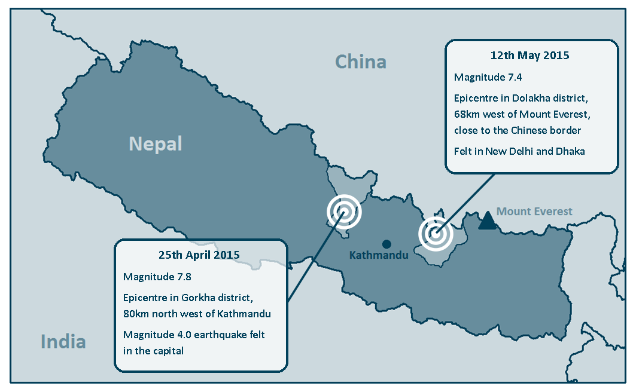
Location of the two Nepalese earthquakes

What were the geological causes of the earthquake?
Nepal lies on an active fault line between the Indian and Eurasian plates. Running the entire length of the country, this thrust fault sees the Indian plate moving north and underneath the Eurasian plate at a rate of about 45mm a year – a movement that continues to generate the uplift needed to create the Himalayas mountain belt. However earthquakes of this nature are caused by the two plates locking together while this movement happens and the release of pressure as the plates become unlocked sends waves of energy through the Earth’s crust and an earthquake at the surface. The focus of the 25th April earthquake was between ten and fifteen kilometres under the Earth’s surface – a very shallow depth in geological scale, and one which would have been partly responsible for the 7.8 magnitude witnessed.

What primary effects were there?
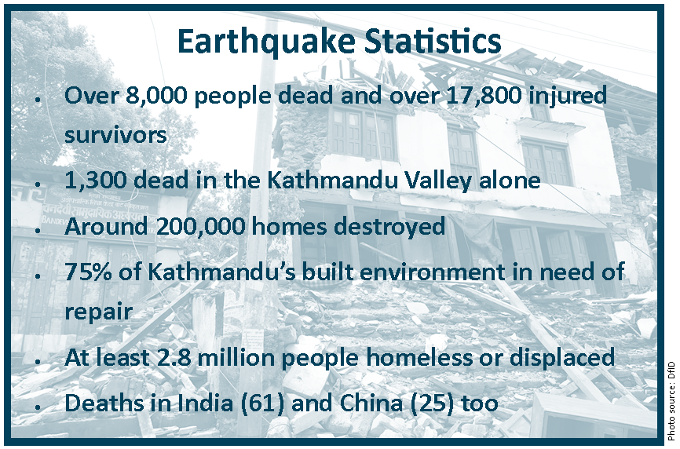

Though the epicentre of the first earthquake was in Gorkha district, eighty kilometres northwest of Nepal’s capital city, Kathmandu, the higher levels of population density and a greater concentration of buildings in the capital meant that arguably more damage occurred there. Many of the city’s buildings collapsed or partially collapsed almost straight away. The streets were soon filled with large piles of rubble and cracks appeared in many roads. The speed with which the earthquake happened meant that people inside the buildings at the time had little chance of escape and many died as the buildings fell around them, trapping injured survivors. With most buildings in the capital sustaining some form of damage, residents abandoned their houses and fled to open ground, fearing aftershocks and the chance of their unstable homes collapsing with them inside. Open spaces became makeshift camps, with many Nepalese sleeping in the open with little protection.
Before the earthquake, Kathmandu was home to a number of temples and some of the oldest built structures in Asia. The 1832 Dharahara Tower, at sixty metres tall, was the tallest building in Nepal. Originally a watch tower for military use, the Tower has more recently been used as a tourist attraction but it fell spectacularly to the ground during the earthquake, leaving nothing but a set of steps and a large pile of rubble. The sixteenth century Kasthamandap Temple in Durbar square, a three storey wooden building and thought to be the culturally most significant temple in Kathmandu was razed to the ground. Four of Kathmandu’s seven UNESCO World Heritage Sites were severely damaged and numerous priceless statues, temples and shrines were also destroyed during the earthquake, mostly in the third century Durbar Square.
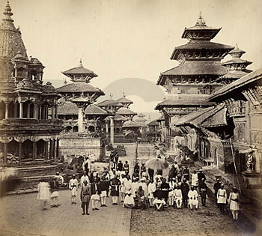
Durbar Square, Kathmandu in 1862 (Source: RGS-IBG Picture Library)
Bir Hospital, the largest and best established medical facility in the centre of Kathmandu, quickly became overwhelmed by the number of people seeking medical assistance. Patients were left to fend for themselves in many cases as staff attempted to assess the immediate needs of the more seriously injured patients. Drugs and beds soon ran out and doctors were forced to treat the injured in the hospital car park and in the streets around the site. As a result many patients spent the night on mattresses in the open, just metres away from where open cremations were happening around the clock: the only way to deal quickly with the rising numbers of bodies being brought to the hospital.
The electricity grid stopped working in almost of Kathmandu when the earthquake struck and getting continuous power became a challenge both for medical teams and search and rescue teams as well as survivors. Water pipelines had cracked and burst in many parts of the city and the chance of drinking water becoming contaminated with sewage and waste water became very high. With shops unable to operate, and stored food often left under piles of rubble, sourcing reliable food supplies quickly became a problem and families struggled to feed themselves for days after the initial quake.
Outside of Kathmandu, the largely mountainous region of Gorkha, which was the site of the epicentre, was also badly damaged. Here ninety percent of buildings collapsed and in the area closest to the epicentre, entire villages were destroyed, some losing their debris in large landslides that happened moments after the earthquake and in some of the subsequent strong aftershocks. The hilly district of Sindhupalchowk had the highest regional death toll after Kathmandu, in large part due to the numerous landslides that affected the area. The height of the Himalayas dropped over one metre in the mountainous area closest to the epicentre (USGS, 2015).
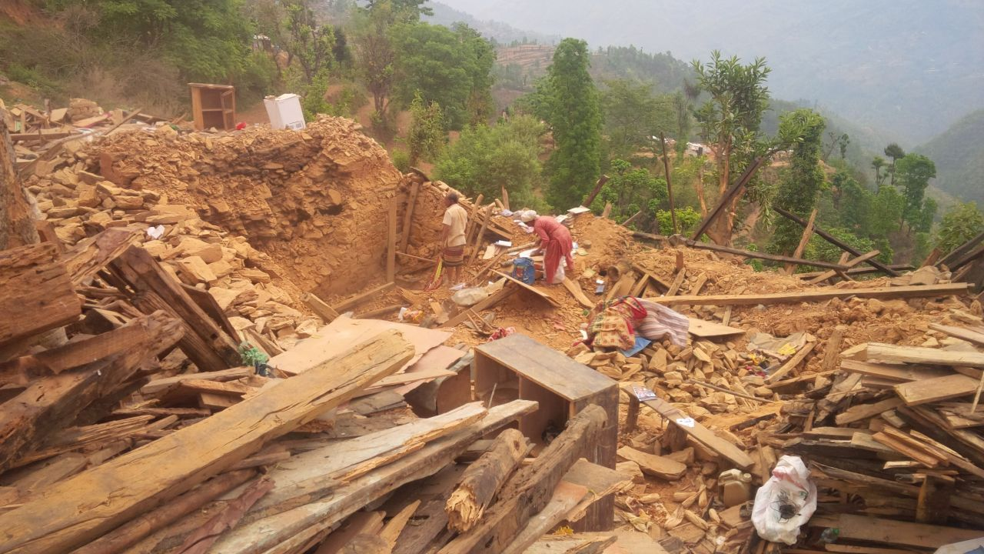
Survivors sort (?) through the rubble that was once their home in Sindhupalchowk, Nepal. (Source: International Organisation for Migration)
https://www.flickr.com/photos/iom-migration/17193248147/in/photolist-sciTET-snYgWD-hgAyis-hgASRs-hgAL52-hf4Ex6-hf4WRi-hf3nBY-hiLHQk-hiLCSe-hiM8jd-s9dDwv-o5ZtN4-rcwH7n-roXRGg-hiN6UQ-rqWQqQ-s676ur-rqKyhD-smDA8i-rp46yL-s4bohs-se4NEb-skSQkM-s5w81Z-hgAeCw-hgBtoc-hf2A2C-ssvuFB-s3mNMV-s6mHrN-s67aPt-snwfYV-s6nTWf-snX8nr-s6mGuN-rqWTxG-sro3Hp-s5Zn3W-snYgs2-s6rP14-snURfr-s6mET1-dzdTYL-s2dPmf-skE4G7-rPuzJ8-s4bozb-s2rAHF-rpYwPj

The second earthquake to strike the region two weeks later brought further misery to those who had survived the first. A least seventy six people lost their lives and a further two thousand were injured by falling buildings. Some structures in Kathmandu that were already unstable completely or partially collapsed and a series of fires began as a result of candles and kerosene lamps (which had been brought in to provide light after the electricity was lost) were knocked over by the force of the shockwaves. Some families had only just returned to their homes when the second earthquake struck, forcing them to return to camp in the same spot in the open air which they had previously vacated.

What secondary effects were there?
As well as the numerous landslides that occurred as a result of the earthquake, the most notable of the secondary impacts was the series of avalanches that occurred on and around Mount Everest. A large avalanche swept down the Khumbu Icefall (the main route taken by mountaineers) and onto the Everest base camp, killing nineteen people and injuring sixty one. One hundred and forty mountaineers were airlifted off Everest and those at camps one and two had to walk back down the mountain to be able to be rescued. The risk of further avalanches was extremely high and all mountaineering companies cancelled their spring expeditions, as well as many tour operators calling off their trips in other areas something that will see a loss of thousands of tourists from the region.
A number of strong aftershocks were felt after both earthquakes in Nepal and many people camped outside their homes for a long time due to the credible fear they felt at being inside. With no immediate access to clean water in these camps, and with no means of treatment, survivors caught water borne diseases very quickly and cases of diarrhoea and nausea were quickly common in just the first two days after the earthquake in April. Weeks after the first earthquake, an improved water supply and electricity supply were still not in place and more and more people suffered from dysentery, putting the lives of the young and elderly at particular risk.
In the initial aftermath, where water and fresh food was available it was sold at inflated prices putting additional pressures on those who had lost everything when the earthquake struck. A week after the first earthquake, and when the main roads out of Kathmandu had cleared, people began to leave the cities in droves, partly to return to the villages of their families, but also to escape disease, aftermath related crime, such as theft and the built environment itself as well-founded fear of further building collapse took hold. It was estimated that around three hundred thousand people left Kathmandu in the two weeks between the two earthquakes, many waiting in lines overnight to get a place on an overcrowded bus.

How is Nepal’s level of development likely to have affected the impacts felt?
Nepal is one of the world’s poorer nations. Twenty five percent of its 28 million population live below the poverty line (World Bank, 2014).
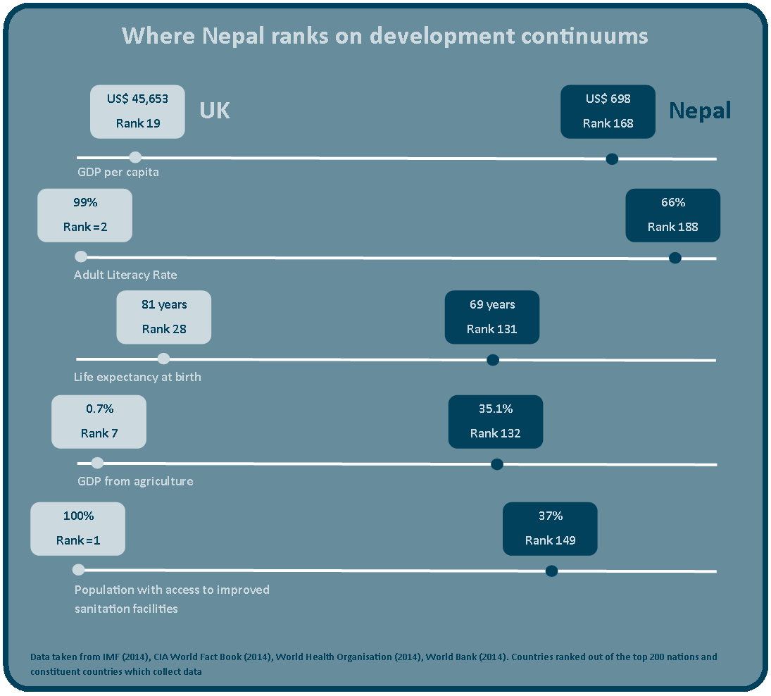

Nepal had few funds in reserve to deal effectively with the immediate aftermath and relied heavily on the goodwill of volunteers until search and rescue teams from overseas could bolster the efforts of the Nepalese army. It is likely that in this lag time many people trapped under buildings would have lost their lives while waiting for assistance from such teams.
With limited opportunities for economic progression in rural areas, large numbers of Nepalese have undertaken rural to urban migration in recent years, and urban populations have grown faster than the housing and infrastructure required to serve them. Between 1980 and 2013 Nepal’s urban population trebled (World Bank 2014), with most people moving into the Kathmandu Valley, creating a city with dense living conditions (13,000 people per km²) and many people being forced to live in substandard housing. Therefore when the earthquake struck it was often the poorest urban dwellers that lost their lives. Poorly built homes made from porous brick and wood collapsed quickly, while the few with steel reinforcement in their structure suffered noticeably less damage.
With a low relative GDP, Nepal has not always had the funds necessary to invest in infrastructural projects such as well-developed road networks. Kathmandu especially is built around narrow and rambling alleyways that date back to medieval times and the palace complexes in the city create a series of squares containing shrines and temples that many visitors find hard to navigate. The nature of the built environment in Kathmandu meant that some streets were easily blocked by rubble and the cranes and the diggers needed to remove such debris could often not access the area. The lack of well-developed road systems in the rural parts of Nepal, where most Nepalese live (and which are difficult to reach in normal times) gave survivors in those regions little opportunity to seek safer surroundings or indeed much needed clean water and food supplies, cutting them off from immediate relief and assistance and making it very difficult for aid agencies to reach them.
As well as poor road systems in parts of the country, Kathmandu Airport, Nepal’s only international airport, was grossly under equipped and had a lack of modern facilities, such as offloading apparatus and services needed to deal with the huge numbers of aid flights that tried to land in the country in the first days following the earthquake. Aid therefore was effectively blocked as the airport was overwhelmed by the number of planes that were trying to land. The authorities decided to close the airport a number of times, fearing the heightened potential devastation that would occur if an aftershock were to hit at a time when the airport was running at full capacity.

How did physical factors affect the impact of the earthquake?
Undoubtedly Nepal’s underdevelopment had a strong role to play in how well it was able to deal with the earthquake. However other physical factors also influenced the scale of the crisis witnessed. Heavy cloud cover prevented helicopter from surveying the more mountainous areas – surveys that would allow search and rescue teams and aid agencies to target the areas that were most desperately in need.
Aftershocks continued to hamper relief efforts as search and rescue teams had to stop work both as they were happening and the time after them as the reassessed damage and rescue priorities. Understandably the many hundred volunteers with no search and rescue training who helped teams in their own communities became scared during the aftershocks, often returning to their families rather than carry on the search effort. The aftershocks also increased the risk of landslides in the more mountainous areas and many villages in Gorkha became even more cut off when landslides blocked roads.
While heavy rainfall created more potential slip planes for landslides, its impact was felt more immediately by the thousands of people forced to sleep rough on open ground in Kathmandu. With little solid shelter, bedding or clothing and temperatures at night dropping to 14°C, the chance of illness from cold and wet conditions increased for those in the capital.

How was the short term emergency relief effort managed?
Almost as soon as the earthquake struck, the call for urgent help went out to the international community. The United Nations Office for the Coordination of Humanitarian Affairs (UNOCHA) organised the majority of the relief effort and advised aid agencies about which areas were most in need of help. UNOCHA estimated that in the aftermath around three million people in Nepal were in immediate need of food assistance and over four million in need of medical care.
Fifteen trained search and rescue teams and fourteen medical teams, as well as tents, dry food, blankets, tarpaulins, medical equipment and drugs were flown in from all over the world though with most non-monetary aid being donated by Nepal’s neighbour, India. International governments were quick to donate financial aid to Nepal, as well as field hospitals (such as that from Israel), aircraft (from Pakistan), and aircraft unloading equipment (from the UK). The World Food Programme delivered food and water to the most remote villages in mountainous Gorkha by helicopter and UN Aid also donated US$15 million from their central emergency response fund. The Disaster Emergency Committee, a coalition of thirteen UK based aid charities, launched an appeal to the general public, an appeal which ten days after the first earthquake had raised £45 million (DEC, 2015).
The total amount of financial assistance given fell short of the US$423 million worth of aid UNOCHA reported to need in the immediate weeks after the earthquake, a third of which was to ensure food security and a further third to provide shelter and sanitation to those made homeless by the disaster.
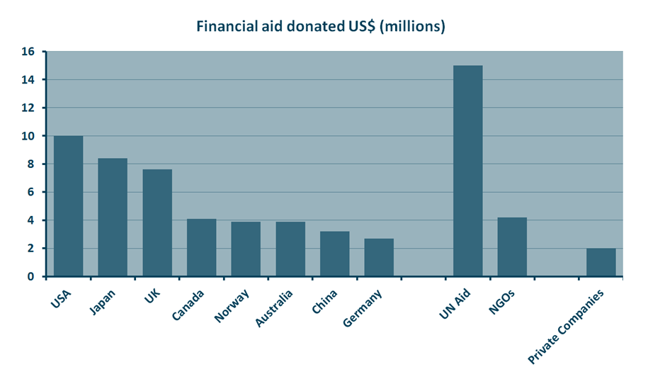
Aid donated by some parties one week after the first Nepal earthquake (Source: CNN, 2015)

The Nepalese were quick to criticise their own government’s lack of response to the earthquake. It was reported by numerous local people that armed services were particularly slow to mobilise after the quake and, as specialised search and rescue teams were spread so thinly over the ground, many were left with no choice but to sift through the rubble of their homes with their own bare hands. This practice was still commonly seen two weeks later after the second earthquake, though now people raided their former homes for food and clothes rather than in search of loved ones.
The total aid budget, including long term reconstruction of all the areas affected by the earthquake was estimated to run to US$10.2 billion.

References
CIA World Fact Book (2014) https://www.cia.gov/library/publications/the-world-factbook/fields/2103.html#xx CNN (2015) Nepal Earthquake Donations – Who’s sending what? http://money.cnn.com/2015/04/27/news/nepal-earthquake-donations/
DEC (2015) http://www.dec.org.uk/appeals/nepal-earthquake-appeal/nepal-two-weeks
International Monetary Fund (2014) World Economic Outlook Database http://www.imf.org/external/pubs/ft/weo/2015/01/weodata/index.aspx
USGS (2015) Magnitude 7.8 Earthquake in Nepal & Aftershocks http://www.usgs.gov/blogs/features/usgs_top_story/magnitude-7-8-earthquake-in-nepal/?from=title
World Bank (2014) Data bank http://databank.worldbank.org/data/home.aspx
World Health Organisation (2014) http://apps.who.int/gho/data/node.main.688?lang=en
__________________________________________________________________________________
Curriculum Links
AQA A Level
Unit 3: Plate tectonics and associated hazards (optional)
Unit 3: Development and globalisation (optional)

Edexcel A Level
Unit 1: Global hazards (core)
Unit 4: Tectonic activity and hazards (optional)

OCR A Level
Unit 3: Earth hazards (optional)
Unit 3: Development and inequalities (optional)

WJEC A Level
Unit 1: Investigating tectonic and hydrological change (core)
Unit 3: Development (optional)
Unit 4: Environmental psychology (optional)

AQA A GCSE
Unit 1: The restless earth (core)
Unit 2: The development gap (core)

AQA B GCSE
Unit 2: Living with natural hazards (core)

AQA iGCSE
Unit 1: Tectonic activity and hazards (optional)

Cambridge iGCSE
Unit 1: The natural environment (core)

Edexcel A GCSE
Unit 2: Tectonic landscapes (core)

Edexcel B GCSE
Unit 1: Restless earth (core)
Unit 2: Development dilemmas (core)

Edexcel iGCSE
Unit 1: Hazardous environments (optional)
Unit 3: Development and human waste (optional)

OCR A GCSE
Unit 1: Extreme environments – mountain environments (core)
Unit 1: Issues in our fast changing world – earthquakes (core)

OCR B GCSE
Unit 3: Natural hazards (core)
Unit 3: Economic development (core)

WJEC A GCSE
Unit 1: Hazards at plate margins (core)

WJEC B GCSE
Unit 3: Development (core)
Unit 3: Interdependence (core)
_____________________________________________________________________________________________
Key Words
Aftershock
Ground tremors occurring after a major earthquake that can persist over a period of weeks, months or years following the earthquake.
Aid
A voluntary transfer of needed resources from one country or region to another.
Avalanche
A sudden, mass movement of snow down a mountain side.
Earthquake
The sudden release of energy through the Earth's crust caused by plate movement which causes seismic waves of different magnitudes.
Infrastructure
The services and facilities needed for an economy to function, for example transport networks, energy supply and health care.
Landslide
A rapid movement of rock and/or earth downslope.
World Heritage Site
An area or place that is deemed to have high natural or cultural significance according to UNESCO.
_____________________________________________________________________________________________
Lesson Ideas
Students can compare the key differences between the 2011 Japanese earthquake and that of Nepal in 2015. Listing the impacts of both, including how long it took for normal life to return for residents, students can decide how each country’s level of development affected its ability to cope with the earthquake.
Introducing the concept of ‘build back better’ students can be asked to design a new Kathmandu that is more earthquake resistant and resilient. This can be done by annotating an overlay map of the city.
Students can imagine they are an aid agency (a real one, or they can make up their own) entering Nepal shortly after the earthquake. In groups they can decide how they would prioritise the multiple and often conflicting needs of the people affected by the earthquake. These ideas could be justified via a presentation with the students in role, giving information about why people should donate to their aid agency over others.
_____________________________________________________________________________________________
Links
Earthquake Tracker Nepal http://earthquaketrack.com/p/nepal/recent
Esri Swipe Map http://www.esri.com/services/disaster-response/earthquakes/nepal-earthquake-swipe-map
Humanitarian Open Street Map Team http://wiki.openstreetmap.org/wiki/2015_Nepal_earthquake
Nepal National Seismological Centre www.seismonepal.gov.np
_____________________________________________________________________________________________
60 second guides
Causes of Avalanches [Haz and Risk]
Myths and Realities in Disaster Situations [Haz and Risk – 21CC]
_____________________________________________________________________________________________
Articles
British Volunteers in Haiti [Haz and Risk – 21CC]
Fault Line Living [Glob Pers and Dev – 21CC]
_____________________________________________________________________________________________
Ask the Experts
Geophysical Global Events [Haz and Risk]
Resilience and Vulnerability in Development [Haz and Risk]
_____________________________________________________________________________________________
On line lectures
A Geological exploration of the Himalaya Karakoram and Tibet [Apr 2013]
_____________________________________________________________________________________________
Resources
Disasters and Development [Glob Pers and Dev – KS3]
Earthquakes in New Zealand [Haz and Risk – KS5]
Tectonic Landscapes [Haz and Risk – KS5]
Mount Everest and its ascent [Land Pro – KS2]

