Threatened heritage landscapes
Investigating how a range of 21st Century pressures can threaten the conservation of Britain’s historic urban and rural landscapes.
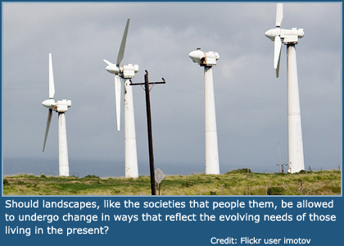
How should our landscapes be managed? If a place is rich with heritage and memories, ought it be preserved and protected from future development? Or should landscapes, like the societies that people them, be allowed to undergo change in ways that reflect the evolving needs of those living in the present?
Two recent UK debates illustrate the complexities of this management challenge. In Yorkshire, modern wind turbines may soon be installed in the same rural landscape that inspired the classic novels of the Brontë sisters (protestors assert this will harm the tourist industry). In Liverpool, the city council recently gave its unanimous backing to a planning proposal that will bring a new complex of skyscrapers to the waterfront (but could rob the city of the unique historic skyline that gives it UNESCO World Heritage Site status). The Yorkshire plan has been justified in relation to energy security and climate change mitigation; Liverpool’s politicians are pursuing economic growth in a competitive global marketplace. This article explores the decision-making in both cases and asks: should heritage sometimes give way to help provide people and places with an environmentally and economically sustainable future?
- Wind and Wuthering: should wind turbines be built on the inspirational moorland made famous by Emily Brontë’s novel ‘Wuthering Heights’?
- Grace under Pressure: will Liverpool’s bid to become a ‘global hub’ come at the cost of its World Heritage Site status?
- What do geographers mean when they talk about ‘the cultural landscape’?

Wind and Wuthering
Bradford councillors have approved the construction of a 60m-high test mast on a West Yorkshire moor, near the former home of the Brontë sisters. If test results are good, the landscape will soon see the addition of four larger wind turbines. Local campaigners say that will be a disaster for local tourism and also for the UK’s natural environmental heritage.
Wuthering Heights is one of the all-time great English novels. Written by Emily Brontë and published in 1847, it has inspired countless films (including a recent 2011 adaptation) and a number one hit single (by 19-year old Kate Bush, back in 1978). The novel tells the story of two thwarted lovers, Catherine and Heathcliffe. Set against the backdrop of Thornton Moor, part of Yorkshire’s South Pennines, the story still holds great power over people’s imaginations, more than 150 years after it was completed. Every year, thousands of tourists make a literary pilgrimage to the moor, which is less than 10km from Howarth and the Brontë Parsonage Museum (where the Brontës spent most of their lives).
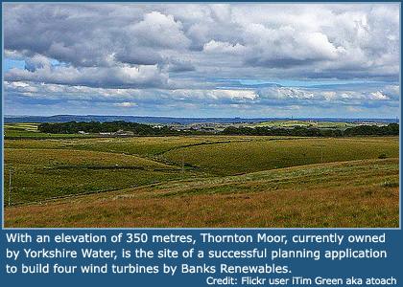
The South Pennine moors are deemed to be useful - but in a very different way - by other players who view this landscape as a prime site for wind turbines. This is a technocentric viewpoint. With an elevation of 350 metres, Thornton Moor, currently owned by Yorkshire Water, is the site of a successful planning application to build four wind turbines by Banks Renewables.
- Each one would be 100 metres tall
- The four together would provide power for approximately 4,400 homes

Meeting the need for renewable energy
Successive governments have agreed that by 2020 Britain should generate 15 per cent of its energy from renewable sources, such as wind and solar power. To do that, it needs to have 13 gigawatts of onshore wind capacity by then, three times more than currently exists (at the moment, it has about 4.5GW from 3,162 wind turbines, all installed since 1991). To meet this target, space needs to be found for another 5,000 or so onshore windmills in the next eight years (Financial Times, 11 April 2012).
There are two important reasons why greater use of renewables is being pursued by the government at this time.
- Climate change mitigation In order to make a greater contribution to the on-going global effort to reduce greenhouse gas (GHG) emissions, the UK has pledged to cut its carbon dioxide emissions. If less carbon-emitting fossil fuel is used, alternative sources are needed. One possibility is nuclear power, although the Fukushima meltdown has meant that a more cautious approach is now being taken (see our recent article on Nuclear Energy). Another is renewable energy sources such as wind, water or solar power. The UK’s geographic location favours wind power, especially along its west coast (which often experiences strong storm conditions) and at higher altitudes, such as Yorkshire’s moors.
- Energy security In recent decades, especially the last few years, fossil fuel prices have become volatile, creating difficulties for businesses and individuals. Reliable domestic sources of energy can help create more stable prices for consumers. In addition, reduced dependency on external sources of imported energy would lessen the UK’s geopolitical vulnerability.
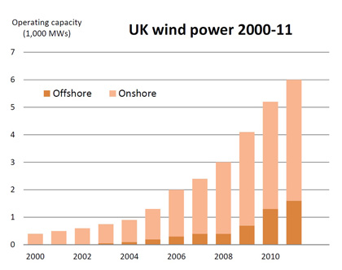

A contested landscape
The same physical space - Thornton Moor - has come to have varying meanings, as a place, for different groups of people. This is why it is a contested landscape, meaning that people disagree over how it should be managed. Three important but conflicting views of the moor are as:
- a romantic place that inspired Brontë to write Wuthering Heights and where tourists are welcome
- a potential site for energy production (the technocentric view)
- a natural place, or wilderness, that would be best left entirely untouched by people
Unfortunately, these different “readings” of the moors may be largely incompatible with one another. Those opposed to the wind turbine scheme, including local residents and the locally-run Brontë society, think the landscape of Thornton Moor should remain untouched by turbines. Anthea Orchard, who chairs the Thornton Moor Wind Farm Action Group, told the Daily Telegraph (06 April 2012): "It is devastating for everybody and everything. The damage to the landscape is going to be irreparable. Our whole way of life is going to suffer and we will fight it to the death”.
However, given that Bradford council has already given the go-ahead for the first phase of the project, it appears that, for now, the technocentric view of the moor has won the day. For the plan to be cancelled, a strong economic case would need to be made that large economic losses for the tourist sector would follow the introduction of turbines. Yet, such a case cannot be proven until it has happened! (It should also be noted that if Brontë-inspired tourism were ever to generate very large tourist flows, then this could create another conflict, given the designation of the South Pennines as a Site of Special Scientific Interest.)
Like Thornton Moor, much of the British countryside has become a site of potential conflict where the needs of different interest groups must be carefully balanced. Writing in 1993, a team of rural geographers led by Terry Marsden suggested that rural Britain, with its complex economic, social and political elements, can be described as contested countryside. In remoter areas, including parts of the national parks, there are many rural districts where conflict between the interests of different user groups is hard to avoid, thereby problematizing decision-making. Thornton moor and the South Pennines is a good example of this type of contested rural environment.
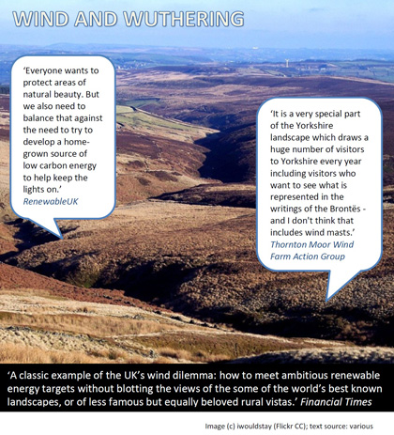

Grace under pressure
Liverpool’s world heritage status - awarded for its historic ‘Three Graces’ skyline - is threatened. The city council recently approved a multi-billion-pound skyscraper scheme that, if it goes ahead, will transform the landscape into a ‘global hub’ for commerce, with an eye on attracting new business clients from China and the Far East. Should the £5.5 billion ‘Liverpool Waters’ scheme be allowed, if it jeopardises the heritage of Liverpool’s built environment?
The new Liverpool Waters plan involves two clusters of tall buildings, one near the city centre and a second further north. Plans drawn up Peel Holdings (a property development firm that has been a big contributor to past regeneration efforts in Liverpool and Manchester) feature:
- 9,000 flats and hundreds of offices
- hotels, bars and a cruise terminal
- the striking 55-storey “Shanghai Tower” and other high-rises
With 20,000 new jobs promised, Liverpool city council is keen to pursue a new rebranding strategy that is focused less on the city’s past heritage and culture, and is instead more focused on the future. Rather than trading on nostalgia tourism, local politicians and businesses are seemingly keen to begin re-orientating the city’s economy towards fresh service sector growth, with Chinese investors and sovereign wealth funds envisaged as major funders for the new project. If the plan succeeds, Liverpool will become a global hub - a focus point for global commerce and financial flows.
Lindsey Ashworth, development director of Peel, said the development of apartments and offices would create a global gateway for north-west England and restore its status as a trading hub. She added: “Heritage should not hold up economic progress in one of the country’s most deprived cities” (Financial Times, 06 March 2012). Business leaders and much of the public have backed the plan to the extent that council leader Joe Anderson was recently elected as the first major of Liverpool!
The road to China
Until recently, Liverpool City Council had pursued a branding and employment strategy focused largely on heritage and culture-led tourism. Key components of this included:
- gaining “European Capital of Culture” designation in 2008
- attaining UNESCO World Heritage Site status in 2004
- delivering arts flagship projects, such as the Tate North gallery
- re-modelling Central Library into a World Discovery Centre
- boosting consumption, for instance by approving the Liverpool One shopping centre
Until recently, the city’s “brand”, according to official literature, was one of world-class culture – comprising tourism, sport, heritage and the creative industries - designed to bring even more visitors to the city’s attractions.
However, during the last few years there have been signs that city planners have been seeking to diversify the local economy further, as part of a long-term growth strategy. In particular, they have promoted Liverpool as a destination for Chinese and other foreign investors looking for an EU base:
- In May 2010, representatives of Liverpool businesses visited China to give the city a presence at the Shanghai Expo (or “World Fair”) – a major global marketing event. Liverpool is actually twinned with Shanghai – and it was the only UK city other than London to be invited to represent itself at this important world event (dubbed the “business Olympics” by one diplomat). 65 Liverpool region businesses (from shipping lines to property developers), worked collectively to raise the £1.4m needed to make the visit possible (Financial Times, 16 May 2010).
- With the 55-storey “Shanghai Tower” at its heart, the new Liverpool Waters project is clearly designed to impress and attract foreign investors in the hope they will become funders and/or users of the planned buildings.
- The Liverpool Waters area, along with Wirral Waters across the Mersey, has been designated a low-tax enterprise zone, which will help attract new inward investment.
‘Damaged beyond repair’
The Liverpool Waters blueprint can best be described as a financescape. This term is applied to modern landscapes of tower blocks and offices that incorporate state-of-the-art architecture, and which are usually designed to impress by reaching greater heights that the surrounding district (outstripping the vertical reach of city towers built in previous eras). Examples include Canary Wharf and the new Shard in London, the 101 Building in Taipei or the Pudong financial district in Shanghai.
New financescapes invite controversy when they overshadow important historical buildings. For Liverpool this may become a real problem because its World Heritage Site (WHS) status derives from an impressive waterfront view which, according to UNESCO, would be “damaged beyond repair” (Liverpool Echo, 07 March 2012), resulting in "a serious loss of historic authenticity" (Guardian, 06 March 2012).
At the heart of Liverpool’s historic waterfront are the Three Graces, a century-old symmetrical trio of iconic buildings sited at the Pier Head. UNESCO originally approved WHS status because the Three Graces are said to represent a “supreme example of a commercial port at the time of Britain’s greatest global significance” in the 18th and 19th centuries during the heyday of the British Empire. The site officially stretches from Albert Dock (which has the largest collection of Grade I listed buildings in the UK) to Stanley Dock.
- UNESCO fears that the scheme would "severely compromise" the setting of some of Liverpool's most significant historic buildings, risk damaging the archaeological remains of parts of the docks and “unbalance” the city's urban landscape (Guardian, 06 March 2012).
- As a result, English Heritage - a government-funded agency responsible for protecting the UK’s heritage - has made a formal objection to the Liverpool Waters scheme on the grounds that it threatens Liverpool’s heritage. As a result, the plans, although approved by the city council, must now be referred for additional approval to the UK government communities secretary. A public enquiry might be called for.
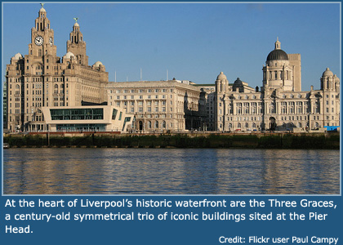
The city council’s planning committee - who unanimously approved the Liverpool Waters proposal - are disappointed that the plan will now be delayed and possibly derailed (Peel have indicated they will pull out if a final decision is not taken quickly).
- The council leader, Joe Anderson, told the Liverpool Echo (07 March 2012) that the city is not “a museum” and investment is crucial to the city's future.
- The council’s decision to shift emphasis away from culture tourism and towards new Chinese investment can be set against the difficulties Liverpool is facing during the UK’s current economic downturn. The inner city district of Bootle, with its struggling high street, was recently classed as a “terminal” place by the retail analyst Colliers International. Another district, Liverpool West Derby, has 33 applications per job vacancy. The city as a whole was characterised as “vulnerable” by a recent Centre for Cities report.
It will be announced during summer 2012 whether the UK government will call for a public inquiry because of the scheme’s size and concerns over its possible impact on the city’s World Heritage Site.

What do geographers mean when they talk about ‘the cultural landscape’?

The United Nations World Heritage Committee defines the cultural landscape as a distinct geographical area that owes its character to ‘the combined works of nature and of man’. Landscape is a key term for cultural geography. Cultural geographers explore how human societies develop mythologies around the landscapes that they occupy, and draw meaning and inspiration from them.
The cultural landscape of cities, or rural areas, may be composed of a mixture of historic and modern elements.
- Historic landscapes - The preserved remains of ancient urban or rural landscapes may be evident (think of the city of Jerusalem, or Stonehenge). Historical and beautiful landscapes are greatly valued by most societies, who frequently attempt to preserve them using laws and regulation (such as English Heritage’s listed building rulings).
- Modern landscapes – new urban landscapes and architecture can reflect the culture, and priorities, of people alive today.
Some geographers additionally distinguish between different types of cultural landscape, including:
- Financescapes These are modern landscapes of tower blocks and offices that incorporate state-of-the-art architecture, and which are usually designed to impress by reaching greater heights than the surrounding district (outstripping the vertical reach of city towers built in previous eras). Examples include Canary Wharf and the new Shard in London, the 101 Building in Taipei or the Pudong financial district in Shanghai. Natural features may still play an important role in shaping a financescape (such as the River Thames at Canary Wharf).
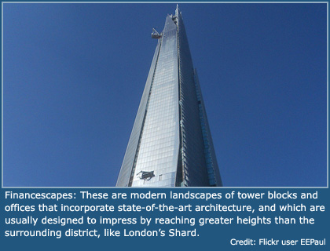
- Commodityscapes These are sites of consumption, such as the Westfield shopping mall in London, the Dubai Mall, or Mall Taman Anggrek in Jakarta. The input of natural features may not always be obvious.
- Ecoscapes These are landscapes based around iconic natural features, such as the Grand Canyon or Antarctica. These landscapes may have been awarded wilderness status; the input of humans is not always obvious. However, some commentators maintain that very few natural environments have in actual fact been left truly “untouched”. Much tropical rainforest is actually secondary growth, thanks to the age-old practices of shifting cultivation. Tropical and temperate grasslands – such as New Zealand’s Canterbury Plains – may owe much to ancient human practices of burning forest (in order to flush out game). Much of the UK’s wilderness moorland has developed over time as a result of animal grazing and the frequent burning of a previously forested landscape.
Some cultural landscapes have been awarded World Heritage Site designation by UNESCO. The United Nations Educational, Scientific and Cultural Organization (UNESCO) was founded in 1945 with the ambitious goal to “build peace in the minds of men”. One of UNESCO’s aims is the “preservation and promotion of the common heritage of humanity” by World Heritage Sites. However, this raises difficult questions about: which cultures and whose cultural landscapes should be preserved and protected? Who should decide how and where cultures are to be preserved and promoted? These questions can be explored further by students in classroom debate, or as part of a homework assignment. A full list of UNESCO sites can be viewed at: http://whc.unesco.org/en/list
References
Financial Times, 11 April 2012 outrage at plan for windfarm near Bronte home
Daily Telegraph, 06 April 2012 Fears over wind turbine plans in Bronte country
Financial Times, 06 March 2012 Council puts heritage at risk
Financial Times, 16 May 2010 Liverpool looks for Shanghai boost
Liverpool Echo, 07 March 2012 Liverpool waters three month wait on 5.5 billion plan after council approval
Guardian, 06 March 2012 Liverpool Waters skyscraper plans get council go-ahead despite heritage fears
UNESCO World Heritage Sites
Sky News, 07 April 2012 Wind farm plan for Bronte’s Wuthering Heights

