What is the Anthropocene?
The purpose
The Anthropocene is an increasingly ubiquitous term used by scientists, geographers, geologists, and climate modelers. It describes a time, the current time period, when humans have become the single most influential species on planet Earth. Such impact is now widely recognised as damaging and ultimately self-destructive — a phenomenon known as global warming.

The Anthropocene is both a time period and a (proposed) geological epoch. An epoch is a subdivision of a geological period when a particular rock series is deposited (see Appendix D). In August 2016, scientists first coined the term ‘the Anthropocene’ however it is yet to be formally declared by geologists. Regardless, the influence of humans on the environment is unquestioned and the Anthropocene is now widely recognised. It was first mentioned by Italian geologist Antonio Stoppani in 1873. Stoppani stated ‘the Anthropozoic era has begun’ predicting human influence on the natural world would last ‘long into the future’ in his work titled Corso di Geologia.

In a 2020 Teachmeet at the Royal Geographical Society (with IBG) former geography teacher and activist Paul Turner explained ‘the choice [of our] words are really important; I can’t emphasise enough that far too often we talk about something like the climate crisis in a distant sense or in an othering. It is really important that we communicate the urgency and agency that is needed to respond.’ You can watch an extract from his talk here.

Specification links
AQA
Core A Level units 3.1 Physical Geography 3.1.1.4 Water, carbon, climate, and life on Earth and 3.2 Human Geography 3.2.1.5.1 Antarctica as a global common.

Edexcel
Core A Level units Topic 5: The Water Cycle and Water Insecurity 5.6 Climate change may have significant impacts on the hydrological cycle globally and locally and Topic 6: The Carbon Cycle and Energy Security 6.9 Further planetary warming risks large-scale release of stored carbon, requiring
responses from different players at different scales and Topic 7: Superpowers 7.5 a. Superpowers and emerging nations play a key role in global action (crisis response, conflict, climate change).

OCR
Core A Level unit Topic 1.2 – Earth’s Life Support Systems 4.a. The impact of long-term climate change on the water and carbon cycles and optional Topic 3.1 – Climate Change.

Eduqas
Optional A Level units 3.2 Ecosystems 3.2.6 Impacts of climate change on the Arctic tundra biome and Development in an African Context 3.3.9. The constraining effects of climate variability, droughts and / or floods on development and 3.5 Weather and Climate.

Introduction
Climate change and climate variability will be the major challenges of the twenty-first century. The UK and numerous other countries will specifically experience an increase in the occurrence of extreme heat, heavy precipitation, and severe flooding (among many other effects).

- In the UK extreme weather has increased in occurrence throughout the twentieth century and into the twenty-first century.

Go to the Met Office Climate Science webpage for UK climate extremes and select UK Temperature by month highest daily maximum temperature (or use Appendix A. Draw a histogram to visualise the pattern of the UK’s highest daily maximum temperatures. Use the x axis for months January — December and the y axis for temperature. Once complete annotate the year onto each column.

n.b. The area of each bar in a histogram, and not the height, shows the frequency of the data. Histograms are typically used when the data is in groups of unequal width i.e., for January there are 4 x values at 18.3°C which requires 4 widths (at whatever measurement you chose) compared to 1 x February at 21.2°C.

- The Stevenson Screen was introduced during the 1860s; consequently, observations are not quoted for pre-1865 and begin from 1866. What do you immediately notice about the yearly dates on your histogram?

- Which 3 months show the most recent maximums of temperature?

The beginning of the Anthropocene is a debated topic, but most scientists agree that it began with the invention of the coal-fired steam engine in the UK, by James Watt in 1750. This was the take-off point for the industrial revolution. Since then, unsustainable growth has continued unabated, spurred on by significant developments such the 1913 ‘technological substitution’ in agriculture (known as the Haber-Bosch process which takes nitrogen from the air and converts it into ammonia to create fertiliser for farming). Without it we would only be able to produce two-thirds of the amount of food we do today. Another spur which fuelled population growth was the 1928 discovery (by Sir Alexander Fleming) of penicillin, the ‘bacteria killer’. This significantly increased life expectancy across the world.

In 2016, climate scientist Ed Hawkins created a colourful climate change graphic to bring the climate crisis to everyone’s attention. Since then, it has received worldwide acclaim for its simplicity and effectiveness in conveying the existential threat of global warming. His graphic called ‘warming stripes’ is shown below in Figure 1.

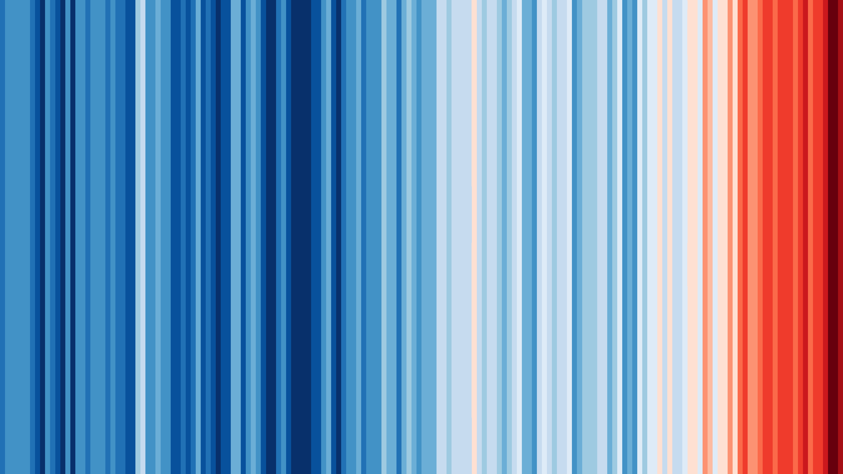
Figure 1 The warming stripes © Ed Hawkins
- Go to the National Oceanic and Atmospheric Administration (NOAA) Global Times Series for Global Land and Ocean Temperatures 1880-2019 (with a base period 1901-2000) or use Table 2 in Appendix B. Create a bar chart to illustrate the exponential rise in global temperature since the start of the industrial revolution (circa.1750).

- Annotate onto the bar chart the 6 highlights from the NOAA 2020 State of the Climate report.
From 1900 to 1980 a new temperature record was set on average every 13.5 years; from 1981–2019, a new record was set every 3 years
The 10 warmest years on record have occurred since 2005
Earth’s temperature has risen by 0.08°C per decade since 1880, and the rate of warming over the past 40 years is more than twice that: 0.18°C per decade since 1981
Despite a late year La Niña event that cooled a wide swath of the tropical Pacific Ocean, 2020 came just 0.02°C shy of tying 2016 for warmest year on record
2020 was the second-warmest year on record based on NOAA’s temperature data, and land areas were record warm

One of the early warnings of serious changes to our climate and weather came in 2012 when the Greenland icesheet was unable to re-establish its ice. The journal The Cryosphere published a study from 1979 to 2012 which noted 2 spells of winter rain per year at the start of the project which substantially rose to 12 spells by 2012. Even if the rain eventually freezes (which it rarely did) it still radically changes the surface of Greenland’s ice, making it smoother and darker. This is a precondition to rapid melting in the Arctic summers. In Small Gases, Big Effect by David Nelles and Christian Serrer they strongly emphasise the importance of fighting Greenland’s ice melt:
Averaged across land and ocean, the 2020 surface temperature was 0.98°C warmer than the twentieth-century average of 13.9°C. 1.19°C warmer than the pre-industrial period (1880-1900)

Unlike the Arctic sea ice, the ice sheet of Greenland is grounded on land. The melting of Greenland’s ice sheet is one of the reasons for rising sea levels. Once the entire mass of the ice sheet is gone, the global sea level will rise by over 7 metres.
David Nelles and Christian Serrer

James Hansen and prior warnings
James Hansen is credited with being the first climate scientist, in the current climate crisis, who confronted the general public with a climate warning (by giving testimony to the US Senate in 1988). His landmark address was a warning that led to the UN Framework Convention on Climate Change in 1992, now regarded as the parent treaty to the 2015 Paris accords. Today he further warns the real danger is national leaders who appear to act but do very little to tackle climate change. In 2018 he stated ‘the world is failing miserably‘ to deal with the worsening dangers.

In the opening line of The Decade We Could Have Stopped Climate Change by Nathaniel Rich he states ‘nearly everything we understand about global warming [now] was understood in 1979’. His work is discussed in a recent Royal Geographical Society podcast. Nathaniel wrote the book to raise awareness about the lost decade of the 1980s when the world could have initiated transformational change, leading up to the inaugural US Senate address by James Hansen. In the podcast Nathaniel explains he is now largely agnostic, explaining that emotional responses to the Anthropocene should rather be: what is our moral response to such an existential threat? And following on from that: what should our policy response be? Nathaniel explains that we are ‘on a pathway now to something like a 4°C rise’ in global temperature which scientists anticipate will cause a considerable amount of suffering over the long-term. A slightly less 3°C rise will bring short-term disaster: forests will sprout in the Arctic, most coastal cities will be abandoned, and mass starvation will be likely in certain parts of the world.

In February 2021 James Hansen returned to centre stage in the climate change crisis when the UK government refused to rule out an offshore coalmine in Cumbria. He was quoted as saying:

In leading the UK, as host to the Cop, you have a chance to change the course of our climate trajectory – or you can stick with business-almost-as-usual and be vilified in the streets of Glasgow, London and around the world. It would be easy to achieve this latter ignominy and humiliation. Just continue with the plan to open a new coalmine in Cumbria and continue to invest funds of the British public in fossil fuel projects overseas, in contemptuous disregard of the future of young people and nature.
James Hansen

The golden spike
This is the colloquial term for what is formally known as the Global Boundary Stratotype Section and Point (GSSP).The golden spike is essentially the boundary between the last geological epoch (the Holocene) and the next (the Anthropocene).

Figure 2 below shows how geological time can be sub-divided.
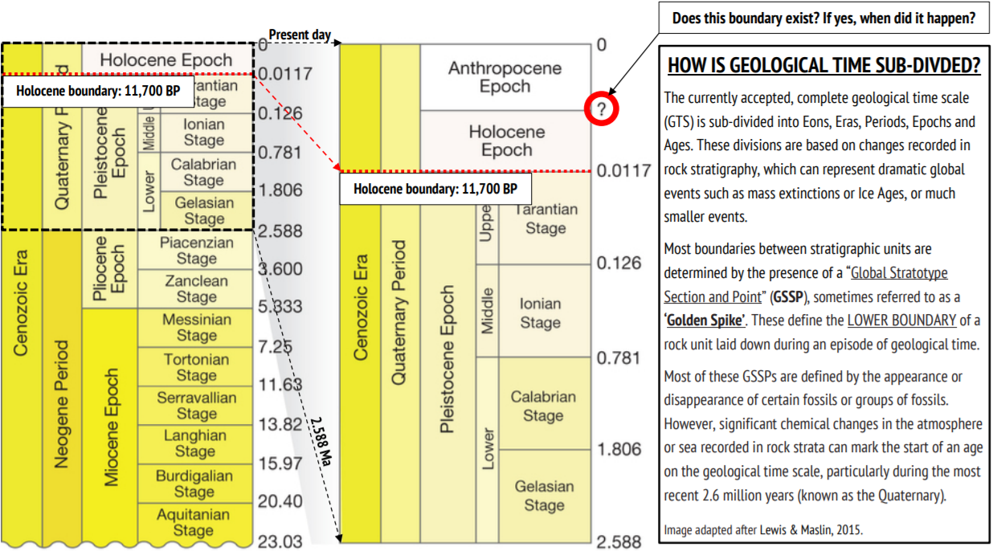
Figure 2 © The Geological Society Anthropocene Resource Pack adapted from Lewis & Maslin, 2015

- Answer the question in Figure 2: does this boundary exist? If yes, when did it happen? Use the suggested links below in your response.

  - The increasing Effects of Climate Change
  - A peak in radionuclide fallout in the nuclear age
  - Species Extinction Rates for plants and animals

Mapping tipping points
Due to slow realisation and a lack of action there has been a persistent march towards severe climate change. As a result, Carbon Brief states ‘a multitude of continuous, incremental changes’ are creeping in year after year. Professor Tim Lenton from the University of Exeter explains that in a complex system (such as global climate) this will create large and irreversible changes to the state and/or fate of a system.

A tipping point — or breeched threshold — describes the accumulation of a series of small changes to create a large and irreversible overall change. Once an irreversible tipping point is passed the system in question will not revert back to its original state, even if the force lessens. In the article Explainer: 9 tipping points that could be triggered by climate change Carbon Brief identify 9 scenarios that may occur if the current climate crisis is not addressed. Scientist Johan Rockström from the Stockholm Resilience Centre explains this in a different way:

9 out of the 15 big biophysical systems that regulate climate are now on the move, showing worrying signs of decline and potentially approaching tipping points.
Johan Rockström

One example of a global tipping point is the possibility that climate change may cause the weakening (or collapse) of the overturning circulation of the Atlantic Ocean i.e., the Gulf Stream. This is an extremely significant current of water which originates off the Florida coast and moves warm water northwards towards the British Isles. It is part of a much wider global process known as the global ocean conveyor belt and without it the UK would have a much colder climate. Changes to the Gulf Stream will cause extreme storms, more intense winters, a greater regularity of heatwaves and seasonal drought across Europe.

- Go to Appendix C. Annotate the worksheet using the Carbon Brief article already mentioned above on tipping points.

Analysing UK extreme weather
Extreme weather in the UK is increasingly being attributed to climate change. It is already worsening and increasing in frequency.

- Go to the Carbon Brief world map for extreme weather events and zoom in on the UK. Fill in the table by clicking each icon to reveal the country, date, impact (look at the symbols in the key), and description. Fill in table 1 below.

Country | Date | Impact | Description
01
02
03
04
05
06
07
08
09
10
11
12
13
14
15
16
17
18
19
20
21
Table 1 extreme weather events in the UK

- Looking at the dates of each UK extreme weather event listed above, has extreme weather become more or less frequent since 2011?

Every year, the American Meteorological Society (AMS) publish a report evaluating extreme weather and climate events around the world. You can read last year’s report here.

Actions
In the 1980s the world acted to protect the ozone, and there are many activists who argue the same mobilisation could occur to fight global climate change now. In 1979 scientists discovered that a particular group of chemicals, called chlorofluorocarbons, had caused ozone destruction of the stratosphere — and announced that the Earth’s natural sunscreen was thinning over the South Pole. You can learn more about the Dobson units of change for the event from the NASA Earth Observatory. The ozone damage culminated in arguably the most successful international environmental collaborations ever as the world united to rapidly eliminate ozone-depleting substances.

Swedish Professor Johan Rockström executive director of the Stockholm Resilience Centre at Stockholm University gave a World Economic Forum presentation in 2017 encouraging delegates to begin ‘a similar exponential journey [to the past 5-decades of exponential growth in unsustainable business] towards a transformation to sustainability’. Professor Rockström argues we must see the scientific opportunities in this ‘new juncture of grand global risk’ stating:

Incremental, linear, business-as-usual is no longer an option.
Johan Rockström, 2017

Paul Turner highlights some of the actions that you as a geography teacher might engage in and promote:

- Talk about climate change
- Teach the Anthropocene
- Switch to a vegetarian or vegan diet
- Switch to renewable energy
- Reduce, reuse, and recycle
- Walk and cycle more
- Use an electric or hybrid car
- Stop flying
- Divest your pension from fossil fuels
- Protest
- Vote

The Royal Geographical Society (with IBG) has worked in partnership with the BBC Radio Four to produce a series of resources to highlight the opportunities for positivism and innovation in the fight against climate change. Listen to the radio show episodes and access our free teaching resources. The first 8 titles are:

- Super rice: super rice is a solution to tackling climate change and the dilemma of a growing population

- Robots of the wind: as of 2020, the UK has more installed offshore wind capacity than any other country in the world

- More power from the sun: solar electricity is clean but the cells we see on our rooftops could be much more efficient

- Siberian rewilding: how trees and fluffy snow are the bad guys when it comes to climate change in Siberia

- Sublime seagrass: can underwater seagrass meadows make a comeback to reduce our carbon?

- Bog-tastic: there is a lot of carbon locked up in the peatlands of Britain and Ireland. Can we keep it there and even return drained bogs to life, sucking more carbon dioxide from the air?

- Chilling food: improving ‘the cold chain’, quickening food transportation and developing new technologies to move food from farm to table are all critical to tackling climate change

- Steel without fossil fuels: steel is an extraordinarily strong alloy of iron and carbon which ‘makes much of the skeleton of our world today’. However, it accounts for a large chunk of our global carbon dioxide emissions. To combat this a new joint venture in Sweden might pave the way for green steel in the future

In 2021 there has been welcomed environmental climate news as Prime Minister Boris Johnson announced the UK would be bringing forward the country’s carbon reduction target to achieve a 78% reduced in CO₂ by 2035. However, critics have been quick to point out that this is only rhetoric, with little immediate environmental action. The bill was made UK law on 20 April 2021 to ‘ensure Britain remains on track to end its contribution to climate change while remaining consistent with the Paris Agreement temperature goal to limit global warming to well below 2°C and pursue efforts towards 1.5°C.’ This will require a fundamental restructuring of our homes, transport, and industry with a move towards better insulation for houses, hydrogen and/or renewable electricity, a more plant-based diet, sustainable factories, and greater supply line efficiency.

Further reading
- ‘A new element, a new force, a new input: Antonio Stoppani’s Anthropozoic’ from the University of Wollongong ro.uow.edu.au/cgi/viewcontent.cgi?referer=&httpsredir=1&article=3995&context=eispapers
- The Anthropocene: The journey to a new geological epoch www.carbonbrief.org/anthropocene-journey-to-new-geological-epoch

- Climate Lab Book Warming stripes | Climate Lab Book (climate-lab-book.ac.uk)

- Ed Hawkins’ warming stripes add colour to climate communication Ed Hawkins’ warming stripes add colour to climate communication - NCAS

- The journey www.carbonbrief.org/anthropocene-journey-to-new-geological-epoch

- National History Museum www.nhm.ac.uk/discover/what-is-the-anthropocene.html

- The world is failing miserably www.theguardian.com/environment/2018/jun/19/james-hansen-nasa-scientist-climate-change-warning

- How fertiliser helped feed the world www.bbc.co.uk/news/business-38305504

- NOAA global temperature data Climate Change: Global Temperature | NOAA Climate.gov

- Johan Rockström Tipping Points www.youtube.com/watch?v=C51RZzTVzwk

- James Hansen and the Cumbria coalmine www.theguardian.com/science/2021/feb/04/top-climate-scientist-warns-pm-over-contemptuous-cumbria-coalmine-plan

- UKRI Responding to climate change www.ukri.org/our-work/responding-to-climate-change/

Answers
- Complete the histogram as instructed, for further help (for GCSE Edexcel or GCSE AQA) consider reading the relevant BBC Bitesize webpages.

- A staggering 47%, almost half, of these record temperatures have been recorded since the year 2000. 74% of the records listed in this table have occurred since the mid-twentieth century.

- February, July, and December all show he most recent temperature maximums for these months.

8. As outlined below.

Country | Date | Impact | Description
01 Scotland | 2018 | Hot and dry summers are now common | Heatwave
02 UK | 2013 | Less likely to occur over time | Cold spring
03 UK | 2013-2014 | All-time record number | Extreme storm
04 England | 2011 | More likely to occur over time | Warm weather
05 UK | 2012 | Minimal human influence | High summer rainfall
06 UK | 2015 | 59% increase in frequency | Storm Desmond
07 Central England | 2014 | Increased chances of warm years 13-fold | Record high temperatures
08 UK | 2018 | Decrease occurrence and less likely | Record cold start to spring
09 UK | 2010 | Cold weather cycle from Scandinavia | Extreme cold winter
10 UK | 2014-2015 | More severe winter sunshine will intensify | Record winter sunshine
11 UK | 1960-2019 | Temperatures exceed 30, 35, 40°C | Extreme heat
12 Europe | 2017 | Intensity, frequency 4 times more likely | Extreme heat
13 Central England | 2014 | New heat record, hottest year on record | Extreme heat
14 Wales | 2000 | Flooding risk increased by 20% | Flooding
15 UK | 2018-2019 | Warm winter days 300 times more likely | Warm winter days
16 UK | 2020 | Expect a year this warm every other year | Unusually warm year
17 England | 2000 | Heavy rain and flooding more likely | Heavy rain
18 London | 2003 | Summer heatwave deaths | 315 estimated deaths in Greater London
19 England | 2010 | Decrease likelihood of this cold | Cold, snow and ice
20 Southern England | 2013-2014 | Increase in westerly winds precipitation | Rain and flooding
Table 2

- Students can select pre-2011 in the dropdown menu options to reveal 38 events of extreme weather. When all is chosen there are 405. Therefore, there has been a substantial increase since 2011.

Appendix A

January | 18.3 | 10-Jan-71 | Aber (Gwynedd)
January | 18.3 | 27-Jan-58 | Aber (Gwynedd)
January | 18.3 | 26-Jan-03 | Aboyne (Aberdeenshire)
January | 18.3 | 26-Jan-03 | Inchmarlo (Kincardineshire)
February | 21.2 | 26-Feb-19 | Kew Gardens (London)
March | 25.6 | 29-Mar-68 | Mepal (Cambridgeshire)
April | 29.4 | 16-Apr-49 | Camden Square (London)
May | 32.8 | 22-May-22 | Camden Square (London)
May | 32.8 | 29-May-44 | Horsham (West Sussex)
May | 32.8 | 29-May-44 | Tunbridge Wells (Kent)
May | 32.8 | 29-May-44 | Regent's Park (London)
June | 35.6 | 29-Jun-57 | Camden Square (London)
June | 35.6 | 28-Jun-76 | Southampton Mayflower Park
July | 38.7 | 25-Jul-19 | Cambridge Botanic Garden
August | 38.5 | 10-Aug-03 | Faversham (Kent)
September | 35.6 | 02-Sep-06 | Bawtry, Hesley Hall (South Yorkshire)
October | 29.9 | 01-Oct-11 | Gravesend (Kent)
November | 22.4 | 01-Nov-15 | Trawsgoed (Ceredigion)
December | 18.7 | 28-Dec-19 | Achfary (Sutherland)
Table 3 United Kingdom: Highest daily maximum temperature records © The Met Office

Appendix B

Year | Value
1880 | -0.13
1881 | -0.09
1882 | -0.1
1883 | -0.19
1884 | -0.27
1885 | -0.26
1886 | -0.25
1887 | -0.29
1888 | -0.14
1889 | -0.1
1890 | -0.36
1891 | -0.27
1892 | -0.32
1893 | -0.34
1894 | -0.32
1895 | -0.25
1896 | -0.1
1897 | -0.11
1898 | -0.27
1899 | -0.16
1900 | -0.08
1901 | -0.16
1902 | -0.26
1903 | -0.37
1904 | -0.46
1905 | -0.28
1906 | -0.21
1907 | -0.39
1908 | -0.44
1909 | -0.45
1910 | -0.41
1911 | -0.44
1912 | -0.34
1913 | -0.32
1914 | -0.14
1915 | -0.1
1916 | -0.32
1917 | -0.4
1918 | -0.3
1919 | -0.25
1920 | -0.23
1921 | -0.16
1922 | -0.24
1923 | -0.25
1924 | -0.24
1925 | -0.18
1926 | -0.07
1927 | -0.17
1928 | -0.18
1929 | -0.33
1930 | -0.11
1931 | -0.07
1932 | -0.13
1933 | -0.26
1934 | -0.11
1935 | -0.16
1936 | -0.12
1937 | -0.01
1938 | -0.02
1939 | 0.01
1940 | 0.16
1941 | 0.27
1942 | 0.11
1943 | 0.11
1944 | 0.28
1945 | 0.18
1946 | -0.01
1947 | -0.04
1948 | -0.05
1949 | -0.07
1950 | -0.15
1951 | 0
1952 | 0.05
1953 | 0.13
1954 | -0.1
1955 | -0.13
1956 | -0.18
1957 | 0.07
1958 | 0.13
1959 | 0.08
1960 | 0.05
1961 | 0.1
1962 | 0.11
1963 | 0.12
1964 | -0.14
1965 | -0.07
1966 | -0.01
1967 | 0
1968 | -0.03
1969 | 0.11
1970 | 0.06
1971 | -0.07
1972 | 0.04
1973 | 0.19
1974 | -0.06
1975 | 0.01
1976 | -0.07
1977 | 0.21
1978 | 0.12
1979 | 0.23
1980 | 0.28
1981 | 0.32
1982 | 0.19
1983 | 0.36
1984 | 0.17
1985 | 0.16
1986 | 0.24
1987 | 0.39
1988 | 0.39
1989 | 0.3
1990 | 0.45
1991 | 0.39
1992 | 0.24
1993 | 0.28
1994 | 0.35
1995 | 0.47
1996 | 0.32
1997 | 0.52
1998 | 0.65
1999 | 0.44
2000 | 0.43
2001 | 0.57
2002 | 0.62
2003 | 0.64
2004 | 0.58
2005 | 0.67
2006 | 0.64
2007 | 0.62
2008 | 0.54
2009 | 0.65
2010 | 0.73
2011 | 0.58
2012 | 0.64
2013 | 0.68
2014 | 0.74
2015 | 0.93
2016 | 1
2017 | 0.91
2018 | 0.83
2019 | 0.95
Table 4

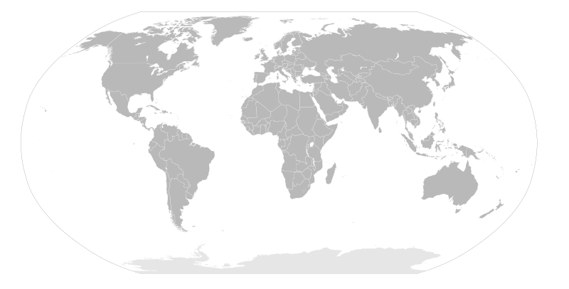

Appendix C

Appendix D
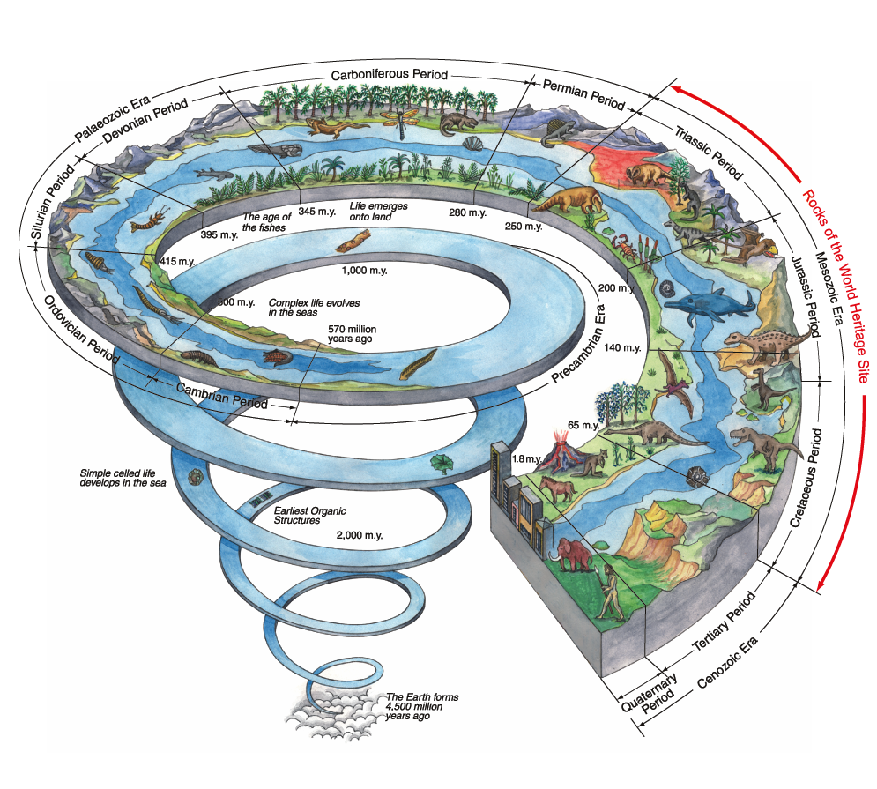

Our Earth History © the Jurassic Coast Trust

