Financial Times: Opec

Theme and specification link

This resource looks at the role of one of the players in energy security: Opec, and the announcement from the UAE that they will be leaving that and the wider Opec+ group.

There are a number of articles which support this activity, links to which can be found here:

UAE opens up an Opec fissure
The twilight of Opec
‘The beginning of the end of Opec’: can the oil cartel survive the UAE’s exit?
UAE to leave Opec in blow to oil cartel
UAE’s Opec exit will drive down oil prices in future, warns Moscow

This article underpins many aspects of resource security within the A Level specifications specifically:

AQA
3.2.5.4 Energy security.

Cambridge International
12.1 Sustainable energy supplies Renewable and non-renewable energy resources.
12.2 The management of energy supply.

Edexcel
Topic 6: The Carbon Cycle and Energy Cycle. Enquiry question 2: What are the consequences for people and the environment of our increasing demand for energy?

Edexcel International Advances
Topic B1: Energy Security

Eduqas / (WJEC)
(4) 3.4 Energy Challenges and Dilemmas


Key terms
Use the article and your own knowledge to define the key terms below:

Cartel

Embargo

Gulf States

Multilateral Organisations

Quotas



Location
Using the map below, information from the articles and this link, use different colours to mark countries that are:
a) Members of Opec
b) Members of Opec+
c) Former members of Opec or Opec+

Annotate your map to identify any patterns you notice and any other useful information such as when they joined and left (if they have left).
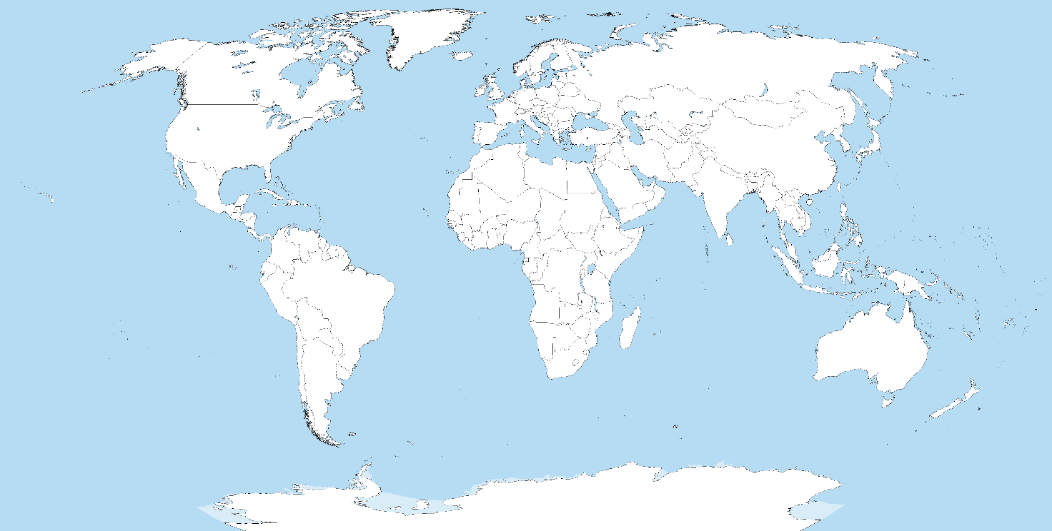
Image credit: Wikimedia CC BY-SA 3.0


Summary in numbers
Find the related statistic in the article and develop it to add context and summarise the report.

3.4mn barrels
Wider issues

Write a question here to help think about other issues which might influence the points in the article.

1973

11 countries

12%

$100

10 countries

75%

2027

60 years


Synoptic links
Note down any synoptic links using your specification to help you. A Mind Map might be helpful here.

Opec



5 examination-style questions

Analyse the graph from this article that looks at the global share of Opec’s global oil production over time.

What impact does the shift in oil production between Opec and Non-Opec countries have on global oil production?

To what extent do multilateral organisations such as Opec influence global energy security?

Explain the wider impacts of the UAE’s departure from Opec.

Discuss the view that UAE’s departure from Opec has wider geopolitical implications.

