|  |
| --- |
| Green hydrogen: Ras Duqm student sheet |

# Starter

Hydrogen is the most abundant element in the universe. It has the chemical symbol H and is composed of a single proton and a single electron. It makes up roughly 90% of all the atoms in the universe.

1. Make a timeline on the evolution of hydrogen use, using the information below.

2. Watch the [video](https://www.bbc.co.uk/bitesize/articles/z3pp97h#zppvcxs). How is hydrogen used?

______________________________________________________________________________________________________________________

___________________________________________________________

# What is green hydrogen?

There are several types of hydrogen (8 in total). Each type serves different purposes and offers varying degrees of sustainability. The main 3 main types are grey, blue and green.

1. Fill in the table with the definitions for brown, blue and green hydrogen.

|  |  |
| --- | --- |
|  | Brown hydrogen is… |
|  | Blue hydrogen is… |
|  | Green hydrogen is… |

# Ras Duqm

Location

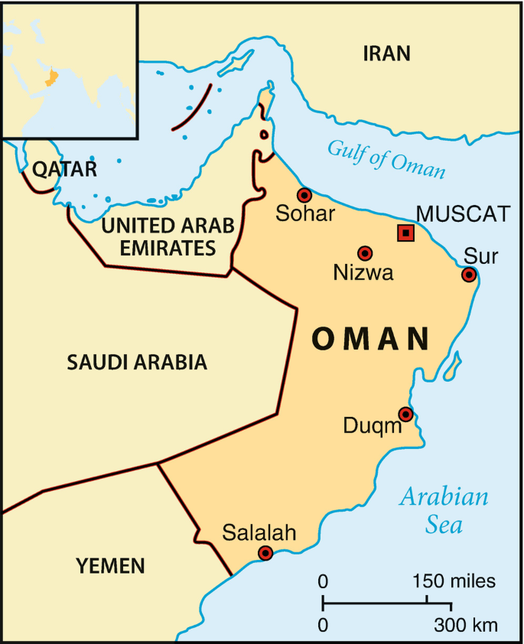 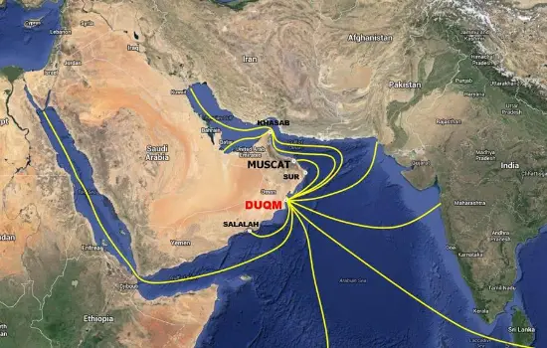

The location of Duqm © [Springer Nature](https://link.springer.com/referenceworkentry/10.1057/978-1-349-96056-9_141) Oman and [map](https://connsect.com/duqm/) SEZAD Duqm-Oman

1. Using the two Figures above, describe the location and connectivity of Duqm in Oman.

___________________________________________________________

___________________________________________________________

___________________________________________________________

___________________________________________________________

___________________________________________________________

___________________________________________________________

Sectors

Ras Duqm has a diverse range of sectors.

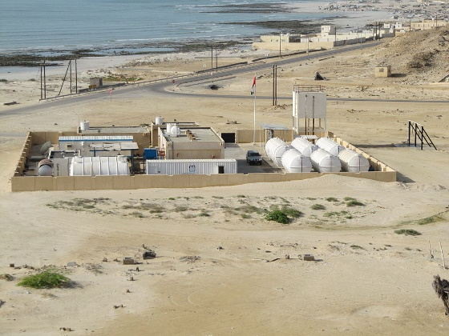 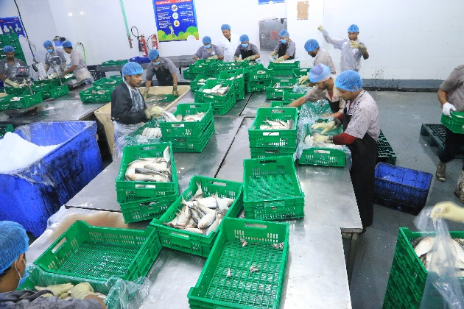

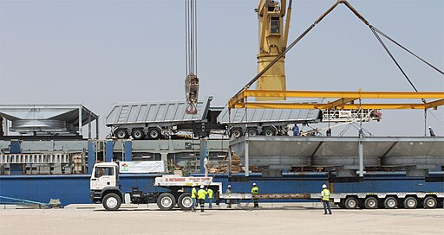 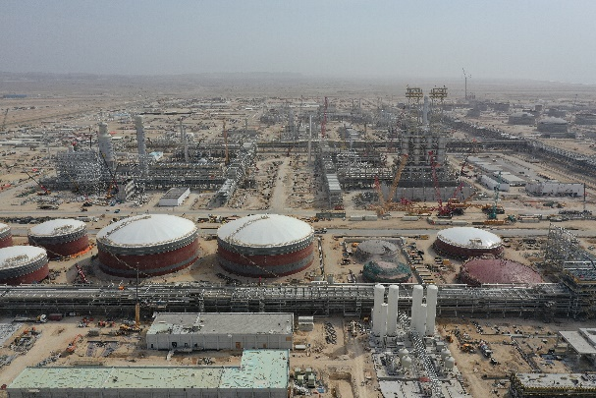

Image Sources: desalination Wikimedia Open Comms, Fishing Industry Abdullah Al Maan, Duqm Refinery Abdullah Al Maani, Duqm Port Meshal Humaid Ali Almoqbali. CC BY-SA 4.0

Map of Duqm Port and SEZ

Image source: [Connsect](https://connsect.com/duqm/)

2. Look at the images above to identify the industries present in the SEZAD. Use the map to describe the distribution of these industries.

___________________________________________________________

___________________________________________________________

___________________________________________________________

___________________________________________________________

___________________________________________________________

___________________________________________________________

___________________________________________________________

___________________________________________________________

___________________________________________________________

___________________________________________________________

Ras Duqm in Oman is involved in both blue and green hydrogen projects.

Blue hydrogen is being developed by Oman Shell, which producing hydrogen from natural gas while capturing and storing the associated carbon emissions.

Green hydrogen is developed in HYPORT Duqm. HYPORT reflects the project focus on HYdrogen and its location in the PORT of Duqm.

The intention is to produce and export green hydrogen and its derivatives (such as ammonia) to the global market.

Read the article [HYPORT Duqm set to be among world’s first green hydrogen projects](https://www.omanobserver.om/article/1151644/business/energy/hyport-duqm-set-to-be-among-worlds-first-green-hydrogen-projects) to answer the following questions.

1. Where will the project rank among the world’s large-scale ventures in green hydrogen?

___________________________________________________________

1. What will HYPORT Duqm be the first in the world to do?

___________________________________________________________

1. What will the production of green hydrogen and green ammonia be powered by?

___________________________________________________________

1. How many green hydrogen projects have been signed by the Sultan of Oman?

___________________________________________________________

1. What is the goal of these projects?

___________________________________________________________

___________________________________________________________

# Costs and benefits

Identify the socioeconomic and environmental costs and benefits outlined below. Which comments do you agree with? Justify your ideas.

Challenge: Are there any points missing? Add them to the comments below.

HYPORT aligns with Oman's Vision 2040 by promoting renewable energy and reducing carbon emissions

Electrolysis requires large amounts of water, a concern for Oman with limited freshwater resources

Developing the necessary infrastructure is complex and expensive

Duqm Port is an ideal hub for exporting green hydrogen and green ammonia

Green hydrogen production is expensive due to the need for advanced technology

The process of producing green hydrogen is energy-intensive, potentially straining electricity supply

HYPORT leverages Oman's abundant solar and wind resources

Green hydrogen can power fuel cell-based vehicles, with zero-emissions

Hydrogen can be delivered in existing natural gas pipes or pure hydrogen pipelines