**Worksheet 1: Mapping Spatial Variations of Climate Change**

**Task 1: Mapping Spatial Variations**

Below is a blank world map. Your task is to identify and **color-code** regions where the number of **hotter days** has increased, particularly in the mid-latitudes.

1. **Red** for areas with a high increase in hot days. **Orange** for moderate increases. **Yellow** for slight increases.
2. **Regions to Highlight** Southern Europe (Spain, Italy, Greece) United States (Southwestern States) Northern China Australia Southern Africa
3. **Annotate Your Map** After coloring, write brief notes next to each highlighted region explaining:

What changes are occurring in the region (e.g., increase in heatwaves, droughts).

Why these changes may be happening (link to climate change, human activities, etc.).

**World Map**

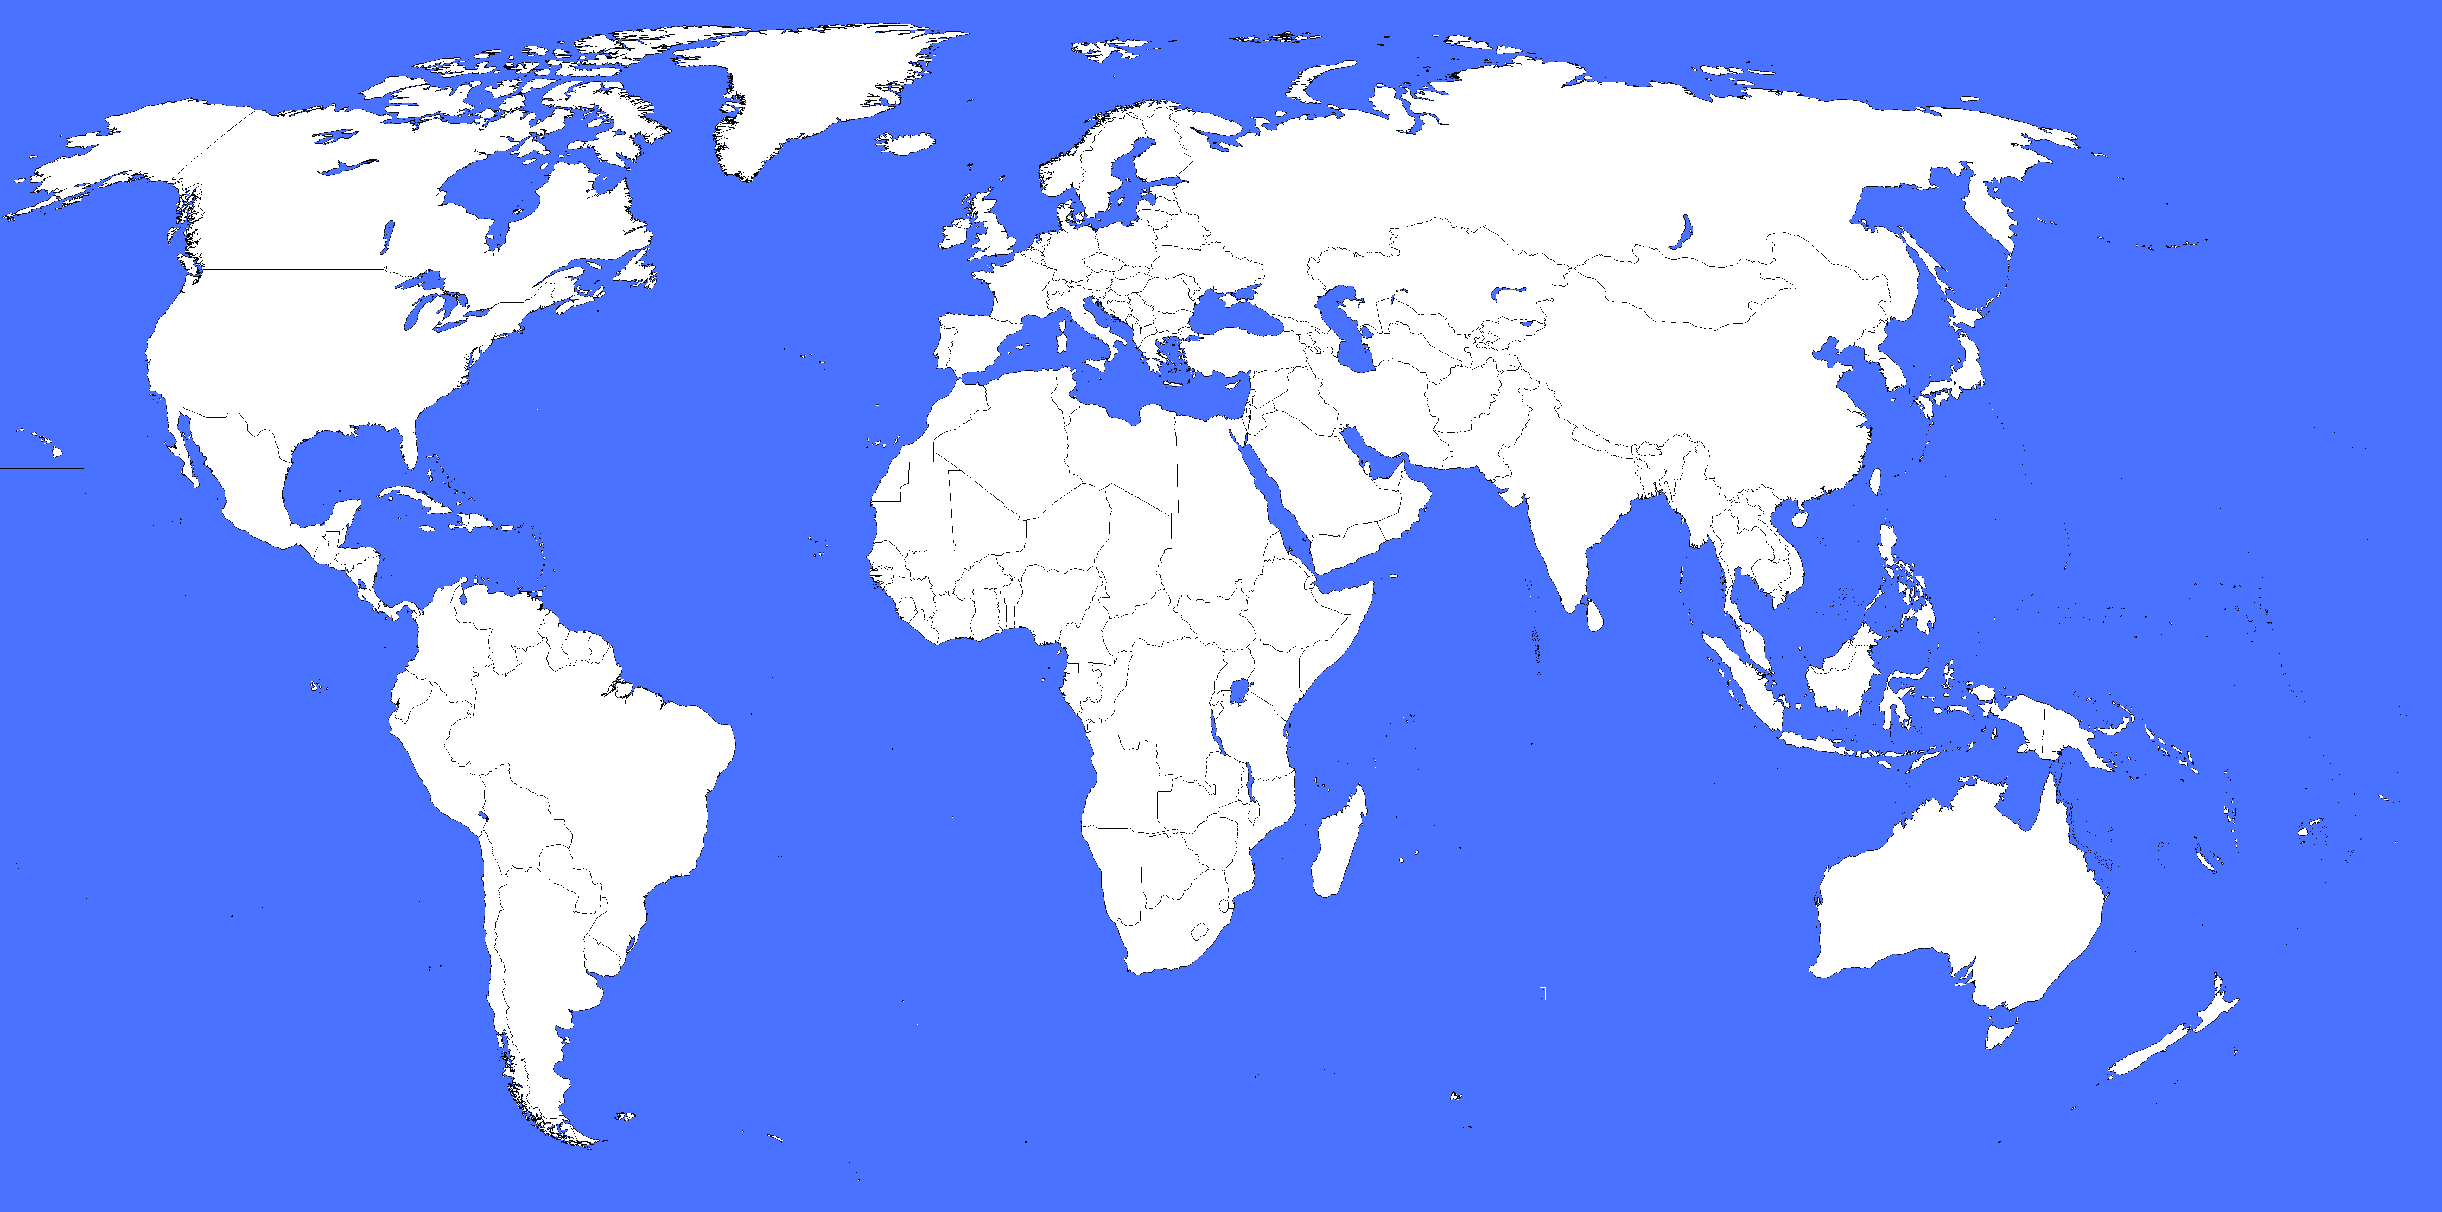

**Task 2 Graphing Temporal Changes in Global Temperatures**

1. **Instructions**

Below is a table with **global temperature anomaly** data (from 1880 to 2020). The temperature anomaly represents how much the global temperature deviates from the average temperature between 1951–1980.

Use this data to create a **line graph** that shows how global temperatures have changed over time.

1. **Temperature Anomaly Data (Sample)**

|  |  |
| --- | --- |
| **Year** | **Temperature Anomaly (°C)** |
| 1880 | -0.12 |
| 1900 | -0.09 |
| 1920 | 0.00 |
| 1940 | 0.12 |
| 1960 | -0.02 |
| 1980 | 0.15 |
| 2000 | 0.45 |
| 2020 | 1.02 |

1. Plot **years** on the **x-axis**. Plot **temperature anomalies** on the **y-axis**. Draw a smooth line connecting the points to show the trend.
2. Answer the following questions based on your graph:
   * 1. In which years did global temperatures begin to rise sharply?
     2. What might explain the rapid increase in global temperatures after 1980?