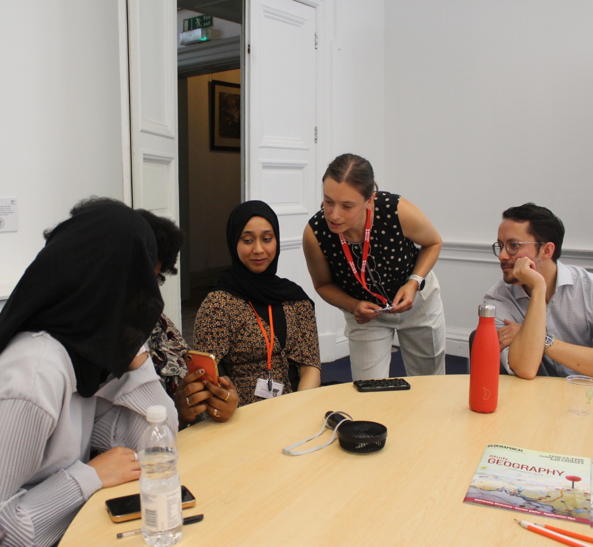

Royal Geographical Society (with IBG)
Professional Ambassador
Support materials

This document intends to equip Professional Ambassadors with the knowledge and resources to deliver with excellence when completing school outreach.

Advocating for your profession as a Professional Ambassador is an excellent way to showcase your geographical knowledge and skills and enhance understanding of the relevance studying geography. Young people can directly benefit from your professional insights and expertise, helping inspire them with making decisions about their future career pathway.
Professional outreach can be a fulfilling experience and is recognised by many employers and professional accreditations, including Chartered Geographer, as a form of continuing professional development.
If you have any questions, would like further support, or have any feedback, please contact professional@rgs.org.

Key messaging

When going into schools to talk about geography, please ensure that you’re celebrating the discipline in these ways:
Choosing geography at school
- Studying geography opens up lots of options for your future
- Employers and universities see geography as a robust academic subject rich in skills, knowledge and understanding
- Geography compliments all subjects, including STEM subjects and social sciences

Choosing geography at university
- Geography courses are popular, demonstrated by strong completion rates and positive student feedback.
- Geographers are highly employable and collectively receive competitive graduate salaries – 75% of geography undergraduates secure full time employment 15 months after graduating – surpassing history, psychology, law and computer science
- Geography courses are flexible, and many allow you to combine human and physical geography topics throughout the course

Choosing geography as a career
- A geography degree is highly respected by employers
- Geography graduates have one of the highest rates of graduate employment, pursuing a wide range of career paths
- The multi-faceted skillset that comes with studying geography is highly desired by employers
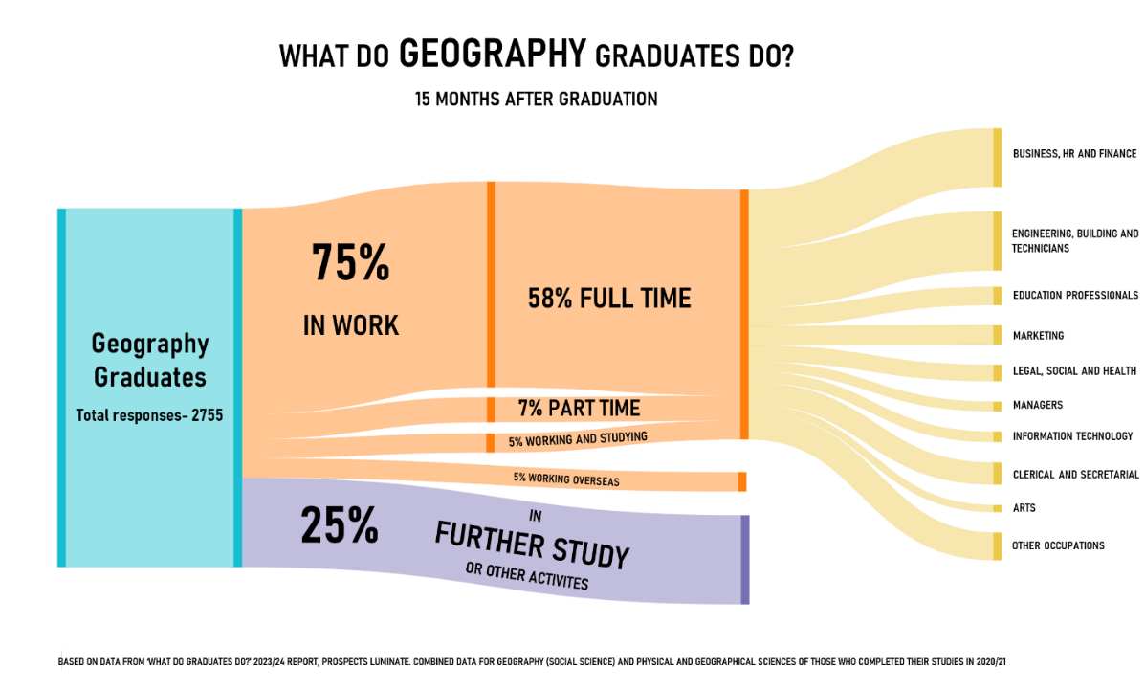

Credit: Royal Geographical Society (with IBG), 2025

Presentation materials

To help you develop materials to support a presentation or classroom activity, we have provided some suggested topics and structures below.

You can also find presentation templates available to download and edit on our website.

Example PPT structure for delivering a presentation about your career with geography:
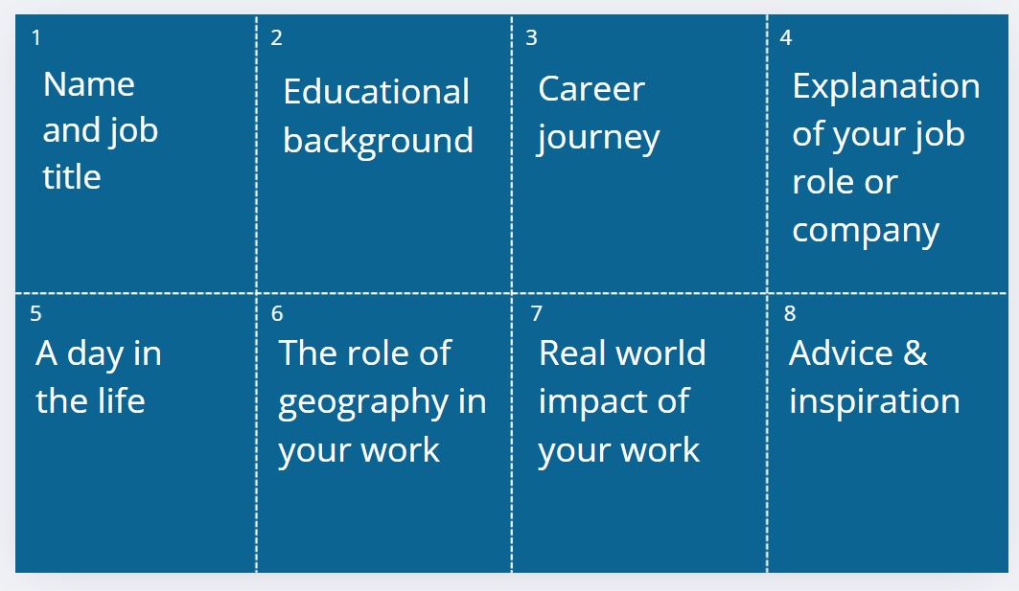

Example PPT structure for delivering a presentation promoting geography as a subject to study and/or as a career:
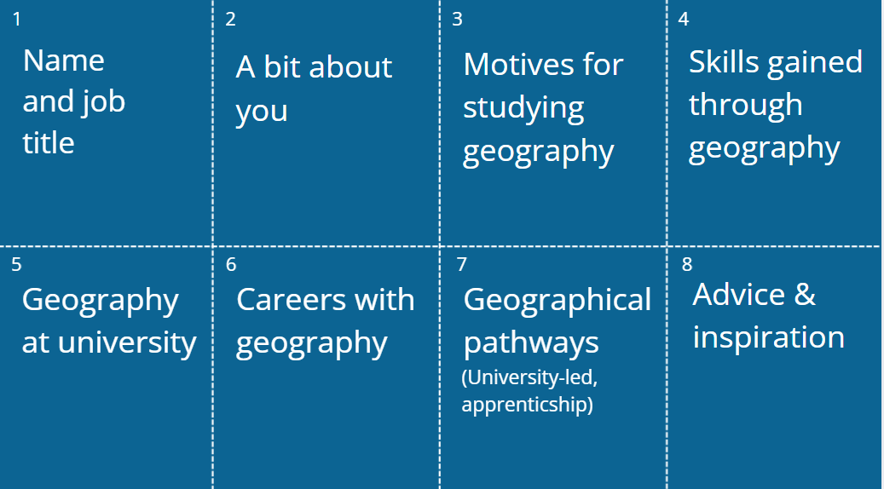

Career resources
You can access examples of short activities here: Choose Geography activities - RGS
Our career profiles hear from professionals from a range of sectors and career stages. You may want to use examples to relate what students are learning about in the classroom to career pathways and sectors. Check them out here: I am a geographer - RGS

In our Use geography webinar series, we speak to geographers across a range of sectors to help students and graduates learn more about the many possibilities that are opened up by studying geography. You may want to use the webinars as examples of the sectors students might be interested in, or point to these as a resource for students to use: Use geography: webinars and resources - RGS

Geographical Magazine’s Study Geography supplement showcases a range of case studies of geographical careers: Study Geography supplement 2025
Careers materials RGS: Geographical careers resources from the Society
Choose geography flyers: Choose Geography flyer for options evenings
About Choose Geography: Choose geography - RGS
Career material provided by other geographical organisations
- National Education Nature Park green careers and geography videos: https://www.educationnaturepark.org.uk/resource/green-careers-and-geography
- OS Placemaker videos:
https://www.ordnancesurvey.co.uk/about/os-placemakers
- Industrial Decarbonisation Research and Innovation Centre video showcase: You can’t be what you can’t see
https://idric.org/impact-areas/equality-diversity-inclusion/video-showcase/
- JBA digital learning resources:
https://www.jbatrust.org/about-the-jba-trust/how-we-help/learning-resources/coasts/

