Building new communities in England

Introduction
With a growing population, England faces many challenges including the need for affordable housing and new communities to release the pressure on existing settlements around the country. To help alleviate this pressure, the Government has pledged to build 1.5 million homes by 2029 and enlisted the help of a taskforce to help identify areas around England where significant development can take place. This taskforce has identified 12 potential locations for developments, taking advantage of brownfield sites where possible.

Location of proposed new developments
The new developments proposed by the taskforce consider existing infrastructure such as roads and railways but, in some cases recommend additional infrastructure to help alleviate congestion and limitations to travel.

The locations of these developments are identified below:
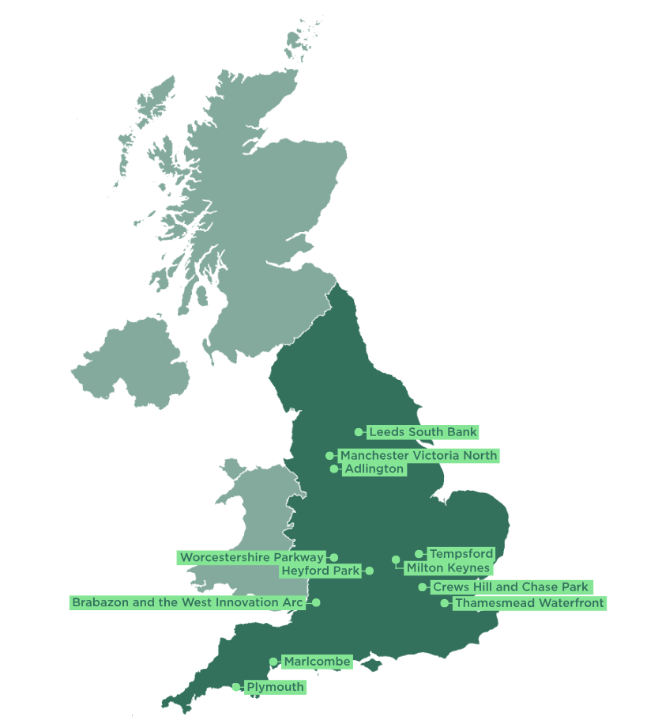
Figure 1: Location of proposed new developments. Image Credit: MHCLG

Thamesmead Waterfront
One of the proposed developments is Thamesmead, located in southeast London. Continuing from the regeneration of the area since the decline of the London Docks in the 1970s and ‘80s, Thamesmead Waterfront is a prime location for the proposed 15,000 homes on a 100-hectare brownfield site. The development of this site will also help towards meeting the 88,000 homes a year housing target for the Capital.

In addition to housing, the developers aim to improve transport links, including extending the Docklands Light Railway (DLR), regenerating the existing town centre and creating new parkland. The hope is to transform the area into a vibrant community.

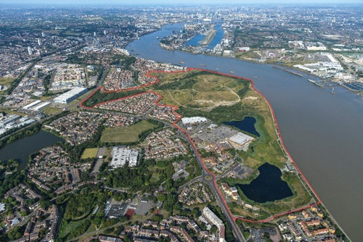

Figure 2: Proposed location of the Thamesmead Waterfront development site © Thamesmead™

This site is located before the Thames Barrier – a large flood defence system designed to reduce the risk of flooding from the Thames in London. Therefore, without its protection, the area is more susceptible to flooding especially from storm surges and the threat of sea level rise from climate change. Therefore, developers will need to consider this when building along the banks of the Thames so that homes and businesses are protected against these events in the long-term.

Although building new homes may address a supply problem in the housing market, with banks loaning less and mortgage rates increasing, being able to afford these homes is another issue which needs to be reviewed so that people can affordably access properties.

Sources and further reading

Thamesmead new town 'no brainer', says politician. BBC, January 26, 2026
Building of three new towns will start before election, Labour pledges. BBC, September 28, 2025
Indicators of house building, UK: overview

Indicators of house building, UK: overview. ONS, January 29, 2025

Housing supply: indicators of new supply, England: July to September 2025. MHCLG, January 15, 2026

Thamesmead Waterfront Development

15,000-home Thamesmead Waterfront project given welcome boost by New Towns Taskforce. Peabody, September 29, 2026

