|  |
| --- |
| Water sources in Oman student sheet |

# Introduction

Oman is a hot, dry, country in the Middle East. Freshwater is limited to areas of high elevation, in the northern and southern extremities of the country.

Oman, therefore, relies on aquifers, in the Dhofar (Najd), Al Dahra (Al Massrat) and Sharqia (Rimal al Sharqia) regions, and the process of desalination.

Desalination makes an important contribution to Oman’s water resources, particularly in areas which lack reliable access to water. Desalinised water, as a share of the overall country’s water budget, is therefore increasing.

1. Describe the geographical context of Oman, either by using a paper atlas or the ArcGIS [Geography Visualiser](https://teachwithgis.co.uk/pages/quick-launcher).

_____________________________________________________________

_____________________________________________________________

_____________________________________________________________

_____________________________________________________________

_____________________________________________________________

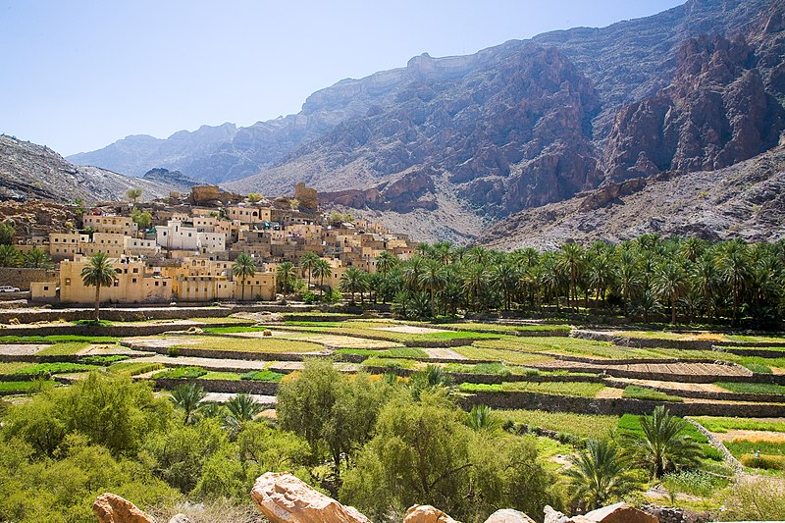 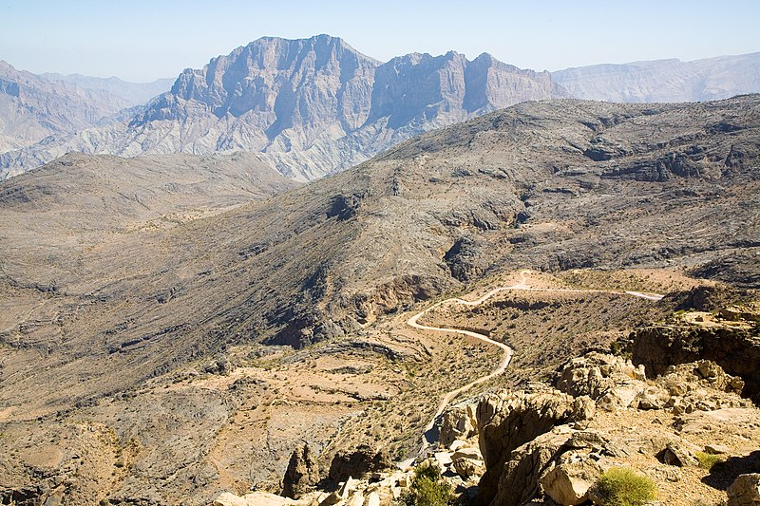

Image Sources: Wikimedia Commons [Bilad Sayt](https://commons.wikimedia.org/wiki/File:Oman_%2816%29.jpg), [Mountain road](https://commons.wikimedia.org/wiki/File:Oman_%2810%29.jpg) from Nizwa to Wadi Bani Awf, Flickr The Sultanate [Sana Tawileh](https://www.flickr.com/photos/sanatawileh/12116251543/), Flickr Wadi Shab [Fabio Achilli](https://www.flickr.com/photos/travelourplanet/)

1. Describe the landscape in Oman.

_____________________________________________________________

_______________________________________________________________________________________________________________________________________________________________________________________

_____________________________________________________________

2. Why is water scarcity a significant issue in some regions?

__________________________________________________________________________________________________________________________

**Data questions**

1. Using the tables on slide 3 in the PowerPoint, identify any patterns in the data over time. Is Oman's population increasing or decreasing? What’s the trend in annual average temperatures?

_____________________________________________________________

_____________________________________________________________

_____________________________________________________________

_____________________________________________________________

_____________________________________________________________

_____________________________________________________________

_____________________________________________________________

_____________________________________________________________

2. Which biome best describes Oman according to [The Five Major Types of Biomes](https://education.nationalgeographic.org/resource/five-major-types-biomes/)?

_____________________________________________________________

_____________________________________________________________

3. Why might the annual freshwater withdrawal data be concerning?

_____________________________________________________________

**Water stress question**

Using the text from slide 6 in the PowerPoint, answer the following question.

1. Create a stacked column chart to represent the major annual sources of water in Oman for the years 1970, 1990, 2010, and 2030.



2. Using slides 7-10, identify another water source in Oman.

__________________________________________________________________________________________________________________________

3. How have water sources in Oman changed over time?

__________________________________________________________________________________________________________________________

__________________________________________________________________________________________________________________________

**Desalination questions**

After watching [the YouTube video](https://www.youtube.com/watch?v=V80Oisz3F6U), answer the questions below.

1. Research what the word *desalination* means.

_____________________________________________________________

2. Why does Oman rely on desalinated water?

_____________________________________________________________

_____________________________________________________________

3. How many desalination plants are there?

___________________________________________________________

4. What are the costs?

___________________________________________________________

5. Annotate the desalination plant diagram below, using the sentences provided in the PowerPoint.

Source: adapted from © [Science Direct](https://www.sciencedirect.com/science/article/abs/pii/S030626191931339X)

**The Sharqiyah desalination plant**

Using the information in slide 13 in the PowerPoint, and the article on [the 5 major aquifer systems in Oman](https://water.fanack.com/oman/water-resources-oman/), answer these questions to finish.

1. Aquifers are an alternative water source. Research the 5 major aquifer systems in Oman.

_____________________________________________________________

_____________________________________________________________

_____________________________________________________________

_____________________________________________________________

_____________________________________________________________

_____________________________________________________________

_____________________________________________________________

_____________________________________________________________

_____________________________________________________________

_____________________________________________________________

_____________________________________________________________

_____________________________________________________________

_____________________________________________________________

_____________________________________________________________

_____________________________________________________________

2. Evaluate the environmental, economic, and social impacts of desalination as a water supply solution in Oman. Consider both the benefits and potential drawbacks.

_____________________________________________________________

_____________________________________________________________

_____________________________________________________________

_____________________________________________________________

_____________________________________________________________

_____________________________________________________________

_____________________________________________________________

_____________________________________________________________

_____________________________________________________________

_____________________________________________________________

_____________________________________________________________

_____________________________________________________________

_____________________________________________________________

_____________________________________________________________

_____________________________________________________________

_____________________________________________________________

_____________________________________________________________

_____________________________________________________________

_____________________________________________________________

_____________________________________________________________

_____________________________________________________________

___________________________________________________________

___________________________________________________________

___________________________________________________________

___________________________________________________________

___________________________________________________________

___________________________________________________________

___________________________________________________________

___________________________________________________________

___________________________________________________________

___________________________________________________________

___________________________________________________________

___________________________________________________________

___________________________________________________________

___________________________________________________________

___________________________________________________________

___________________________________________________________

___________________________________________________________

___________________________________________________________

___________________________________________________________

___________________________________________________________

___________________________________________________________