Storm Claudia

Introduction
Storm Claudia - a low-pressure system which formed in the Atlantic Ocean, brought strong winds and heavy rainfall to parts of Ireland, Wales and England on Friday November 14, 2025, as well as parts of Spain and Portugal between Wednesday November 12 and Saturday November 15, 2025.

Unlike many of the storms which hit the UK, Claudia was named by the Spanish Meteorological Service due to its impacts on the Canary Islands, mainland Spain and Portugal.

Effects in the UK
As the storm contained a lot of moisture, its heaviest impacts came from intense rainfall. The storm had an occluded weather front, and was unusual as it was being driven by east-north-easterly winds.

In this area of the UK, the prevailing (most common) wind direction tends to come from the south-west. Therefore, when the east-north-easterly wind met the typical (but weaker) south-westerly wind, the rain fell mostly on eastern facing slopes, instead of the typical western facing ones. As a result, flooding occurred in places that do not usually flood due to the different slopes the water was running down.

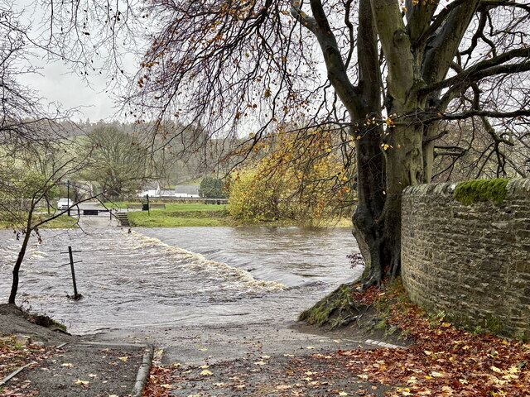

Figure 1: Flooding due to Storm Claudia. © Trevor Littlewood, Geograph CC BY-SA 2.0.

A total of 119.6mm of rainfall was recorded at the Natural Resources Wales rain gauge in Gwent, south-east Wales and 80.6mm in Worcestershire, England. Although heavy rainfall caused most of the problems, the storm also brought strong winds, with speeds of 63mph (101kph) recorded in Gwynedd, Wales and 68mph (109kph) in Cumbria, England. The severe and widespread flooding in Monmouth was so serious that emergency services declared a major incident in Monmouthshire.

Due to a high-pressure system from the Arctic that had formed over parts of northern England and Scotland, Storm Claudia was stopped from moving further north and was, therefore, concentrated in particular parts of the UK.

Some of the effects of the storm in the UK are summarised in the table below:

Social | Economic | Environmental
Dozens of people had to be rescued from their homes or evacuated in Monmouth. | According to the UK Parliament 57 properties were flooded. However, 18,000 properties were protected by flood defences. | River Monnow in Monmouth recorded its highest ever water level at 6.658m bursts its banks causing flooding in the area.
The fire and rescue services in Monmouth reported that hundreds of homes were without power. | Train services were delayed or cancelled in parts of England and Wales on Saturday 15th November with Great Western Railway reporting that all lines between Swindon and Bristol Parkway were blocked as well as severe impacts to services between London Paddington and Swansea. | Heavy rainfall meant a significant increase of water levels in reservoirs, rivers and aquifers in Yorkshire with Sheffield’s reservoirs now 80% full, an increase of 29% from the previous week.

Figure 2: Table of effects from Storm Claudia in the UK © RGS

Effects across Europe
Storm Claudia first appeared as a slow-moving band of rain in the Galicia, NW Spain with 80-150mm of rain falling in 24 hours from Wednesday November 12. Due to previous rainfall, the already saturated ground meant that localised flooding occurred in Spain and Portugal. An elderly couple died inside their flooded home in Fernao Ferro when the River Tagus near Lisbon burst its banks.

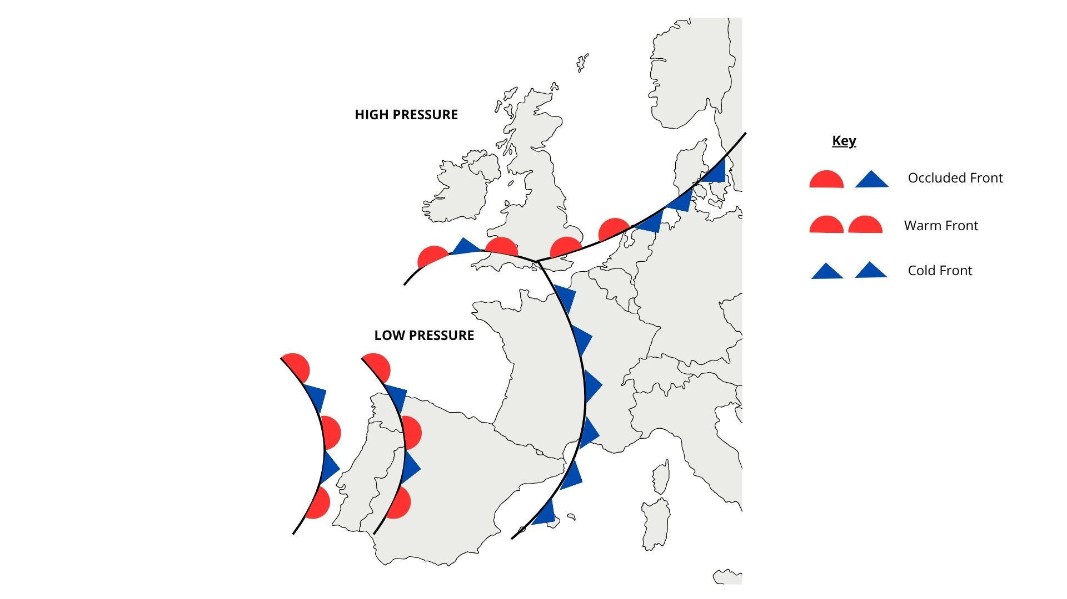
Figure 3: A simplified weather map showing the pressure systems and fronts from Storm Claudia © RGS

Concentrated strong winds which were believed to be a tornado formed in Albufeira, Portugal on Saturday November 15, destroying caravans in a campsite and damaging a nearby hotel. As a result, an 85-year-old British woman died, and 28 people were injured.

The storm brought in warm, moist air from the subtropics which contributed to temperatures reaching 29.8ºC in south-west France – the highest ever temperature recorded in the country for November. This moisture ridden air collided with the colder air from the north bringing a band of frontal rain across northern parts of Europe.

Responses
The Met Office issued yellow weather warnings for rainfall across most of southern England and Wales with Amber warnings issued in central Wales to the Midlands as well as south-east Wales. Similar warnings were issued across the Algarve in Portugal.

In Wales, emergency teams responded to over 80 calls for support from the public and assisted with evacuations, cleared areas of fallen debris and checked on those who chose to stay in their properties. In addition, the local community, including charities and businesses, offered shelter, food and clothing for those who had been affected by the storm.

The Welsh Government has made over £2.5m available to support funding for grants for those affected by the flooding. Households can apply for grants between £500 and £1000 to help with recovering losses.

Although there were flood defences in place, there are calls for improvements to ensure these defences can withstand increased flood risk in areas such as Monmouth.

In Portugal, rescue teams were dispatched to the campsite in the Algarve which was affected by the suspected tornado as well as to flooded areas in Lisbon to help treat those who had been injured or trapped due to the weather event.

Further Reading
Amber warnings come into force as Storm Claudia brings heavy rain and flooding to UK. BBC 13 November 2025
British woman, 85, killed after storm at Portuguese campsite. BBC, 15 November 2025
Storm Claudia kills three in Portugal, causes flooding in Britain. Reuters, 16 November 2025.
Major incident still in place after Storm Claudia causes severe flooding. BBC, 14 November 2025.
Weather tracker: Storm Claudia brings more flooding to Portugal and Spain. The Guardian, 17 November 2025.
Ruined furniture dumped as town calls for better flood defences. BBC Wales 17 November 2025.
Storm Claudia brings intense rain to England and Wales. Met Office 14 November 2025.
https://www.metoffice.gov.uk/about-us/news-and-media/media-centre/weather-and-climate-news/2025/storm-claudia-brings-intense-rain-to-england-and-wales

Storm Claudia, Volume 775, UK Parliament, November 18, 2025

