Nigeria

Introduction
Nigeria is an ethnically and culturally diverse country in West Africa. Abuja, a planned settlement, replaced Lagos as the capital city in 1991 due to its central location and greater potential for expansion. However, Lagos remains the country’s financial hub.
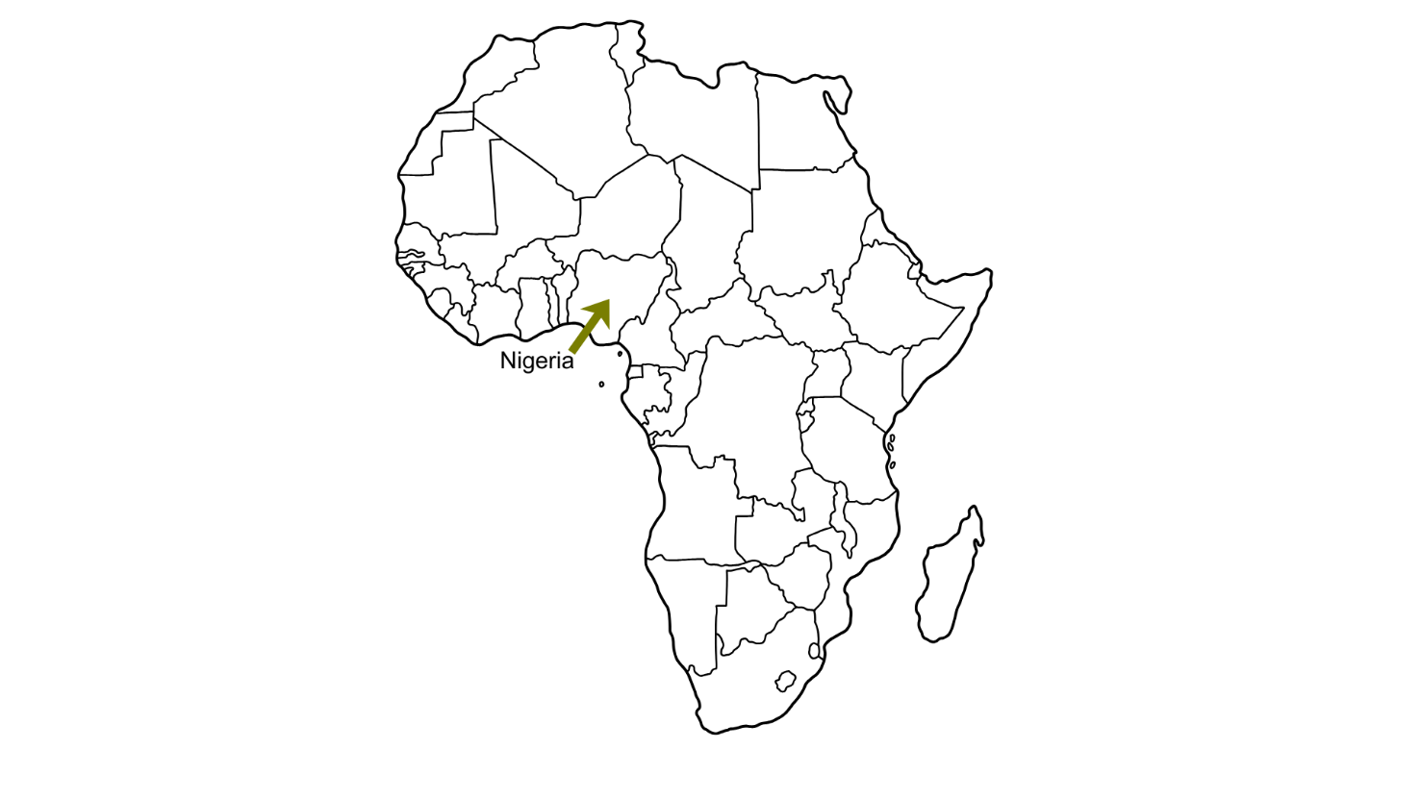
Figure 1: Location of Nigeria © RGS

Home to 371 ethnic groups and with over 500 native languages spoken, Nigeria boasts a vibrant cultural landscape. However, even with such diversity, one ethnic group - The Hausa-Fulani - holds significant political influence and has been the dominant force in Nigerian politics since the country gained independence from Britain in 1960.

There are a range of climates varying from arid savannah in the north, to tropical in the south. Consequently, the distribution of precipitation is uneven, leaving some areas without water for prolonged periods of time.

The country is rich in natural resources, especially natural gas and petroleum. Using GDP as a measure, the country was ranked the 30th largest economy in the world in 2022. It accounted for 0.47% of the World’s GDP and had a GDP per capita of $2,139.

Development
In 2013, Lord Jim O’Neill, former Chief Economist at Goldman Sachs and the creator of the BRIC (Brazil, Russia, India and China) acronym in 2001, identified the next wave of emerging economies - the MINT (Mexico, Indonesia, Nigeria and Turkey) countries. At the time, Nigeria, along with Mexico, Indonesia, and Turkey, demonstrated strong potential for rapid economic growth, similar to the BRIC nations before them.

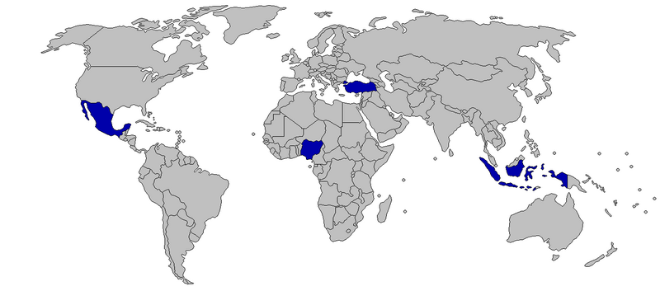
Figure 2: Map of MINT countries. Credit: Wikimedia

However, heavy reliance on a fluctuating oil export market, along with the economic impact of COVID-19 meant that Nigeria did not make as much of an economic gain as first predicted when it was added into the MINT economic group. As a result, money which could have been used to invest in improving standards of living, wasn’t available. Despite these setbacks, Nigeria is still classified as a Newly Emerging Economy (NEE), as it continues to experience economic growth, albeit at a slower pace.

According to a United Nations Development Report (UNDP) in 2024, although there has not been as much income from oil to economically boost its development, the country’s human development index (HDI) has steadily improved from 0.38 in 1990 to 0.548 in 2022. This classifies Nigeria as having a low to medium level of human development.

The main reasons for this level are gender inequality - Nigeria had the highest Gender Inequality Index in Africa in 2021 at 0.68 - and extreme wealth disparity, with 33% of the population classified as multidimensionally poor, according to the Multidimensional Poverty Index (MPI).

Population
Nigeria is the most populous country in Africa and 5th in the world rankings, with a population of 237 million in 2025. Projections indicate that this figure could surpass 337 million people by 2050.

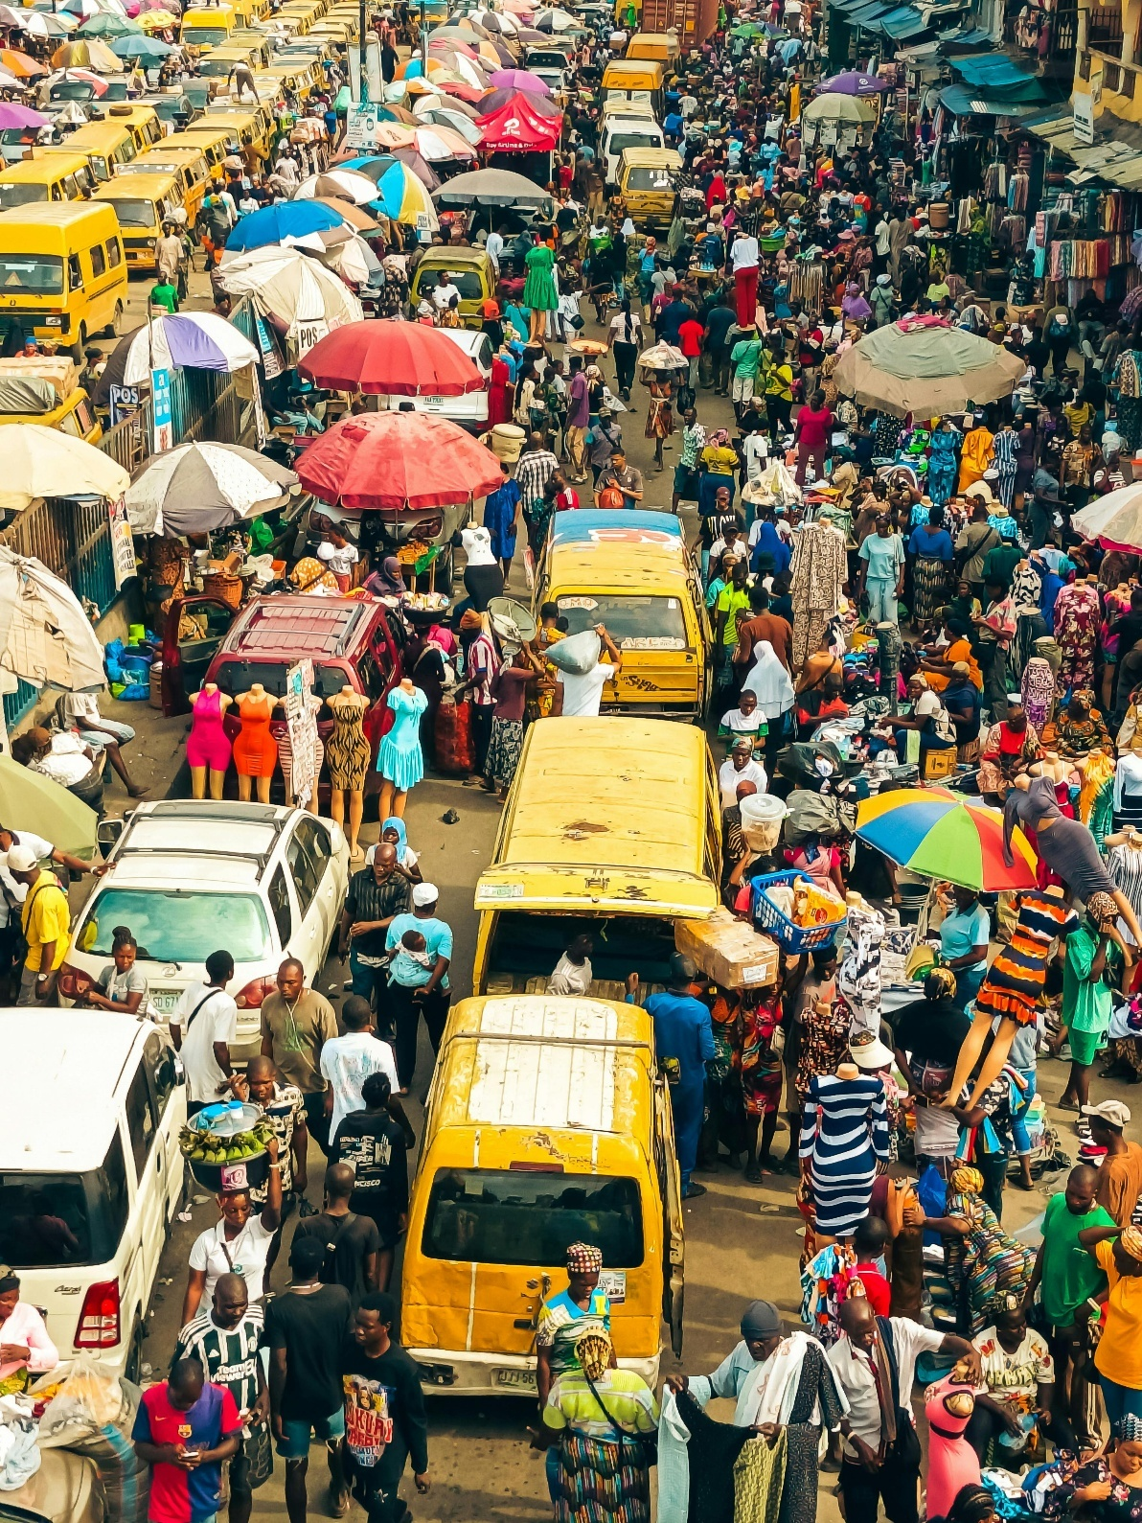
Figure 3: Crowded street in Lagos, Nigeria. Image Credit: Onakoya Opeyem, Pexels

As of 2024, Nigeria’s birth rate stands at 35.7 per 1,000 people, reflecting a 0.95% decline from 2023 and continuing a gradual decrease over the past 45 years. However, the birth rate remains significantly higher than the global average, with stark regional differences. In southern Nigeria, the average woman is expected to have 3.3 children in her lifetime - a rate comparable to the global average in 1990. In contrast, the birth rate in northern Nigeria is 7.4 children per woman, exceeding the average global level recorded in 1800.

Opportunities
With 60% of Nigeria’s population being under the age of 25, the country has a unique opportunity for growth and innovation. The creativity and ingenuity of young Nigerians are shaping new cultural trends and expanding Nigeria’s presence on the world stage. This has the potential to drive substantial economic progress and has already been seen in the rise of Nollywood and the reemergence of Afrobeats in modern music. In addition, the role of agriculture and livestock farming are fuelling opportunities for this growing nation.

Nollywood

Nollywood is the colloquial (informal) name given to the film industry in Nigeria. It is the world's second-largest film industry and contributes more than $600 million to Nigeria's GDP. It serves as both a regional and international cultural force, positioning Nigeria as the headquarters of African cinema.


Figure 4: Filming in Nigeria. Image Credit: Glsts and Thrills Studios, Pexels

The industry is mainly based in an area called Surulere – a densely populated area of Lagos originally known as a route leading to the Eko Bridge, connecting Lagos Mainland with Lagos Island and Victoria Island. Today, Surulere has evolved into a major creative hub for film and entertainment. The movie industry has grown rapidly, and streaming companies such as Netflix invest in the films and series produced here to show on their platform. In 2020, Netflix released its first Nigerian original series. This highlights the global growth and success of Nollywood.

Afrobeats

Afrobeats, with its roots in the 1960s through Nigerian musician Fela Kuti, has gained new popularity in the past decade linking diaspora groups and attracting mainstream audiences alike. In 2023, Afrobeats accumulated 14 billion streams on Spotify. Streaming platforms like Spotify and Netflix have played a crucial role in expanding the global reach of Nigeria’s music and film industries.

Agriculture

While oil remains Nigeria’s best-known export, agriculture is the foundation of the economy, providing livelihoods for millions. In 2023, 33% of Nigerians were employed in agriculture, with key crops including millet, sorghum, cassava, and yams.

Nigeria is the largest producer of rice in Africa, harvesting over 8.5 million metric tons (about 1.3 million African elephants) in 2022. On average, Nigerians consume 39.7 kg of rice per person per year. The country also leads the world in cassava production, accounting for 20% of global output, with the majority (66%) grown in the south. However, large-scale commercial farms are rare, and most agricultural production is carried out by smallholder farmers.

Livestock (pastoralism)

Although there is still a high number of imported livestock in Nigeria, as demand far outstrips supply, pastoralism plays a crucial role in meeting the needs of the country’s emerging middle class. Around 60% of livestock farmers are based in the semi-arid northern region. Livestock farming has grown exponentially, with Nigeria now home to nearly 21 million livestock heads in 2022. The sector continues to expand in importance, supporting both rural livelihoods and evolving dietary preferences.

Challenges
Although birth rates are starting to slow down, the overall population of Nigeria is still growing. This is especially true in cities such as Lagos, which attracts people through internal migration mainly from rural areas. As more people move to these urban centres and start families, the population continues to grow through both migration and natural increase. This rapid urban growth creates several challenges, including traffic congestion, air pollution, shortages of housing, and difficulties managing waste.

Waste management

Nigeria’s National Policy on Solid Waste (2020) states that ‘Nigeria produces a large volume of solid waste out of which less than 20% is collected through a formal system’. This means that 80% of waste remains uncollected and unsorted, posing serious public health and environmental risks and is a major concern for the government. However, with support of private funding, NGOs and other organisations such as Tearfund, a policy has been developed to help tackle the solid waste issue and create a national approach to a cleaner future for the country.

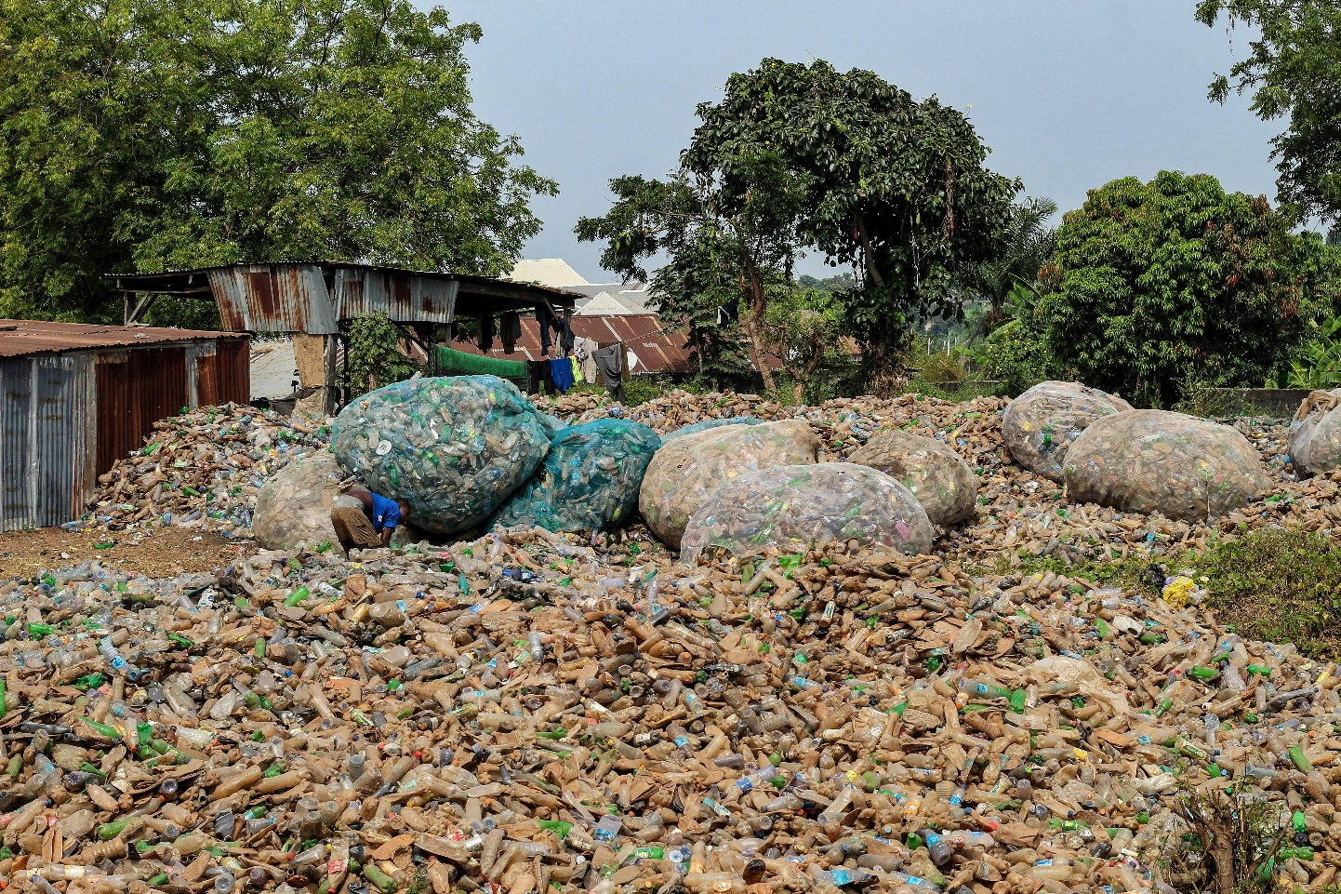

Figure 5: Waste collection in Nigeria. Image Credit: Fatima Yusuf, Pexels

Traffic congestion

Traffic congestion in Nigeria’s urban centres is a major issue, worsened by limited infrastructure investment, small road networks, and a lack of alternative transport options. Commuters often spend hours in gridlocked traffic, impacting both mental health and air quality due to increased vehicle emissions. To address this, plans are underway to expand and improve road networks, introduce dedicated bus lanes, and, in the case of Lagos, develop rapid transit systems. These efforts aim to ease congestion and modernise urban infrastructure.

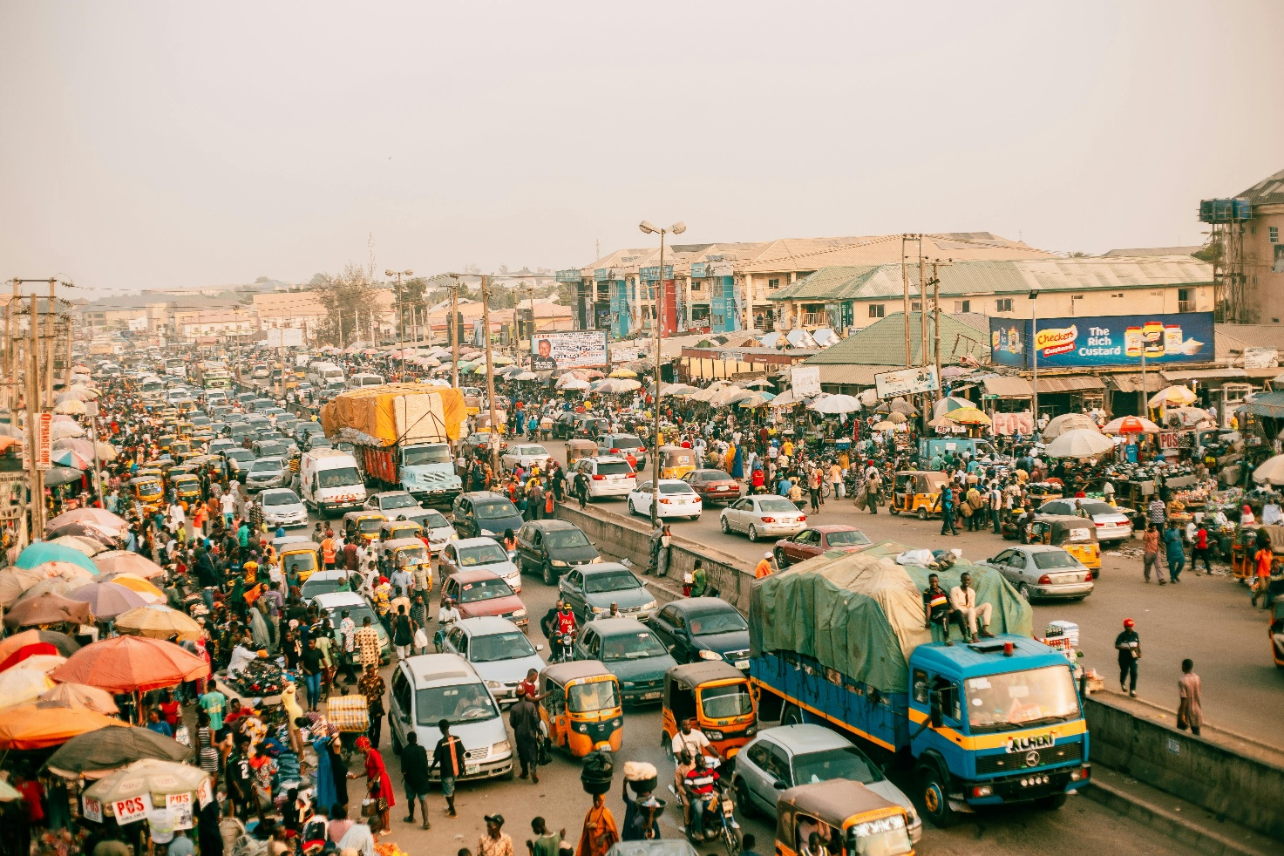

Figure 6: Busy street with traffic congestion in Nigeria. Image Credit: Meshack Emmanuel Kazanshyi, Pexels

Housing

Nigeria faces a housing deficit of an estimated 17 million units. The lack of affordable (and available) housing across Nigeria has resulted in the creation of densely populated, informal settlements, many of which lack access to portable (piped) clean water, sanitation services and reliable electricity. Coupled with the reliance on imported building materials and inadequate infrastructure, housing issues present significant challenges for both Federal and State Governments.

Despite national housing programmes dating back to the 1960s, successive governments have struggled to address the crisis. Therefore, there are calls to introduce a national government-led viable mortgage scheme to enable more of the population (not just the top 1% high-income earners) to access affordable housing. Additionally, using locally sourced building materials - such as cement from factories in Calabar, Sokoto, and Shagamu - could help reduce construction costs and improve housing affordability.

Investment
Nigeria is Africa's third-largest host economy for FDI (foreign direct investment), after Egypt and Ethiopia, attracting investments in hydrocarbons, energy, and construction from both governments and TNCs (transnational corporations). Although 2022 saw a negative FDI flow (-$187 million), new project announcements rose by 24% in the same year.

Major projects include Airtel’s (India's leading telecom provider) investment in a $731 million data centre in Lekki and Sun Africa's (Clean Energy Solutions) $1.8 billion solar power and battery facility.

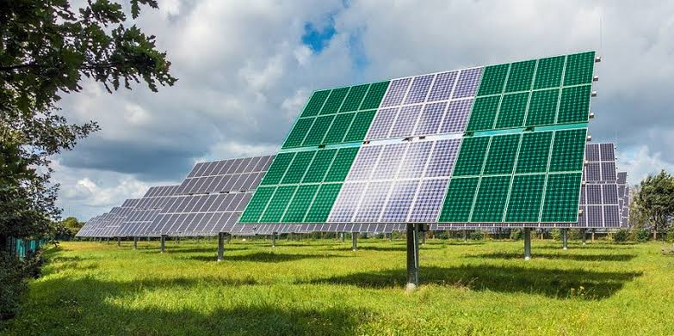
Figure 7: Ashama Solar Power Station. Newtrains, via Wikimedia Commons. CC BY-SA 3.0

The country’s total FDI stock stands at $88.2 billion (18.5% of GDP), with oil and gas as the dominant sector, followed by telecommunications, manufacturing, real estate, and agriculture. The UK remains a key investor, while China has increased its presence in infrastructure. The United States is also a major player, particularly in oil and gas.

Nigeria aims to reduce its oil dependence by developing a competitive manufacturing sector. Key advantages include a partially privatised economy, a favourable tax system, rich natural resources, and low labour costs. However, corruption, political instability, security issues, weak infrastructure, and bureaucratic hurdles limit FDI potential.

Activities
1. Use the following link to read about the climatic and cultural range in Nigeria. Find or draw an outline of Nigeria then add the following:

a. The location of Lagos and Abuja.
b. Annotations identifying the main climatic regions.
c. Annotations identifying the main cultural regions.

2. Analyse the map you have created. What patterns do you notice? Is there a link between culture and climate?

3. Look at the five generic population pyramids below.

Five Stages of Population Pyramids
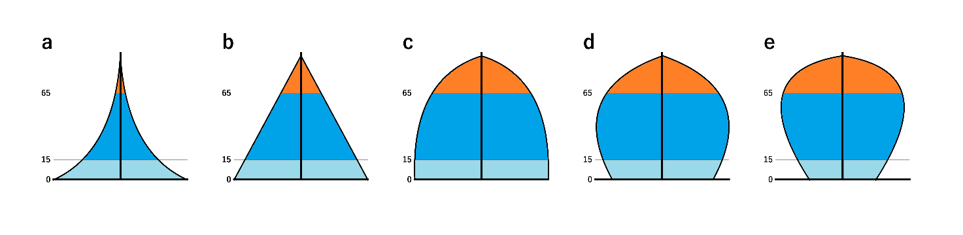
Zero Growth
Negative Growth
Severe Negative Growth
Slow Growth
Rapid Growth
Figure 8: Five stages of population pyramids. Source: Wikimedia

a. Add the relevant letter from the pyramids above to the descriptions below. The first one has been done for you.

Description | Letter
Declining birth rate, low death rate | C
Low birth rate, low death rate
High birth rate, rapid fall in each upward age group due to very high death rate
High birth rate, fall in death rates
Very low birth rate, low death rate, older population

b. Using the data in the table below, create a population pyramid for Nigeria using the population pyramid template.

c. What type of pyramid does Nigeria’s population show?

Population Pyramid Age | Male % | Female %
0-4 | 8.1 | 7.9
5-9 | 7.1 | 6.9
10-14 | 6.4 | 6.2
15-19 | 5.6 | 5.4
20-24 | 4.6 | 4.5
25-29 | 3.8 | 3.7
30-34 | 3.1 | 3.1
35-39 | 2.7 | 2.6
40-44 | 2.3 | 2.3
45-49 | 1.9 | 1.9
50-54 | 1.5 | 1.5
55-59 | 1.1 | 1.2
60-64 | 0.9 | 0.9
65-69 | 0.6 | 0.7
70-74 | 0.4 | 0.4
75-79 | 0.2 | 0.3
80+ | 0.1 | 0.1

Data source: Statista

Population Pyramid Template

Male |  |  |  |  |  |  | Female
 |  |  |  |  |  | 80-84
 |  |  |  |  |  | 75-79
 |  |  |  |  |  | 70-74
 |  |  |  |  |  | 65-69
 |  |  |  |  |  | 60-64
 |  |  |  |  |  | 55-59
 |  |  |  |  |  | 50-54
 |  |  |  |  |  | 45-49
 |  |  |  |  |  | 40-45
 |  |  |  |  |  | 35-39
 |  |  |  |  |  | 30-34
 |  |  |  |  |  | 25-29
 |  |  |  |  |  | 20-24
 |  |  |  |  |  | 15-19
 |  |  |  |  |  | 10-14
 |  |  |  |  |  | 5-9
 |  |  |  |  |  | 0-4
12 | 10 | 8 | 6 | 4 | 2 | 0 | 2 | 4 | 6 | 8 | 10 | 12
Percent (%) of Population

4. Watch West Africa ENRG is powering Nigeria using rubbish about waste recovery in Lagos.

a. Why is the potential for clean energy ‘huge in Nigeria’?

b. WestAfricaENRG is a regional TNC in the Economic Community of West African States (ECOWAS) that specialises in municipal solid waste management. They have set up the first waste recovery facility in Alimosho, Lagos.

What do waste company WestAfricaENRG plan to do in the future?

c. What percentage of the WestAfricaENRG workforce are female and why is this important in a country’s development?

d. What will the new clean energy waste facility support in the future in Lagos?

5. Watch this video on e-waste.

a. Describe in detail what happens to the e-waste.

b. What opportunities and problems does this bring?

6. Plot a triangular graph using the data below on agricultural land, forested area and urban land use in Nigeria between 1990 and 2020. To distinguish one year from another, colour code the data per row.

Nigeria date | Forested area % of land area | Agricultural area % of land area | Urban/ rural areas % of land area
1990 | 19% | 68% | 13%
1995 | 17% | 75% | 8%
2000 | 14% | 78% | 8%
2005 | 12% | 80% | 8%
2010 | 10% | 77% | 13%
2015 | 8% | 78% | 14%
2020 | 7% | 78% | 15%

Data Source: World Bank open data
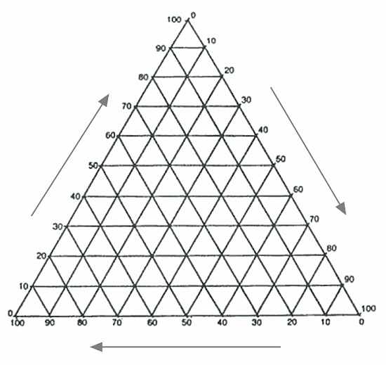
Challenge: There is further reading from the FT on the loaming crisis of Sahel nomadic herders versus Nigerian farmers. Create a costs and benefits table summarising what you have found.

7. Take one of the challenges Nigeria faces and imagine that you are responsible for improving that particular challenge.

Write a letter to explain the steps you would take to improve this challenge. If there are other obstacles you need to overcome, what would you do to address them?

8. Study the data in the table below.

Year | FDI (% GDP) | FDI (US$ billion)
2005 | 2.8 | 4.98
2007 | 2.2 | 6.04
2009 | 2.9 | 8.56
2011 | 2.1 | 8.84
2013 | 1.1 | 5.56
2015 | 0.6 | 3.06
2017 | 0.6 | 2.41
2019 | 0.5 | 2.31
2021 | 0.8 | 3.31
2023 | 0.5 | 1.87

Data source: World Bank open data

a. Using the data table and the graph paper below, complete a combination graph (bar and line) showing the net inflows of FDI as both a % of GDP and in US$.



b. Analyse the results of the graph created.

Extrapolation is when you make a statistical forecast (prediction) using a historical trend. Using your combination graph answer the following questions:

c. What do you think the future trend will be for FDI investment in Nigeria? Extrapolate the investment data up to 2023.

d. Challenge: read this article and summarise the role the UK has in investing in Nigeria. There are quite a few pages so you might want to focus on one area.

Further reading
All the suggestions below are free to access. Remember you can read content from the FT for free if you are a student aged 16-19 or a teacher. Sign up by visiting http://bit.ly/FTschools.

Financial Times, special report: investing in Nigeria

Nigeria’s Brics partnership: economist outlines potential benefits, The Conversation 5th February 2025

World Bank: Nigeria Overview

Netflix Naija: creative freedom in Nigeria’s emerging digital space? The Conversation, 19th March 2020

Nigeria country profile, BBC 29th July 2023

ENRG waste

Nigerian recyclers

Nigeria needs to close the financial inclusion gap for women smallholder farmers. The Conversation, 6th March 2020

Boosting rice production in Nigeria. BBC, 12th April 2019

Nigeria’s plastic bottle collectors turn waste into wealth: survey sheds light on their motivation. The Conversation, 30th January 2025

https://guardian.ng/nigerian/why-is-nigeria-culturally-diverse/
https://www.worldometers.info/gdp/gdp-by-country/
https://www.worldbank.org/en/topic/poverty/brief/multidimensional-poverty-measure
UNDP development report on Nigeria, 20th March 2024
Statista analysis of the population of Nigeria, 30th September 2024
Stock of live cattle in Nigeria 2010 – 2022, Statista
Nigeria’s National Policy on Solid Waste (2020)
https://www.tearfund.org/about-us/our-impact/where-we-work/nigeria
MeritAbode blog: Affordable Housing in Nigeria, 18th July 2024
Foreign direct investment (FDI) in Nigeria, Lloyds Bank May 2024

