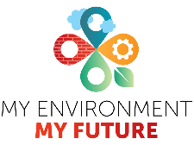
Careers that build sustainable cities: Bristol Temple Quarter

The green boxes showcase geographical jobs in the built environment sector. When you are reading this case study and examining the links, keep in mind all the geographical knowledge and skills that have been used to create each element of the development.
For more info on geographers in the built environment sector, visit: https://memf.careers/

Cities across the UK are experiencing rapid growth, climate pressures, and shifting population needs. Meeting these challenges requires a diverse range of professionals who can plan, design, negotiate, and deliver places that are resilient, inclusive, and future focused.

Bristol Temple Quarter, and the area within it of St Philip’s Marsh, offer a powerful example of how complex city transformation unfolds. This case study examines the preparatory thinking and actions that must occur for long term economic, social, and environmental sustainability to be achieved. Alongside this, the careers involved in the strategic thinking, planning and preparatory work are explored.

“This is a complex picture of evolution… you cannot ignore what’s there today.” Ben Mason, Senior Principal at Cities Studio

The 135-hectare (ha) regeneration project is one of the largest in the UK and has taken a mammoth amount of Master Planning and Place-making by the Bristol Temple Quarter Limited Liability Partnership (BTQ LLP) to deliver sustainable development.

This case and place study will examine the overall development of the area and then focus in on the St Philip’s Marsh future planning and how they hope to achieve sustainability.

Three professionals kindly gave their time to produce this case study:
- Ben Mason who is Senior Principal at Cities Studio (Mott MacDonald)
- Jane Greenaway who is the Consultation and Engagement Project Lead for the Bristol Temple Quarter LLP
- Polly Hopkins who is the Company Secretary for Storm Geomatics as well as being a key member of The Survey Association's drive to promote geospatial surveying

What is Place-making?
Environmental Careers involved in master planning:
- Ecology officer
- Environmental advisor
- Field Surveyor
- Biodiversity Advisor
- Project Manager
The London Borough of Hounslow advertised the role of an Ecology Officer in August 2026, salary £52,000-55,000
An Ecology Officer will help with the delivery of major development sites; ensuring they meet Biodiversity Net Gain obligations and the Council’s ambitions for a cleaner, greener borough.
The officer will also assist with the development, delivery and monitoring of important Council projects including its Nature Recovery Strategy Action Plan, Green and Blue Infrastructure strategy and Parks Masterplan and monitoring key performance indicators. (13)

According to the Urban Design Lab (6), place-making is an approach to urban design that prioritises people over infrastructure; it suggests that places should inspire and promote social interaction and cultural exchange thus promoting a sense of place and identity that can be vital elements of social sustainability.

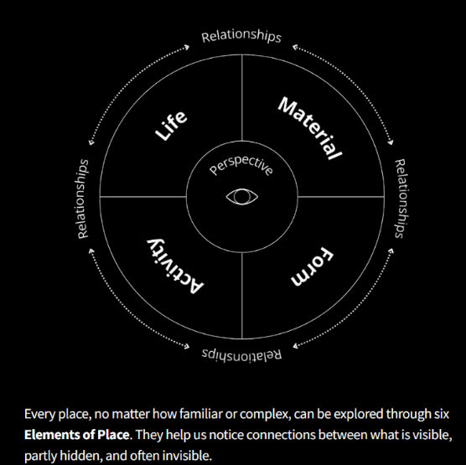
The “Place Is…” project from IF Design Labs put forward six Elements of Place as shown in Figure 1 that are used to “help us notice connections” between the various elements of an area so that we make better decisions about how we can change places (7). IF Design Labs use the term Place Futuring to support in envisioning the future of neighbourhoods that are imagined and created together rather than inheriting from what was once there.
Figure 1: Six Elements of Place, with permission from IF/Design labs (7)
The concept of Place Futuring is a key challenge for the Bristol Temple Quarter LLP as the majority of the 135ha are brownfield sites; either derelict or still in use and need regenerating or re-purposing. Bristol Temple Quarter and St. Philip’s Marsh offer a powerful example of how complex city transformation unfolds.
Unlike greenfield developments, these areas must evolve within an existing urban fabric - one shaped by heritage, geography, infrastructure, and active business ecosystems.

As Ben Mason, Senior Principal at Cities Studio (Mott MacDonald) notes, “This is a complex picture of evolution… you cannot ignore what’s there today.”

Ben was involved in the initial planning and thinking and outlines that a phased approach is taken by Master Planners as they know that such massive developments could take 25 years. He acknowledges that “you have to start somewhere,” by setting out a roadmap that is informed by a wide range of disciplines such as urban designers, transport planners, landscape architects, vision architects, geospatial surveyors and environmentalists (to name a few). Polly Hopkins, of Storm Geomatics, is clear that "it is vital that geospatial surveyors are around the table from the beginning of a project." Without the geospatial element, expensive mistakes can occur.

Ben Mason describes that everyone involved in a development needs a vision of how such large projects can evolve in phases, and highlights that at every stage there are geographical elements to consider.

To facilitate this, the original master planning starts with a contextual analysis of the whole 135ha; this ensures that the area is not just arbitrarily divided up but that the character of each place emerges in the plans. To do this, “multiple lenses” are applied such as transport infrastructure, flooding maps, business and housing to ensure that all stakeholders are considered and consulted.

Strategic thinking is necessary to ensure success in placemaking by first considering what the city needs and how those needs will be met and what steps they will need to go through.

Ben Mason describes how each of the areas within the development area is considered in three ways to ensure sustainable place making:
- What characterises the place now? It is vital to appreciate the geography, history and land use of the area including constraints such as rivers, flooding, heritage assets, existing employment and business ecosystems as well as ecological and land quality issues, land ownership and infrastructure and transport networks
- What is this place likely to become?
- What is our ability to influence the changes this place will undergo?
Ben states that geographers are intrinsically able to understand that you must know what the place is like now.

For Placemaking to be successful, consultation is vital. As the Consultation and Engagement Project Lead for the BTQ LLP, Jane Greenaway has a key role in the consultations needed to deliver the aims as seen in figure 2.
What does a Consultation and Engagement Project Lead do?
Jane says that there is no such thing as a typical day. In the week that she was interviewed, she had met with the Youth Council, led the monthly walk with members of the public to review the plans, taken out KS4 and KS5 geography groups, and met with a range of consultation groups to hear their views on the masterplan. She works in person, in supermarkets, updates and briefs councillors, works in online engagement and importantly meets with accessibility advisory groups. After meetings, the qualitative and quantitative data collected needs analysing and then decisions need making.
Soft skills needed include:
- Empathy
- Listening
- Diplomacy
- Conflict resolution
- Clear communication
- Cultural awareness
- Patience and resilience

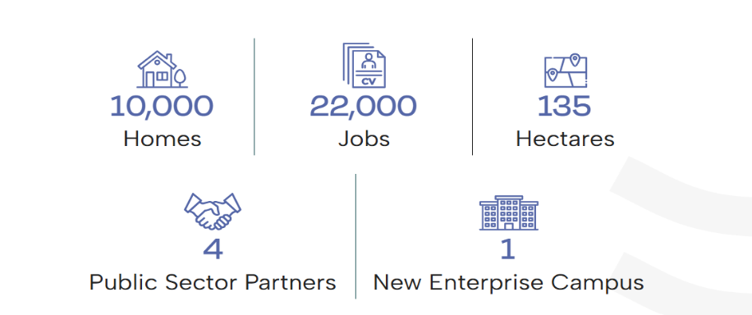
Figure 2: Key aims for the Bristol Temple Quarter Regeneration project. (with permission from Bristol Temple Quarter LLP).

One of the reasons that Jane’s job is so varied and requires so many soft skills is the complexity of a project like this one. “Communication, teamwork and problem solving are now ranked above technical ability as the most important skills for early-career workers. These ‘soft skills’ aren’t soft at all, they’re foundational and that’s becoming harder to ignore.” (11)

To be sustainable, the BTQ LLP wants the following to be in place:
- A mix of housing types including housing that is affordable, varied and accessible; “access is key to affordability”
- An integrated business quarter
- Transport networks that include active travel, a reduction in cars, more green space and more pleasant routes for walking
- A thriving community – engagement and consultation has shown that access groups prefer smaller and more plentiful green spaces with walkable spaces, whilst other groups have expressed a preference for larger open spaces. This feedback, including the differing viewpoints, feed into the plans being drawn up
- The Big Heat network (Heat network zones “recycle excess heat – generated for example by data centres or from factories – to enable the heating of several buildings at once.” Bristol is one of six areas announced by the government in October 2024). (8)
- Flood mitigation measures
- Place-making measures

St Philip’s Marsh
Civil engineers design and integrate the physical systems that make cities function.

Ben Mason’s career illustrates how engineers often “zoom out” from individual structures to city-scale thinking.

Key responsibilities of a civil engineer include:
- Designing within constrained urban environments
- Integrating utilities, transport, streets, parks and accessible spaces for the public
- Working across multiple agencies
- Balancing technical details with strategic vision
This blend of micro-level understanding and macro-level strategy is essential for sustainable city building.

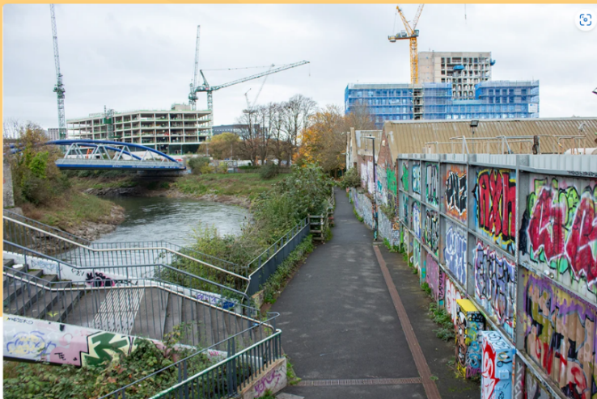
Picture with permission from St Philip’s Marsh - Bristol Temple Quarter

The aims of the LLP for St. Philip’s Marsh are a “series of sustainable, mixed-use neighbourhoods that are integrated with their surrounding communities” and would include affordable housing, thriving business and community infrastructure to support the well-being of all and meet the future needs of the growing city of Bristol (1).

Despite what the picture may suggest, St Philip’s Marsh is not derelict brownfield land. It contains thriving businesses; most are in rented premises, but the area has fewer than 1,000 residents. The long-term plan anticipates 7,500 homes and over 20,000 residents, requiring careful integration of existing uses with future aspirations. In addition to the housing and community aims, the planners want a series of “new employment opportunities and business spaces that increase and diversify the jobs in the area whilst supporting existing businesses and employers” (1). To ensure sustainability, they plan to ensure that this area is a low-carbon and climate adapted area for all users including residential and commercial. They are planning for active travel, green infrastructure, and biodiversity to be at the heart of the development (1).

The same evolutionary and character processes that have been applied to the overall project have been applied to the St. Philip’s Marsh area. As the map shows, it has been split down into six different character areas as the planners are determined that it will not become a monoculture.
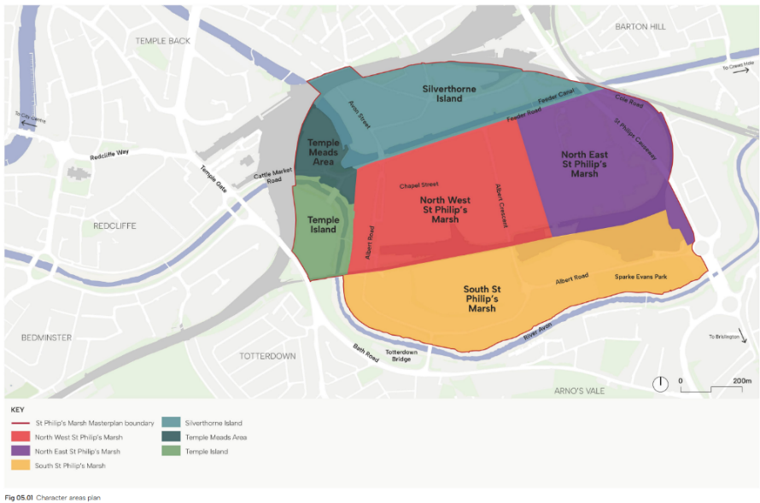

Map 1: the six character areas of St. Philip’s Marsh (1). With kind permission from Bristol Temple Quarter LLP.

Key contextual factors include:
- The River Avon and feeder canal
- Flooding and climate resilience
- Historic assets such as the Grade I listed Temple Meads Station
- Transport networks and constrained pedestrian routes
- Existing employment land and business ecosystems
- Lack of public transport
- Fragmented land ownership

Understanding these constraints is essential before any vision can be developed.

One thing that all six areas of St. Philp’s Marsh have in common is their proximity to water. Bristol is known all over the world as a port-city and that maritime heritage influences much of its character. However, people and property face an increasing risk of flooding as climate change brings an increased severity and frequency of storms that lead to both more water in the River Avon and the increased risk from tidal surges from the Severn Estuary. The Bristol Avon Flood Strategy (now known as Avon Riversides 2100, (18)) suggests that “a major flood event that currently has a 0.5% (1 in 200) annual chance of occurring now, could become as frequent as once a year by the end of the century if no strategic management of the risk is implemented.” (15)

The Environment Agency Flood Map for St. Philip’s Marsh (14) shows that over 50% of it is at risk in Flood zones 2 and 3 (Flood Zone 3 has a greater than 1% annual probability of flooding from rivers and is the highest risk used in the Flood Map).
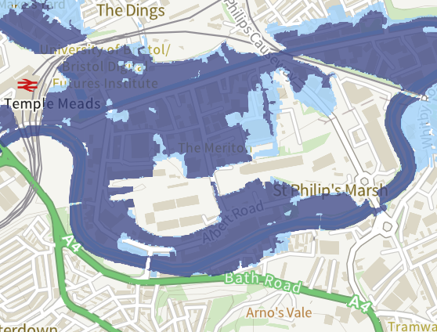
(14) The Environment Agency Flood Map for St. Philip’s Marsh

If you like the idea of working on, in or near water as a part of a Built Environment career then some of these roles may be right for you;
Environmental Advisor, Remediation Specialist, Environmental Engineer,
Structural Engineer

Canalside regenerations have proved popular across Britain in the last 30 years as they are an opportunity to provide waterside living and working along with ecosystem and biodiversity improvements. Canals are human-made waterways and have been in existence in the UK since the Industrial Revolution. Part of their attraction to developers is that they are ready-made blue and green spaces that are already in existence. The Avon Riversides 2100 plan wants enhanced riversides that will provide new open spaces, improved walking, cycling and wheeling routes and a "certainty for new and existing businesses to grow" (18). However, as has been discussed throughout this case study, to ensure long-term sustainability, a range of preparatory planning and activities must take place ahead of any work starting. The age of the canals means that a Bathymetric Survey was needed to ensure the stability of the canal walls. This produces a data image as seen in Figure 3 below. An initial survey conducted by divers was unsuccessful due to the turbidity of the canal, (17) meaning Storm Geomatics were contracted to carry out a digital survey.

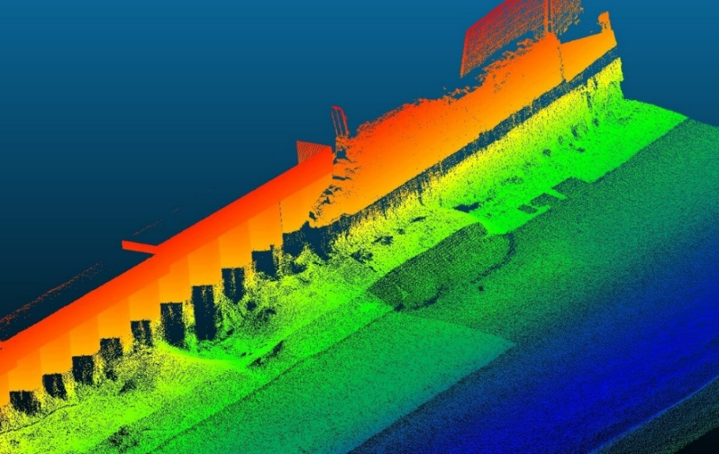
The Hydrographic Surveyors use a range of equipment including laser scanners and involves working on a small survey vessel as seen in Photo 2 below (17).
You may have heard of Surveying as a role, however you may not have realised that there are so many different types of surveyor.

The website Become a Surveyor is an excellent place to start your exploration of surveying as a future career.
If working on and with water appeals to you, one of Storm Geomatics’ surveyors is featured on the website;
Hydrographic Surveyor, Storm Geomatics - Become a Surveyor

Figure 3: Data produced from a Bathymetric Survey of Feeder Canal on the north boundary of St. Phillip’s Marsh (with kind permission from Storm Geomatics (17))

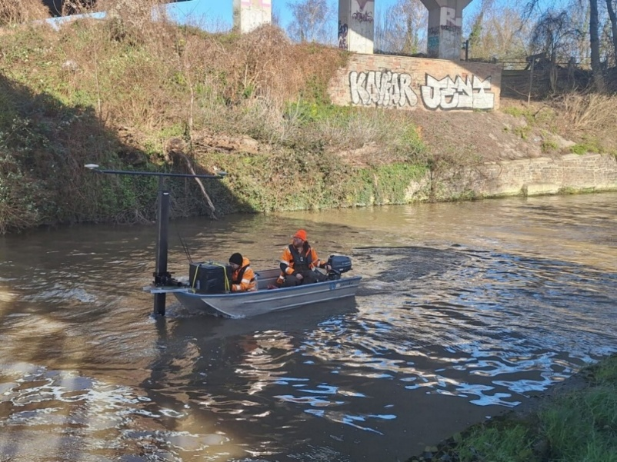

Photo 2 (17): Storm Geomatics staff surveying the Feeder Canal in St. Philip’s Marsh
.

Once the surveyors have completed this work, the planners and designers can move to the next stages.

This case study has examined the preparatory work needed for sustainability in developments, whether they be brownfield or greenfield sites, and examined a range of careers you can explore within those fields. The Bristol Temple Quarter regeneration is a long-term plan and will be providing roles for many years; use the information in this case study to plan your future!
Student Activity – Think Like a Geographer
1. If you were on the Master Planner team for St. Philip’s Marsh, what would be your top three priorities for the area based on this picture? Justify your choices.
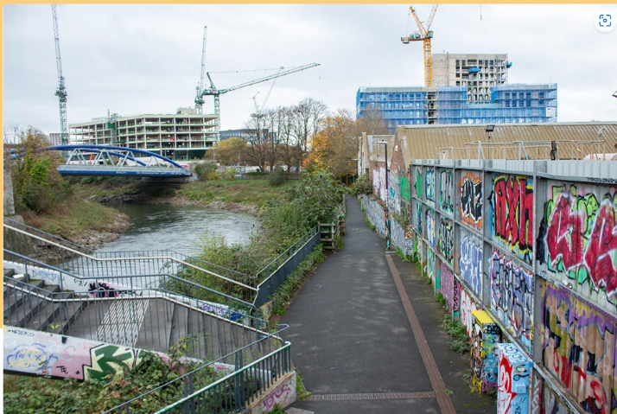

Priority 3
………………………………………………………………………………………………………………………………………………………………………………

Justification
…………………………………………………………………………………………………………………………………………………………………………………………………………………………………………………………………………………………………..

Priority 2
………………………………………………………………………………………………………………………………………………………………………………

Justification
…………………………………………………………………………………………………………………………………………………………………………………………………………………………………………………………………………………………………..

Priority 1
………………………………………………………………………………………………………………………………………………………………………………

Justification
…………………………………………………………………………………………………………………………………………………………………………………………………………………………………………………………………………………………………..

2. Suggest one reason why Planners specify mixed-use neighbourhoods as a way of supporting sustainability?

…………………………………………………………………………………………………………………………………………………..…………………………………………………………………………………………………………………………………………………..…………………………………………………………………………………………………………………………………………………..…………………………………………………………………………………………………………………………………………………..…………………………………………………………………………………………………………………………………………………..…………………………………………………………………………………………………………………………………………………..

3. Look at the overview of the Consultant and Engagement Lead’s role; what geographical skills and knowledge are transferable into this kind of role?

…………………………………………………………………………………………………………………………………………………..…………………………………………………………………………………………………………………………………………………..…………………………………………………………………………………………………………………………………………………..…………………………………………………………………………………………………………………………………………………..…………………………………………………………………………………………………………………………………………………..…………………………………………………………………………………………………………………………………………………..

4. You have studied physical and human geography as a part of your GCSE/ A Level. How would you employ this holistic knowledge to ensure the character of a place as in St. Phillip’s Marsh is retained whilst place-making for the future?

…………………………………………………………………………………………………………………………………………………..…………………………………………………………………………………………………………………………………………………..…………………………………………………………………………………………………………………………………………………..…………………………………………………………………………………………………………………………………………………..…………………………………………………………………………………………………………………………………………………..…………………………………………………………………………………………………………………………………………………..

5. What part do green and blue infrastructure play in ensuring a sustainable development?

…………………………………………………………………………………………………………………………………………………..…………………………………………………………………………………………………………………………………………………..…………………………………………………………………………………………………………………………………………………..…………………………………………………………………………………………………………………………………………………..…………………………………………………………………………………………………………………………………………………..…………………………………………………………………………………………………………………………………………………..

Key terms

Limited Liability Partnership – a legal requirement that combines the benefits of partnerships and corporations. It is good for redevelopment work because it allows for a range of partners to work together from different backgrounds as personal assets are protected.
Affordable housing – Housing for sale or rent, for those whose needs are not met by the market (including housing that provides a subsidised route to home ownership and/or is for essential local workers). The housing meets government rent policy, is at least 20% below local market rents or sale prices and/or offers affordable routes to home ownership. (2)
Active travel – Everyday journeys made by walking, wheeling or cycling. This encompasses modes of transport that involve some sort of physical activity, thus promoting health benefits and reducing emissions. (3)
Mixed-use neighbourhoods - Integrating diverse land uses within a single area to create walkable, efficient, and vibrant communities. (4)
Green infrastructure - A network of multi-functional green and blue spaces and other natural features, urban and rural, which can deliver a wide range of environmental, economic, health and wellbeing benefits for nature, climate, local and wider communities and prosperity. (2)
Soft Skills - In business, soft skills typically focus on collaboration to complete a task, solve problems or brainstorm ideas together. However, collaborating efficiently and productively entails a social aspect that goes beyond work roles and responsibilities to demonstrate that you care about the person just for who they are, not for what they may represent. (9)
Character of Place – the specific qualities, attributes or features of a location that make it unique; affected by endogenous (internal) and exogenous (external) factors. (10)
Bathymetric Survey - a form of hydrographic survey which is used to map out the details of underwater terrain, showing the bed topography that is beneath the body of water, from rivers, lakes, ponds to estuaries. It can be used for a variety of purposes such as flood risk assessments, volume calculations, hydraulic modelling, water quality studies, habitat mapping, and more. (16)
Turbidity – this is when a liquid, in this case, the canal water, is cloudy because of many tiny particles within the water.

References
1. St Philip’s Marsh - Bristol Temple Quarter last accessed 21.07.26
2. National Planning Policy Framework page 70, last accessed 14.07.26
3. www.activetravelengland.gov.uk last accessed 14.07.26
4. Mixed-Use Development → Term last accessed 14.07.26
5. Careers that build sustainable cities: Ebbsfleet Garden City last accessed 14.07.26
6. Placemaking In Urban Design Last accessed 14.08.26
7. Place Literacy — IF Design Labs Last accessed 14.08.26
8. Six towns and cities to pilot clean heating innovation - GOV.UK last accessed 15.07.26
9. 10 Essential Soft Skills (With Examples) – Forbes Advisor last accessed 20.07.26
10. Detailed Notes - Changing Places - AQA Geography A-level.pdf Last accessed 20.07.26
11. The Surveying Skills Gap No One Expected – Get Kids Into Survey, LinkedIn, 20.07.26
12. Bristol Temple Quarter - Welcoming and inclusive, Bristol Temple Quarter is a place built on partnerships. Last accessed 20.07.26
13. Ecology Officer - London Borough of Hounslow Last accessed 20.07.26
14. Map – Flood map for planning – GOV.UK Last accessed 13.08.26
15. Bristol Avon Flood Strategy, Strategic Outline Case Last accessed 14.08.26
16. Bathymetric Surveys UK - Storm Geomatics Last accessed 14.08.26
17. Bristol Canal Regeneration- A Bathymetric Survey - Storm Geomatics Last accessed 14.08.26
18. Avon Riversides 2100 - A long-term project to better protect Bristol and neighbouring communities from flooding along the River Avon up to the year 2100 and beyond.

This resource is produced with the support of the My Environment My Future programme. For more resources, visit: www.memf.careers

