Disaster in the Philippines: Typhoon Haiyan
The Philippines is a disaster prone area experiencing both earthquakes and typhoons in recent years. On 7 November 2013 Typhoon Haiyan hit the Philippines killing over 6,000 people and affecting more 16 million people. It has become the most deadly natural disaster in country’s history. (BBC, 2013). Typhoon Haiyan is known in the Philippines as Yolanda, and was the 25th typhoon to hit the country in 2013.
Devastation in Guian, Philippines after Typhoon Haiyan
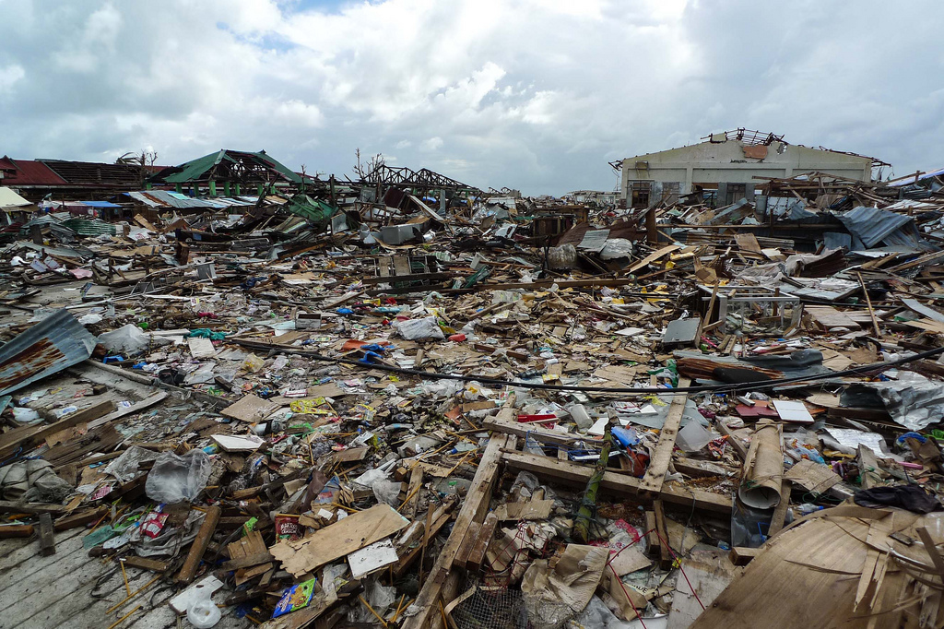
Source: Flickr user robertodevido
When the typhoon made landfall at Samar on 7 November, 315km/h winds caused what was described by local people as ‘a wall of wind and rain’. The winds near Tacloban city in Leyte province, which was one of the worst affected areas, blew water ashore over 7.5m high. As much of the city is less than 5m above sea level meaning that most of the city was completely engulfed by water.
The government issued a major typhoon warning and evacuated thousands of people to shelters prior to the typhoon making landfall but Haiyan was unique in both scale and impact and it went beyond the capacity of preparations. In some areas the risks from the typhoon were not fully understood. Even some of the shelters that were considered safe were totally destroyed.
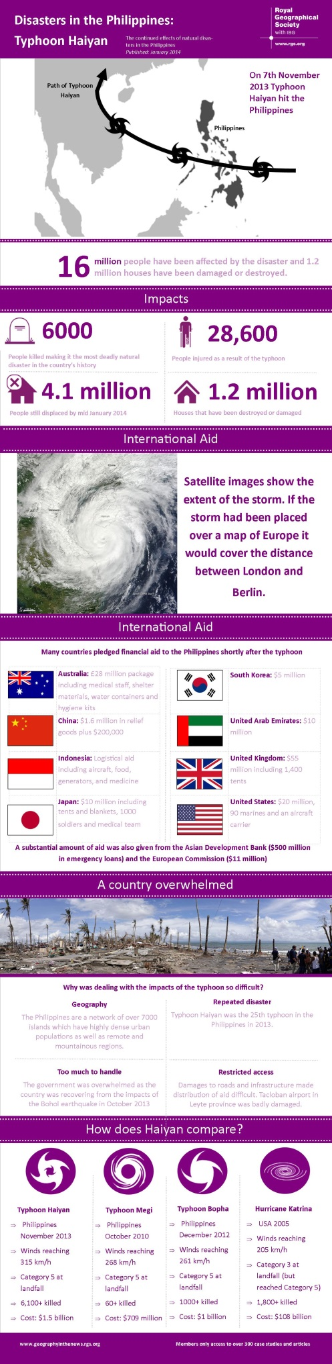

Relevance
This can be used as a case study in the area of natural hazards across most specifications.
AQA – Unit GEO3 Contemporary Geographical Issues: can be used as a case study of a tropical revolving storm, and also when considering hazards associated with weather and climate.
Edexcel – Unit 1 Global Challenges: can be used to explore how physical and human environments combine to cause disasters. Unit 2 Geographical Investigations: will be useful for those covering the optional theme of ‘Extreme Weather’.
IB – Part 2 Optional theme hazards and disasters: risk and response.
OCR – F763: Global Issues: can be used a case study of a tropical storm hazard and for considering the impacts of such storms at different scales.
Pre-U – Component 1: Geographical Issues Section A Hazardous Weather: can be used to explore causes, consequence of and management of hazardous weather event. S
WJEC–Unit 3: Theme 3: Climatic Hazards: can be used as a case study to examine the impacts of hazardous weather and strategies to reduce such impacts.
References

‘DEC Philippines typhoon appeal’
http://www.dec.org.uk/appeals/philippines-typhoon-appeal#map

‘Footage of house being washed away – Plan International’
http://www.youtube.com/watch?v=rS0gv4Xbw7w

Haiyan Southwest Pacific Ocean NASA
http://www.nasa.gov/content/goddard/haiyan-northwestern-pacific-ocean/#.Usa7O9JdXKO

‘Haiyan death toll rises over 5,000’ BBC News 22 November 2013
http://www.bbc.co.uk/news/world-asia-25051606
‘Mapping the Destruction of Typhoon Haiyan’ New York Times 11 November 2013
http://www.nytimes.com/interactive/2013/11/11/world/asia/typhoon-haiyan-map.html

‘Here have a measly 100,000 in aid’ Time 19 November 2013 http://world.time.com/2013/11/13/china-to-philippines-here-have-a-measly-100000-in-aid/

‘Online volunteers map Typhoon after Haiyan’ Guardian 15 November 2013
http://www.theguardian.com/technology/2013/nov/15/online-volunteers-map-philippines-after-typhoon-haiyan

‘Mapping Typhoon Haiyan’ BBC News 12 November 2013
http://www.bbc.co.uk/news/world-asia-24917722

National Disaster Risk Reduction and Management council
http://www.ndrrmc.gov.ph/

‘Supertyphoon Haiyan, Satellite images, BBC News 08 November 2013
http://www.bbc.co.uk/news/world-24866265

Super Typhoon Haiyan, Yolanda in Tacloban City, Philippines
http://www.youtube.com/watch?v=4wrgrJwYdy8
‘The Philippines is devastated as much by unfair debt as typhoon Haiyan’ Guardian 23 December
http://www.theguardian.com/global-development/poverty-matters/2013/dec/23/philippines-devastated-unfair-debt-typhoon-haiyan

‘Typhoon Haiyan Aid in Numbers’ BBC News 14 November 2013
http://www.bbc.co.uk/news/world-asia-pacific-24899006

‘Typhoon Haiyan: China gives less aid to the Philippines thank Ikea’ Guardian 14 November 2013
http://www.theguardian.com/world/2013/nov/14/typhoon-haiyan-china-aid-philippines-ikea

‘Typhoon Haiyan: Tour a Street devastated by the storm’ BBC News 19 December 2013
http://www.bbc.co.uk/news/world-asia-25400193

‘Typhoon Haiyan cuts a path of destruction across the Philippines’ Time 09 November 2013
http://world.time.com/2013/11/09/typhoon-haiyan-cuts-a-path-of-destruction-across-the-philippines/photo/philippines-typhoon-19/

