Introducing the Aosta Valley
x

What is the Aosta Valley like?

Within the Aosta Valley region label any features you feel are important in order to understand the area and its needs with regards to landslide risk management.

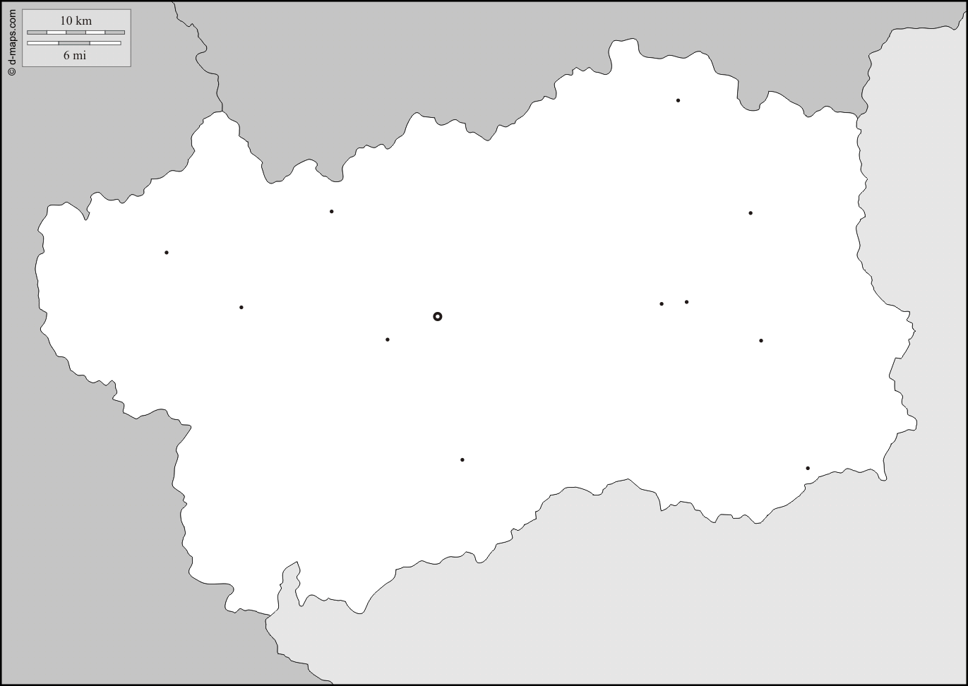
The Aosta Valley region of Italy
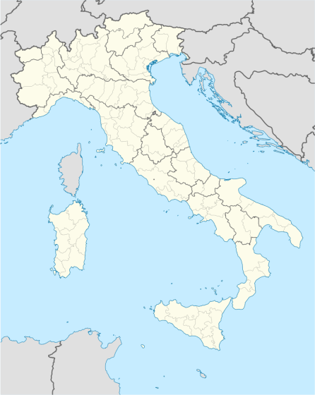
Key:

. . . . . . . . . . . . . . . . . . . . . . . . . . . . . . . . . . . . . . . . . . . . . . . . . . . . .

. . . . . . . . . . . . . . . . . . . . . . . . . . . . . . . . . . . . . . . . . . . . . . . . . . . . .

. . . . . . . . . . . . . . . . . . . . . . . . . . . . . . . . . . . . . . . . . . . . . . . . . . . . .

Why have you chosen to label these features? How are they important to understanding the management of landslide risk?

. . . . . . . . . . . . . . . . . . . . . . . . . . . . . . . . . . . . . . . . . . . . . . . . . . . . .

. . . . . . . . . . . . . . . . . . . . . . . . . . . . . . . . . . . . . . . . . . . . . . . . . . . . .

. . . . . . . . . . . . . . . . . . . . . . . . . . . . . . . . . . . . . . . . . . . . . . . . . . . . .

. . . . . . . . . . . . . . . . . . . . . . . . . . . . . . . . . . . . . . . . . . . . . . . . . . . . .

