Read the Christchurch Earthquake factsheet and then extend the spider diagram to explain whether the consequences of the earthquake would have been different under the scenarios posed.
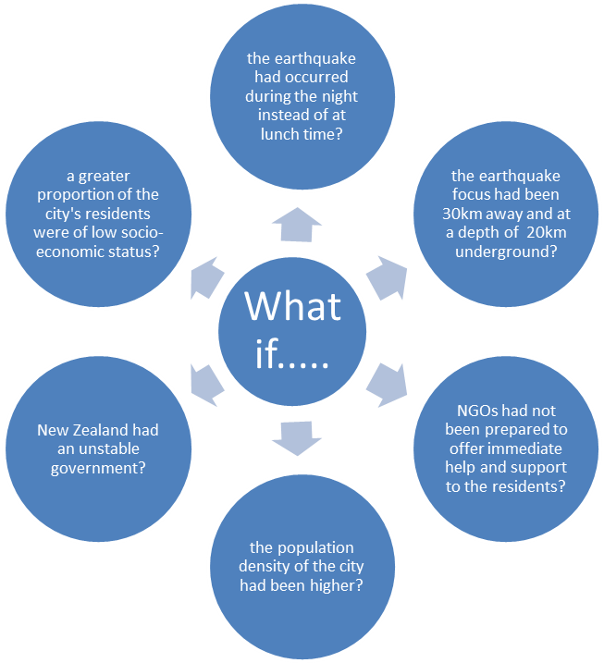
Link – Christchurch Earthquake Factsheet

