|  |
| --- |
| Oman Vision 2040: Climate change student sheet |

# Starter – climate change

Oman is a country in the Middle East, bordering Yemen, Saudi Arabia, and the United Arab Emirates. It is in the southeast corner of the Arabian Peninsula. It has a long 3,165-kilometre coastline which plays a significant role in the country’s economy.

Due to this extensive coastline, Oman is vulnerable to the impacts of climate change. Its proximity to the tropical waters of the Indian Ocean, the arid climate, economic dependency on hydrocarbons, and fragile biodiversity are all potential environmental challenges.

On the next page there is a topographic map of Oman. Use it to:

1. Annotate the geographical features of the country.

a. Can these features be categorised? for example, into water / landforms, or fluvial / geological.

2. Use this information to answer the following question: Why might Oman be vulnerable to climate change?

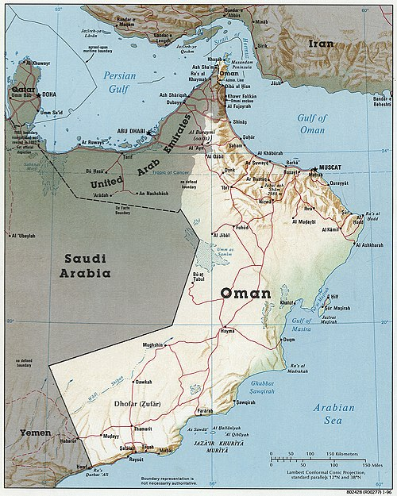

Oman 1996 CIA map. Wikimedia Commons, Public Domain

3. Study the photographs below.

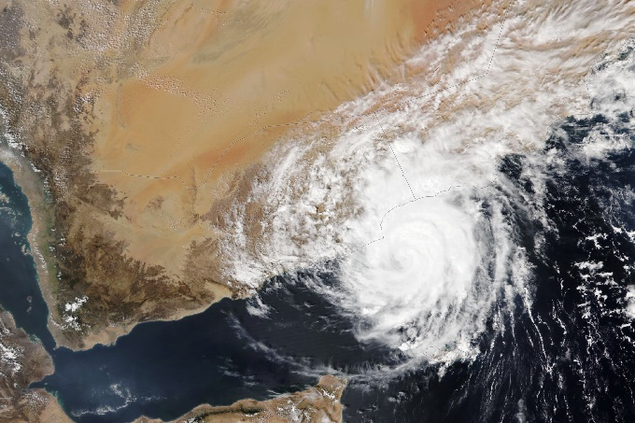 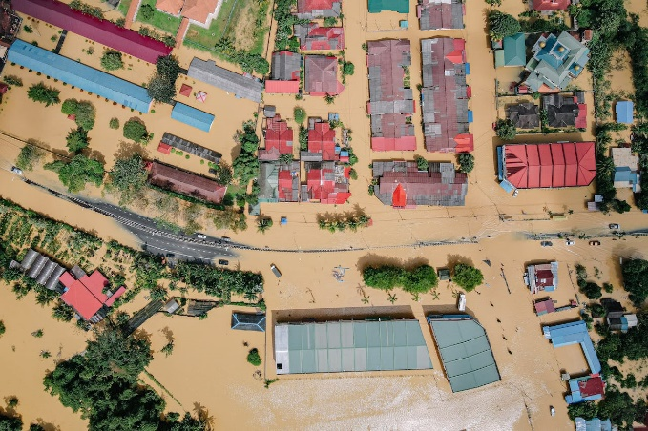

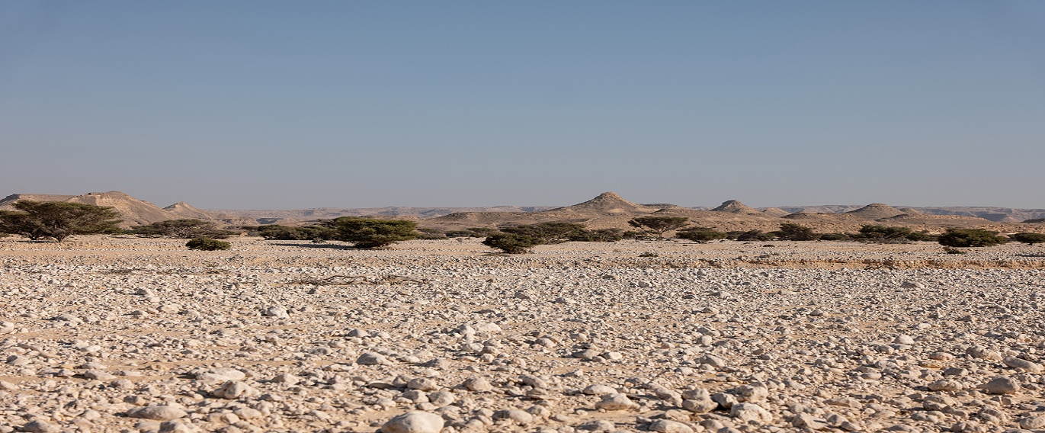

Image sources: Cyclone, NASA Earth Observatory, Flooding, Pok Rie Pexels, Drought © Ana-Maria Pavalache

a. Using evidence from the images, identify the environmental challenges Oman faces from climate change.

Oman has a dry hot climate. Since 1980, the country has experienced a gradual temperature increase. Due to climate change, average annual temperatures are expected to continue to rise.

4. Below is a data table showing surface temperature and a linear regression line for Oman. Linear regression fits a straight line through data points to predict or explain the relationship between variables.

|  |  |  |
| --- | --- | --- |
| Year | Annual surface temperature | Linear regression |
| 2000 | 27.53 | 27.54 |
| 2002 | 27.51 | 27.58 |
| 2004 | 27.59 | 27.62 |
| 2006 | 27.60 | 27.65 |
| 2008 | 27.21 | 27.69 |
| 2010 | 28.07 | 27.73 |
| 2012 | 27.81 | 27.77 |
| 2014 | 27.53 | 27.81 |
| 2016 | 27.85 | 27.85 |
| 2018 | 28.01 | 27.88 |
| 2020 | 27.72 | 27.92 |

Table 1 showing temperature in Oman 2000-2020 © [iea](https://www.iea.org/reports/national-climate-resilience-assessment-for-oman)

a. Copy the above table into excel. Choose the Insert tab and select Recommended Charts. Accept the suggested line graph and click OK. Change the title to: Temperature in Oman 2000-2020.

b. Analyse the data which the graph has shown.

# Specific risks from climate change

Oman faces 4 specific climatic risks from its proximity to tropical waters, an arid climate, economic dependency, and fragile biodiversity. The information below explains each one of these risks in turn.

5. Match the explanation to the climatic risk.

|  |  |  |
| --- | --- | --- |
| **Climatic risk** |  | **Explanation** |
| Tropical waters |  | ~82% of Oman is desert, with limited water resources. Climate change exacerbates water scarcity, impacting agriculture and drinking water supply |
| Arid climate |  | Being near the Strait of Hormuz, a major oil transit route, the economy relies heavily on oil and gas exports |
| Economic dependency |  | Oman’s diverse ecosystems (mountainous regions to coastal areas) are at risk due to changing weather patterns |
| Fragile biodiversity |  | Oman's coastal position makes it vulnerable to rising sea levels and extreme weather events like cyclones, which have increased in intensity due to climate change |

# Oman’s climate change policy

Oman Vision 2040

There are several elements to Oman’s climate change policy for the twenty-first century.

Oman plans to invest in renewable energy, specifically solar power, in the coming decades. Water resource management, international cooperation through, for example, the Gulf Cooperation Council as well as mitigation and adaptation strategies for vulnerable communities are all key priorities.

Get into groups of 3 or 4. In your groups choose one of the four sections list below. Research and make notes ready to present to the class at the end of the lesson.

Group 1: Renewable energy

1. The renewable energy overview [International Trade Administration](https://www.trade.gov/country-commercial-guides/oman-renewable-energy)

2. What are the advantages of solar for Oman? [SPOTLIGHT ON](https://www.britishomani.org/uploads/downloads/spotlight%20on-%20solar%20power%20in%20oman.pdf) Anglo-Omani Society

3. What is the current largest domestic energy source in Oman? [iea](https://www.iea.org/countries/oman/energy-mix)

Group 2: Water resource management

1. Who is involved in the Omani water sector? [Fanack Water](https://water.fanack.com/oman/water-management-oman/)

2. Identify the conventional and non-conventional water resources WSTAGCC [Oman’s Strategy for Securing Water Resources](https://wstagcc.org/WSTA-11th-Gulf-Water-Conference/Oman-Water_Resources_Strategy.pdf)

3. Water challenges in Oman [Fanack Water](https://water.fanack.com/oman/water-challenges-oman/)

Group 3: International cooperation

1. Oman joins global effort at COP29 [Oman Observer](https://thegulfobserver.com/oman-joins-global-efforts-at-cop29-to-combat-climate-change-and-achieve-carbon-neutrality/)

2. Oman joins regional climate change initiative [Oman Observer](https://www.omanobserver.om/article/1128668/business/economy/oman-joins-regional-climate-change-initiative)

3. Just energy transitions? Lessons from Oman [Carnegie Endowment for International Peace](https://carnegieendowment.org/research/2024/05/morocco-oman-energy-transition-oil-exporting-renewable?lang=en)

Group 4: Mitigation strategies

1. Building resilience: Oman’s approach to climate change [Oman Observer](https://www.omanobserver.om/article/1162667/magazine/building-resilience-omans-approach-to-climate-change)

2. Read [Policy readiness for climate resilience](https://www.iea.org/reports/national-climate-resilience-assessment-for-oman) section from the iea

3. What are the 5 key sectors in The Vulnerability & Adaptation theme of the Climate

Change Strategy page 14 [National Strategy for Adaptation and Mitigation 2020-2040](https://www.ea.gov.om/media/03nlovjc/%D8%A7%D9%84%D8%A7%D8%B3%D8%AA%D8%B1%D8%A7%D8%AA%D9%8A%D8%AC%D9%8A%D8%A9-%D8%A7%D9%84%D9%88%D8%B7%D9%86%D9%8A%D8%A9-%D9%84%D9%84%D8%AA%D9%83%D9%8A%D9%81-%D9%88%D8%A7%D9%84%D8%AA%D8%AE%D9%81%D9%8A%D9%81-%D9%85%D9%86-%D8%A7%D9%84%D8%AA%D8%BA%D9%8A%D8%B1%D8%A7%D8%AA-%D8%A7%D9%84%D9%85%D9%86%D8%A7%D8%AE%D9%8A%D8%A9.pdf)

# Plenary – be the advisor

Imagine you are a government advisor. If you were advising Oman’s government, what would you prioritise in their climate change policy?

How does Oman’s climate change policy differ from others in the region?



