This teacher support pack supplements the Royal Geographical Society’s resource ‘Place makers: how geographers are regenerating Newport’s Leisure Centre’ careers resource
This teacher support park contains the following:
1. Aim of student resource
2. Links to A Level specification
3. Suggested answers to student activities
4. Links to further support

- Aim of student resource
The aim of this resource is to showcase the role of geographers working on the development of placemaking projects, specifically the redevelopment of Newport Leisure Centre in South Wales as a net-zero leisure facility. This regeneration project is led by WSP, a major employer of geographers. The redevelopment of the leisure centre is part of Newport City’s Council’s 15-year placemaking plan. You can read more about the project here: https://www.wsp.com/en-gb/projects/newport-leisure-centre and more about Newport’s placemaking plan here: https://www.newport.gov.uk/our-city/placemaking.

The resource spotlights three geographical roles: Quantity Surveyor, Environmental Consultant and Land Use Consultant, although these roles are by no means exhaustive of the roles geographers play in the development of regeneration projects. Other roles may include Sustainability Officers, Town Planners and roles within Local Authorities.

Page 1 of the resource provides context about the regeneration of Newport Leisure Centre, including the sustainability of the leisure centre and how it can meet the needs of local communities in response to Newport’s 15-year placemaking plan. Page 1 also introduces the role of Quantity Surveyors and WSP.

Page 2 of the resource spotlights the role of two Quantity Surveyors and the role of two early career geographers working at WSP - an Environmental Consultant and Land Use Consultant. Featured geographers, Olivia, Lauren and Suha, have spoken in detail about their jobs at one of our Choose Geography webinars. You and your students can watch the webinar recording here: https://www.rgs.org/events/talks-on-demand/careers-in-built-environment.

Teachers may wish to spend time reading through page 1 and 2 of the resource with students, pausing at points to allow for questioning and/or group discussion.

Pages 3 to 5 of the resource contain student activities. Pages 3 and 4 require students to use information from the resource and their own geographical understanding, and page 5 of the resource gives students the opportunity to engage with the career profiles on page 2 of the resource.
Please note that, as referenced, the employment data on page 2 has been put together using data published on LinkedIn, therefore may not reflect actual employment statistics.
The resource supports teachers in providing careers provision under Gatsby Benchmark 4: Linking curriculum learning to careers. For more information on the Gatsby Benchmarks, visit: Gatsby benchmarks of good career guidance

- Links to specification

A Level links:
AQA: 3.2.2 Changing Places and 3.2.3 Contemporary urban environments, specifically 3.2.3.8 Sustainable urban development

Edexcel: Topic 4, Shaping Places Option 4a Regenerating Places
OCR: Topic 2.1 Changing Spaces; Making Places. How are places created through placemaking processes? Specifically 5.b The placemaking process of rebranding constructs a different place meaning through imagining and regeneration and 5.c. Making a successful place requires planning and design
WJEC GCE AS: Unit 2 Changing Places. 2.1.9 The rebranding places and players in urban places

- Suggested answers

Activity 1a:

1a. Describe the site of Newport Leisure Centre, including key human and physical features of the surrounding environment

- Located to the West of the River Usk
- Located near main roads
- Surrounding amenities including a shopping centre, central library and university
- Built up area surrounded by lots of buildings and roads

1b. Suggest one opportunity and one challenge of building on this site
Think about: renewable energy, community impact, green space, transport, air pollution

Opportunity – Near other local amenities that can improve the wellbeing of local residents, supports health and wellbeing of University of South Wales students, river water could be used as renewable energy source, lack of green space means there’s opportunity for a green roof

Challenge – located on floodplain, lots of surrounding roads mean high air pollution from vehicles/ traffic

2a. Define the term sustainable

Sustainable refers to meeting the needs of today’s population without compromising the needs of future generations

2b. Suggest one way the Newport Leisure Centre regeneration plan is sustainable
- It will have a green roof, increasing habitats and supporting biodiversity/ help sequester carbon from the atmosphere
- Reuses old materials therefore reducing waste
- Will use more energy efficient technology such as a heat pump and/or solar panels, therefore less burning of fossil fuel is needed


2c. Sort into advantages and disadvantages of building on a brownfield site
2. Easier to get planning permission
1. Land is contaminated
4. Water, drainage, electricity and roads may already be in place
3. Demolition costs

5. Reduces urban sprawl

2d. Look at the nine community responses in the orange box.
Make a list of responses that the building of the Leisure Centre may help address. Explain your choices

Guerilla gardening – facilitated through the biodiverse green roof
Renewable energy – building has capacity for solar power
Evening cafes – Leisure centre will include cafe
More social spaces – Leisure centre will include café, gym and swimming pool

3a. Choose the correct definition of Quantity Surveyor

- Surveys the land using satellite imagery to decide the best site for a construction project
- Measures how damaging a new construction project will be on the surrounding habitats
- Oversees the financial side of a construction project

3b. Theo and Suha are both Consultants. Theo is an Environmental Consultant focusing on Environmental Impact Assessments and Suha is a Land Consultant.
What is the difference between their roles?
Sentence starter: Theo’s role involves … whereas Suha’s role focuses on …

Theo’s role involves investigating the environmental impacts of building on a particular site, including the impact on factors like habitats and soil whereas Suha looks at who owns or occupies an area of land. Theo with ecologists and archaeologists to gather this data whereas Suha uses digital maps and GIS to gather data.
3c. Sort the statements into whether the apply to Quantity Surveyor, Environmental Consultant and Land Use Consultant
- Uses GIS and digital mapping
- Day-to-day involves a mixture of desk-based work and site visits
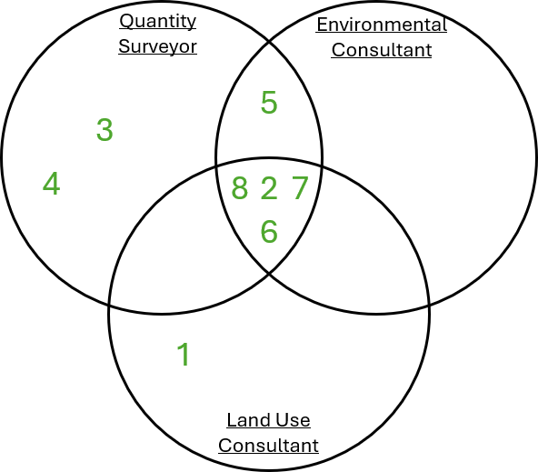
- Uses numerical skills
- Responsible for the financial side of project
- Works with a range of specialists, like ecologists
- Uses problem solving skills
- Requires good understanding of sustainability
- Requires good understanding of the impacts of climate change

Links to further support

- Royal Geographical Society’s career pages: Choose a career with geography - RGS
- Teacher CPD: Teacher events - RGS
- I am a geographer: I am a geographer - RGS
- Statutory careers guidance for schools: Careers guidance and access for education and training providers - GOV.UK

