Tectonic Hazards

GCSE Specification links
AQA
3.1.1.2. Earthquakes and volcanic eruptions are the result of physical processes. Management can reduce the effects of a tectonic hazard.

Edexcel B
1.7. Earth’s layered structure, and physical properties is key to plate tectonics.
1.8. There are different plate boundaries, each with characteristic volcanic and earthquake hazards.
1.9. Tectonic hazards affect people, and are managed, differently at contrasting locations.

Eduqas A / WJEC
3.1.1. How do tectonic processes work together to create landform features at different scales?
3.2.1. What are the impacts of tectonic processes?
3.2.2. How might the risks associated with tectonic hazards be reduced?

OCR B
1.2.a. What processes occur at plate boundaries?
1.2.c. How does technology have the potential to save lives in hazard zones?

Key terminology
Subduction – the process of a plate being pushed beneath another. This is primarily due to slab pull and ridge push.
Friction – the resistance between the plates in the lithosphere.
Pressure – a force exerted on a given area, e.g. the force of gasses within a volcano pushing against the solid rock.
Magma – hot molten rock under the Earth’s surface.
Plate boundary – the place where two tectonic plates meet.
Epicentre – the point on the Earth’s surface vertically above the precise location of where an earthquake starts.
Focus – the point underground where rocks start to fracture to cause an earthquake.
Pyroclastic flow – a fast moving, super-heated cloud ejected from some volcanic eruptions.
Ash – fragments of minerals, glass, and rock particles ejected during a volcanic eruption.
Population density – the amount of people per 1km².
Seismic waves – shock waves that emanate from the focus of an earthquake. There are different types of waves. For example, P-waves and S-waves travel through the Earth whilst Surface waves remain on the surface, are slower and, with their have larger amplitudes, do the most damage to surface structures.
Ground deformation – the change in shape of the surface of the Earth resulting either from tectonic movements of the Earth’s solid surface or movements of magma beneath it.
Seismometers – tools which detect, record and measures seismic waves.
Tsunami – a series of ocean waves which can send surges of water onto the coastline. These surges can be over 30 meters high and can create a lot of damage in the process.

Plate tectonic theory
Continental plate average 40 km thick, made mainly from granitic rock, up to 4 billion years old.

Oceanic plate average 6km thick, made mainly dense basaltic rock, up to 200 million years old.

Slab pull theory colder and denser oceanic plates sink into the mantle at ocean trenches pulling the plates down.

Ridge Push: The force of gravity acting on the higher mid-ocean ridges causes them to spread outwards from the ridge.

Convection currents the circular (heat rising and cold falling) movement of the mantle which is heated as a result of the intense pressures at depth, and also by radioactive decay within the mantle.
Alfred Wegner, widely regarded to be a pioneer in this area of earth sciences, presented a paper on the theory of continental drift in the 1920s. It was based on evidence from the distribution of fossil organisms found on different land masses and now separated by vast distances across oceans. He theorised that this was evidence of a large supercontinent, called Pangea, which allowed these species to live together before the continents broke up and drifted apart.

In the 1950s, geologists examining the direction and strength of the Earth’s magnetic field, as recorded in a specific mineral (magnetite) found in rock on the ocean bed, observed that there were variations in the directions of the magnetic fields that had been preserved in these minerals over time. By linking the location of these rocks with Wagner’s continental drift theory, it showed that the hypothesised pathways of these rocks had been very similar, therefore, supporting the theory of continental drift even further. In addition, the work of Marie Tharp in the 1970s helped map the oceans to reveal a network of ridges and trenches along the ocean floor. This, together with the jigsaw fit of continents, heat flow measurements and the age of the ocean floor, provided evidence for the theory of Plate Tectonics.

The Earth has a concentric structure that is divided into the crust, mantle and core, based on its chemical composition and characteristics of the rock. Together, the crust and the upper part of the mantle form a solid, cold, outer mechanical layer, called the lithosphere, which is broken into a series of large and smaller sections that form the lithospheric (or tectonic) plates which are in constant relative movement.
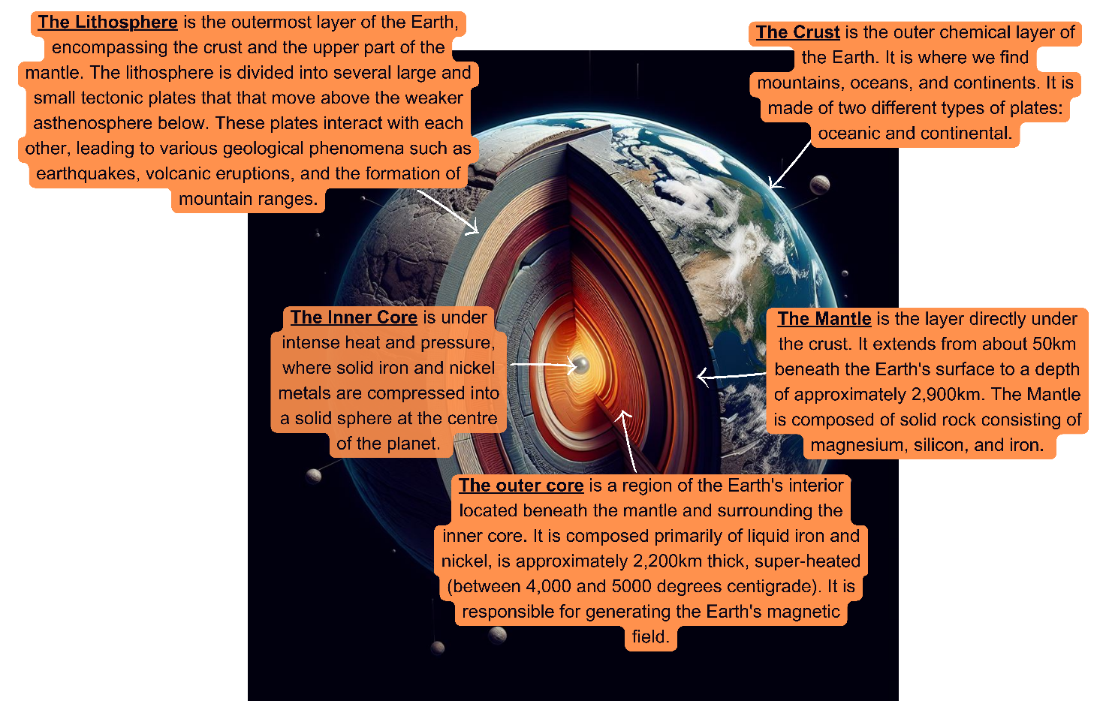
Figure 1: Cross section of the Earth © RGS

Global distribution of tectonic activity
By mapping the locations of volcanic activity and earthquake events, scientists started to realise that, by and large, they were not occurring in random places; there was a pattern. Not only this but other features such as particular coastal islands and mountain ranges also correlated with certain tectonic events. It was then that scientists realised that these were all associated with tectonic activity along plate boundaries.

Additionally, certain tectonic events took place in specific places, thus linking the understanding about the two different plate types: continental and oceanic. Oceanic plates, without continental crust, are characterised by their denser, younger, thinner composition and primarily consist of a rock called basalt. Continental plates on the other hand are older, thicker, relatively lighter, and predominantly made from a rock called granite. A continental plate is one where some of the area of the plate is composed of continental crust but in most cases a single plate is composed of both continental and oceanic lithosphere. Interactions between these plates give rise to certain tectonic activities.

There are, however, some exceptions to this rule. Some earthquakes occur far beyond plate boundaries, these are often attributed to ancient plate boundaries and subducting plates. Additionally, hotspot volcanoes can be found in the middle of plates. These volcanoes occur because of a continuous rising plume of heat from within the mantle, melting the lower part of the lithosphere creating magma which rises through cracks in the crust forming volcanoes. In such cases, if the resulting volcanoes reach the sea surface, they create a chain of islands as the plate moves over the hotspot. Examples of oceanic volcanic hotspots are the Hawaiian, Canary, and Galapagos Island chains. There is also evidence of hotspot volcanoes forming on continental plates. The most famous example of this is Yellowstone.

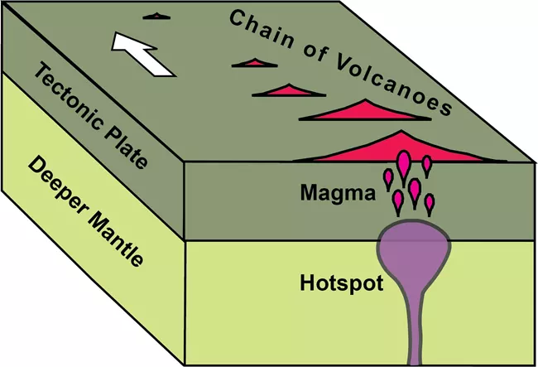

Figure 2: Diagram of a volcanic hotspot © National Park Service

Processes at plate margins
Given that not all tectonic events happen at all plate margins, the relationship between continental and oceanic plates also must be considered. The table below details what happens at each plate boundary with a link to an animation that demonstrates the movement at the plate boundary in detail.

Convergent (destructive) plate margin
Name (with video link) | Description | Examples of where to find them
Subduction zone | At converging oceanic and continental plate boundaries, the denser oceanic plate is pulled beneath the continental plate, in a process called subduction. This is driven by slab pull forces. This process forms a deep ocean trench at the edge of the continental plate and can generate earthquakes from friction and from the subsequent release of pressure. The water held in the subducting plate heats up. This causes the mantle above to melt forming magma. This magma, upon reaching the surface, releases gases and may cause volcanic eruptions. The explosiveness, and in-turn hazardousness, of the volcano depends on the viscosity (a fluid’s resistance to flow) of the magma erupting. | Nazca and South American plate. Láscar volcano in Chile. Last erupted 1993.
Collision (continental to continental) | In most cases, these colliding plates are of similar density and so, when such plates meet, neither subducts. Instead, these plates crumple, pushing the Earth’s crust upwards creating fold mountains. As they push together, pressure builds up and is released in the form of earthquakes. Volcanoes do not tend to occur at this boundary as the compressed crust is too thick. | Indian and Eurasian plate. Himalayan mountains are examples of fold mountains. Gorkha earthquake in Nepal, 2015.
Collision (oceanic to oceanic) | When two oceanic plates converge, the denser and cooler of the two subducts beneath the other. During subduction, and because of the curvature of the Earth, a semi-circular chain of volcanoes is formed on the overlying plate; we call this an island arc. A similar process to subduction zones takes place here generating earthquakes under the sea, and explosive volcanic eruptions. | Pacific and Philippine Sea plate. Mariana trench.
Divergent (constructive) plate margin
Mid-ocean ridges & Continental rifts | As the cold, denser plate is pulled under at a subduction zone, it pulls the whole plate sideways, including the remainder at the surface. This creates tension at other parts of the plate making areas thinner. As the plates continue to pull apart, the area between depresses, and sometimes cracks and sinks, creating a rift valley. Magma forms in the mantle as it partially melts and injects itself into the thinner area of the plate, forming volcanoes in some parts and therefore, a new part of the plate. The magma moves upwards to form a ridge. If the rift valley is filled with ocean water, this raised area will create a mid-oceanic ridge. | The African Rift Valley is an example prior to flooding with ocean water. The Mid-Atlantic Ridge is a more mature example, with the rift valley long gone (and now the Atlantic). Iceland is a landmass atop of the ridge created by repeated volcanic activity.
Transform (conservative) plate margin
Transform plate margins | Transform margins happen when plates move past each other. This can either be in opposite directions or in the same direction but at different speeds. Their passing is not smooth and therefore pressure builds up when they get stuck. The release of this pressure generates earthquakes. | North American and Pacific plates. San Andreas fault in California.

Hazards, effects, and responses to tectonic hazards
Volcanoes can unleash a variety of hazards that impact people in numerous ways. Primary hazards stem directly from volcanic activity itself, while secondary hazards arise indirectly from these primary events.
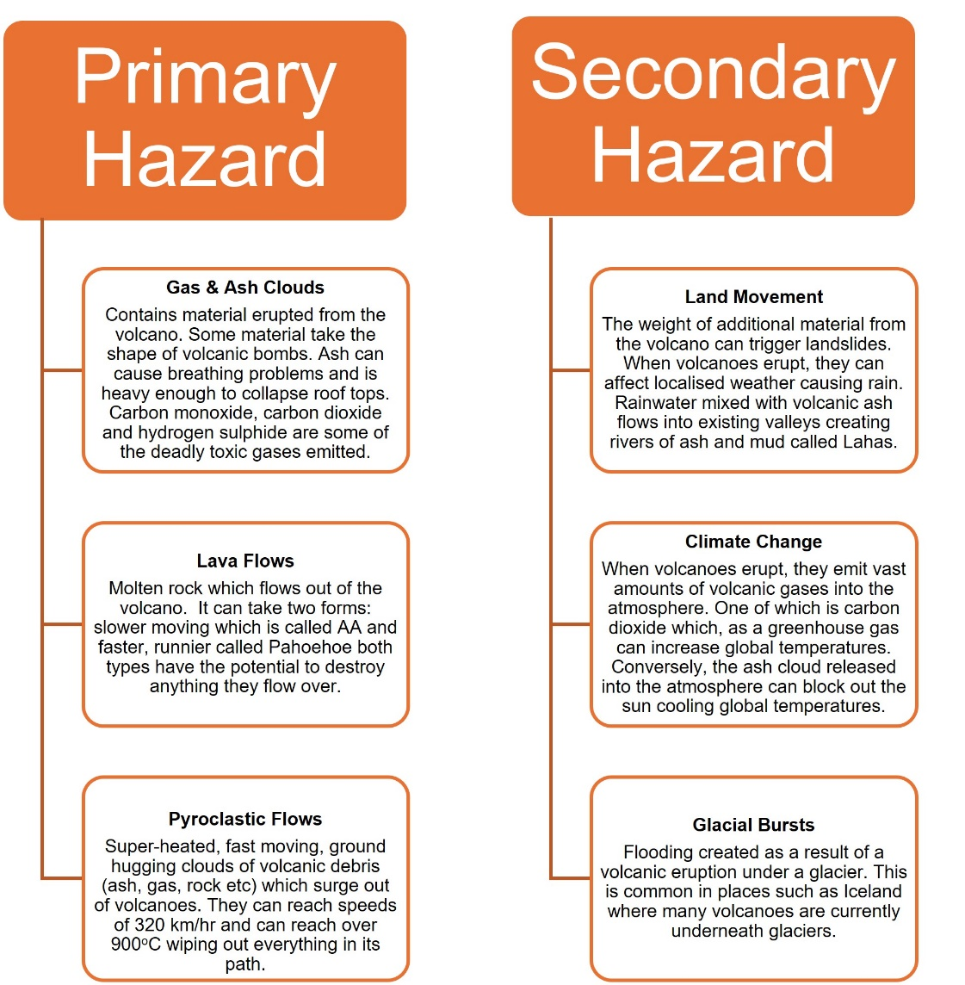

Figure 3: Primary and Secondary Hazards of Volcanoes © RGS

The primary hazard of an earthquake is the ground shaking, which in turn can trigger secondary hazards (see Figure 4) such as:

- Liquefaction: intense shaking transforms the ground into a liquid-like state, similar to quicksand. Anything on the ground can then sink into it.
- Landslides: the shaking of the land dislodges the ground causing it to move down the side of a slope.
- Tsunamis: earthquakes occurring beneath the sea can displace water above the epicentre, resulting in the formation of tsunamis.

Hazards stemming from tectonic events can vary depending on factors such as the type of volcano, earthquake intensity, and the location of the event.

For instance, stratovolcanoes, also known as composite volcanoes, may not erupt frequently but have steep sides with cooler, less viscous lava which tends to trap gases and in turn, result in more explosive and violent eruptions. In contrast, wider shield volcanoes have a runnier lava which does not trap gases or result in hazardous large explosions; however, these volcanoes often erupt more frequently, and are hazardous from the perspective of their lava destroying everything in its path.

Regarding earthquakes, it is often the case that those of higher magnitude can cause stronger ground vibrations therefore potentially more damage. Sometimes however, a weak earthquake can cause huge amounts of damage if the epicentre is within an area of high population density, whilst in contrast, a strong earthquake might be less destructive if it occurs deep in the crust, as the energy released is lost by the time it arrives at the surface.

Even in countries that have enough wealth to help mitigate the impact of an earthquake, the challenge in managing all foreseeable hazards is still a complicated business. For example, the tsunami generated after the Tohoku earthquake in Japan in 2011, caused immense destruction and loss of life even though the area had what they thought were sufficient tsunami defences.

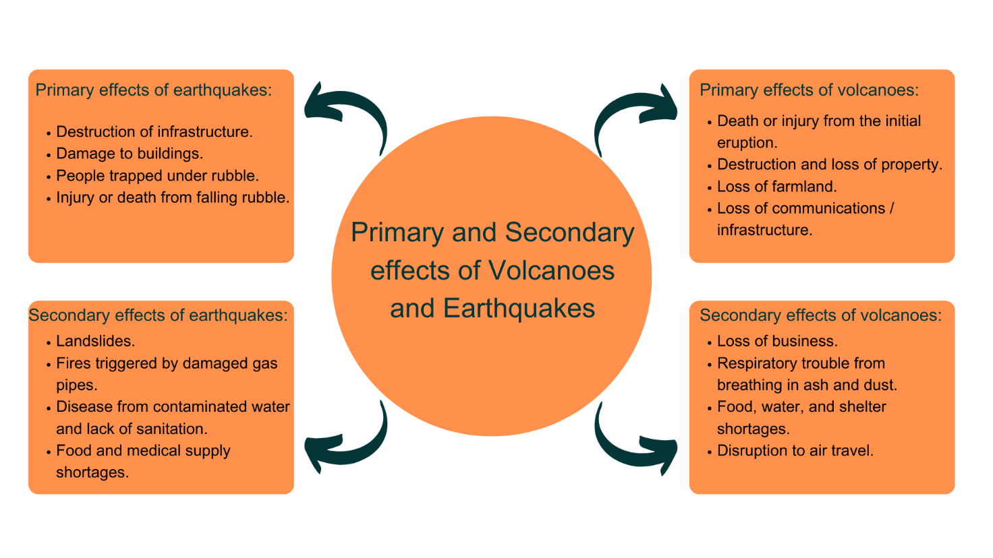

Figure 4: Primary and secondary effects of volcanoes and earthquakes © RGS

Why do people live in areas of tectonic activity?
It is thought that over 600 million people live in areas of tectonic activity around the world. Some live in very densely populated areas such as Japan and Indonesia. It cannot be a coincidence that so many people are attracted to these areas. So why do they live there?

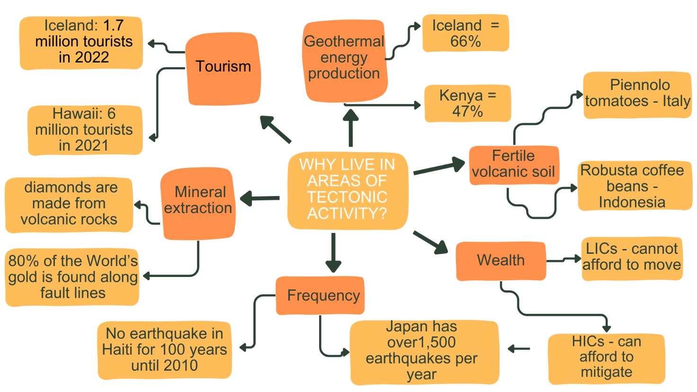
Figure 5: Reasons why people live near areas of tectonic activity © RGS

Management to reduce the effects of a tectonic hazard
The way in which many places attempt to reduce the risk posed by hazards of any kind is to use all or a combination of the following:

Monitoring
This consists of the use of specific technologies to watch over areas which are particularly susceptible to tectonic events and to record certain types of data.

In the case of volcanoes, tiltmeters, for example, can be used to detect the changes in the level of the ground as some volcanoes are known to bulge before an eruption. Seismometers can also be used to detect movements of magma beneath the ground, gases can be monitored, as changes in these can indicate impending activity, and thermal imagery from satellites can be used to see if volcanoes are starting to heat-up.

Earthquakes are a little trickier to monitor, as they often occur without warning. One of the keyways that scientists do try to monitor them, however, is by measuring tectonic plate movements. This is undertaken by a network of GPS stations installed in tectonically active regions, which allows scientists to measure plate movements. Where plates continually move, it suggests tensions at plate boundaries are continuously relieved, preventing buildup and associated earthquakes. However, where plates may not seem to be moving, it might suggest they are locked, pressures are building, and that the potential for an earthquake could be increasing.

Gas sensors for both earthquakes and volcanoes are useful monitoring tools as radon gas increases and/or is released before an earthquake or volcanic eruption.

Prediction
Prediction works hand in hand with monitoring, with scientists taking the monitoring data and trying to work out what it shows.

For volcanoes, what scientists look for are changes in the data that is being collected. For example, if a volcano starts to bulge, heats up, if gas emissions change or if the numbers of tremors increase, it might indicate that the volcano is becoming unstable and that an eruption is imminent.

Without clear indicators of impending earthquakes, their prediction is much more difficult, and scientists often prefer to use the term ‘forecast’. In such cases, scientists will take the data they have monitored, look at when past events have occurred, and then use this information to forecast when and where an earthquake might occur, usually over a long time period. For example, scientists might forecast that there is the chance of an earthquake occurring in a particular location, within the next 30 years. What shows more potential however, are Early Warning Systems (EWS). Once an earthquake happens, seismic waves are sent out from the focus, and the less-destructive P-waves shoot out at speed. If automated EWSs can detect these P-waves quickly enough, then they can send warnings out to people in the vicinity that the more destructive surface waves will be arriving imminently. Japan and Mexico have such systems in place, and they have been successfully used a number of times.

Protection
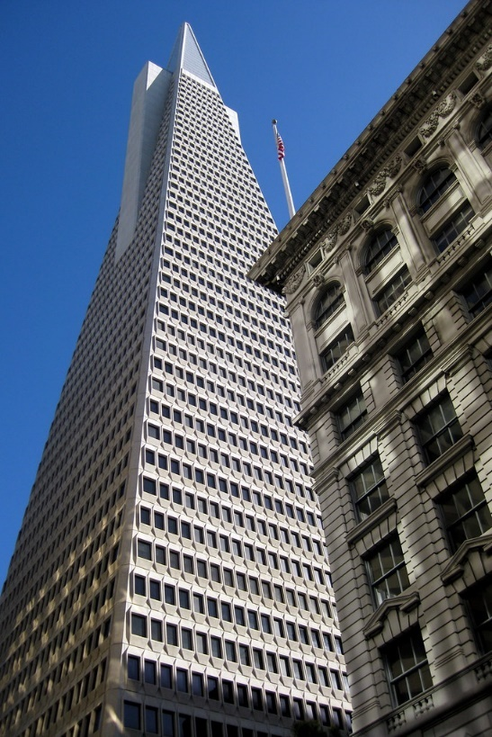
Protection consists of the construction of infrastructure that can withstand a tectonic event. One way in which this can be done is to design buildings that can withstand the shaking from an earthquake. The Transamerica Pyramid (pictured left) in San Francisco is an excellent example of this. It is built with a base larger than its top therefore, increasing the stability of the building. Triangles are one of the most solid shapes and so anything shaped this way will be stronger than a cube. Engineers have also added other features in buildings such as isolators built into the foundations to absorb some of the shaking, counterweights suspended in the upper floors to correct the building’s sway and lattice work on the outside to stabilise the building.

Planning
Methods are available to help people be ready for a tectonic event, or to ensure that when they happen, their impacts are not as bad as they could be. There are many densely populated areas in the world which experience regular earthquakes. Japan is one of these places which have over 1,500 earthquakes each year. To help the population prepare for such an event, Japan holds a Disaster Prevention Day every 1st September. On this day, the population practices evacuation drills, firefighting, emergency meetings, hospital drills, and much more. Other earthquake prone areas such as California in the US encourage its citizens to have emergency kits at home to help survive after an earthquake has hit and provide grants for people to strengthen their homes. Also in California, planning regulations are in place which prevent the construction of new buildings within designated distances from known fault lines.
Figure 6: Transamerica Pyramid San Francisco © Wally Gobetz Flickr

Suggested learning activities
1. Project the names of the different layers of the Earth on the board. From this, pupils draw a diagram to represent the layers of the earth and label their diagram with the names and what they already know about each layer next to the label. They will return to this diagram once they have information about each layer and correct / add to any further information they find out.
2. Complete an annotated diagram explaining convection currents, slab pull and ridge push.
3. Pupils could use this link to analyse the locations of different tectonic hazards and their relationship with plate boundaries.
4. Pupils could complete a series of diagrams or a cartoon to explain the formation of hot spot volcanoes.
5. Pupils produce annotated diagrams to explain the different plate boundary types.
6a. Split the class into 5 differentiated groups – one per plate margin type as follows: challenge group – subduction zone, support group – transform (conservative) then the remainder of the class into the final three groups. If you have a large class size, have two groups per boundary. Hand out a copy of a plate boundary map to each pupil as well as information about the plate margins each group is representing.
b. Pupils read about their specific plate margin for their group and annotate next to an example of that plate margin with information about the processes which happen at that margin on their own copy of the plate margin map.
c. Pupils complete a ready, steady, teach! exercise to the rest / half of the class based on their plate margin. The rest of the class should then complete that part of the plate margin map so that they have a full set of notes.
8. Pupils could read the poem after the earthquake by Angela Topping and annotate it to identify the different effects and hazards of earthquakes.
9. Pupils could design their own earthquake proof building or complete a decision-making exercise on what to pack in an emergency bag.
10. To further understand slab pull, pupils could conduct a similar activity found here.
11. As a mini-plenary, pupils could play ‘Geobattleships’ to help understand the matching pattern between the distribution of volcanoes and earthquakes.

Practice ‘examination-style’ questions
Describe the global distribution of volcanic eruptions (3)
Explain how subduction plate boundaries create volcanoes (4)
Explain why people live in areas of tectonic activity (6)
Describe and explain the global distribution of volcanoes (6)
Discuss the challenges associated with managing tectonic hazards (9)
Evaluate the effectiveness of different monitoring and prediction techniques for tectonic hazards (9)
‘Primary effects outweigh secondary effects of earthquakes’. Discuss (9)

Further reading
Learner.org revision of this topic
A cooling Earth and monitoring its hazards, Dr Matthew Blackett, RGS (with IBG)
Mountains, volcanoes and earthquakes poster, RGS (with IBG)
Hazards and volcanic gas emissions, RGS (with IBG)
A year without summer – the effects of the Tambora volcanic eruption of 1815, RGS (with IBG)
Volcanoes and volcanology, RGS (with IBG)
Hazard management with Dr Amy Donovan, RGS (with IBG)
Subject knowledge animation: mountains, volcanoes, and earthquakes, RGS (with IBG)
The Geological Society ‘Plate Tectonic website’

