Projections based on Emission Scenarios

The UKCP18 National Climate Projections Headline Findings were released in August 2022. The overall headline summary is there will be “a greater chance of warmer, wetter winters and hotter, drier summers.”

Read the Met Office UKCP headline findings for more information.
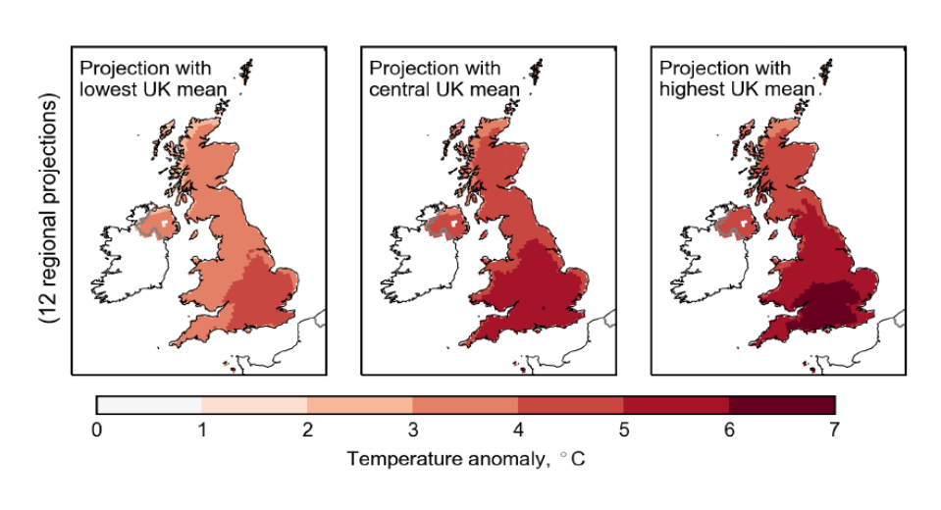
Figure 1 The future UK temperature anomaly 2061-2080, RCP8.5

- Study Figure 1. Which of the statements below is correct.
❍ The north of the UK is projected to warm.
❍ The southwest of the UK is projected to cool.
❍ All areas of the UK are projected to experience warming.
❍ Only England will see higher temperatures.

- Which region of the UK is projected to warm the most, across all 3 categories?

❍ Scotland
❍ Northern Ireland
❍ The southeast
❍ The northwest

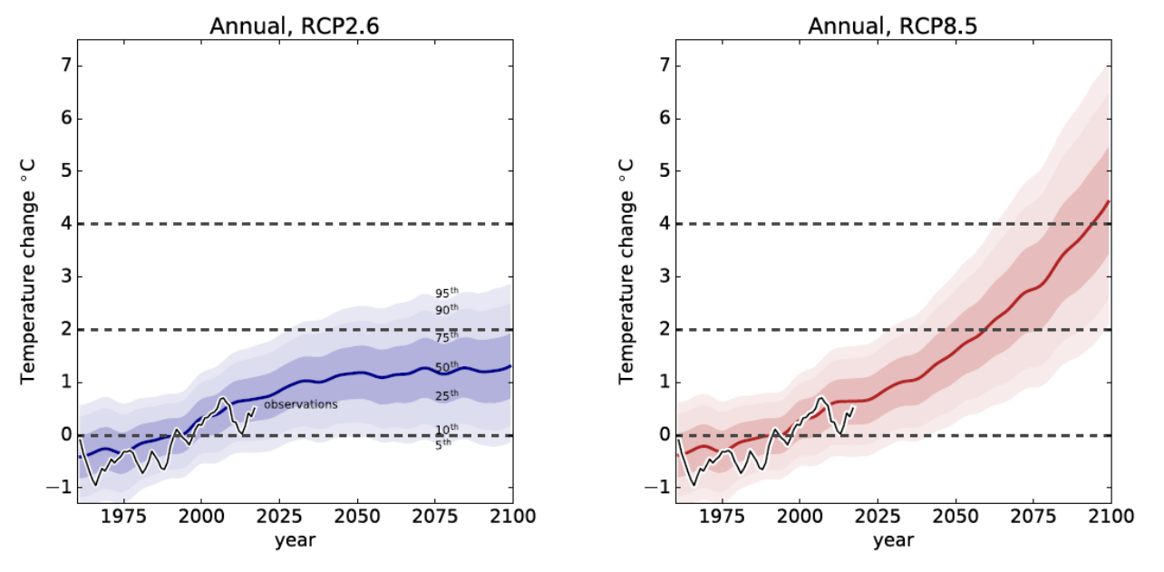

Figure 2 Annual future UK temperatures following RCP2.6 and RCP8.5 projections

- For the RCP2.6 projection, in which decade is fastest growth in temperature change predicted?

- For the RCP8.5 projection, in which decade is fastest growth in temperature change predicted?
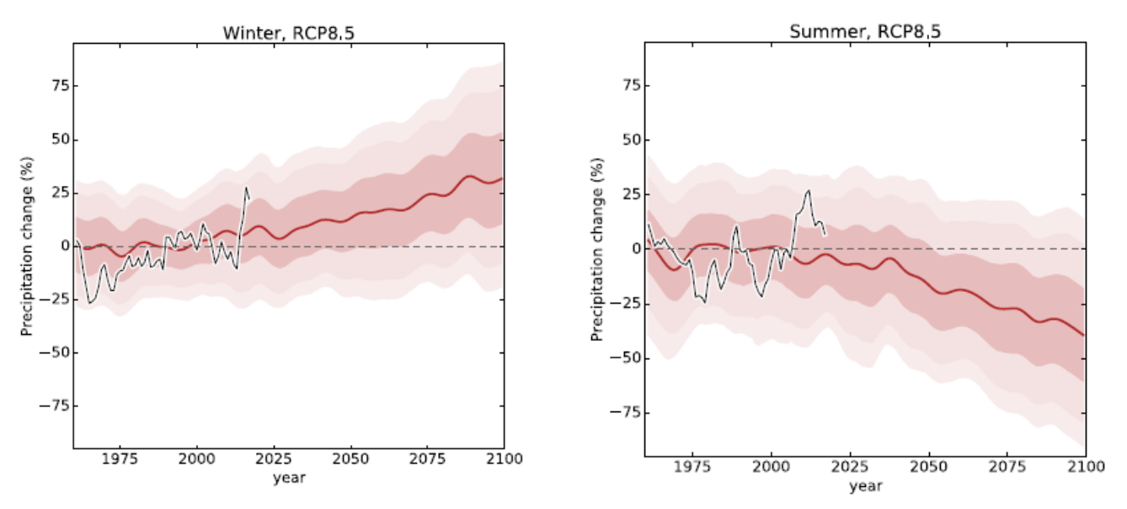
Figure 3 Future UK precipitation

- What predictions can you make for future UK precipitation?

- Contrary to your answer in question 5, why might we still need to prepare for hydrological hazards in the summer?

