|  |
| --- |
| Carbon capture in Oman |

# Starter – Ophiolite and Peridotite

Ophiolite

Ophiolite is a rock formation, or suite of rocks that often includes rocks such as limestone, basalt, gabbro, and **peridotite**.

The ophiolite rock formations represent a section of Earth's oceanic crust that has been uplifted above sea level through tectonic processes, such as subduction or continental collision.

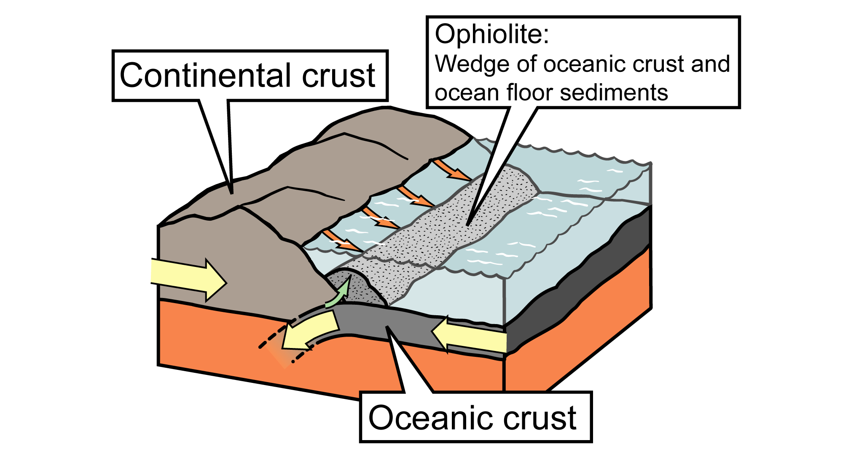

Source: J. Houghton © modified by the [Earth@Home project](https://earthathome.org/hoe/ne/rocks-a-p/)

Using the world map in the PowerPoint, describe the distribution of ophiolite. ___________________________________________________________

______________________________________________________________________________________________________________________

___________________________________________________________

___________________________________________________________

What is carbon capture?

Watch the FT video and answer the following 5 questions below.

1.What needs to happen ‘long term’? 0:40

___________________________________________________________

___________________________________________________________

2. It can be ‘a part of how we address the problem’ but what can it *not* be? 1:20

___________________________________________________________

___________________________________________________________

___________________________________________________________

___________________________________________________________

3. How many billion tonnes of emissions are there per year?

___________________________________________________________

___________________________________________________________

___________________________________________________________

___________________________________________________________

4. By 2030, what increase is needed in carbon capture to be on track to hit NetZero by 2050?

___________________________________________________________

___________________________________________________________

___________________________________________________________

5. Oil and gas companies are the leading investors in CCS. What two reasons are given for their investment? 3:25

___________________________________________________________

___________________________________________________________

___________________________________________________________

___________________________________________________________

Who are 44.01?

Watch The Earthshot Prize video and answer the question below.

Who are 44.01 and they do?

___________________________________________________________

___________________________________________________________

___________________________________________________________

___________________________________________________________

# Exit ticket

Using your exit ticket, write a question on something to do with today’s lesson. Swap the ticket with your partner. To exit the classroom, you must answer the question correctly.

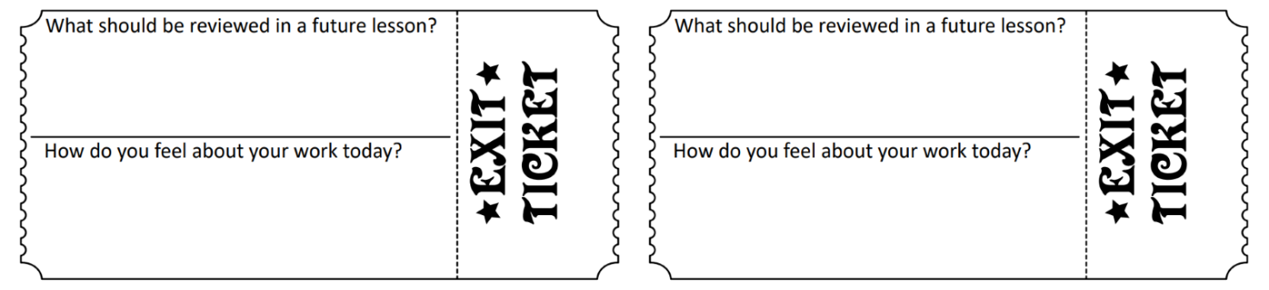Exit Ticket © Grefintec’s Shop via the [TES](https://www.tes.com/teaching-resource/exit-ticket-11505826)