|  |
| --- |
| Geographical careers in real estate – student activity |

Knight Frank is a real estate consultancy firm. One of their services is ‘providing property solutions’: this means working with different clients to match them with the best residential (homes) or commercial (e.g. offices) property for their specific needs. They work with people, businesses and organisations: for example, they might assist a family to find a new home near to a good school or help a business to find suitable office space for their workers that has good public transport links to reduce the need to drive. They also help organisations find suitable locations for their operations, like working with the police to find warehouses to store equipment or collaborating with hospitals to identify the best location for a new unit that effectively serves the local community.

Clients will typically provide a brief of what they’re looking for and it’s Knight Frank’s role to identify the right property or land that meets the client’s needs. To ensure that these decisions are robust and evidence-based, Knight Frank have a **Research Analytics Team** which leverages maps, spatial data and analytical tools to filter down appropriate locations for a client.

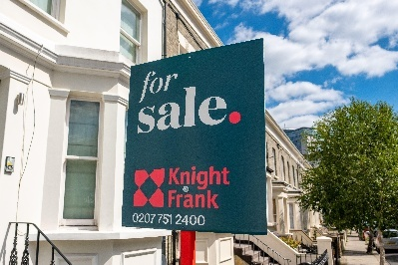

*Examples of Knight Frank advertisements out and about in London. Image credit: Knight Frank*

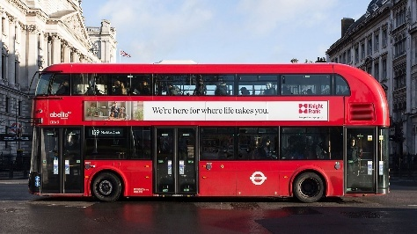

The Research Analytics Team at Knight Frank use a variety of different tools in their work. One of the most important ones is **GIS** (Geographic Information Systems). GIS is a computer-based system used to capture, store, analyse, manage, and present spatial data. GIS is used by a wide variety of organisations. These include businesses like Uber Eats and Deliveroo to match users with nearby drivers and restaurants and ensure services are reliable; it is used by environmental agencies to map areas of land that are at risk of flooding or identify areas of habitat that are at risk; and it is used by police forces to map where crimes take place so that they can allocate resources appropriately, helping to protect the community.

The Research Analytics Team at Knight Frank come from a range of educational backgrounds. Many of the team have geography degrees, but some of the team have degrees in other subjects like economics and engineering. All the team have a passion for data and have strong geospatial skills. A geography degree is a great choice for building geospatial skills and gaining confidence in using data, which opens doors into a wide variety of careers.

Meet some of Knight Frank’s Research Analytics Team:

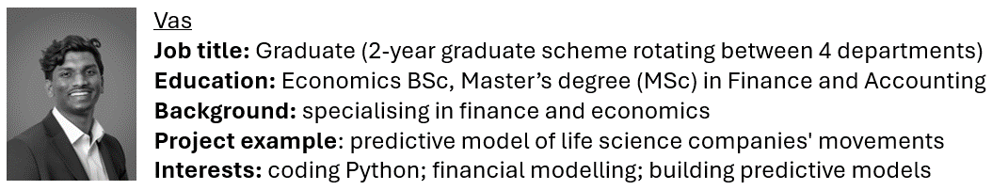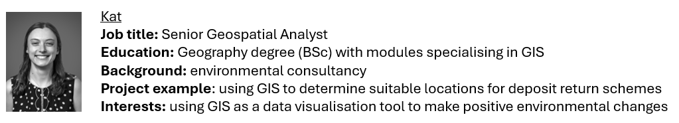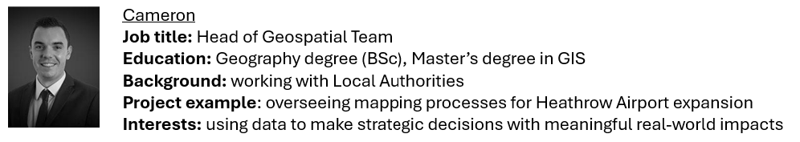

**Over to you!**

**Map A** and **Map B** are examples of two maps that the Research Analytics Team have developed for clients using GIS.

**Task** – Study the maps and complete the skills questions below each map.

**1a.** Map A shows the total area of public parks and gardens reachable within a 10-minute walk of a tube station in London Zones 1-3.

**Map A**

Using Map A, answer the following questions:

1. Describe the distribution of public parks and gardens that are 250+ hectares accessible in size.
2. Evaluate the effectiveness of Map A for showing the distribution of green space in London

**1b.** The RAY Farringdon is an office building in Farringdon, London. Map B shows the density of amenities (shops, cafes, restaurants etc.) in the local area by number. Map B also shows the walking distance (in minutes) between the RAY Farringdon and areas where these amenities are located.

**Map B**

Using Map B, answer the following questions:

1. Describe the density of amenities within a 5-, 10- and 15-minute walk of the RAY Farringdon.
2. Imagine you are part of Knight Frank’s Research Analytics Team. A property developer wants to build a block of flats that are less than a 15-minute walk away from the RAY Farringdon. Based on the density of amenities in the surrounding area, suggest a location for the block of flats:
3. Circle the location on the map
4. Justify your choice using evidence from the map
5. Evaluate the effectiveness of Map B for showing density of amenities in London