Filming on Mount Everest
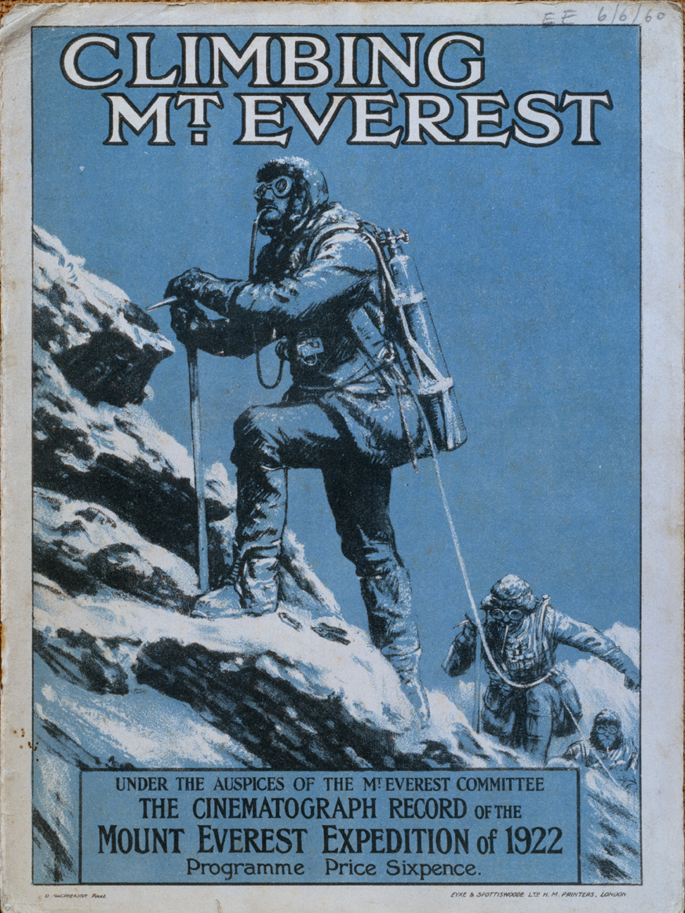
Climbing Mount Everest (1922) was the first of many documentary films of expeditions to Everest. It was the first to be made inside Tibet with the permission of the Dalai Lama. It was made by Captain John Noel, whose achievement was to film using a specially adapted camera at 23,000 feet.
From a very early stage in the planning, Noel was convinced that the film’s success depended on including scenes of local culture and religious life. As well as showing the high-altitude climb, the film he planned and edited while still in Tibet shows scenes of the appointment of 60 Sherpas in Darjeeling and a sequence of masked ritual dances at Rongbuk monastery at the foot of Everest.
There is also an important scene showing the expedition leader General Charles Bruce with the Head Lama of Rongbuk, supposed to represent the blessing of the expedition as it made its way towards the Mountain. This footage was actually taken after the climbing expedition, which ended after 7 porters lost their lives in an avalanche.
The film shows the role of interpreters such as Karma Paul who worked on expeditions on Everest until 1938. He was born in Tibet, but raised as an orphan in Darjeeling, and spoke Tibetan, Nepali, Bengali and other Himalayan dialects. General Bruce described him as “the most important subordinate member of the expedition…He served us very well from one end of the expedition to the other.”
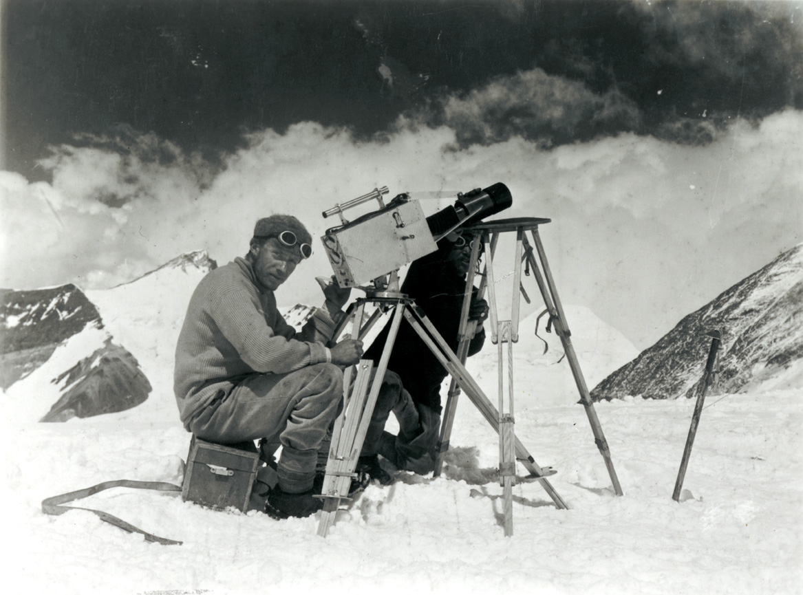
The film also includes footage of the Sherpas and aspects of their culture which shows how the local culture became part of the story of climbing expeditions to a British audience.

