Views of Everest

Students will need to have an understanding of the location of Everest, how it was named and the people who live in the area for this activity. The following activities can be done in pairs or groups, or half the class given the British map and extract and half the class given the Tibetan map. They then share their findings to each other.

Activity One
Give the students each map to study carefully and think about the following questions, answers can be written round each map. They should be presented to the students without any prior information about the maps.

- Who produced this map?
- What is the purpose of this map?
- Who do you think it is for?
- What is the map showing?
- What features does it have to show that it is a map?
- What type of map is it?
Discuss the students’ responses, pointing out the different information on the maps and the different perceptions of Everest; a British map for climbers, a Tibetan map for pilgrims. In the 1920s, Nepal was closed to foreigners so expeditions had to travel through Tibet. The Royal Geographical Society sponsored these expeditions and played a key role in the wider growth of knowledge about the geography of the whole of the central Asian area. The Society adopted the name of Everest for the highest mountain in the world in 1865.

Activity Two
Ask the students to read the information and extracts from the Geographical Journals. The extracts may be divided into separate paragraphs and given to different pairs or groups to answer the following questions.
1922 article
- Who wrote the article and why was it published in the Geographical Journal?
- What was the expedition for?
- Who went on the expedition and what were their roles?
- What does the extract tell us about the attitudes of the British to Everest?

1898 article
- Who wrote this article?
- What were the author’s views of the Tibetan map and local names of mountains?
- What does the extract tell us about the Tibetan and Nepalese views of Everest?
- Why do you think the author wants to “wipe out the standing slur on our geographical knowledge?”
Activity Three
Give the students a question to debate. This can be based on what they have learnt already about the surveying and mapping of Everest; Do you think that the highest mountain in the world should have been named after Everest? Each pair or group can think of 5 points to back up their argument and a vote can be taken at the end of the session.
Information

Map A
This map was a preliminary map to illustrate the route of the first Mount Everest Expedition in 1921, drawn by Major H T Morshead and assistants of the Survey of India. It was the first reconnaissance expedition led by Lt.-Col. Charles Howard Bury and included George Mallory and Guy Bullock. Nepal was forbidden territory and the only approach was a month-long journey through Tibet by foot and pony from Darjeeling. Nothing was known of Everest except that its summit was the highest and no-one knew whether if a route were found, it would be possible for a human being to follow the route to 29,002 feet (8840m) above sea level.

The broken line on the map marks the route of the various members during their reconnaissance of the area. The map covered an area never surveyed before, of enormous scope and detail, all achieved on foot and on horseback. It was published in the Geographical Journal, 1922.

Extract from Geographical Journal

“The object of this year’s expedition was to make a thorough reconnaissance of Mount Everest and of the approaches to it from the north, east, and west, and to find out whether a possible route existed that would lead to the summit, and that was not physically impossible. For the purely mountaineering part of the work we had Mr H Raeburn, the leader of the mountaineering party, Dr Kellas, Mallory and Bullock, all members of the Alpine club. In addition there was the very important work of surveying and mapping the unknown territory through which we were travelling and the very difficult mountainous regions that surrounded Mount Everest. “

“To the west, and close at hand, towered up Mount Everest, still over 8000ft above us, at first cold and grey, like the dead, and with a sky of the deepest purple behind. Then, of all a sudden, a flash of golden light touched the utmost summit of Mount Everest and spread with a glow of gold all over the highest snows and ridges of this wonderful mountain, while behind the deep purple of the sky turned to orange.”

“The scientific results have not been fully worked out, but in general outline some 13,000 square miles of new country have been surveyed and mapped, part of this by the method of photographic survey and on a large scale; a number of birds and mammals of all sizes have been collected; the geology of the whole region has been carefully worked out…and a series of photographs have been taken of a country quite unknown and containing some of the grandest scenery in the world.”
Map B
This is a Tibetan picture map of the Mount Everest range in the 1890s, an indigenous hand drawn map showing temples and stupas in the mountain range. It was reproduced in an article called The Environs and Native Names of Mount Everest in Geographical Journal vol. X11, 1898 where Major L A Waddell discusses the “alleged native names for mountains.”

Extract from Geographical Journal

“(Everest) lies so far behind the outer snows that its height is not apparent to the Nepalese, who seldom go near any of the snowy mountains…hence has arisen the confusion in the names of peaks as obtained from Nepalese sources-owing partly to the extreme difficulty in identifying peaks from great distances, but mainly due to the remarkable looseness of the Nepalese in their nomenclature of the snowy mountains.

The Tibetans, on the other hand, worship all the snowy mountains individually; and they especially worship Everest as the abode of the “five sister-nymphs of Long Life”… and troops of pilgrims regularly ascend its flanks as far as the latter shrine, and still higher, for purposes of worship. “

“…a curious Tibetan picture map obtained by Mr A W Paul at Darjiling. This map bears no title, but it evidently represents the southern flanks of the Everest range…As it gives a rough bird’s-eye projection of villages, bridges, and pilgrims’ routes on one of the flanks of Everest, with many new names, I have made a tracing of it, on which I have printed the names in Roman characters; and whilst reproducing an exact transcript of the Tibetan spelling, I have added in thicker letters the spoken form when this differs considerably from the written, so that the names may be generally recognisable. A few of the names were too illegible to be deciphered.”

“In this picture map, the snowy mountain range at the top is represented as ending in five peaks of conventional form, of which the middle three are capped by clouds, and the other two snowy peaks on the right border, above Ch’ubar, are also cloud-capped. The bold cliffy peak between the two passes has such an individuality of form that it may possible prove to be something of a portrait of the sacred rocky peak on the shoulder of Everest. The shrines and villages are all marked by fluttering prayer-flags; and in the original are figured by numerous pilgrims ascending and descending the mountain-paths.”

“…There are many ways of spelling native names in Tibet, owing to the frequent differences between the written and spoken forms of the majority of native names, which are not fixed by printing…None of the villages named on this picture are to be found on any of the Himalayan Survey maps to which I have had access…It is hoped that some explorer soon may penetrate the Everest range, and wipe out the standing slur on out geographical knowledge, in that, although its highest peak is visible from Darjiling and other parts of British territory, we know as yet next to nothing about the king of mountains.”

MAP A
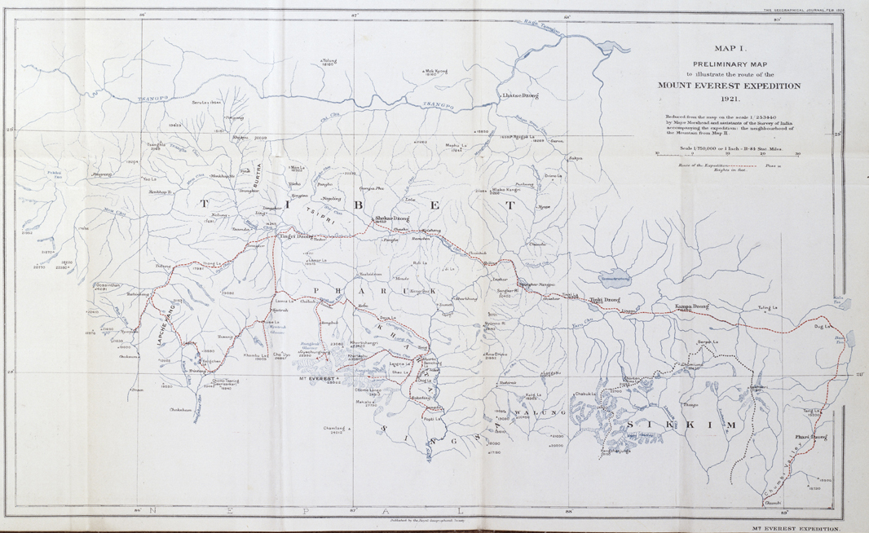

MAP B

