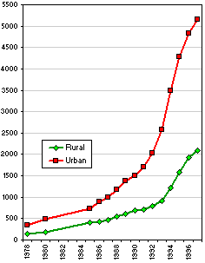
Changes in urban and rural income over time – the gap between rural and urban incomes is not closing!

 |  | Total population | Population living in | Population not living in | Percentage
 |  | Total population | town, township, | town, township, | of population not
 |  | Total population | or subdistrict where | or subdistrict where | living where registered
 |  | Total population | registered | registered
 |  | (1000's) | (1000's) | (1000's) | (%)
 | National | 1,242,799 | 1,173,466 | 69,333 | 5.6
 | Beijing | 12,850 | 10,734 | 2,116 | 16.5
 | Shanghai | 14,913 | 12,931 | 1,982 | 13.3
 | Tianjin | 9,678 | 8,732 | 946 | 9.8
A selection of data to illustrate the huge numbers of ‘temporary residents’ in China as a whole and in three of the largest cities – Beijing alone has over 2 million migrants living in the city on temporary residents visas (or with no visa at all).

