|  |
| --- |
| Working in energy law – teacher support |

This student activity is split into two sections.

**Section A – Research Activity**

This section aims to increase students’ awareness of different organisations based in the energy sector. Many of the organisations listed run graduate schemes, and/or apprenticeships (e.g. National Grid, EDF, Ofgem and Ørsted. This activity could be extended to include a secondary research activity exploring graduate/apprenticeship schemes, which will increase students’ understanding of career opportunities available to them, helping inform their next steps.

**Section B – Energy Law & Geography**

This section explores the links between energy law and geography, with the intention of highlighting geography as a subject that compliments a career pathway in law, as demonstrated below:   
  
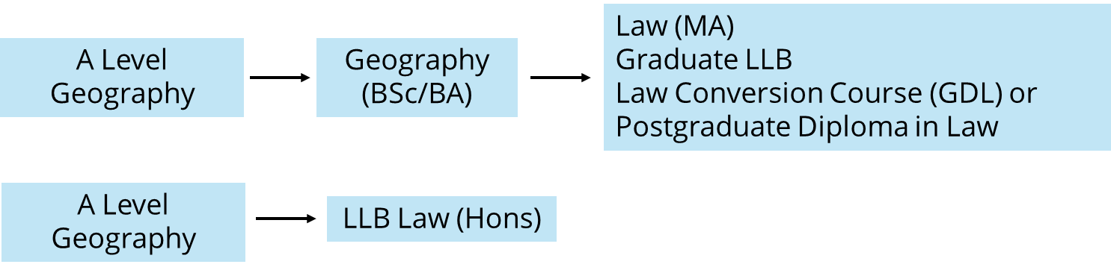

You can find out more about Marianne and her work as an energy lawyer here: [Marianne Anton : Clyde & Co](https://www.clydeco.com/en/people/a/marianne-anton)

**Curriculum links**

**GCSE**   
  
Edexcel A: Topic 6a, Energy resource management   
  
Edexcel B: Topic 9, Consuming energy resources   
  
AQA: Challenges in the human environment, specifically Section C, the challenge of resource management, 3.2.3.4

OCR A: Living in the UK today: UK environmental challenges, specifically 1.3.4 and 1.3.5

OCR B: People and society: Resource reliance

**A Level**

Edexcel: Topic 6, The Carbon Cycle and Energy Security

AQA: 3.2.5, Resource security, specifically 3.2.5.4 energy security   
  
OCR: Topic 3.3, Exploring Oceans, specifically key idea 2.a., biological resources can be used in sustainable or unsustainable ways

WJEC: Unit 4, Cotemporary themes in geography, Energy Challenges and Dilemmas

**Answers – Section A**

**Government Body**

A part of the government that makes rules, keeps order, or provides services for people, like building roads or protecting the environment.

Department for Energy, Security and Net Zero

Ofgem

Climate Change Committee

**Charity**

A group that helps people, animals, or the planet, using money from donations instead of selling things for profit.   
  
Green Alliance   
  
Centre for Sustainable Energy

**Oil and gas firm**

A business that finds, drills, and sells oil or natural gas for fuel and products.   
  
Shell   
  
BP

**Nuclear energy firm**A company that uses nuclear reactions to make electricity.

EDF Energy

Sellafield

**Energy provider**   
A company that brings power (like electricity or gas) to homes and businesses, also called an energy supplier

Octopus Energy

E.ON UK

British Gas

**Utility infrastructure company**  
A business (sometimes owned by the government) that provides the infrastructure for everyday essentials like water, gas, or electricity.

National Grid

**Engineering and construction firm**

A company that designs and builds big projects like bridges, skyscrapers, power plants, or roads.

AECOM

Jacobs

**Consulting and research firm** A business that gives expert advice or does research to help other companies or organizations solve problems.

The Carbon Trust

PwC

**Renewable energy firm**

A company produces power from natural sources that will not run out e.g. solar and wind.

Renewables First

Orsted

EDF Renewables

SEE Renewables

**Answers – Section B**

**1a.** Circle the correct definition of offshore wind …

1. *Offshore wind refers to the generation of electricity using wind turbines located in bodies of water, usually in the ocean*
2. *Offshore wind is a type of tidal energy that uses the movement of ocean waves to spin underwater turbines and produce electricity.*
3. *Offshore wind describes strong winds that blow from the land out toward the sea*

**1b**. What geographical knowledge will Marianne need to help advise the energy company on where is best to build an offshore wind farm? Tick all that apply

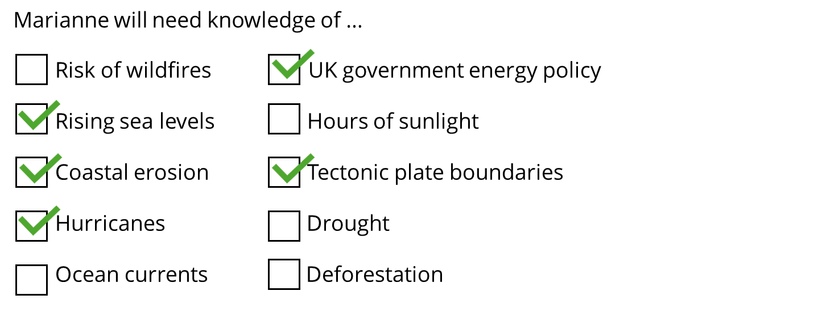

**1c(i).** Using the information on page 3, fill in the table to show what geographical knowledge versus what legal expertise Marianne will need.

|  |  |
| --- | --- |
| **Geographical knowledge** | **Legal Expertise** |
| * Understanding boundaries of UK’s territorial seabed * Climate change * Borders | * How energy is connected to the power grid * Power purchasing agreements * Knowledge of licences |

**1c(ii).** Complete the sentence

Geography and energy law are interconnected because …

*Example responses:*

* In order to build new renewable energy infrastructure, knowledge of the physical geography of a place is needed
* Understanding the effects of climate change is important for deciding where to build new renewable energy infrastructure to ensure that it will be impactful

To help Marianne provide expertise, it’s important to know the reasons in favour of offshore wind, and the challenges associated with it.   
  
**1c.** Sort the statements below into reasons for and reasons against offshore wind in the UK

1. UK is an island which has up to 12 miles of territorial water
2. Wind is unpredictable
3. Creates jobs
4. UK government is aiming for net zero power system by 2030
5. Wind is an abundant and free resource
6. Lots of other countries are building offshore wind farms which means lots of competition for supplies
7. UK lacks current infrastructure to support high level of offshore wind farm
8. Will lead to more investment in the infrastructure of ports

|  |  |
| --- | --- |
| Reasons for | Reasons against |
| 1, 3, 4, 5, 8 | 2, 6, 7 |

**1d.** Using the answers to activity 1c and your own geographical knowledge, complete the following sentences

The UK is a good location to build an offshore wind farm because …

It has lots of territorial water because it is an island nation

However, one challenge with building an offshore wind farm in the UK is …

Wind is unpredictable, and this uncertainty is amplified by changing weather patterns