Seasonal Shopping

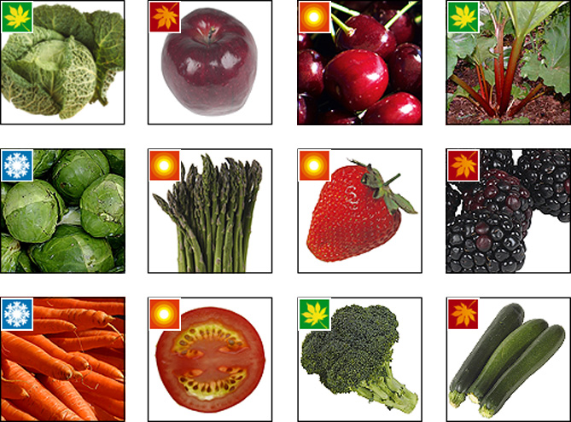
- Spring greens – Spring!  - Apples – Autumn  - Cherries – Summer  - Rhubarb – Spring  - Brussels sprouts – Winter  - Asparagus – Summer | - Strawberries – Summer  - Blackberries – Autumn  - Carrots – Winter  - Tomatoes – Summer  - Broccoli – Spring  - Courgettes- Autumn

