|  |
| --- |
| United Kingdom |

**Location Basic facts**

|  |  |
| --- | --- |
| Population per km2 | 279 (2022) |
| GDP/GNI per person | $49,240 (2022) |
| Climate | Maritime Temperate (mild and moist |
| HDI (closest to 1 = most developed) | 0.931 (2021) |

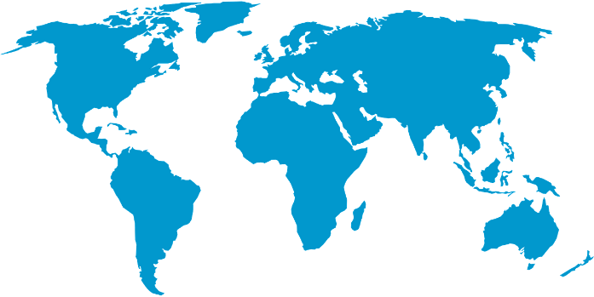

*World Map © Clker-Free-Vector-Images, Pixabay*

**Environmental facts**

|  |  |
| --- | --- |
| 1. | The UK has relatively few natural hazards. However, the main hazards in the UK are flooding caused by heavy rainfall and storms. These usually occur in the winter months and can be inland along river basins or along the coast. Some locations experience high winds, but these do not tend to be at hurricane speeds. |
| 2. | According to Ordnance Survey, the coastline of Great Britain and its islands is 31,368 kilometres long. In fact, it’s one of the longest in Europe. Being an island nation, no-one lives more than 129 kilometres from their nearest coastline. The coastline is made from different rocks - some are soft and eroding creating bays and beaches, others are harder and create rugged cliffs. |
| 3. | As the UK’s climate is temperate, the sea is a ‘melting pot’ of different marine life. The UK is a point where the warm waters from the Equator mix with the colder waters of the Arctic. This brings many nutrients to the sea. There are many marine species to be found including seahorses, jellyfish, turtles, seals and even dolphins! |

**Protecting the oceans**

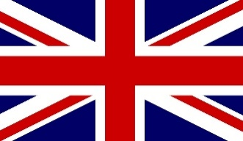At the UN nature summit in December 2022, the UK pledged, along with other nations to protect at least 30% of the world’s oceans by 2030. In 2023, the UK renewed its support of the Blue Planet Fund which aims to protect and restore marine habitats such as seagrasses, coral reefs and mangroves. It is also putting an additional £24 million to the Global Fund for Coral Reefs. It has also pledged to donate £4 million towards the Blue Carbon Action Partnership to help protect blue carbon ecosystems.

*Union flag © Pete Linforth, Pixabay*