
Careers that build sustainable cities: Ebbsfleet Garden City

The green boxes showcase geographical jobs in the built environment sector. When you are reading this case study and examining the links, keep in mind all the geographical knowledge and skills that have been used to create each element of the development.
For more info on geographers in the built environment sector, visit: https://memf.careers/

Ebenezer Howard founded the Town and Country Planning Association in 1899.

Over 100 years later, planners must have a deep understanding of sustainability and have a key part to play in developing a sustainable future for us all. Find out more from the Royal Town Planning Institute.

Ebbsfleet Garden City, located to the east of London and the M25 and comprising approximately 1150ha of brownfield land in north Kent, may not seem like a “garden” location. However, the Garden City movement is seen by the Town and Country Planning Association as one of the “most influential and enduring example of an alternative and sustainable way of living that the UK has ever produced” (1). In this case study, we will examine the Garden City movement and examine how a new settlement on a brownfield site is brought into sustainable reality and the careers that bring the vision to reality.
Diagram 1: Aims for Ebbsfleet Garden City, reproduced with permission from Ebbsfleet Development Corporation (5).

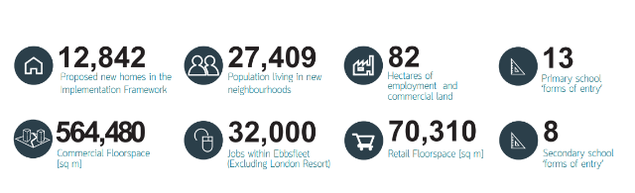
The Garden City Movement

Writing in 1898 and revising in 1902, Ebenezer Howard built on the Model Village examples of Saltaire, New Earswick and Bourneville to propose a third alternative to Town OR Country as a Garden City (2). In his proposals, Howard laid foundations for modern sustainable planning by setting out social, economic and environmental elements in his sustainable garden city model. These were:
- Economic: financing considered, low rent/rates and process for inhabitants but with high wages and plenty of scope for enterprise, flow of capital
- Social: bright homes and gardens, no slums, freedom, co-operation, social opportunity of easy access, plenty to do
- Environmental: pure air and water, fields and parks, good drainage, no smoke, no informal settlements

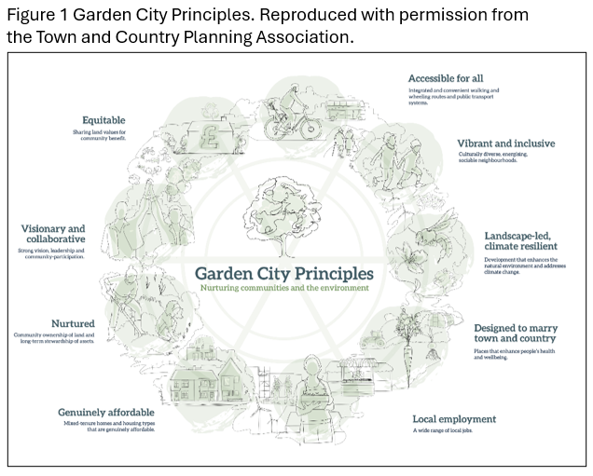
More than a century later, the Town and Country Planning Association’s Garden City Principles (Figure 1 (3)) reflect those early ideals and have been used to formulate the plans for Ebbsfleet Garden City.
These principles for living underpin the “first garden city in 100 years that is being created across 2,500 acres of previously used, brownfield land on the Kent Thames riverside.” (4).
Ebbsfleet Garden City’s 6 Delivery Themes (5) are:
- Quality Homes and Neighbourhoods
- Enterprising Economy
- Connecting People and Places
- Healthy Environments
- Civic Community
- Resilient and Sustainable Systems
Development corporations provide a large range of opportunities for exciting careers in the Built Environment, for example:

A Development Corporation Officer assists in the delivery of projects, builds relationships with stakeholders and plays a key role in developing an area.
Salary:
~ £32,000 per year

Ebbsfleet Garden City – Background
Located on the southern bank of the River Thames (Map 1), on an inner bend of a large meander, the area designated for the Ebbsfleet Garden City has grasslands, chalk cliffs and old quarry and riverside industrial sites as well as a rich cultural heritage (4). The brownfield site is extensive. The area is criss-crossed by train lines leading in and out of Ebbsfleet International, which is on the HS1 line and is not only 17 mins from central London but also only 2 hours from Paris (5). Being bordered by both the Thames to the north and east (with possible future plans for the Thames Clipper to operate from here) and the A2/M2 and M25 road network to the south, gives extra transport options; there is no denying it is a well-connected location for a development corporation to create something exciting.
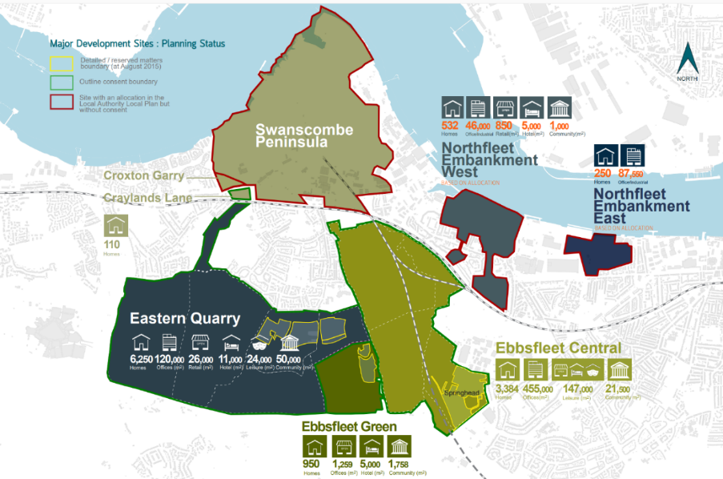
Maps like Map 1 and 2 (below) are constructed using Geographical Information Systems software (GIS). You don’t need to be a coder to use GIS but coding is used in formulating the software. You do need a good understanding of the geography being shown in the maps.
Jobs in GIS are usually well-paid and can be found all over the world. ESRI is a leading GIS platform and a great place to learn more about where GIS can take you.

Map 1: Major Development Sites for the Ebbsfleet Garden City (reproduced with permission from Ebbsfleet Development Corporation (5)).
Achieving Sustainability
Simon Harrison, Head of Design and Sustainability for the Ebbsfleet Development Corporation (EDC) oversees the master planning of Ebbsfleet, the design management of planning applications, and the co-ordination of the Environmental Sustainability programme at EDC.
Simon Harrison trained as an Architect and a Town Planner and now works as an Urban Designer.
He is clear that to achieve sustainability in a new town such as this, a systems approach is vital along with an awareness that everything is changing as it is developing and therefore changes to plans will be needed to meet the complexities of such a system. The concept that places are complex systems working at an inter-related range of scales means that geographers are ideally suited to working in the Built Environment.

We know that for sustainability to be achieved, social, economic and environmental needs must all be met. Planning for sustainability at Ebbsfleet started with the concept of 9 walkable and liveable villages (Map 2 (5)) that would together form the whole settlement; great consideration was given as to what is needed to make villages viable and able to thrive. As an urban designer, Simon Harrison advocates for starting with simple systems questions (Box 1).

Careers for geographers in the built environment: Town Planner
A town planner designs and develops towns and cities to ensure that they meet the needs of the communities who live there as well as support economic growth and environmental sustainability. An urban planner has to balance demands for housing, transport, shops and services and green space. They help ensure that places are safe and attractive to live and work in.
Geographical knowledge & skills that urban planners use includes:
- Urbanisation, including push and pull factors to urban areas
- Knowledge of urban challenges and how these challenges can be managed
- Historical understanding of urban growth in the UK
- GIS and map knowledge
- Understanding of Census data

Salary:
£28,000 – £50,000+ per year

For more information, click the link: What Does A Town Planner Do?

To turn these sustainable plans into reality requires a number of different people working in different job roles. These may include jobs as a:
- Urban Designer
- Town planner
- Transport modeller
- Design manager
- Setting out engineer
- Highways engineer
- Highways maintenance technician

Box 1: What does a village need to function and be liveable each day?
Each “village” started with a two-form entry primary school; without children a village can’t be sustainable. This would need 700 children to make it economically sustainable.
To make that happen they needed the following information:
1. How many people per dwelling?
The average UK household size was 2.35 residents per household in 2024 (6); Ebbsfleet is above the national average with 2.98 people per household. They know that they are attracting a younger population so far, therefore 700 homes should yield the children needed for the primary school to be viable.
2. Planning for a walkable settlement.
Working on the basis that people will walk for an average of 5 minutes before jumping into a car and the average walking speed is 100m per minute, the team planned for a walkable catchment for the primary schools using a 500m radius (Map 2).
Therefore, they planned for 700 dwellings in a 500m radius of each primary school (giving a density of 60 dwellings per hectare).
For those that live further away, they will drive to a carpark on the outside of the settlement (within the 500m radius) and walk to school from there.
For bigger settlements such as Alkerden, where there is an education campus and hence a secondary school (Map 2), there is NO parking provided by the high school but instead planning of routes for the rapid transit bus system ensures that the stops outside the school will provide the public transport needed. All secondary school students are planned to be within a 10-15 minute maximum walk from the secondary school (8).
3. What else needs to be provided, as well as the primary school, to ensure that a village will flourish?
Each settlement was planned to have a pub, a shop and a connection to a rapid transit bus. Where the settlement is large enough, it will have a GP surgery.
The urban design team accepts that over 3 miles, the car will be used and therefore the transport system must be fit for purpose and link to the rail network that will provide vital access to the city of London for commuters.
Map 2 below clearly shows the walking radius for each local area and the planned social and community infrastructure needed to ensure social, economic and environmental sustainability.

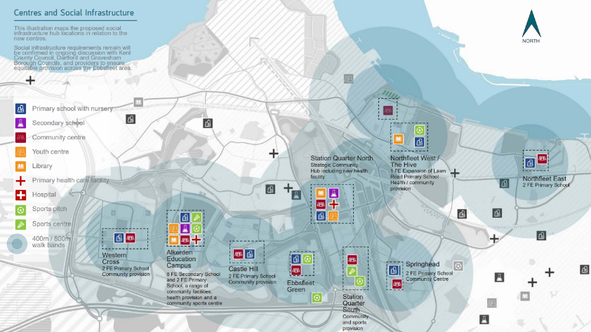
Developing a Brownfield location
Careers for geographers in the built environment: Environmental Advisor
An environmental advisor ensures that projects meet environmental regulations. This may include collecting data on air, water and waste pollution, creating waste management plans and ensuring that a project complies with environmental laws.

Geographical skills and knowledge that environmental advisors use includes:
- Understanding impacts of climate change, including impacts on ecosystems and biodiversity
- Knowledge of a variety of solutions to climate change challenges
- Knowledge of climate change policies, such as the Paris Agreement
- Fieldwork skills, including data collection and data analysis

Salary:
~ £25,000 for newly trained environmental advisors to £56,000 with experience

For more information on this job role, click the link: Environmental Advisor

Turning a brownfield site into a sustainable settlement involves many different people working across different job roles. These include jobs as a:
- Landscape Architect
- Environmental Advisor
- Ecologist
- Drainage Engineer
- Groundworker
- Hydrographic surveyor
- Groundworker
- Hydrographic surveyor

Map 2: Centres and Social Infrastructure for the 9 planned settlements that make up Ebbsfleet Garden City (reproduced with permission from the Ebbsfleet Development Corporation (5)).
You will have studied the pros and cons of developing brownfield sites throughout your geography education, but what is often overlooked is the cost and time it takes to convert disused sites into something that is fit for humans to live on.
Much of the Ebbsfleet area was formerly a quarry and was home to the cement industry for the last 150 years. Much of this land will need another two years of re-profiling to make it fit for building; the cost of reformatting the land and making it capable of supporting all the systems that a city needs to function is large, thus presenting considerable financial, design and planning challenges for sustainable development.
The cement industry disposed of waste such as cement kiln dust on the Swanscombe peninsular which has led to the soil having a more alkaline pH of 10.5-12.2 meaning that there is diverse plagioclimax here leading to its designation as a SSSI for the diverse landscape including grassland, scrub, wetlands and saltmarsh habitats. Balancing the needs of the environmental sustainability of the area, including the 1,700 invertebrates a quarter of the UK’s beetle species and the critically endangered jumping spider alongside the development aspects of building 15,000 new homes and all the infrastructure, is just one of the many brownfield puzzles that the developers contend with.
The quarries have presented some design challenges however have been commended for “innovative environmental management approaches” in the conversion of the quarries in lakes that have promoted ecosystem and habitat creation, provide recreational opportunities and aided with flood management (7).
Balancing the quarry site with 15,000 new homes has presented other challenges and opportunities. It is hoped that the residential developers have a Sustainable Drainage System “menu” to promote water saving measures across the 9 villages; the planning guidance is designed to push developers towards rainwater harvesting (9) whereby rainwater is captured and held and doesn’t go straight into surface water drainage. Each village is separated by linear parks with swales to collect rainwater that is fed into the quarry lakes. Developers are encouraged to build rain gardens, tree pits and use permeable blocking and asphalt solutions. Within these detailed menus are explanations of cost-effectiveness, practicalities and information on net-biodiversity gains. Similar menus are available to householders to encourage them to save money and water in their usage (9).
Careers for geographers in the built environment: Environmental and Sustainability Manager

An environmental and sustainability manager conducts environmental assessments on buildings and advises on low carbon or renewable energy technologies to ensure that a site is environmental sustainable.

Geographical knowledge and skills required for this role includes:
- Understanding impacts of and solutions to climate change
- Understanding the pros and cons of different types of energy and has good knowledge of renewable energy
- Understands the concept of sustainability
- Fieldwork skills, including data collection and data analysis

Salary:
£29,000 for newly qualified sustainability managers, increasing to £86,000 with experience

For more information on this job role, click the link: Sustainability Manager

Ensuring Social Sustainability
The EDC use a range of data capture and evaluation tools to keep in consistent and frequent conversation with their residents. This has allowed them to know that they have “younger, family-orientated households, with greater cultural and ethnic diversity” than neighbouring areas (10). They use this information to develop events and activities to reflect their residents but also to target groups that are needed for a truly sustainable community such as older residents. The 2024 Resident Satisfaction Survey gave 80% of residents with a “strong sense of belonging,” this compares with just over 70% nationally indicating that successful social sustainability is possible. In placemaking a new community, “community collaboration…can guide better decision-making” that helps with understanding the population’s lived experiences and leads to “long-term improvements in quality of life” (10).
In ensuring social sustainability, Ebbsfleet Development Corporation aim for opportunities for both the new and other established neighbourhoods:
- “To date, over £35m in social value has been generated for the benefit of the local community – with a focus on supporting those in neighbouring communities of Dartford and Gravesham, who experience high indices of deprivation, including childhood obesity, and adult diabetes” (10)
Strategy and Placemaking Roles are increasingly recognised as central roles in shaping high quality public spaces and creating thriving, inclusive and sustainable communities. As with many roles, a public sector role will be a key way of helping the community and having a varied career, but may not pay as well as a private sector role.

Other roles for geographers include being a Corporate Social Responsibility Coordinator
and a Marketing and PR Manager

- “Recognising the skills gaps in the sector and higher than average unemployment in neighbouring wards including Northfleet and Swanscombe, we have addressed this challenge with short employability programmes designed to give local residents the ‘tickets’ required to work on-site in construction” (10).
- “In the 10 years since the Corporation was established, over 8,000 students have received careers advice and over 30 local residents assisted into work in the built environment” (10).

Conclusions
There is no doubt that creating a brand new sustainable settlement is in many ways easier to do than retrospectively attempting to impose sustainable elements, and this was in the original aims of the Garden Cities, over a century ago. However, as shown, developing a brownfield site, is not without its issues.
What is clear throughout, is that geographical knowledge and understanding pervades this Garden City and the associated careers; whether it is ecosystems, SuDS, transport nextworks, push and pull factors or all of the elements of sustainability, geography is crucial throughout. The systems thinking that Simon Harrison has used in creating and designing Ebbsfleet is a clear way that we can further develop our own geographical understanding and application of knowledge of the Built Environments.

Study Activity 1
- Examine Map 1. What map evidence is there that this will be a sustainable settlement?
……………………………………………………………………………………………………………………………………………………………………………………………………………………………………………………………………………………………………………………………………………………………………………………………………………………………………………………………………………………………………………………………………………………………………………………
- Read Box 1.
i) What elements of physical and human geography are needed in planning a settlement?
………………………………………………………………………………………………………………………………………………………………………………………………………………………………………………………………………………………………………………………………………………………………………………………………………………………………………………………
ii) Why is geography an excellent subject to study to have a career in the built environment?
………………………………………………………………………………………………………………………………………………………………………………………………………………………………………………………………………………………………………………………………………………………………………………………………………………………………………………………

Student Activity 2 - Think like a geographer
Using the information above, put yourself in the shoes of each geographical job role to answer the questions. Think like …



- An Urban planner – In your opinion, what would be the main differences between the social, economic and environmental issues that modern planners contend with compared to those of the planners working in 1900?

- A Conservation Planning Manager – read this article and detail how the concept of place is important in conserving somewhere like Saltaire.


- A Sustainability Manager – making a New Town sustainable is much easier and cheaper than making an existing site sustainable. Think about your local area, what would be your first actions in making it a more sustainable place? How would you combine social, economic and environmental sustainability?


- A Geographical Information Systems Consultant – Look at Map 2. Identify the “layers” that have been added to make the plans clear. Evaluate this map; what would you have done differently to make this map useful when presenting the plans to a different audience such as the general public?


- An Environmental and Sustainability Manager - What would be the key messages that you would be giving residents in order to ensure the sustainability of Ebbsfleet into the next decade

Key terms

Brownfield Site – land that has been used previously and having been abandoned can be used again. Often needs considerable remediation measures to make it fit for new purposes.
Development Corporation – In the 1940s the first development corporations developed the new towns. In the 1980s they were brought back by the government as a mixture of public and privately funded groups designed to breathe new life into urban areas.
Model village Movement – self-contained communities built in the late 18th century by landowners and successful industrialists to ensure high-quality housing and amenities for their workers e.g. Bourneville, Port Sunlight and Saltaire
Sustainability – meeting the needs of the present without reducing the ability of future generations to meet their needs; must have social, economic and environmental elements in balance
Plagioclimax – When ecosystem succession is interrupted by human activity the “new” final stage in succession is known as a plagioclimax
SSSI - An area protected by law as a Site of Special Scientific Interest (Wildlife and Countryside Act 1981).

References
1. Garden Cities Accessed 03.04.26
2. Garden cities of to-morrow (being the second edition of "To-morrow: a peaceful path to real reform") Accessed 03.04.36
3. Town and Country Planning Association – We work to challenge, inspire and support people to create healthy, sustainable and resilient places that are fair for everyone Accessed 10.04.26
4.Homepage - Ebbsfleet Garden City
5. Ebbsfleet-Summary-Framework-5.pdf
6. Families and households in the UK - Office for National Statistics Accessed 20.04.26
7. Yu, Haoxuan, From Quarry to Carbon-Conscious City: The Ebbsfleet Garden City Regeneration Experience, International Journal of Energy Research, 2026, 9942560, 9 pages, 2026. https://doi.org/10.1155/er/9942560 Accessed 27.04.26
8. A Sustainable Travel Strategy. Ebbsfleet Garden City.
9. Ebbsfleet Garden City: A sustainable development | EWSC Case Study - YouTube accessed 10.04.26
10. Listening to build better: How resident insights are shaping life in Ebbsfleet | Building New Communities Accessed 21.04.26

With Thanks to Simon Harrison, Head of Design and Sustainability, Ebbsfleet Development Corporation for his valuable time in supporting this case and place study.

This resource is produced with the support of the My Environment My Future programme. For more resources, visit: www.memf.careers

