Country Fact Sheet - India

India is found within the continent of Asia and is the 7th largest country in the world. The country is made up of 28 states and each state has a different size and population.

This map shows you where India is:
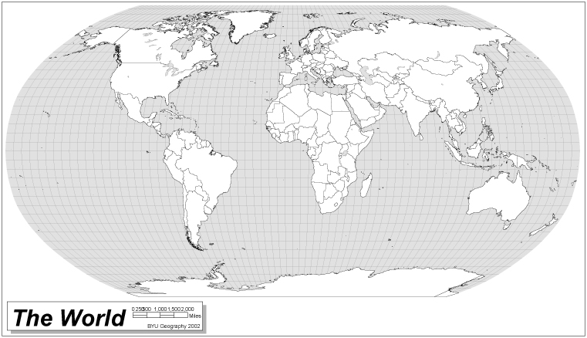
Equator
India is in South Asia and has 7,000 km of coastline bordering the Arabian Sea and the Bay of Bengal (which are sections of the Indian Ocean)

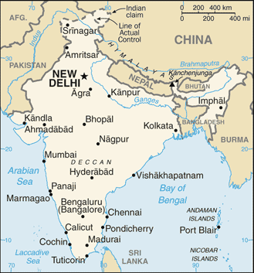
This map shows India in more detail, can you pick out the important cities?

Mumbai used to be called Bombay. It is India’s largest city with a population of 18 million people.
New Delhi is the capital city of India.

© CIA

Fast Facts:
Country Name: Republic of India

Land Area: 3.2 Million Square Kilometres

Population: 1.1 billion (2007 estimate)

Capital City: New Delhi (this is the country’s second largest city with a population of approximately 14 million)

Other important cities and the reasons for their importance: Mumbai (financial centre), Kolkata (export centre), Chennai (spice and cloth trading), Bangalore (science & technology centre), Hyderabad (technology capital).

Borders with: Pakistan, China (including Tibet), Nepal, Bhutan, Myanmar (formerly Burma), Bangladesh and the Indian Ocean.

Longest River: Brahmaputra (measuring 2,840km)

Highest mountain: Kanchenjunga (the 3rd highest mountain in the world measuring 8,598m)

Major Religions: Hinduism, Islam, Christianity and Sikhism

Main Languages: Hindi and English

Government: The Prime Minister of India is Manmohan Singh, he was elected in 2004.

Life Expectancy: 63 years (men) and 66 years (women)

Adult Literacy Rate: 61%

Main Industries: Textiles, chemicals, food processing, steel

Main Crops: Sugar cane, rice, wheat, pulses

Currency: Rupee (100 paise = 1 Indian Rupee)

The Indian Flag:
This flag was launched in 1947 when India became an independent country. The blue wheel in the centre of the flag is a Buddhist symbol representing justice. The Indian flag is always made of homespun cloth called ‘Khadi’. The colours of the flag (saffron, white and green) also mean something.
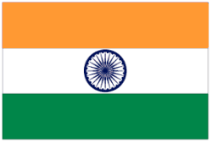
Saffron: For courage & sacrifice
White: For truth & purity
Green: For faith & fertility

Information was obtained from the following sources: Foreign & Commonwealth Office, Central Intelligence Agency, BBC News & the United Nations.

