|  |
| --- |
| Nigeria |

**Location Basic facts**

|  |  |
| --- | --- |
| Population per km2 | 231 (2021) |
| GDP/GNI per person | $6,200 (2023) |
| Climate | Tropical monsoon in the south, savannah in the centre and semi-arid in the north. |
| HDI (closest to 1 = most developed) | 0.535 (2021) |

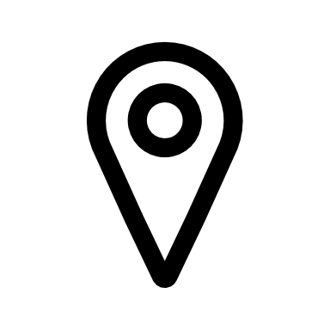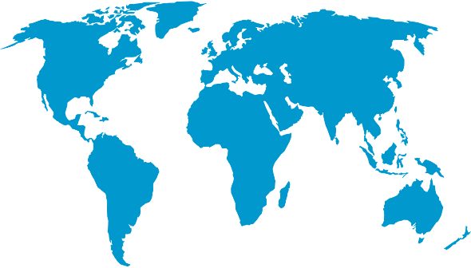

*World Map © Clker-Free-Vector-Images, Pixabay*

**Environmental facts**

|  |  |
| --- | --- |
| 1. | Half of Nigeria's government areas face the threat of river flooding. In 2022, flooding claimed the lives of a at least 660 individuals and demolished more than 200,000 homes. Moreover, Nigeria grapples with issues like drought, landslides, and extreme temperatures. |
| 2. | Nigeria's coastline extends more than 850 kilometres along the Atlantic Ocean. The coastline features predominantly low-lying areas with floodplains and estuaries. The primary rock type found along the coast is sedimentary, which can be prone to erosion. |
| 3. | 30% of Nigeria’s coastline is mangrove forest. The Niger Delta has the largest number of mangroves in Africa harbouring a rich biodiversity including marine reptiles and 5 species of sea turtle. However, these mangroves are also the least conserved and the fish stock often over fished. The estimated 37 billion barrels of oil within the Niger Delta also poses a threat to marine wildlife through oil extraction. |

**Protecting the oceans**

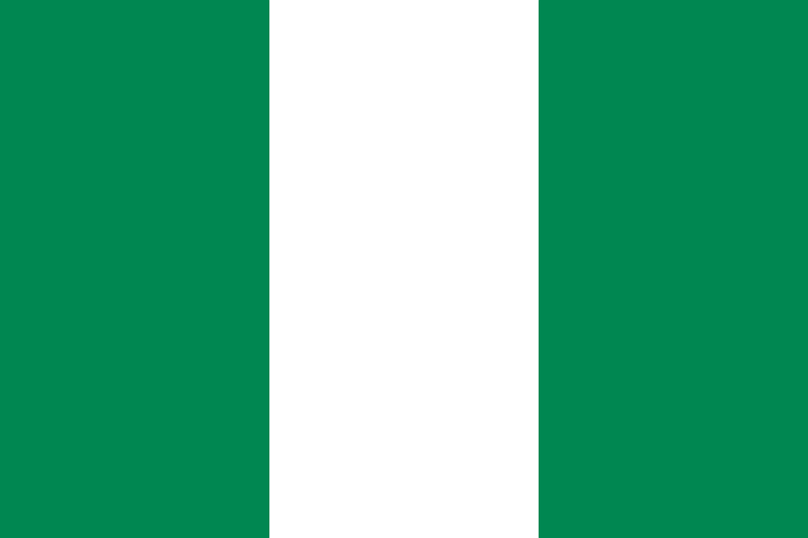In 2023, Nigeria established a ministry for blue economy which will help drive economic growth through the sustainable use of ocean and coastal resource. This could help to replace Nigeria’s reliance on oil for income and focus on conserving their coastal ecosystem. There is also a drive for community-led activities such as beach cleaning and recycling to remove plastic pollution and help the marine environment recover.

*Nigerian flag © OpenClipart-Vectors, Pixabay*