KS3 Russia teacher notes lesson four (Russia: a powerful place)
In this lesson, students will study a sequence of maps showing changes over time in the boundaries of the Russian Empire, the Soviet Union and today’s Russia (properly called the Russian Federation). They will look for signs of continuity and change in the geopolitical map of Eurasia.
Whilst historians might pay greater attention to the events that triggered successive changes for Imperial and Soviet Russia, this geography lesson instead aims to foster spatial understanding through thematic map analysis. We are also interested in understanding what a profound influence Russia has had on the rest of the world both in terms of its hard power (military might) and soft power (arts and culture, which provides a focus for the starter activity).
- They will start to consider important ways in which Russia has influenced culture on a global scale through its art, literature and sporting prowess, amongst other ways. This contributes to the soft power of a past and present superpower like Russia
- In terms of skills, they will identify the changes that have taken place along the border regions of Russia over time, as neighbour countries have come under the direct rule or influence of the Russian state. Throughout history, Russia has surrounded itself with satellite states such as Ukraine, which has sadly found itself under great pressure again - as a ‘buffer zone’ between Europe and Russia - in recent times.
Russia on the map: change and continuity
In the main part of the lesson, students will be analysing three maps of Eurasia.
1781-1917 | Russian Empire  22.8 million square km (1860)  - Prior to 1917, Russia exercised direct rule over many of its present day neighbours. The Russian Empire included most of Ukraine, Belarus, Moldova (Bessarabia), Finland (Grand Principality of Finland), Armenia, Azerbaijan, Georgia, Kazakhstan, Kyrgyzstan, Tajikistan, Turkmenistan, Uzbekistan, Lithuania, Estonia, Latvia and part of Poland.  - Alaska was also ruled as a colony until 1867!  - ‘It was the largest country in the world stretching from the Black Sea in the west to the Bering Sea in the extreme east of the Asian continent. It also had a huge population that included, alongside Russians, large numbers of Germans, Poles, Slavs and Asians. Among this diverse population, just about every major religious faith was represented.’ (BBC)
1918-1991 | Soviet Union  22.4 million square km (1991)  - Between 1918 and 1922, Russia was known as Soviet Russia. It then formed the Soviet Union of Socialist Republics, which, under rule from the Kremlin in Moscow, included many of its neighbours. Some of these states were occupied during or after the Second World War.  - The Soviet Union included the present-day states of 1. Armenia; 2. Azerbaijan; 3. Belarus; 4. Estonia; 5. Georgia; 6. Kazakhstan; 7. Kyrgyzstan; 8. Latvia; 9. Lithuania; 10. Moldova; 11. Russia; 12. Tajikistan; 13. Turkmenistan; 14. Ukraine; 15. Uzbekistan.
1991- | Russian Federation  17 million square km (2013)  - Continues to exercise influence over ex-Soviet states through a series of trade and security agreements, for instance the Eurasian Economic Community (which includes Belarus, Kazakhstan, Kyrgyzstan, Tajikistan, Uzbekistan and Russia) and the Commonwealth of Independent States (CIS).  - The Russian military has been deployed in Chechnya, Ukraine and Georgia.  - Note the Russian Federation claims ownership of two outlying areas (Crimea is disputed).

Some ex-Soviet states are shown here. This graphic is used as the students’ outline quiz, without names.
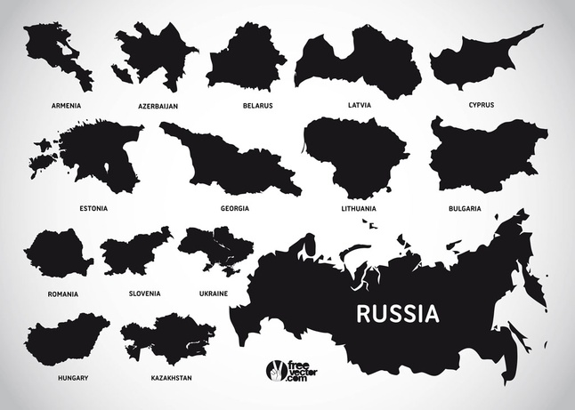

‘Back in the USSR’
Vladimir Putin, the Russian prime minister, has worked towards building an economic trade bloc composed of neighbouring ex-Soviet states. A customs union (the Eurasian Economic Community) has been launched between Russia, Belarus and Kazakhstan (leading to the removal of export tariffs and the growth of a common market).
Russia’s renewed geographical ambition became clear in 2011 when Mr Putin recently announced that ‘for the first time since the collapse of the Soviet Union, the first real step has been made towards restoring natural economic and trade ties in the post-Soviet space’ (Financial Times, 17 August 2011). At a 2011 Moscow summit, the prime ministers of the three ex-Soviet states talked of perhaps one day introducing a common currency.
Source: “Putin gains traction for his Eurasian grand union” Financial Times, 17 August 2011 http://www.ft.com/cms/s/0/a7db2310-b769-11e0-b95d-00144feabdc0.html#axzz1VP5xepTp

Russia’s continued need for satellite states
Russia has always felt the need of a ‘cordon sanitaire’.
The Russian empire from its very inception under Tsar Mikhail Romanov in 1613 tried to respond to repeated invasions by creating a “cordon sanitaire” around Russia itself, hence its participation in the partitioning of Poland in the late 18th century and its gradual occupation of present Ukraine under Catherine the Great, completed by the annexation of Crimea in 1783.
During Soviet times, this safety belt included the satellite states in eastern Europe in a crescent from Poland and Czechoslovakia through to Hungary and Romania as a first-line zone of defence and then the Baltic Soviet republics as well as Belarus, Ukraine and the three republics in the Caucasus defending the country from the west and south.
After the collapse of the Soviet Union in 1991, most of these states have now joined Nato, encircling Mother Russia with potential enemies and depriving it of its customary shield. Apart from its role as a buffer zone, Ukraine is also the producer of a number of vital parts and equipment for the Russian military such as engines for the Mi-28 attack helicopters.
Rather than threatening increased sanctions and a forever expanding Nato, it would do much good to declare that countries such as White Russia (Belarus), Ukraine, Georgia and all the -stan republics to the south and east of Russia will never ever become members of Nato.
An attempt by Georgia, for example, to become a Nato member will not enhance its security but rather invite an immediate invasion to prevent the alliance from expanding further to encircle Russia.
Accepting the legitimate interests of Russia might perhaps be seen as a return to the cold war, perhaps even as a lack of face, but the alternative is much worse.
Source: Letter from Professor Johan Lybeck Financial Times, 12 May 2014 http://www.ft.com/cms/s/0/7a3c9736-d45d-11e3-a122-00144feabdc0.html#axzz38xqVkXOh

